Supplementary Table 1. The sequence of primers

Genes | Primer sequence(5’-3’)
VEGF | F | AGGGCAGAATCATCACGAAGT
VEGF | R | AGGGTCTCGATTGGATGGCA
HIF-1α | F | GAACGTCGAAAAGAAAAGTCTCG
HIF-1α | R | CCTTATCAAGATGCGAACTCACA
bFGF | F | AGTGTGTGCTAACCGTTACCT
bFGF | R | ACTGCCCAGTTCGTTTCAGTG
PDGFRα | F | AGCGCCGAAGTCCAGAAAAC
PDGFRα | R | TACTCTCACGACAGTTGCCAT
GAPDH | F | ACAACTTTGGTATCGTGGAAGG
GAPDH | R | GCCATCACGCCACAGTTTC
miR-21-5p | F | GCAGTAGCTTATCAGACTGATG
miR-21-5p | R | GGTCCAGTTTTTTTTTTTTTTCAAC
SPRY2 | F | CCTACTGTCGTCCCAAGACCT
SPRY2 | R | GGGGCTCGTGCAGAAGAAT
U6 | F | TGGAACGCTTCACGAATTTGCG
U6 | R | GGAACGATACAGAGAAGATTAGC

Supplementary Figure S1

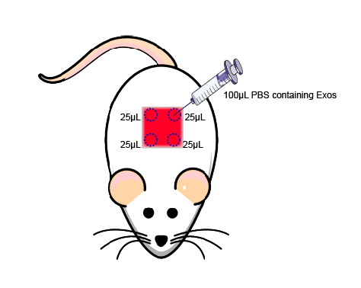
Figure S1. The 4 injection sites were the four corners of the wound. The rats were subcutaneously injected with 100 μl PBS, BMSC-Exos (100 μg dissolved in 100 μl PBS), and mag-BMSC-Exos (100 μg dissolved in 100 μl PBS) around the wounds at 4 injection sites (25 μl per site).

Supplementary Figure S2

Figure S2. Magnetic stimulation increased the production of exosomes in BMSCs. (***) p < 0.001.

Supplementary Figure S3

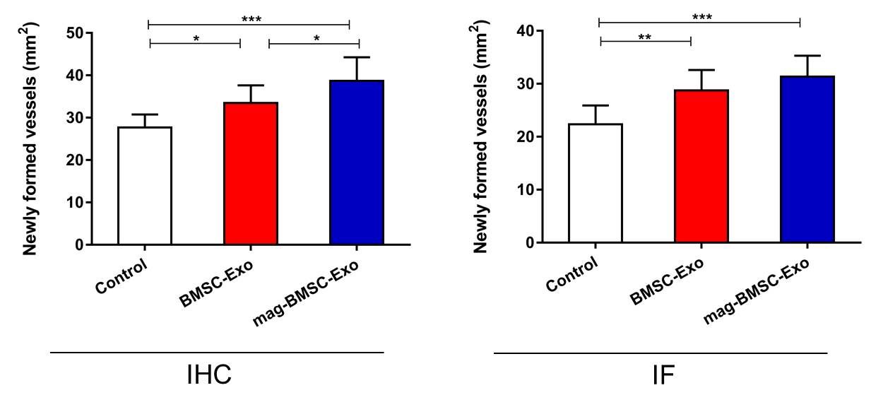

Figure S3: IHC for CD31 and IF for CD31 of wound sections in the control, BMSC-Exo, and mag-BMSC-Exo groups on day 14 after wounding. (*) p < 0.05, (**) p < 0.01, (***) p < 0.001. Quantitative determination of the number of blood vessels in these groups. Scale bar = 50 μm.
IHC: immunohistochemical staining; IF: immunofluorescence staining.

Supplementary Figure S4

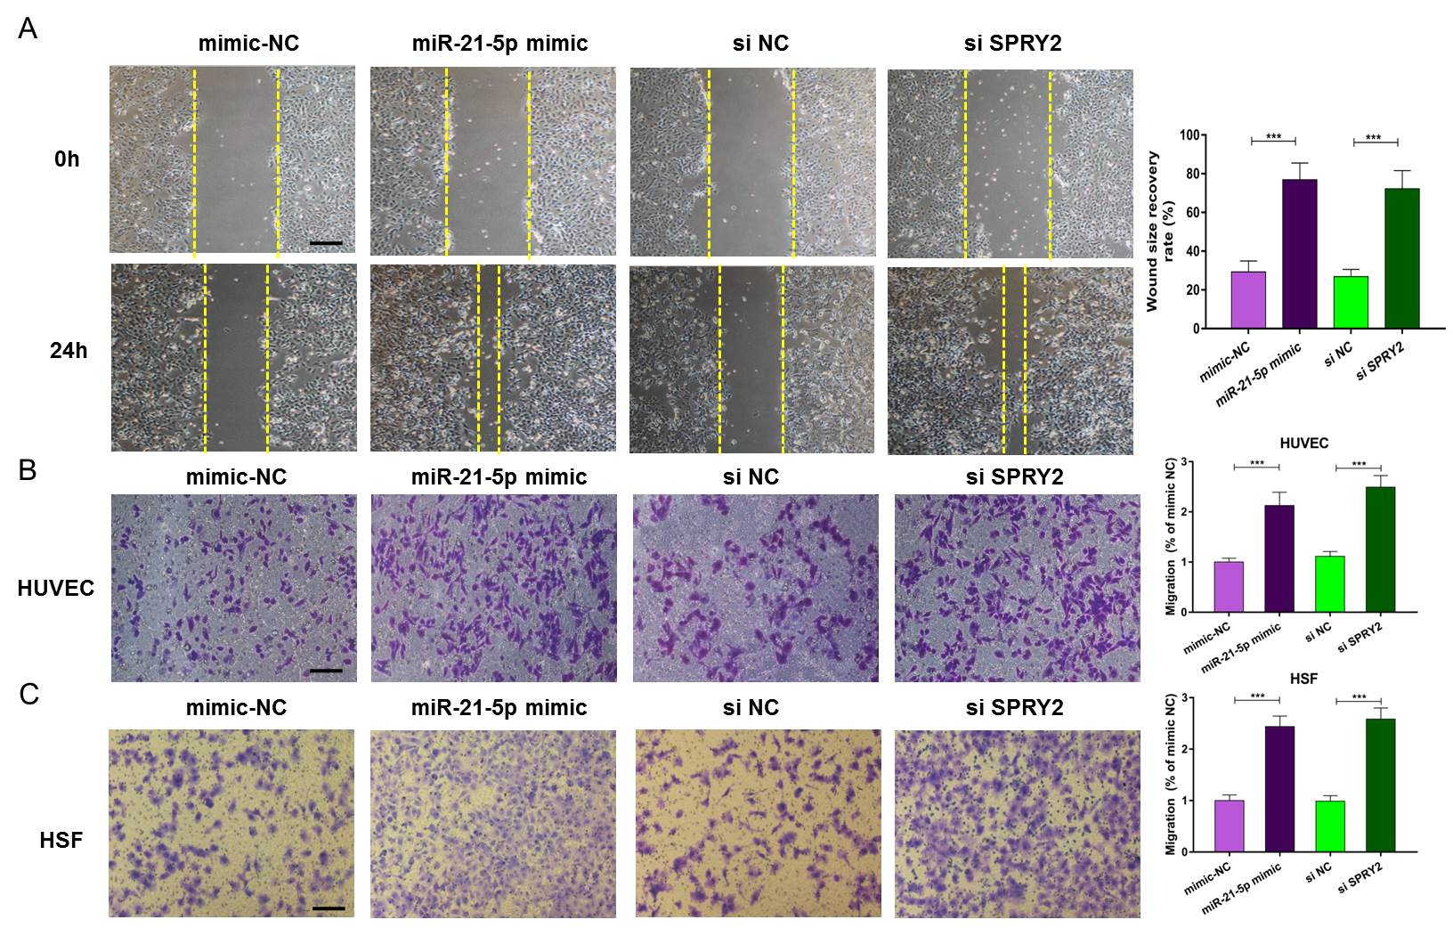

Figure S4: Knocking down the expression of SPRY2 can achieve similar effects as miR-21-5p on angiogenesis and fibroblast function. (***) p < 0.001. (A) Scratch wound assays showed the migration ability of HUVECs after transfection with miR-21-5p mimic, si-SPRY2 or their negative controls and quantitative analysis of the wound size recovery rate. (B, C) Transwell assays showed the migration ability of HUVECs and HSFs after transfection with miR-21-5p mimic, si SPRY2 or their negative controls and quantitative analysis of the migration rates. Scale bar = 200 μm.

