Supplementary materials
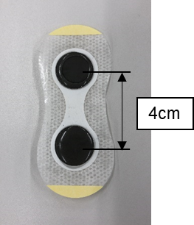

Figure S2 Inner surface of electrode
holding sheet.
Figure S1 Circuit diagram: The red and blue lines show the two pairs of electrodes with different carrier frequencies (2000 Hz or 2050 Hz).

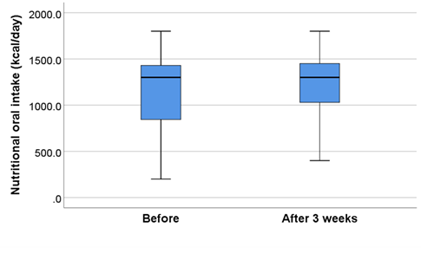

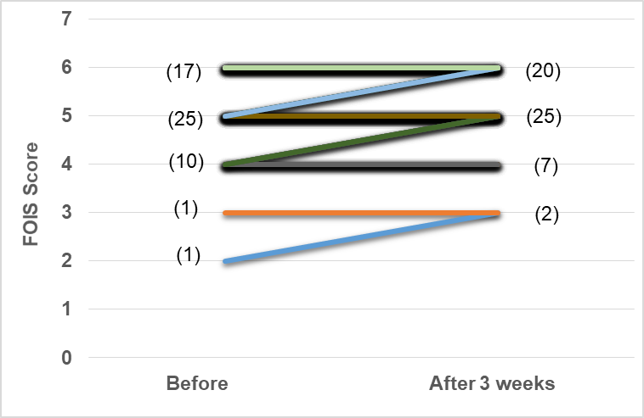
Figure S3 Comparison of nutritional oral intake before and after the 3-week IFC-TESS
Notes: Data are presented as median and 25–75% IQR for the Wilcoxon signed-rank test (p < 0.001).
Figure S4 Comparison of FOIS scores before and after 3-week IFC-TESS
Notes: Each number in the parentheses is the number of cases analyzed in the Wilcoxon signed-rank test (p = 0.02). The line colors are varied to make it easier to see the difference in scores.
Abbreviations: FOIS, functional oral intake scale

