Supplementary Materials
Supplementary table Complications
MedDRA Preferred Term, n (%)ª | Working Ability  Recovered  N = 122 | Working Ability  Not Recovered  N = 91
Hypertension | 2 (1.6) | 5 (5.5)
Essential hypertension | 1 (0.8) | 2 (2.2)
Sleep disorder | 0 | 3 (3.3)
Asthma | 1 (0.8) | 1 (1.1)
Gastrooesophageal reflux disease | 2 (1.6) | 0
Panic disorder | 2 (1.6) | 0
Rheumatoid arthritis | 1 (0.8) | 1 (1.1)
Anal prolapse | 0 | 1 (1.1)
Anxiety disorder | 0 | 1 (1.1)
Arrhythmia | 1 (0.8) | 0
Autonomic nervous system imbalance | 0 | 1 (1.1)
Cerebral infarction | 0 | 1 (1.1)
Cervicobrachial syndrome | 1 (0.8) | 0
Chloasma | 0 | 1 (1.1)
Constipation | 0 | 1 (1.1)
Dermatitis atopic | 0 | 1 (1.1)
Diabetes mellitus | 0 | 1 (1.1)
Dyslipidaemia | 0 | 1 (1.1)
Glaucoma | 0 | 1 (1.1)
Hepatic steatosis | 0 | 1 (1.1)
Ligament rupture | 0 | 1 (1.1)
Menopausal symptoms | 1 (0.8) | 0
Menstruation irregular | 0 | 1 (1.1)
Migraine | 1 (0.8) | 0
Rhinitis allergic | 0 | 1 (1.1)
Seasonal allergy | 1 (0.8) | 0
Sleep apnoea syndrome | 0 | 1 (1.1)
Thyroid neoplasm | 0 | 1 (1.1)
ªMedDRA version 18.1.
If patients had multiple complications, all complications were counted separately.

Abbreviation: MedDRA, Medical Dictionary for Regulatory Activities.
Supplementary Figure 1 Time course of effectiveness outcome measures for the 12-week treatment period by working ability. (a) HAM-D17 total score; (b) HAM-D17 core score; (c) HAM-D17 insomnia score; (d) HAM-D17 anxiety score; (e) HAM-D17 somatic score; (f) BPI-SF; (g) SASS; (h) GAF; (i) EQ-5D.
Notes: The means and standard deviations are shown for the time points at baseline and Weeks 2, 4, 8, and 12. **p<0.01, *p<0.05, comparison between the working ability recovered group and the working ability not recovered group using Welch's t-test for means of each outcome measure.
Abbreviations: BPI-SF, Brief Pain Inventory-Short Form; EQ-5D, EuroQol-5 Dimensions questionnaire for quality of life; GAF, Global Assessment of Functioning; HAM-D17, 17-item Hamilton Rating Scale for Depression; SASS, Social Adaptation Self-evaluation Scale.
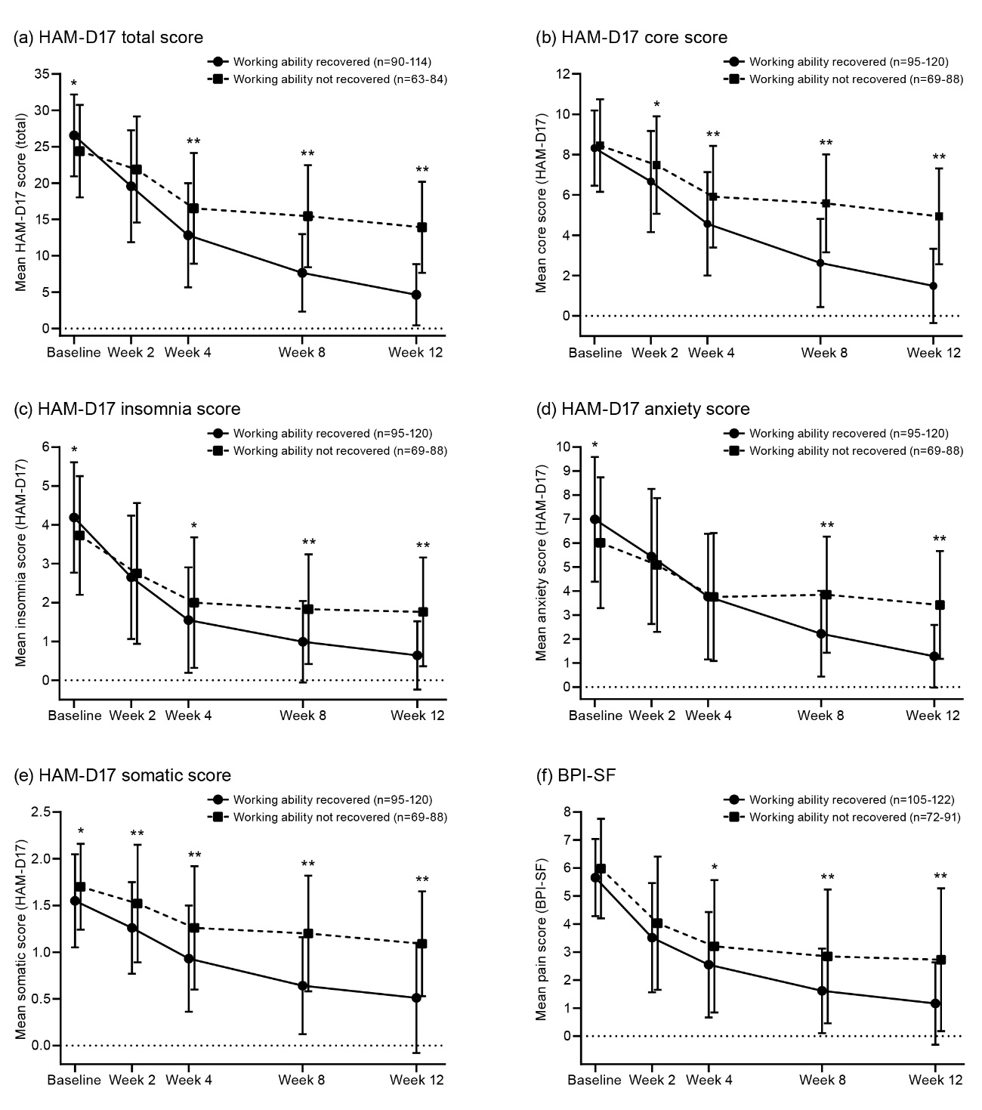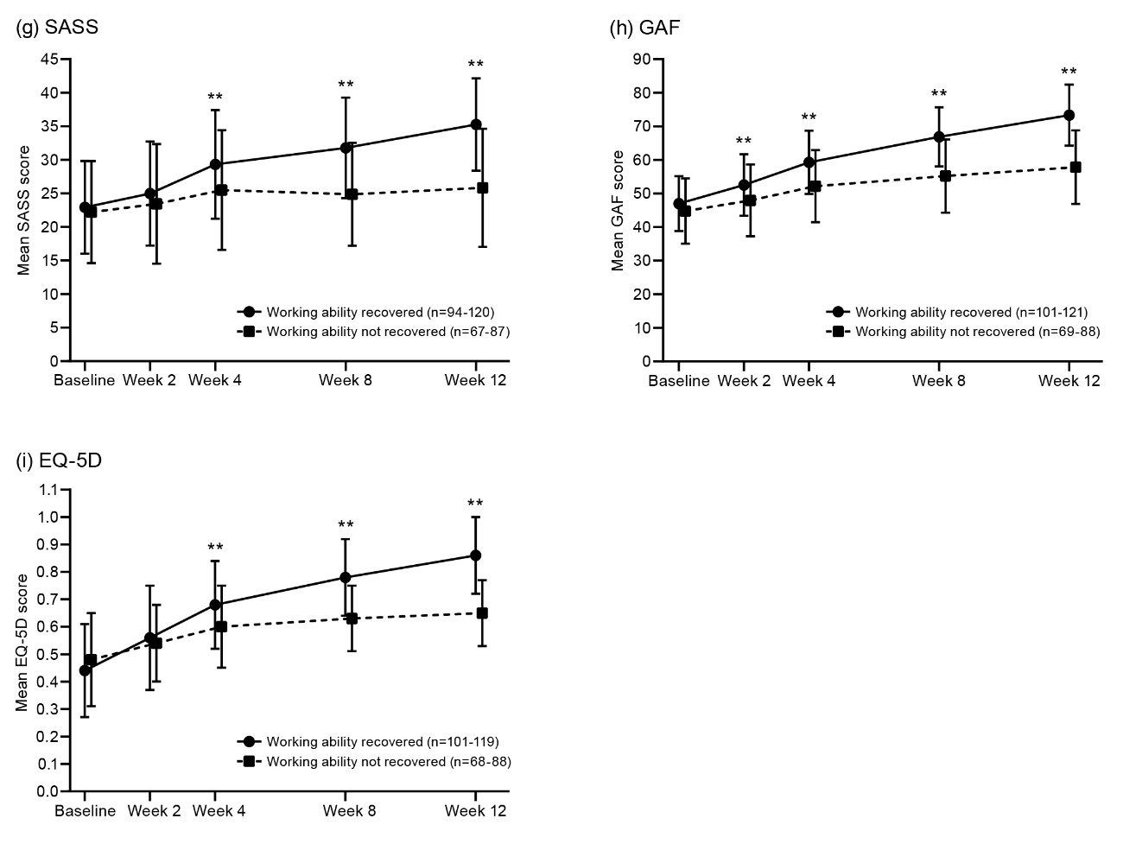

Supplementary Figure 2 Time course of effectiveness outcome measures for the 12-week treatment period between groups by working ability and depressive episodes. (a) HAM-D17 total score; (b) HAM-D17 core score; (c) HAM-D17 insomnia score; (d) HAM-D17 anxiety score; (e) HAM-D17 somatic score; (f) BPI-SF; (g) SASS; (h) GAF; (i) EQ-5D.
Notes: The means and standard deviations are shown for the time points at baseline and Weeks 2, 4, 8, and 12. **p<0.01, *p<0.05, comparison between groups by working ability and depressive episodes using Welch's t-test for means of each outcome measure.
Abbreviations: BPI-SF, Brief Pain Inventory-Short Form; EQ-5D, EuroQol-5 Dimensions questionnaire for quality of life; GAF, Global Assessment of Functioning; HAM-D17, 17-item Hamilton Rating Scale for Depression; SASS, Social Adaptation Self-evaluation Scale.
