Supplemental Figure 1. The miR-647 expression in xenograft formed by Caski-shNC and Caski-shZFAS1 cells was detected by qRT-PCR.

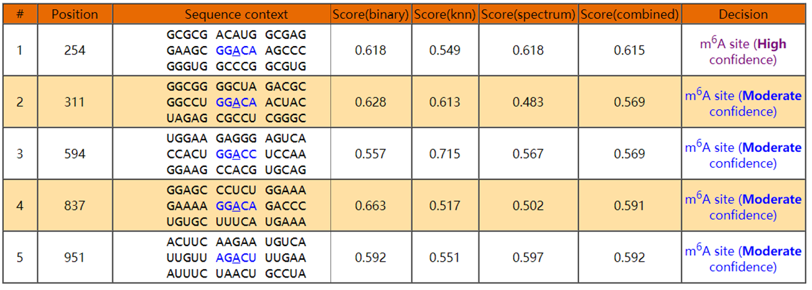
Supplemental Table 1. Prediction of m⁶A modification sites of ZFAS1 using SRAMP online tool.

