Supplementary material

Patients in the strengthening group and the stretching group performed these exercise protocols, respectively, always supervised by a trained healthcare professional.

Strengthening protocol

The strengthening protocol consisted of two phases: (1) Warm-Up Phase and (2) Active Phase, which included 5 strengthening exercises.

Warm-up phase
- Pelvic tilt movement:
- Placed on supine position, subject flattens the lumbar spine against the floor, in a pain-free range.
- Placed on hands and knees, subject flattens the lumbar spine.
- Each exercise was held between 5 and 10 seconds.

- Abdominal drawing-in maneuver (ADIM). Main maneuver to strengthen the deep muscles:
- Placed on supine position with knees bent and feet flat on the floor, subject slowly pulls the belly button in towards the spine, tightening the abdominal muscles and keeping the hips and chest still.
- Exercise was performed while breathing out gently.

Active phase
The strengthening protocol was performed following these guidelines:
- Two sets of 10 repetitions was performed for each exercise.
- Each repetition was hold for 5 seconds.
- Load was increased if the first set was completed properly.
- If full range of motion (ROM) was not maintained for more than 2 repetitions, load was not increase in the next set.

Strengthening exercise 1. Lumbar extension

In a prone position on a Swiss ball with the knees bended in contact with the floor (see Figure 1):
- First set: lumbar extension keeping the arms by the sides.
- Second set: lumbar extension keeping the arms at 90º abduction and the elbows flexed at 90º.

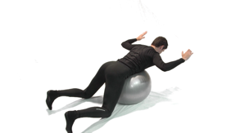
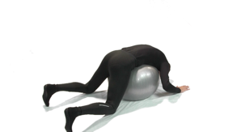
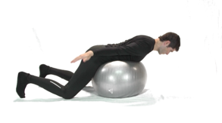
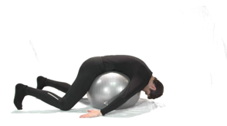
Figure 1. Initial (a) and final (b) position of the lumbar extension exercise at first set. Initial (c) and final (d) position of the lumbar extension exercise at second set.
(d)
(c)
(b)
(a)

Strengthening exercise 2. The bridge

In a supine position with the knees flexed and 30º hip abduction (see Figure 2):
- First set: lift the pelvis until knees, hips and shoulders are aligned.
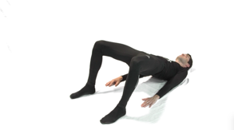
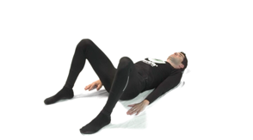
- Second set: lift the pelvis until knees, hips and shoulders are aligned, with an extra 1,5 kg load.
(b)
(a)
Figure 2. Initial (a) and final (b) position of the bridge exercise at first set.

Strengthening exercise 3. McGill curl up
Lying on the floor with one leg flexed and the other leg straight (see Figure 3):
- First set: with both hands below the low back in order to keep the lumbar curve in neutral position, subject lifted the chest as high as neutral curve could be maintained.
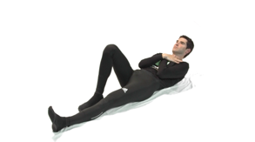
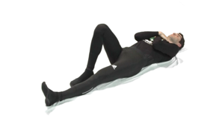
- Second set: the same exercise with the arms crossed over the chest.
(b)
(a)

Figure 3. Initial (a) and final (b) position of the McGill curl up exercise at second set.

Strengthening exercise 4. The clam

Lying on the right/left body side with the knees flexed (see Figure 4):
- First set: knees flexed at 135º, lift the upper knee avoiding pelvis and lumbar compensation. Repeat with the opposite leg.
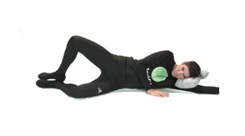
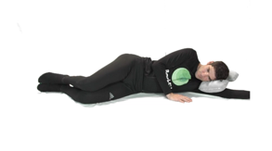
- Second set: the same exercise with the knees flexed at 90º. Repeat with both legs.
(b)
(a)
Figure 4. Initial (a) and final (b) position of the clam exercise at second set.

Strengthening exercise 5. Dead Bug
Lying at supine position with one leg flexed on the floor and the other leg flexed on the air (see Figure 5):
- First set: extend the leg and maintain 5 seconds at final position using ADIM contraction and then return to the initial position. Repeat with the opposite leg.
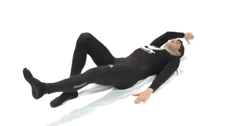
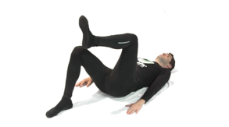
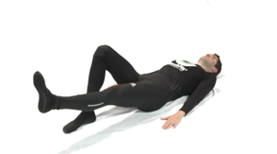
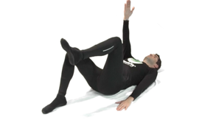
- Second set: the same exercise, but with the opposite arm moving backwards.
(d)
(a)
(b)
(c)

Figure 5. Initial (a) and final (b) position of the dead bug exercise at first set, and initial (c) and final (d) position of the dead bug exercise at second set.

Stretching protocol

The stretching protocol consists of 5 stretching exercises performed on a mat and following these guidelines:
- The intensity of the stretching was determined based on the stretch perceived sensation by the subject.
- Each exercise was repeated 3 times.
- Each repetition was hold for 30 seconds while breathing gently.

Starting position

Place the foam roller on the sacrum. Lumbar region must move closer to the ground. Keep legs bent and feet on the floor (see Figure 6).
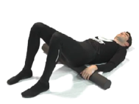

Figure 6. Stretching exercise using a foam roller (starting position).

Stretching exercise 1. Hip flexors

From the starting position, one leg bends towards the chest, holding it with the hands. The other leg remains straight on the mat. Repeat with both legs (see Figure 7).

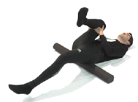

Figure 7. Hip flexors stretching exercise using a foam roller.

Stretching exercise 2. Lumbar extensors

From the starting position, both legs are bent towards the chest, holding the legs with hands to make a small pressure towards the chest (see Figure 8).
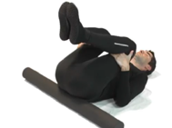

Figure 8. Lumbar extensors stretching exercise using a foam roller to stretch the lumbar extensors.

Stretching exercise 3. Lateral muscle chain

From the starting position and the arms placed open at 90º roll both knees over to one side keeping the shoulders firmly on the floor. Head turns to the opposite side. Repeat the stretch to the other side. Return to the starting position and then gently roll knees over to the opposite side, hold, and then return to the starting position (see Figure 9).
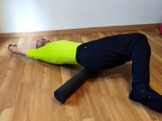

Figure 9. Stretching exercise using a foam roller to stretch both lateral muscle chains.

Stretching exercise 4. Hamstrings

In the supine position and maintaining lumbar region neutral position, raise the leg fully straight without ankle dorsiflexion (neutral position). To perform the stretching, the subject uses a strap that helps maintaining hip flexion (see Figure 10).

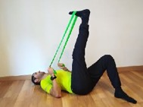

Figure 10. Stretching exercise using a strap to stretch the hamstrings.

Stretching exercise 5. External rotators

From the starting position, place the right ankle on the left knee and flex the left hip until the stretch was perceived. Repeat with both legs (see Figure 11).

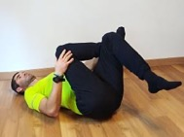

Figure 11. Stretching exercise without any support to stretch both external rotators.

Supplementary Table 1. Cohen’s d values from t-test comparisons of the pre-post absolute differences between all groups (i.e., stretching, strengthening, aerobic and control) for each body location (i.e., spinal erector muscle, gluteus medius muscle, sacrum and forefinger) of tactile thresholds, pain intensity ratings of non-painful pressure, pain pressure thresholds, pain pressure intensity ratings, pain sensitivity index, and isometric lumbar muscle endurance and flexibility measures.

 | Stretching vs. Strengthening | Stretching vs. Aerobic | Stretching vs. Control | Strengthening vs. Aerobic | Strengthening vs. Control | Aerobic vs. Control
Tactile thresholds
Forefinger | .26 | .00 | -.00 | -.26 | -.26 | -.00
Spinal erector | .15 | -.50 | -.16 | -.66 | -.32 | .34
Sacrum | -.23 | -.41 | -.21 | -.17 | .02 | .20
Gluteus | .17 | .63 | .60 | .46 | .43 | -.03
Pain intensity ratings to non-painful pressure
Forefinger | -.03 | .28 | -.18 | .31 | -.16 | -.46
Spinal erector | .10 | -.31 | .03 | -.42 | -.08 | .34
Sacrum | -.40 | -.29 | -.45 | .11 | -.05 | -.16
Gluteus | .19 | .23 | .37 | .03 | .17 | .14
Pain pressure thresholds
Forefinger | -.01 | .19 | .12 | .21 | .13 | -.07
Spinal erector | .06 | .28 | -.17 | .22 | -.23 | -.45
Sacrum | -.07 | -.06 | -.05 | .00 | -.12 | .01
Gluteus | .03 | .17 | .11 | .14 | .08 | -.06
Pain pressure intensity ratings
Forefinger | -.22 | -.18 | .05 | .04 | .28 | .24
Spinal erector | .21 | .21 | .71 | -.00 | .30 | .50
Sacrum | .15 | .14 | .56 | -.00 | .27 | .42
Gluteus | -.14 | .12 | .24 | .26 | .28 | .12
Pain sensitivity index
Forefinger | -.20 | .09 | -.07 | .29 | .31 | -.16
Spinal erector | -.22 | -.23 | .27 | -.01 | .33 | .50
Sacrum | -.15 | -.31 | .10 | -.15 | .29 | .41
Gluteus | -.22 | -.32 | -.11 | -.09 | .33 | .21
Lumbar flexibility | -.51 | -.22 | -.56 | .29 | .28 | -.33
Lumbar strength | -.27 | -.33 | -.59 | -.06 | .33 | -.25

