Supporting information
The adjuvant of α-galactosylceramide presented by gold nanoparticles enhances anti-tumor immune responses of MUC1 antigen-based tumor vaccines
Yonghui Liu,† Zhaoyu Wang,† Fan Yu,‡ Mingjing Li,† Haomiao Zhu,† Kun Wang,† Meng Meng,†,* and Wei Zhao†,*
† State Key Laboratory of Medicinal Chemical Biology, College of Pharmacy and KLMDASR of Tianjin, Nankai University, NO.38 Tongyan Road, Haihe Education Park, Tianjin 300353, P.R. China
‡ College of Life Sciences, Nankai University, Tianjin 300071, P.R. China

Characterization of MUC1(Tn) glycopeptide
NH₂(CH₂CH₂O)₂CH₂CO-His-Gly-Val-Thr-Ser-Ala-Pro-Asp-Thr(α-D-GalNAc)-Arg-Pro-Ala-Pro-Gly-Ser-Thr-Ala-Pro-Pro-Ala-OH (MUC1(Tn))
Scheme S1. The structure of MUC1(Tn) glycopeptide.

Analytical HPLC: R_{t} (retention time) = 10.7 min, 10-35% of acetonitrile and H₂O (0.1% TFA) over 25 min on a C-18 column, 99.9% purity, λ=220 nm.
ESI-MS: m/z for C₉₄H₁₅₁N₂₇O₃₆ [M+2H]²⁺ calcd 1118.7, found 1118.8; [M+3H]³⁺ calcd 746.1, found 746.1.
Scheme S2. HPLC and ESI-MS spectra of MUC1(Tn)

Characterization of AuNPs vaccines

UV-Vis spectrum
UV/Vis spectra were plotted with an UV-2600/2700 (Shimadzu).
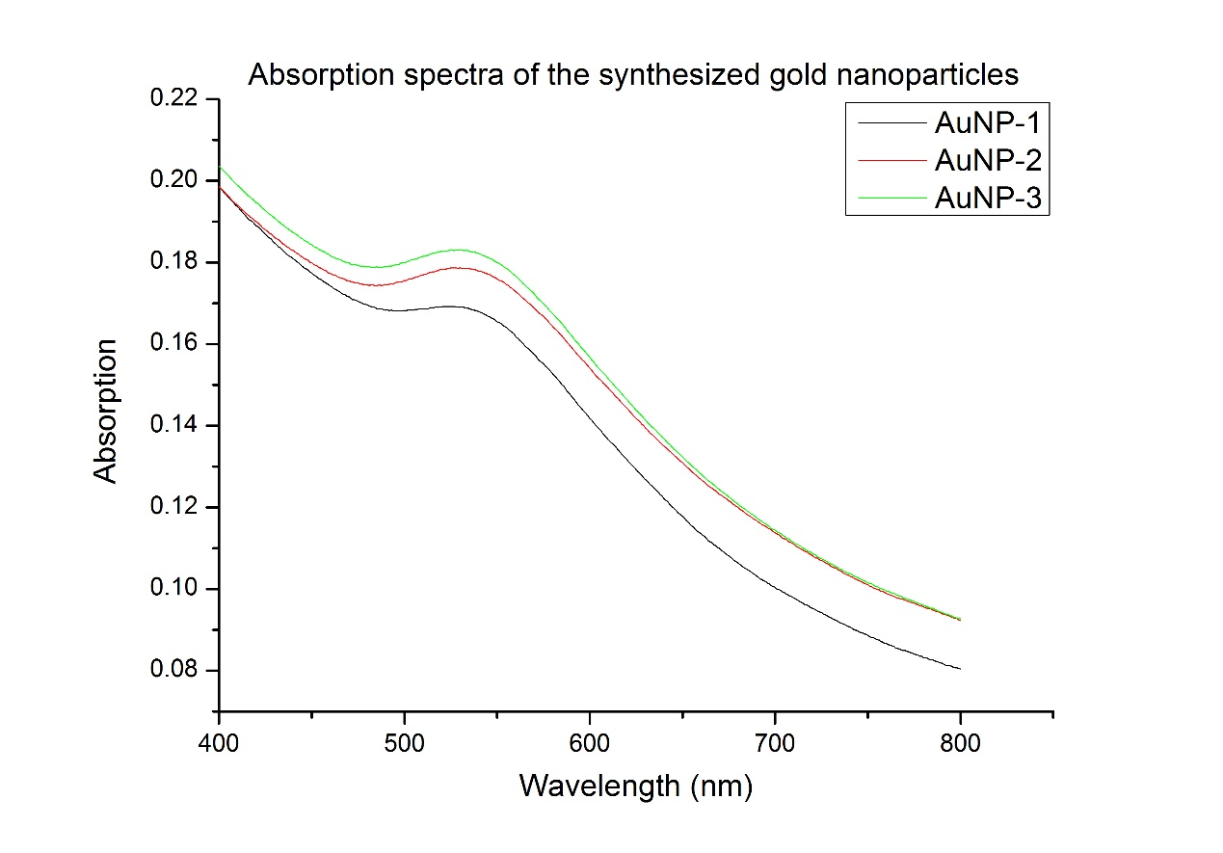
Figure S1. UV-Vis spectrum of the prepared AuNPs vaccine candidates. AuNP-1, MUC1(Tn)/6-NH₂-α-GalCer=2:1; AuNP-2, MUC1(Tn)/6-NH₂-α-GalCer =1:1; AuNP-3, MUC1(Tn)/6-NH₂-α-GalCer =1:2.

TEM measurement
AuNPs in PBS solution in injection concentration were prepared. 3 μL of each sample was dropped to copper grids with carbon-coated support films. The excess solution was removed with filter paper and washed the copper grid twice with double distilled water. The grids were allowed to dry in air overnight, and then observed with JEM100CXII system operating at 100 kV.
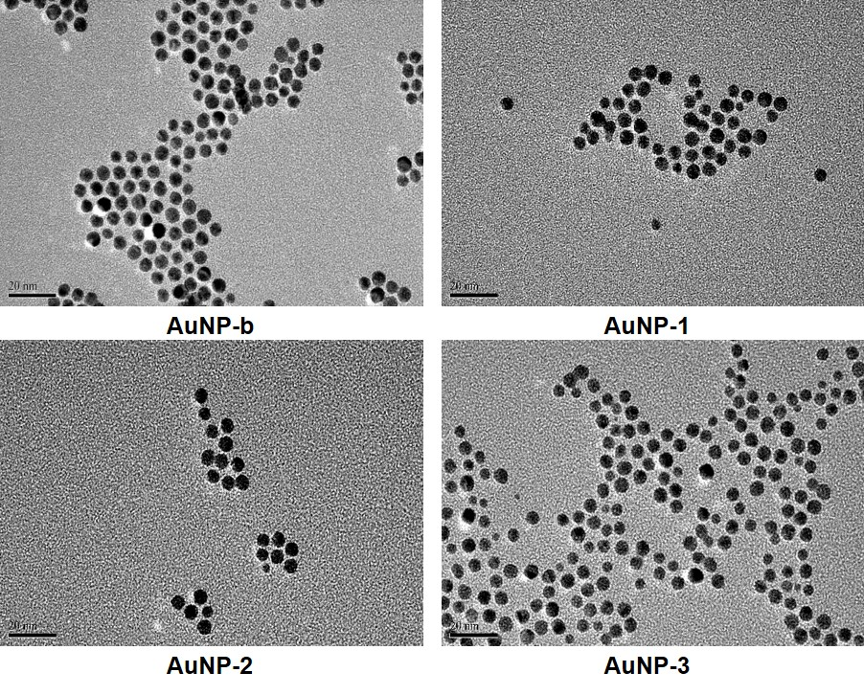
Figure S2. TEM images of the prepared AuNPs vaccine candidates. AuNP-1, MUC1(Tn)/6-NH₂-α-GalCer = 2:1; AuNP-2, MUC1(Tn)/6-NH₂-α-GalCer = 1:1; AuNP-3, MUC1(Tn)/6-NH₂-α-GalCer = 1:2; AuNP-b, gold nanoparticles without MUC1(Tn)/6-NH₂-α-GalCer. Scale bar = 20 nm.

DLS and Zeta potential
Dynamic light scattering measurements were acquired using a Malvern Panalytical Zetasizer Nano ZSP. Samples were passed through a 0.22 μm syringe filter prior to analysis.
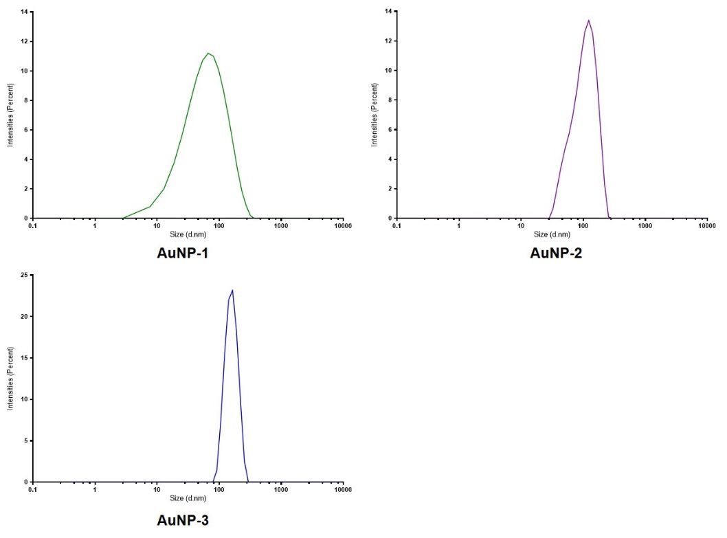
Figure S3. The size distributions of the prepared AuNPs vaccine candidates. AuNP-1, MUC1(Tn)/6-NH₂-α-GalCer = 2:1; AuNP-2, MUC1(Tn)/6-NH₂-α-GalCer = 1:1; AuNP-3, MUC1(Tn)/6-NH₂-α-GalCer = 1:2.

BCA method to measure the loading of MUC1
The BCA Kit was employed to measure the loading efficiency of MUC1 glycopeptide antigen on the AuNP by analyzing the free MUC1 in supernatant. The standard curve was established. The loading efficiency was calculated with the formula: Loading efficiency (%) = [(Total MUC1 – Free MUC1 in supernatant)/ Total MUC1] × 100%

Figure S4. The standard curve of BCA method

The calculated loading of AuNP1-3 was 92%, 86% and 83% respectively.

¹H-NMR to measure the loading of α-GalCer
The loading of 6-NH₂-α-GalCer was determined by ¹H NMR spectroscopy by comparison of the integrals of selected peaks of the supernatant to the anomeric hydrogen of the α-glycoside (¹H of 6-NH₂-α-GalCer: δ = 5.17 ppm). Before the NMR detection, the supernatant was evaporated completely and redissolved in deuterated pyridine. The overall conversion was almost complete as no observable anomeric hydrogen was found.

¹H NMR , ¹³C NMR spectra
¹H NMR Spectrum of compound 2 in CD₃OD (400 MHz)
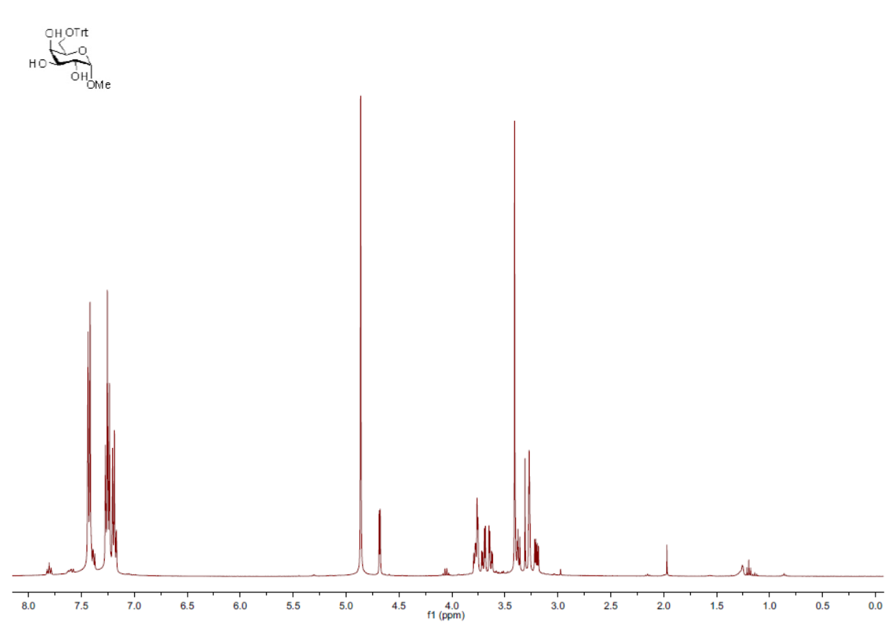
¹³C NMR Spectrum of compound 2 in CD₃OD (100 MHz)
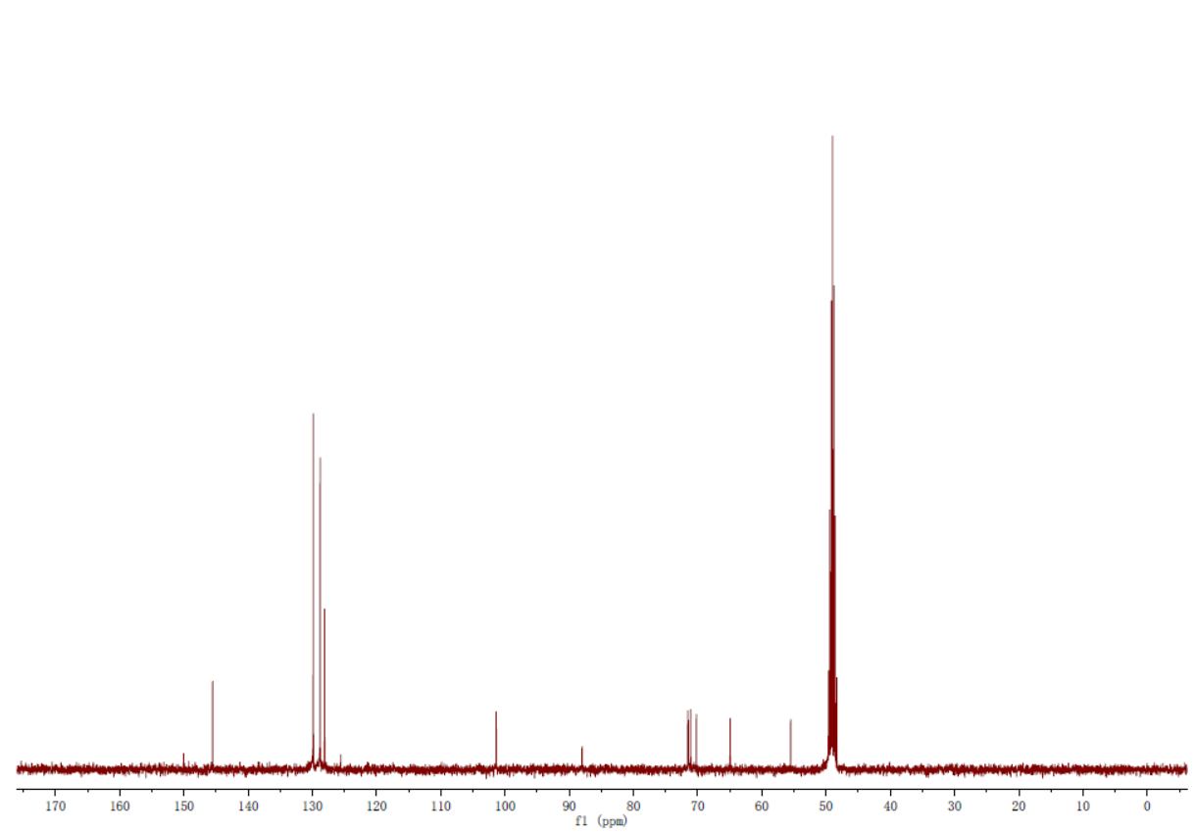
Figure S5. ¹H and ¹³C NMR spectra of compound 2 in CD₃OD
¹H NMR Spectrum of compound 4 in CDCl₃ (400 MHz)
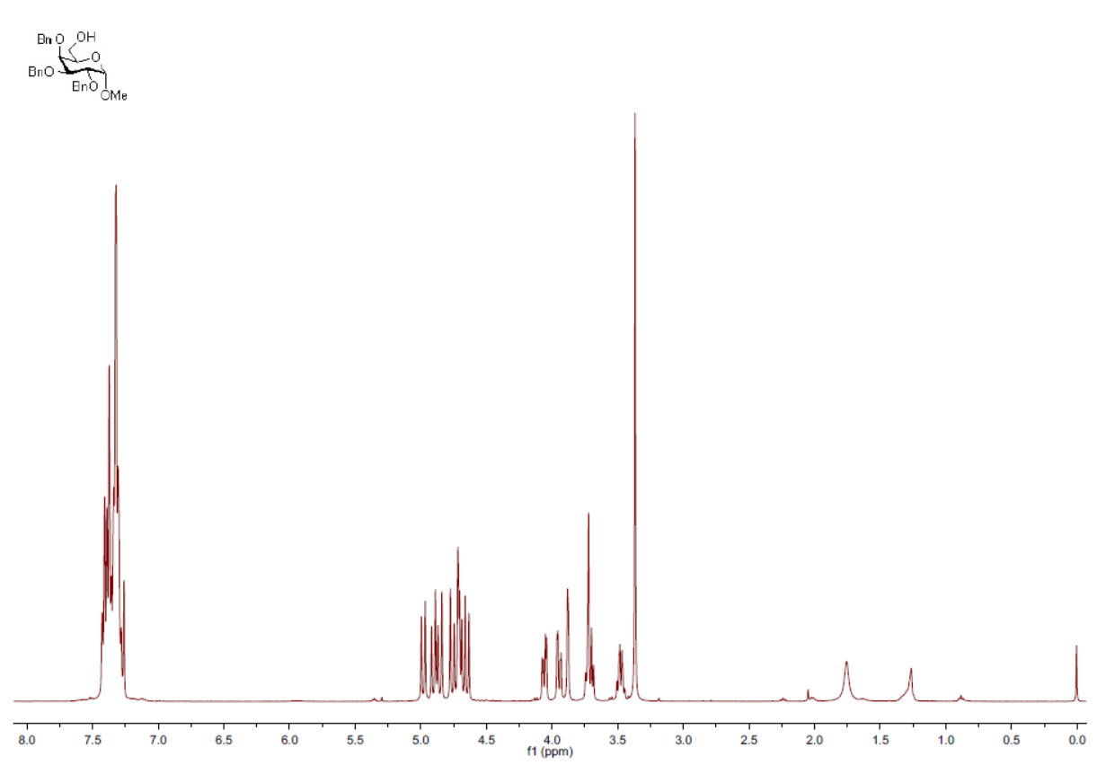
¹³C NMR Spectrum of compound 4 in CDCl₃ (100 MHz)
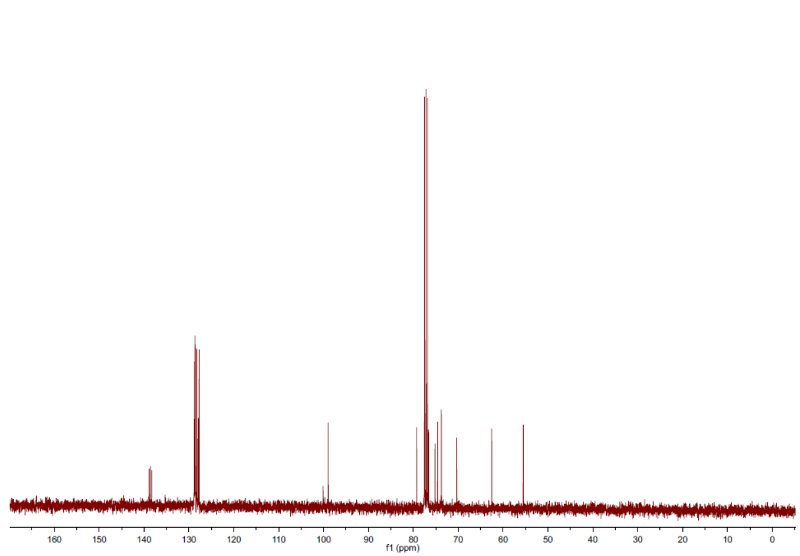
Figure S6. ¹H and ¹³C NMR spectra of compound 4 in CDCl₃

¹H NMR Spectrum of compound 6 in CDCl₃ (400 MHz)
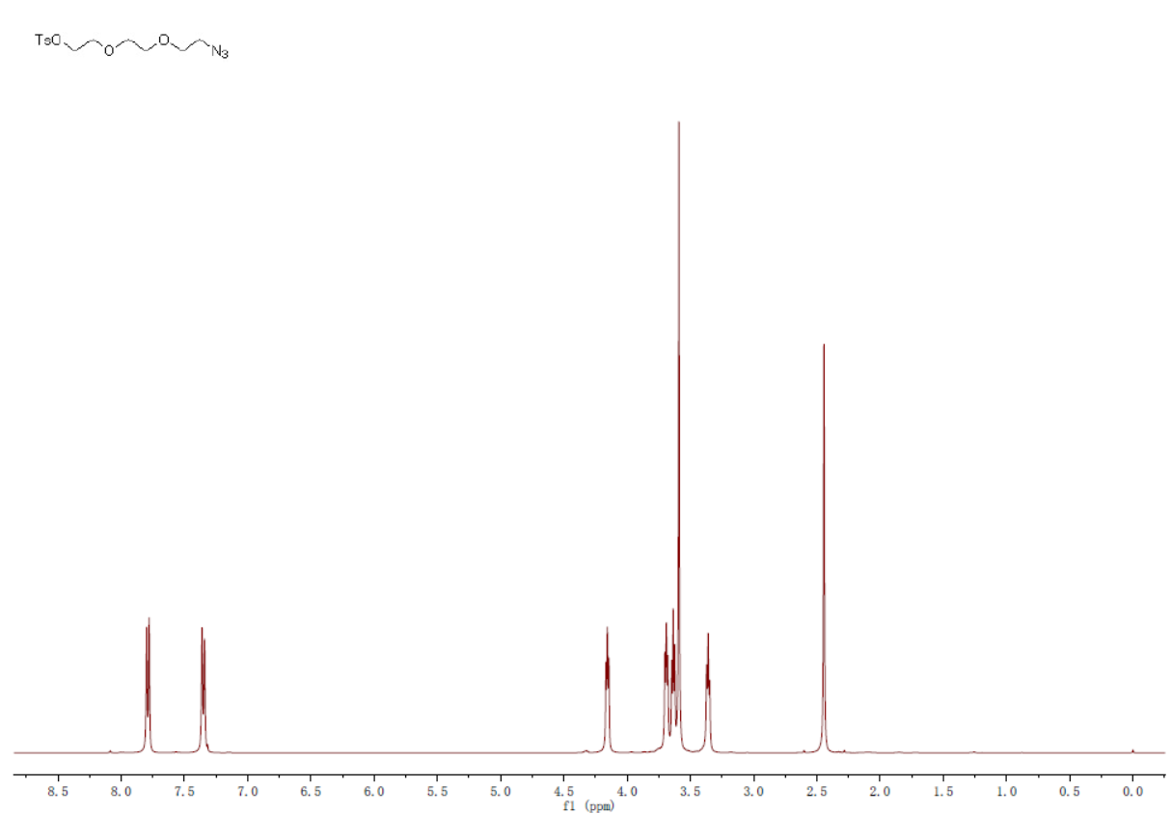
¹³C NMR Spectrum of compound 6 in CDCl₃ (100 MHz)
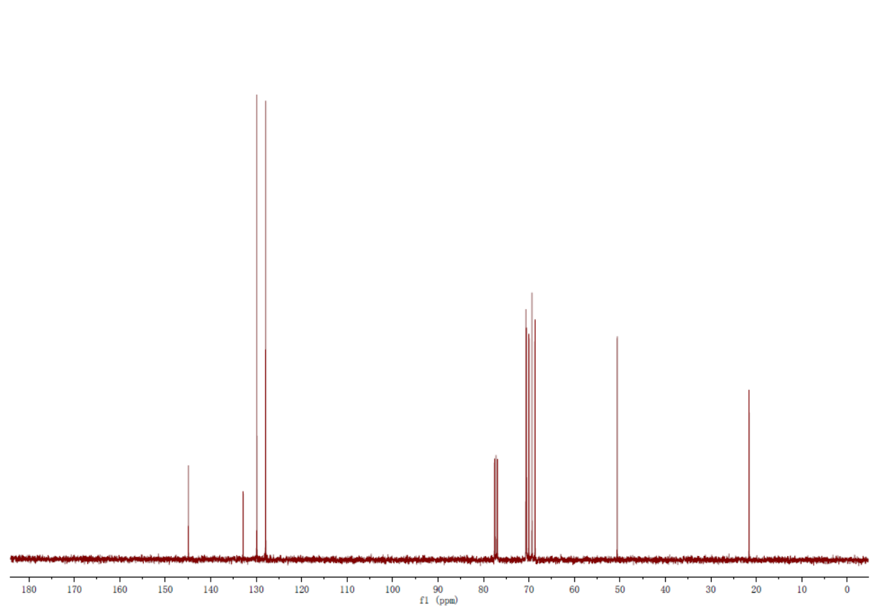
Figure S7. ¹H and ¹³C NMR spectra of compound 6 in CDCl₃

¹H NMR Spectrum of compound 7 in CDCl₃ (400 MHz)
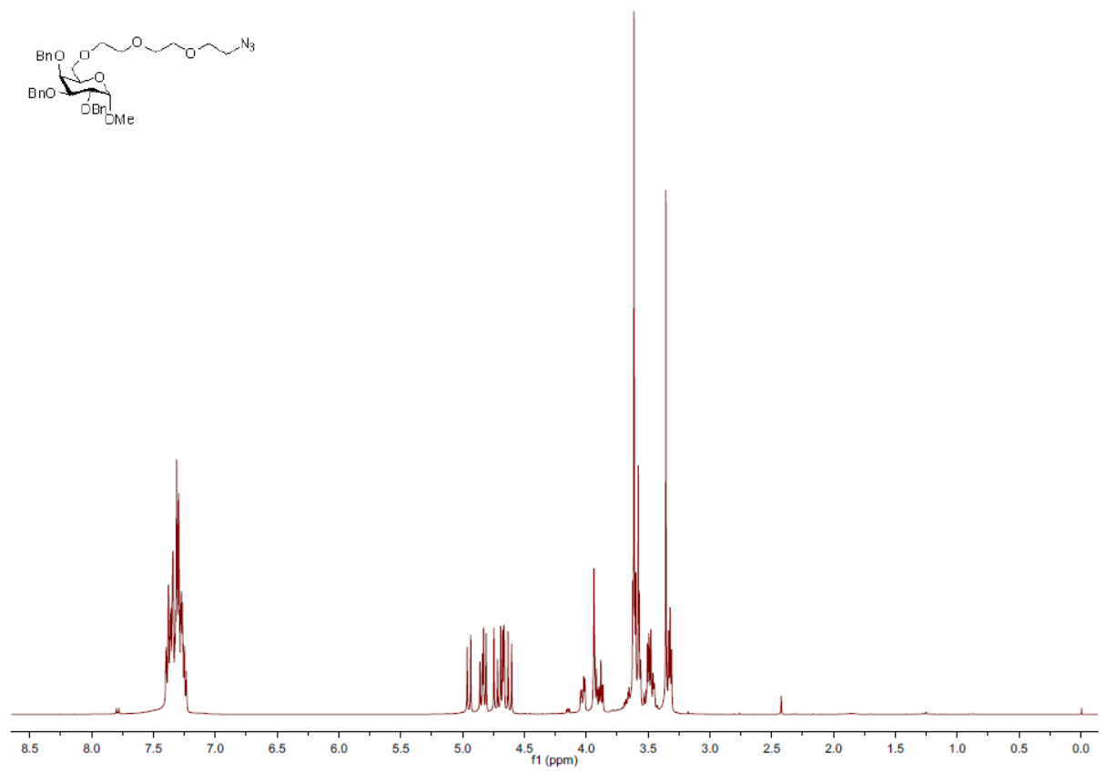
¹³C NMR Spectrum of compound 7 in CDCl₃ (100 MHz)
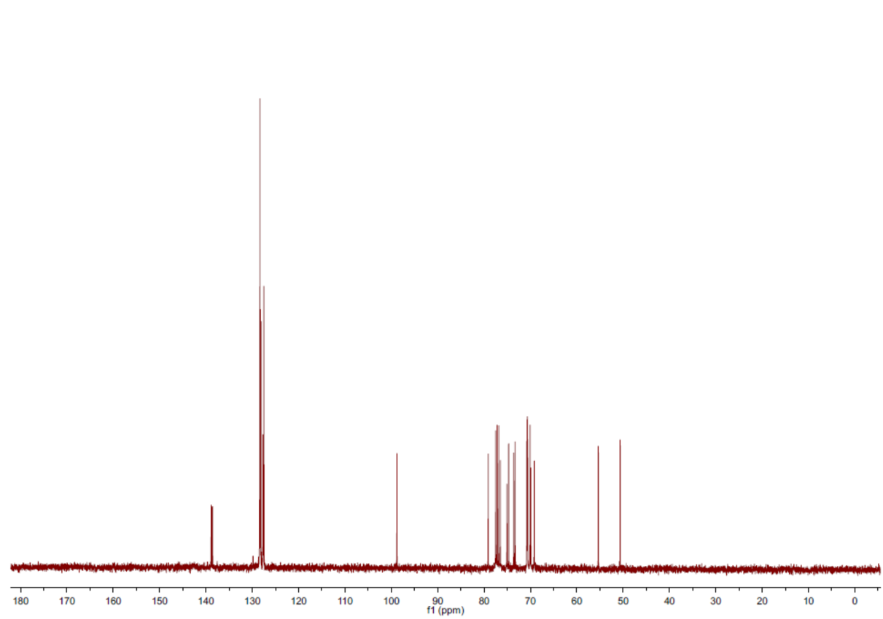
Figure S8. ¹H and ¹³C NMR spectra of compound 7 in CDCl₃

¹H NMR Spectrum of compound 11 in CDCl₃ (400 MHz)
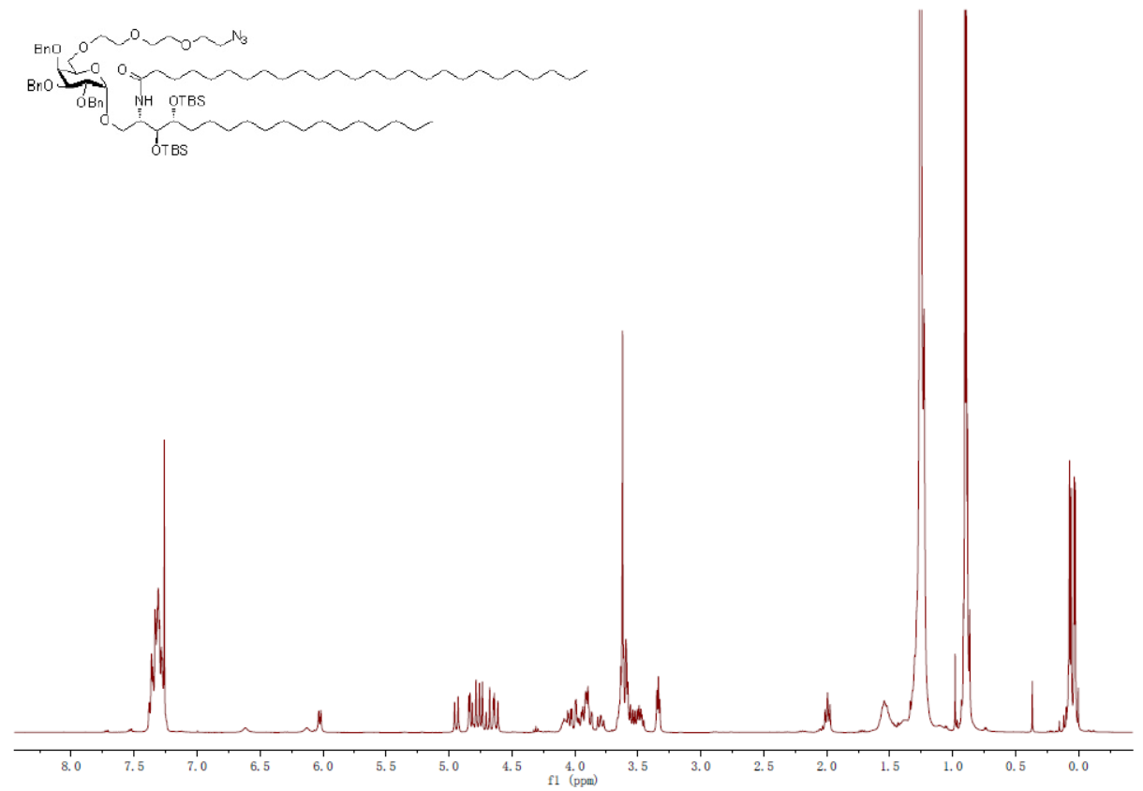
¹³C NMR Spectrum of compound 11 in CDCl₃ (100 MHz)
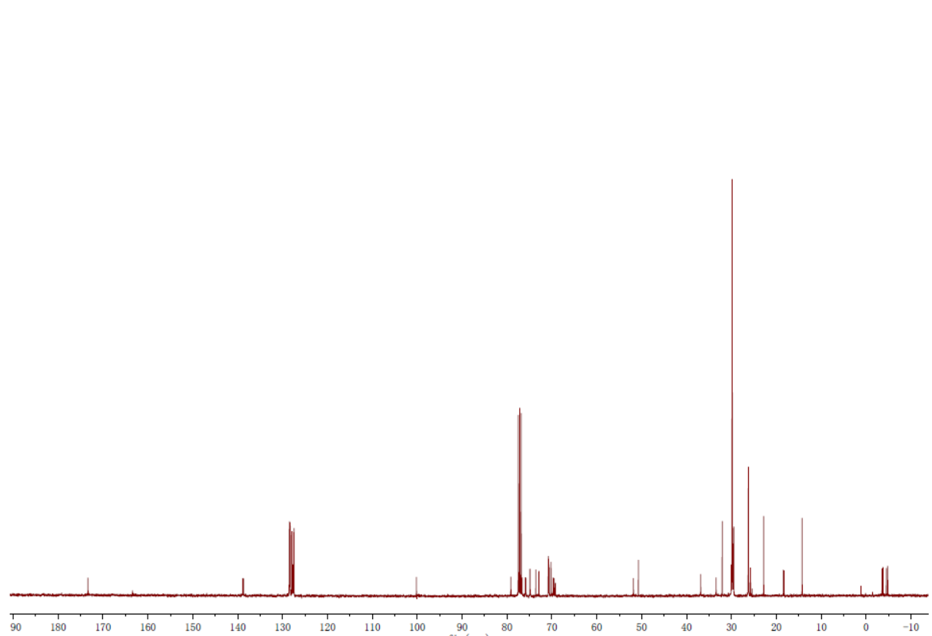

Dept-135 Spectrum of compound 11 in CDCl₃
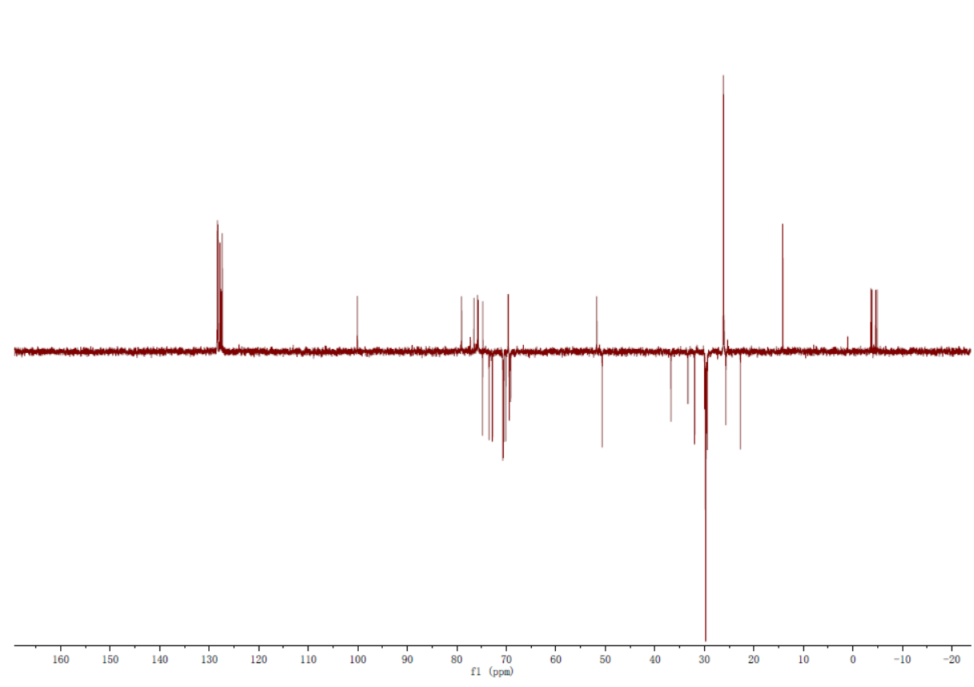
HSQC Spectrum of compound 11 in CDCl₃
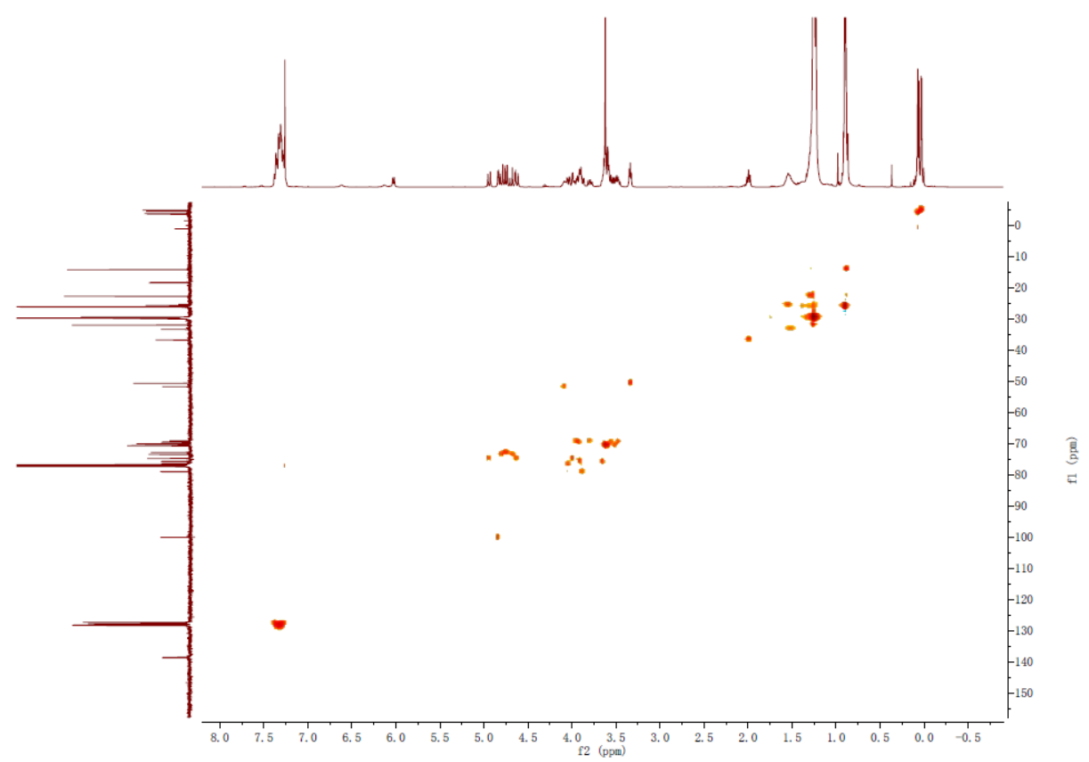
Figure S9. ¹H, ¹³C, Dept-135 and HSQC NMR spectra of compound 11 in CDCl₃

¹H NMR Spectrum of compound 12 in CDCl₃ (400 MHz)
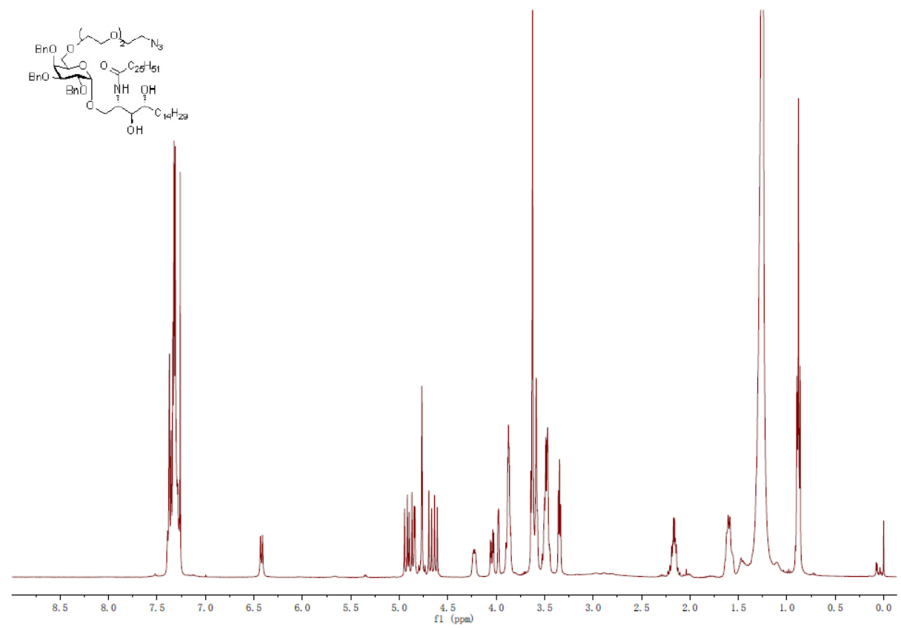
¹³C NMR Spectrum of compound 12 in CDCl₃ (100 MHz)
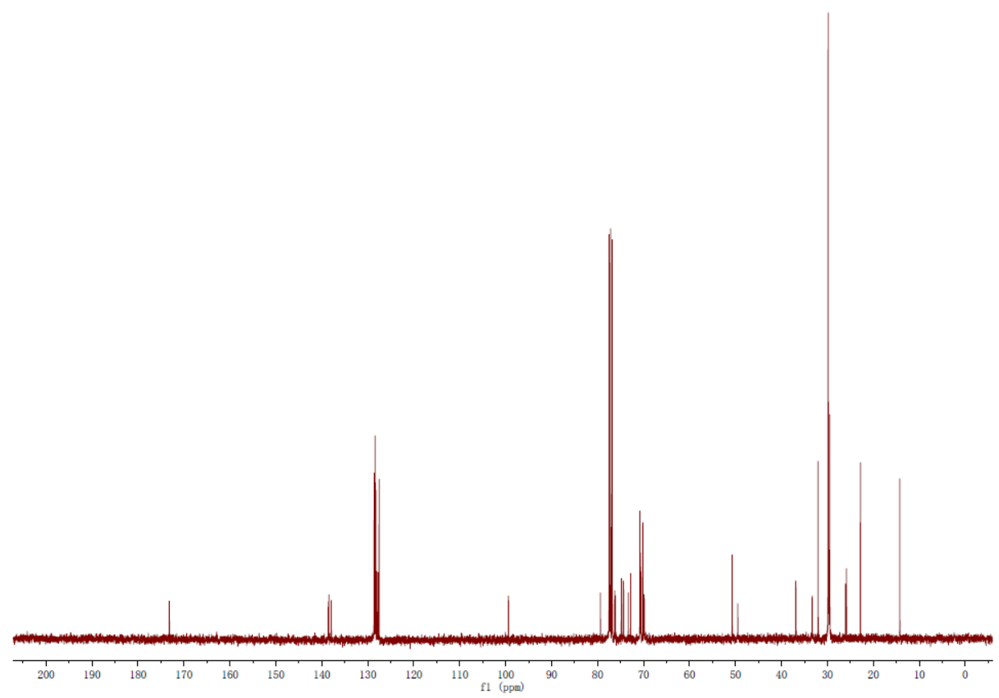

Dept-135 Spectrum of compound 12 in CDCl₃
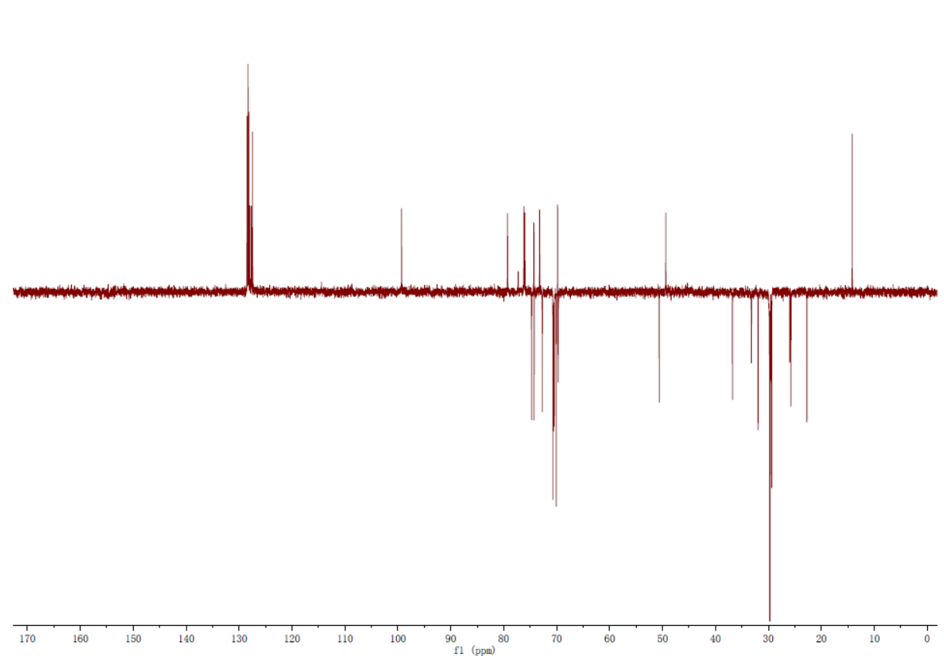
HSQC Spectrum of compound 12 in CDCl₃
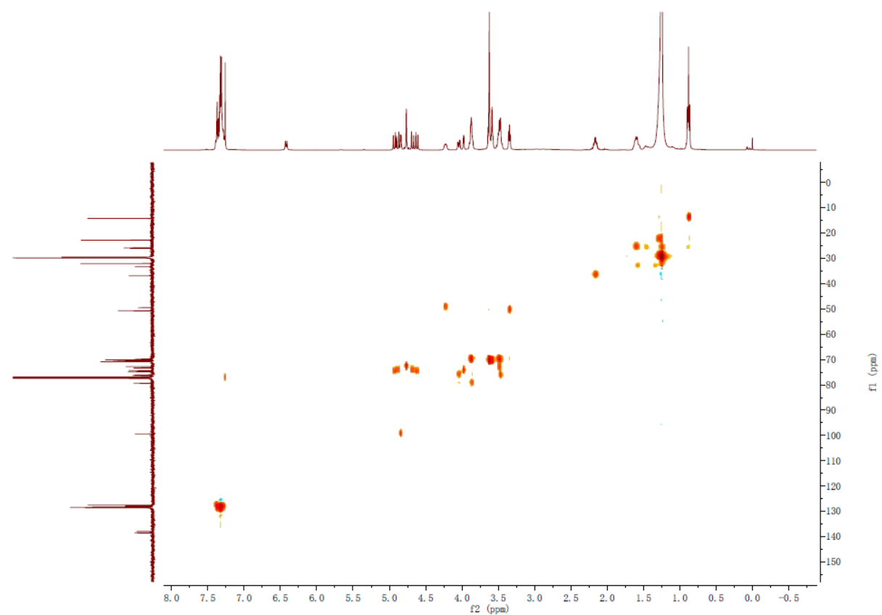
Figure S10. ¹H, ¹³C, Dept-135 and HSQC NMR spectra of compound 12 in CDCl₃

¹H NMR Spectrum of compound 13 in pyridine-d5 (400 MHz)
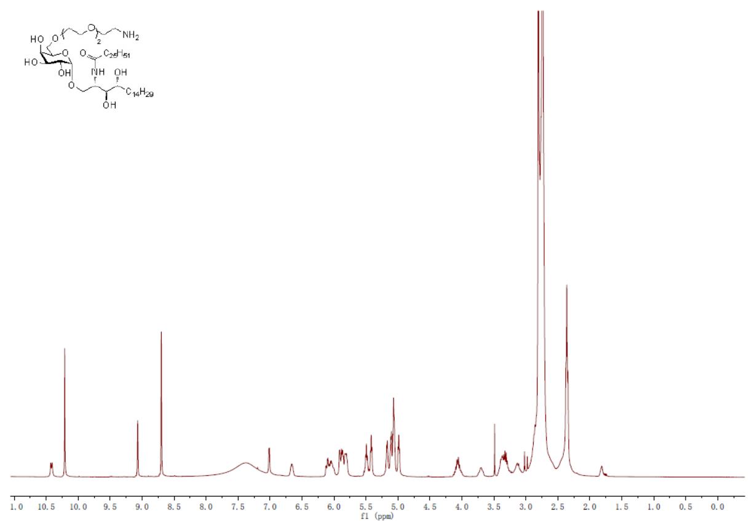
¹³C NMR Spectrum of compound 13 in pyridine-d5 (100 MHz)
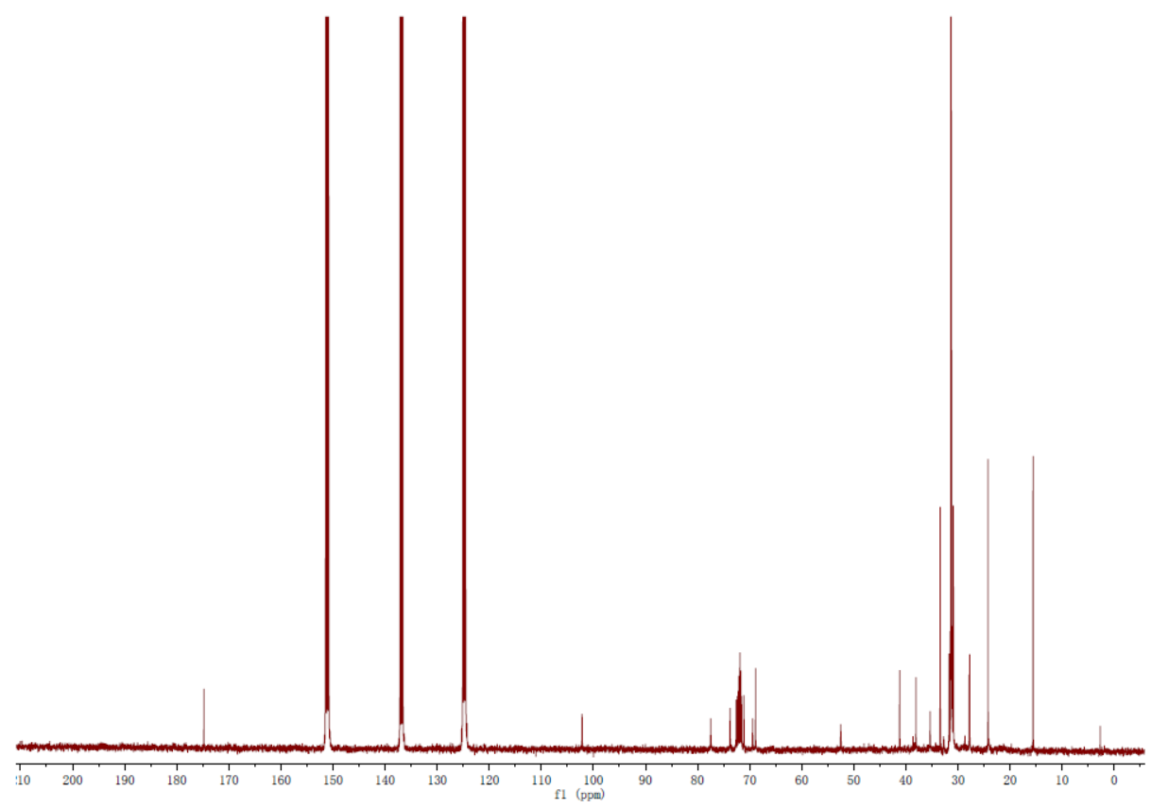
Figure S11. ¹H and ¹³C NMR spectra of compound 11 in CDCl₃

