Figure S1 and figure legend

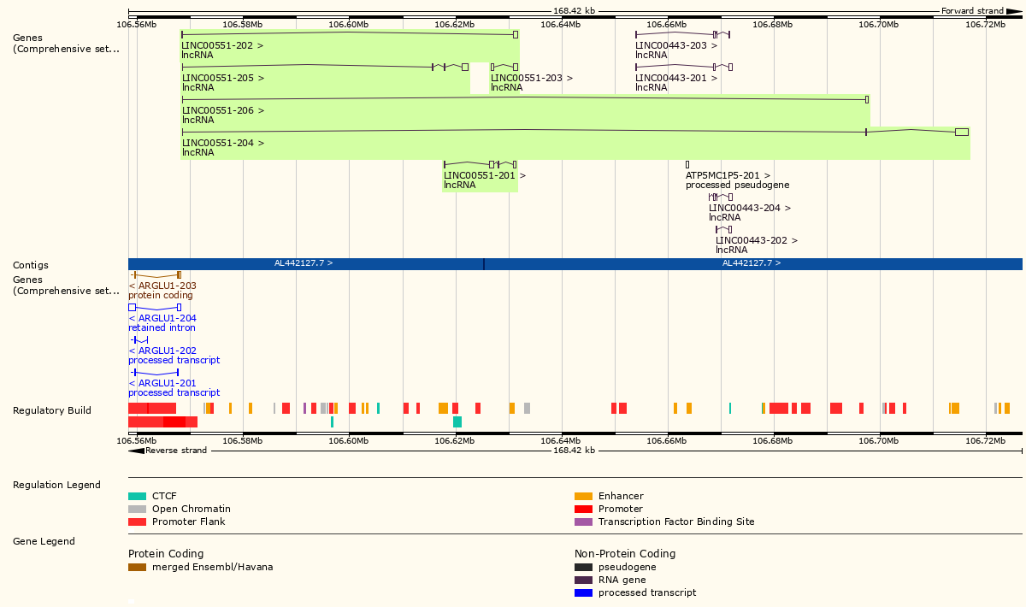

The genomic information of LINC00551 was shown.

Figure S2 and figure legend

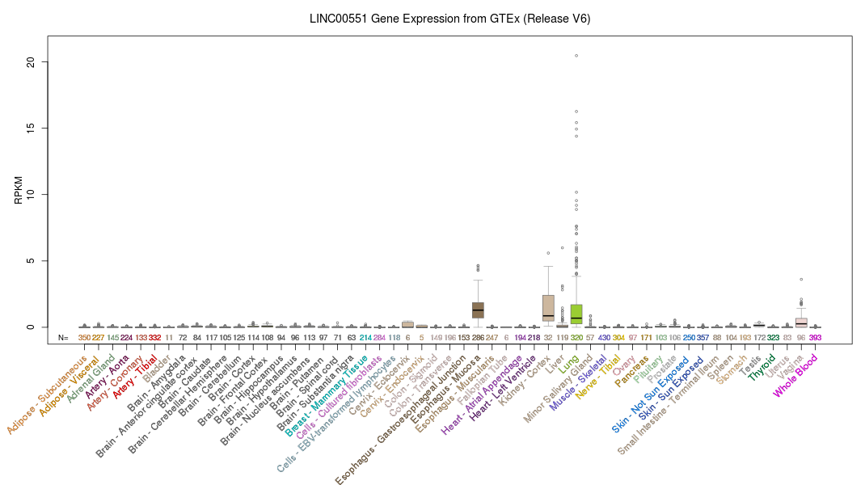
LINC00551 was significantly highly expressed in normal lung tissue as shown in GTEx dataset.

Figure S3 and figure legend

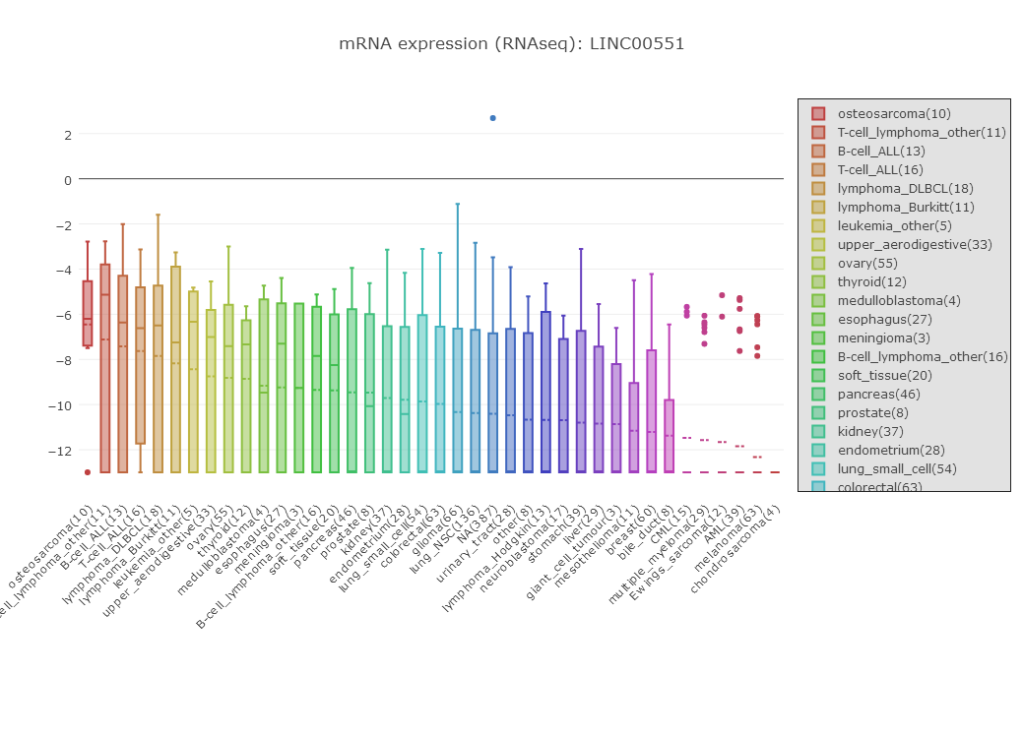
Cancer cell line encyclopedia (CCLE) data revealed that the expression of LINC00551 was at a relatively low level in Non-small-cell lung cancer cells.

Table S1 The clinical characteristics and treatment history of 32 patients with lung adenocarcinoma were shown.
Patients ID | Gender | Age | Tumor size (cm) | Lymph node metastasis | Distant metastasis | TNM stage | Pathological type | Radiotherapy History | Chemotherapy History
1 | Female | 64 | 3.2*1.5 | Yes | No | II | LUAD | No | No
2 | Male | 59 | 2.8*1.3 | Yes | No | I | LUAD | No | No
3 | Female | 63 | 3.4*2.1 | Yes | No | IIIA | LUAD | No | No
4 | Female | 55 | 2.3*1.9 | No | No | I | LUAD | No | No
5 | Male | 57 | 3.5*2.8 | Yes | No | II | LUAD | No | No
6 | Male | 68 | 3.3*1.9 | Yes | No | II | LUAD | No | No
7 | Female | 51 | 1,7*1.1 | No | No | I | LUAD | No | No
8 | Female | 59 | 2,6*1.7 | Yes | No | II | LUAD | No | No
9 | Female | 56 | 2.1*1.5 | No | No | I | LUAD | No | No
10 | Female | 68 | 2.8*1.8 | Yes | No | II | LUAD | No | No
11 | Female | 51 | 1.3*0.9 | No | No | I | LUAD | No | No
12 | Female | 55 | 3.1*2.7 | Yes | No | IIIA | LUAD | No | No
13 | Female | 62 | 3.8*1.7 | Yes | No | IIIA | LUAD | No | No
14 | Female | 68 | 3.2*1.8 | Yes | No | IIIA | LUAD | No | No
15 | Female | 63 | 2.9*1.1 | Yes | No | II | LUAD | No | No
16 | Female | 52 | 1.7*0.9 | No | No | I | LUAD | No | No
17 | Female | 64 | 2.9*1.7 | Yes | No | II | LUAD | No | No
18 | Female | 71 | 4.2*3.1 | Yes | Yes | IV | LUAD | No | No
19 | Female | 57 | 3.1*1.3 | Yes | No | IIIA | LUAD | No | No
20 | Female | 56 | 1.7*0.8 | No | No | I | LUAD | No | No
21 | Female | 68 | 3.4*2.1 | Yes | No | II | LUAD | No | No
22 | Female | 54 | 2.1*1.3 | No | No | I | LUAD | No | No
23 | Female | 59 | 3.7*1.8 | Yes | No | IIIA | LUAD | No | No
24 | Male | 67 | 3.5*1,6 | Yes | No | II | LUAD | No | No
25 | Female | 57 | 2.3*1.4 | No | No | I | LUAD | No | No
26 | Female | 65 | 3.1*1.8 | Yes | No | II | LUAD | No | No
27 | Female | 58 | 2.7*1,3 | No | No | I | LUAD | No | No
28 | Female | 69 | 4.1*2.6 | Yes | No | IIIA | LUAD | No | No
29 | Male | 65 | 3.0*1.4 | Yes | No | II | LUAD | No | No
30 | Female | 67 | 3.7*1.9 | Yes | No | IIIA | LUAD | No | No
31 | Female | 53 | 3.1*1.7 | Yes | No | II | LUAD | No | No
32 | Female | 64 | 2.8*1.4 | Yes | No | I | LUAD | No | No

