Supplement Table 1 The correlation analysis of LINC00466 expression and pathological parameters in glioma tissues
Characteristics | （N=30） | LINC00466 |  | χ² | P Value
Characteristics | （N=30） | High（15） | Low（15） |  | P Value
Age(yr) |  |  |  | 0.600 | 0.439
≧60 | 20 | 11 | 9
＜60 | 10 | 4 | 6
Gender |  |  |  | 1.292 | 0.256
Male | 11 | 7 | 4
Famale | 19 | 8 | 11
Tumor size |  |  |  | 0.536 | 0.464
≧4cm | 14 | 6 | 8
＜4cm | 16 | 9 | 7
Tissue type |  |  |  | 2.222 | 0.136
Mixed | 18 | 7 | 11
Other | 12 | 8 | 4
WHO grade |  |  |  | 8.571 | 0.003
Ⅰ-Ⅱ | 16 | 4 | 12
Ⅲ-Ⅳ | 14 | 11 | 3

Supplement Table 2 All cell lines used in experiments
Cell lines | Cell types | Number | Sources | Country
HEB | Astroglia | HEB09 | Cell bank of CAS | Shanghai, China
T98G | glioma | T98G49 | Cell bank of CAS | Shanghai, China
A172 | glioma | A172-67 | Cell bank of CAS | Shanghai, China
SNB19 | glioma | SNB19-90 | Cell bank of CAS | Shanghai, China
U251 | glioma | U251TZ | Cell bank of CAS | Shanghai, China
Supplement Table 3 All primer sequences used in experiments
qPCR | sense sequence | anti-sense sequence
LINC00466 | 5’- AGCCCTTCCGTCTTGTTACG -3’ | 5’- GCTTCCCAACTGCAGGTTTC -3’
miR-137 | 5’- GCGCTTATTGCTTAAGAATAC -3’ | 5’- CAGTGCAGGGTCCGAGGT -3’
PPP1R14B | 5’- CAGCTCACGCGCCTCTAC -3’ | 5’- CTCATCCACGTCAATCTCCA -3’
GAPDH | 5’-GGAGCGAGATCCCTCCAAAAT-3’ | 5’-GGCTGTTGTCATACTTCTCATGG-3’
U6 | 5’-CTCGCTTCGGCAGCACA-3’ | 5’-AACGCTTCACGAATTTGCGT-3’

Supplement Table 4 Information for all antibodies used in the experiment
Antibody | WB/  RIP | Product code | Specificity | Company
N-cadherin | 1:1000 | ab76057 | Rabbit Polyclonal | Abcam, China
E-cadherin | 1:1000 | ab15148 | Rabbit Polyclonal | Abcam, China
Vimentin | 1:2000 | ab137321 | Rabbit Polyclonal | Abcam, China
MMP-2 | 1 µg/ml | ab37150 | Rabbit Polyclonal | Abcam, China
MMP-9 | 1:1000 | ab38898 | Rabbit Polyclonal | Abcam, China
PPP1R14B | 1 mg/ml | 46151-1 | Rabbit Polyclonal | Signalway Antibody, USA
β-catenin | 1:5000 | ab32572 | Rabbit Monoclonal | Abcam, China
Cyclind1 | 1:200 | ab16663 | Rabbit Monoclonal | Abcam, China
Ago2 | / | ab32381 | Rabbit Polyclonal | Abcam, China
IgG | / | ab6721 | Goat anti Rabbit | Abcam, China
Antibody | IHC | Product code | Specificity | Company
PPP1R14B | 1:200 | ab188150 | Rabbit Polyclonal | Abcam, China
Ki-67 | 1:150 | ab15580 | Rabbit monoclonal | Abcam, China
IgG | / | ab6721 | Goat anti Rabbit | Abcam, China

Supplement Figure1 information of human ethics statement (Approval No. 2020549)
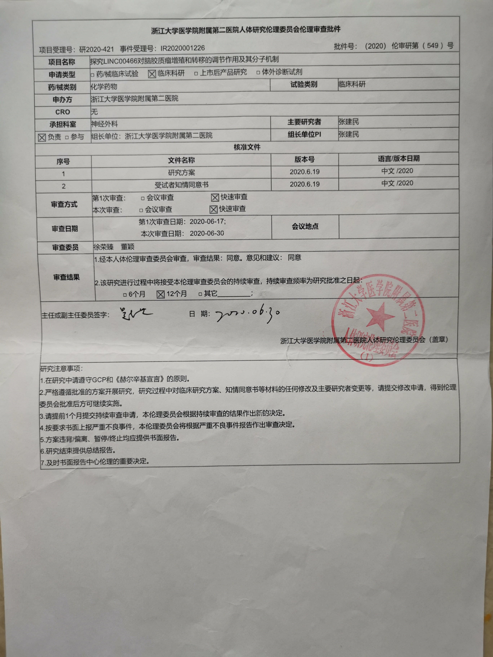

Supplement Figure2 information of animal ethics statement (Approval No. 2020106)
