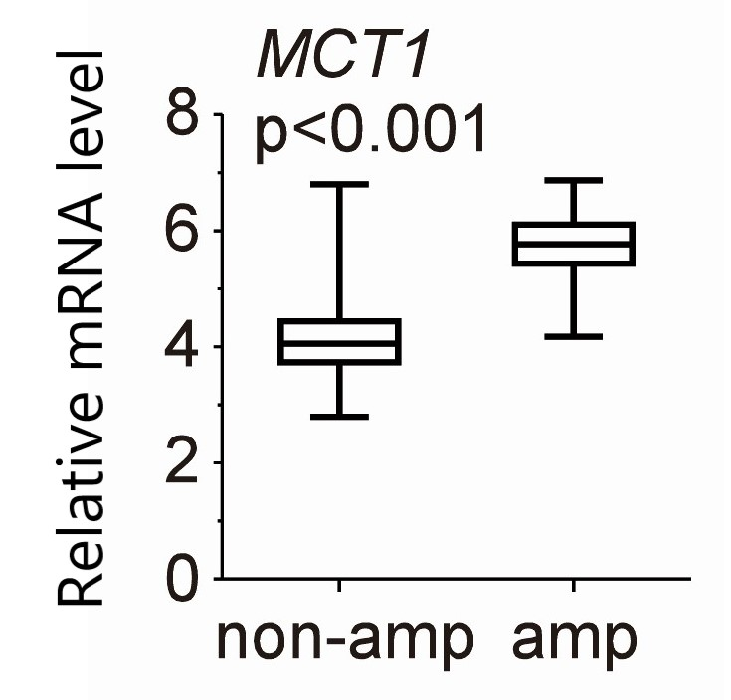
Supplementary Figure 1 The expression of MCT1 in MYCN-amplified neuroblastomas and MYCN-nonamplified neuroblastomas.
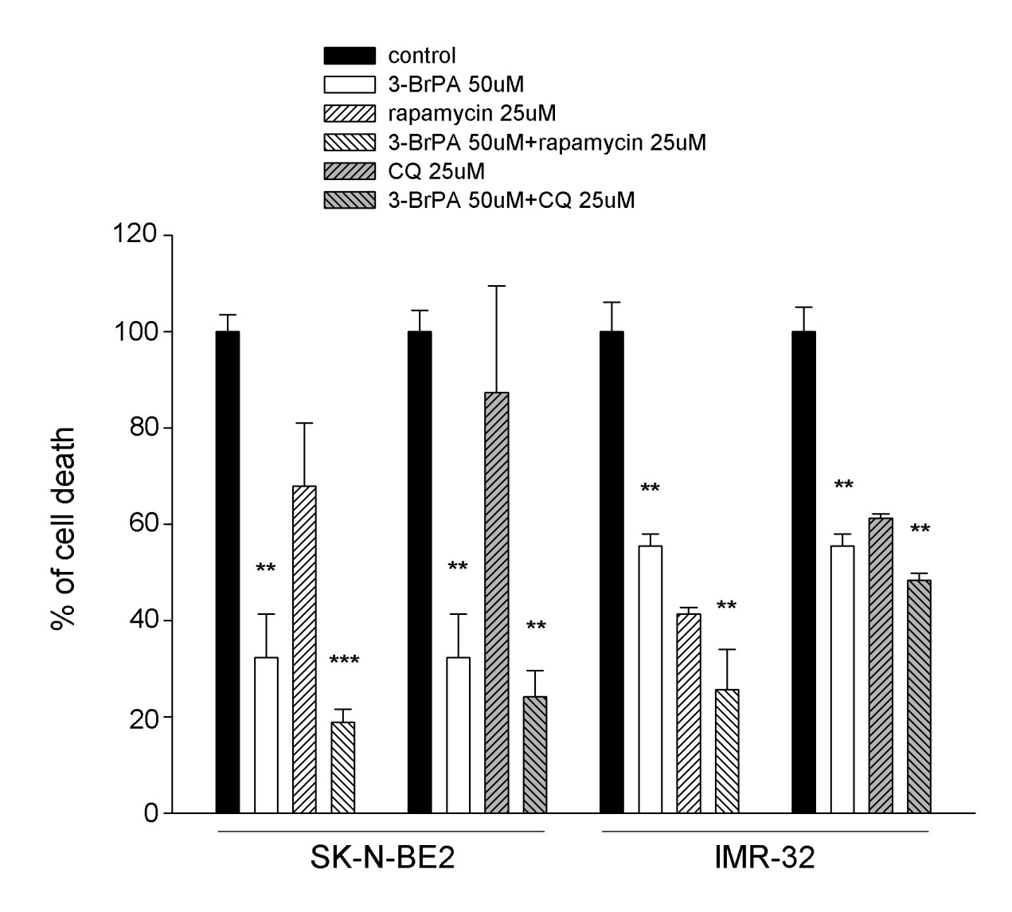
Supplementary Figure 2 Effect of 3-BrPA and rapamycin in MYCN-amplified neuroblastoma cells by CCK-8 analysis. The cell proliferation effect of 3-BrPA, rapamycin, 3-BrPA + rapamycin, CQ, 3-BrPA + CQ treatment in SK-N-BE2 and IMR-32 by CCK-8 analysis.
*P<0.05; **P<0.01; ***P<0.001.
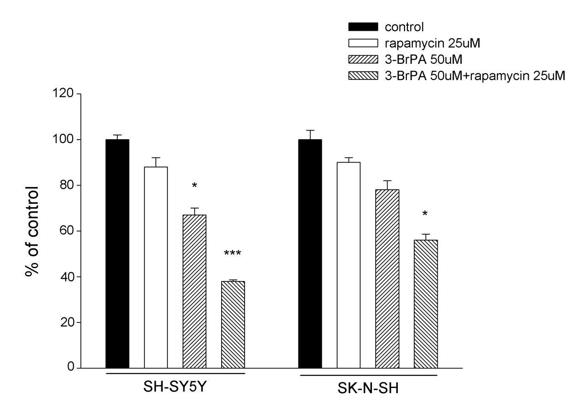
Supplementary Figure 3 3-BrPA combined with rapamycin induced cell apoptosis in SH-SY5Y and SK-N-SH. Histogram analysis of differences in the number of neuroblastoma cells under microscope after drug treatment (control, 25μM rapamycin, 50μM 3-BrPA, 50μM 3-BrPA + 25μM rapamycin).
*P<0.05; ***P<0.001.

