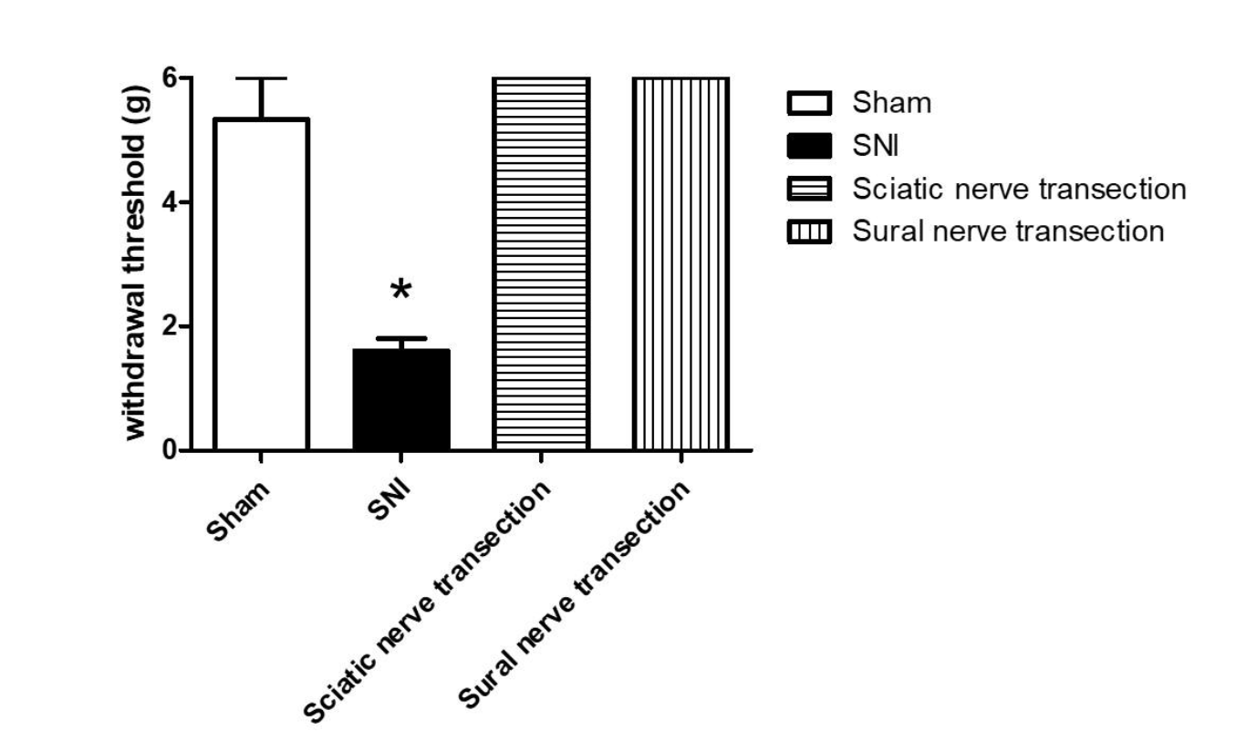

Supplementary Figure 1 Von Frey filament test of the four different models 3 weeks after injury (n = 4 per group). *p<0.05 versus PBS-treated mice.

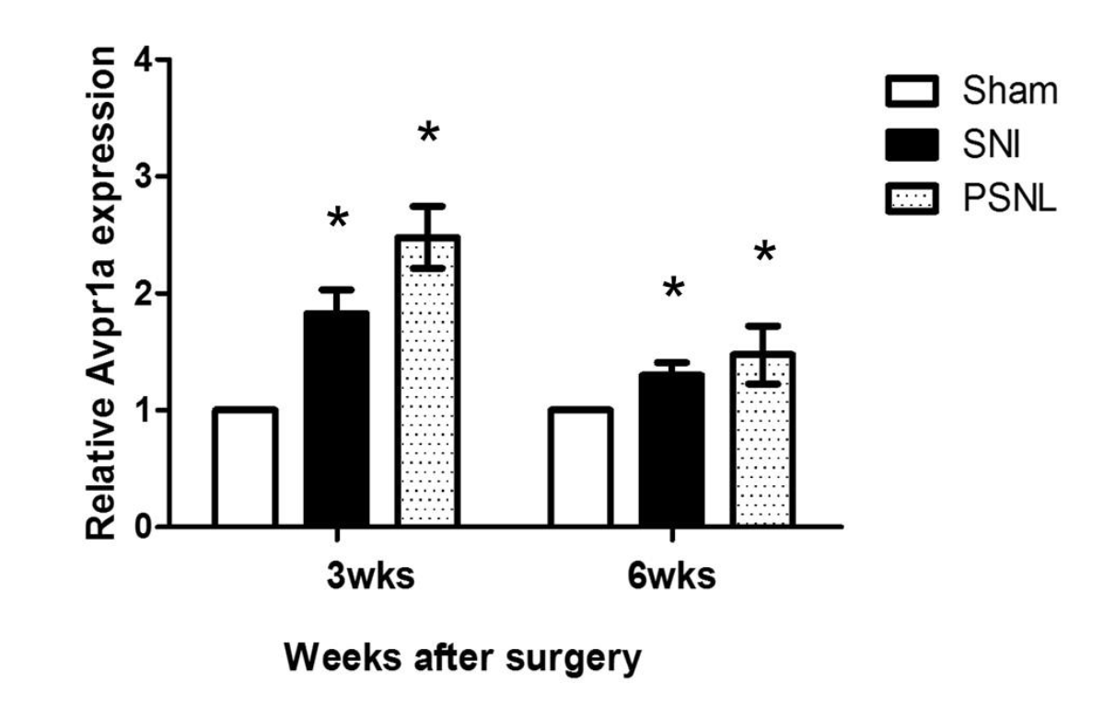

Supplementary Figure 2 V1a expression in the DRG 3 and 6 weeks after SNI surgery. The SNI model showed a significant 1.82±0.2-fold increase and the PSNL model a significant 2.48±0.1-fold increase in expression at 3 weeks. The SNI model also exhibited a significant 1.29±0.3-fold increase and the PSNL model a significant 1.47±0.2-fold increase in expression at 6 weeks. SNI, spared nerve injury; DRG, dorsal root ganglia; FC, fold change. *p<0.05.

