Supporting Information

Polymeric Nanoparticles-Based Brain Delivery with Improved Therapeutic Efficacy of Ginkgolide B in Parkinson’s Disease
Yuying Zhao¹, Sha Xiong¹, Piaoxue Liu¹, Wei Liu¹, Qun Wang¹, Yao Liu¹, Hanxu Tan⁴, Xiaojia Chen², Xuguang Shi³, Qi Wang¹*, Tongkai Chen¹*
¹ Science and Technology Innovation Center, Guangzhou University of Chinese Medicine, Guangzhou 510405, China
² State Key Laboratory of Quality Research in Chinese Medicine, Institute of Chinese Medical Sciences, University of Macau, Macau 999078, China
³ School of Pharmaceutical Sciences, Guangzhou University of Chinese Medicine, Guangzhou 510006, China
⁴ Dongzhimen Hospital, Beijing University of Chinese Medicine, Beijing 100700, China

S1. Methods
1.1 Fourier-transform infrared (FITC)
Add 1mg PEG-PCL (Mw 2000) and 200 mg KBr to mold. The sample was pressed into a transparent sheet and put into the infrared spectrum (Thermofisher, Nicolet, iS10) for a test. The wave number range is 4000-400/cm, the scanning number is 32, and the resolution is 4/cm.
1.2 ¹H-nuclear magnetic resonance (¹H-NMR)
0.25 mg PEG-PCL was dissolved in 0.5 mL methanol and measured by NMR (JEOL 400MHZ). The samples were collected for a total of 8 times with a sampling interval of 5s.
1.3 Particle Size, PDI and Zeta Potential
The particle size and polydispersity index (PDI) of GB-NPs were measured by using a Zetasizer Nano ZS90 (Malvern Instruments Ltd., Worcestershire, UK) at 25 °C and 90° scattering angle after dilution. Zeta potential of GB-NPs was measured with disposable Zeta cells, while Zeta potential was measured by electrophoretic mobility technique.
1.4 Transmission Electron Microscope (TEM)
The morphology of GB-NPs was observed using TEM with a camera system (H-7650, Hitachi Ltd., Tokyo, Japan). Briefly, a droplet of GB-NPs was carefully placed on a membrane-coated grid surface with a filter paper. The samples were negatively stained with phosphotungstic acid (2%, w/v) for 30 s. Excess fluid was removed from the carbon-coated grid after staining. The grid surface was air dried at room temperature before being loaded on the microscope.
1.5 Differential Scanning Calorimetry (DSC)
The thermal properties of GB, PEG-PCL, F68, GB-NPs, and a physical mixture of F68 and GB (GB-PM) were determined using DSC. Approximately 2.5 mg of each sample was sealed in an aluminum pan and heated from 50 to 250 °C at a rate of 10 °C/min by a nitrogen purge of 35 mL/min.
1.6 Encapsulation Efficiency (EE) and Drug Loading (DL) Measurements
EE and DL were determined based on free drug amounts via an ultrafiltration approach. Briefly, 1 mL of GB-NPs was added to the upper portion of a tube fitted with an Amicon ultrafilter (MWCO 10 kDa; Millipore), after which samples were spun at 1000 ×g at 4 °C for 20 min. HPLC was then used to assess free drug levels in the resultant ultra-filtered solution. To measure the total amount of drug within GB-NPs, 1 mL of these particles was dissolved using methanol, and the resultant suspension was passed through a 0.45 μm filter. HPLC was then used to analyze this solution as previously described in this manuscript. EE and DL were calculated as follows:
1
2
1.7 Drug Release
We used dialysis to assess drug release of GB-NCs. GB and GB-NCs (1 mL) were passed through 3.5 kDa cut-off dialysis to simulated gastric media and phosphate buffer saline (PBS, pH = 7.4) was added. The media was replaced and collected at different timepoints. GB content was measured via HPLC. An Agilent 1100 series HPLC (Santa Clara, USA) workstation was used with a DAD detector, an auto-sampler, and an Ecosil C18 (4.6 mm × 150 mm, 5μm) analytical column. Samples (20 ml) were injected into the HPLC system with mobile phase methanol/water (50:50) at 1.0 ml/min and detected at 220 nm. A reliable HPLC method was developed with a linear range of 0.05-2.00 μg/ml for GB (r=0.9997). The intra- and inter-day precision was lower than 2% in relation to relative standard deviation, while accuracy was within ± 1.6% in terms of relative error. The limit of detection (LOD) and limit of quantification (LOQ) of GB were determined to be 0.01 μg/ml and 0.03 μg/ml, respectively.
1.8 Solubility of GB in Different Buffers
Excess GB powder was dispersed in different buffers with continuous shaking for 36 h in a water bath at 37 °C. After reaching a balanced state, the saturated solution was filtered with a 0.2 μm membrane. The solution was evaporated to dryness at 50 °C under a gentle steam of nitrogen. The residue was re-dissolved in methanol. The content of GB was qualified by HPLC.
S2. Results
Table S1. GB solubility in different buffers
Buffer | GB solubility (mg/mL)
PBS | 0.35
pH 7.4 | 0.32
pH 1.2 | 0.37
Table S2. Endocytosis inhibitors used in the present study.
Inhibitors | Function | Final concentration
Methyl-β-cyclodextrin (MβCD) | Depletes cholesterol. Inhibits lipid- and caveolae-dependent endocytosis ²⁰. | 10 mM
Chlorpromazine (CPZ) | Cationic amphiphilic compound. Disrupts AP2 and clathrin complex formation at the cell surface, thereby inhibiting clathrin-dependent endocytosis ²¹. | 30 μM
Hypertonic sucrose (HS) | Inhibits clathrin vesicle formation via dispersing plasma membrane clathrin lattices ²². | 0.4 M
5-(N-ethyl-N-isopropyl)-amiloride (EIPA) | Blocks Na⁺/H⁺ ion channels and thereby disrupts micropinocytosis ²³. | 40 μM
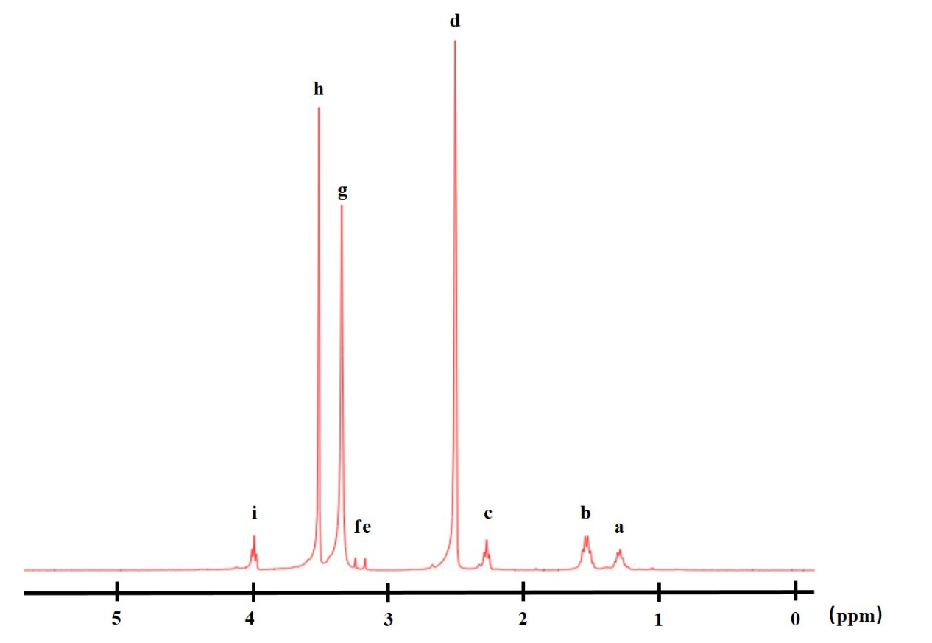
Figure S1. ¹H-NMR spectrum of PEG-PCL. a, 1.30 ppm; b, 1.65 ppm; c, 2.30 ppm; d, 2.61 ppm; e, 3.17 ppm; f, 3.24 ppm; g, 3.34 ppm; h, 3.61 ppm; i, 3.99 ppm.
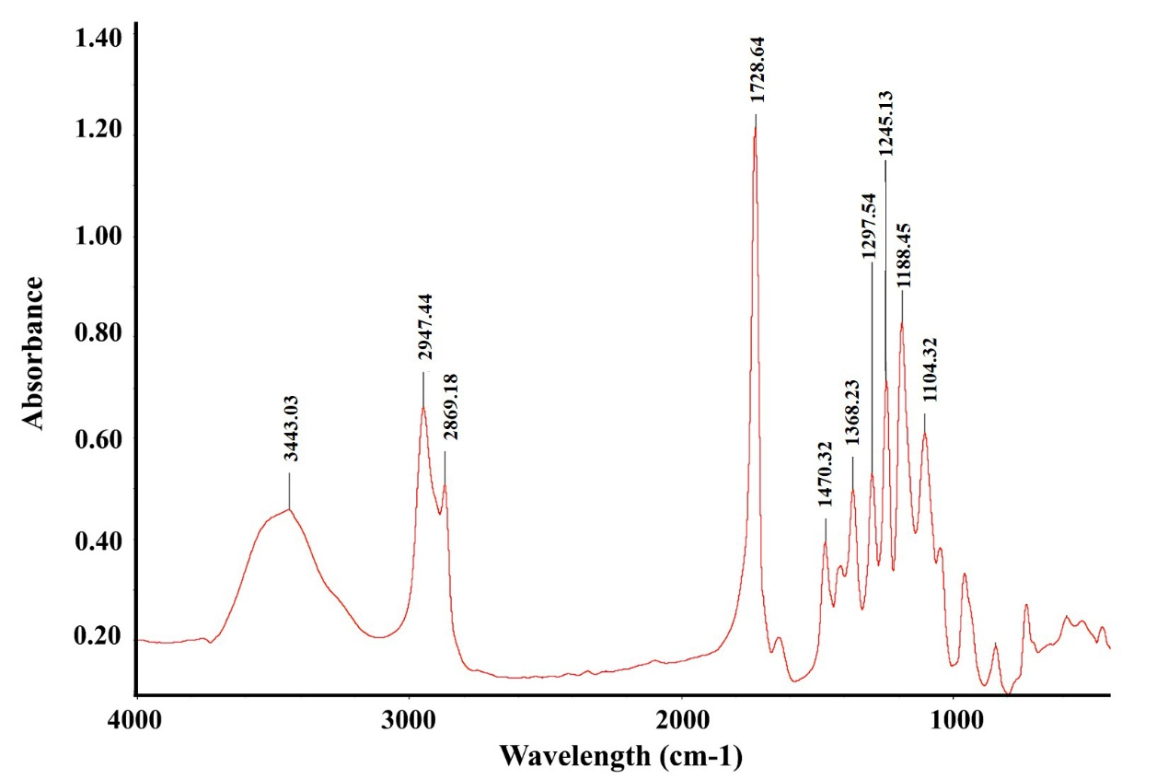
Figure S2. FTIR spectrum clearly showing the representative peaks of PEG-PCL.

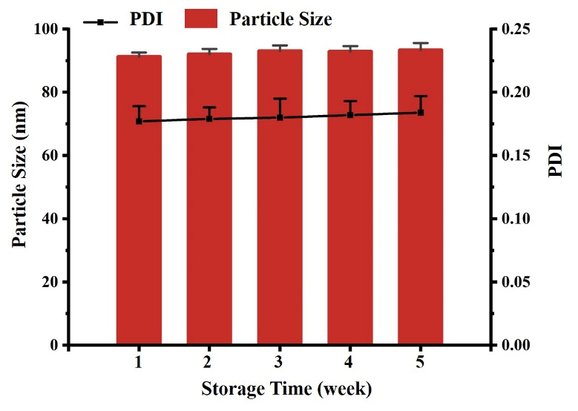
Figure S3. Stability of GB-NPs during a 4-week storage at room temperature.

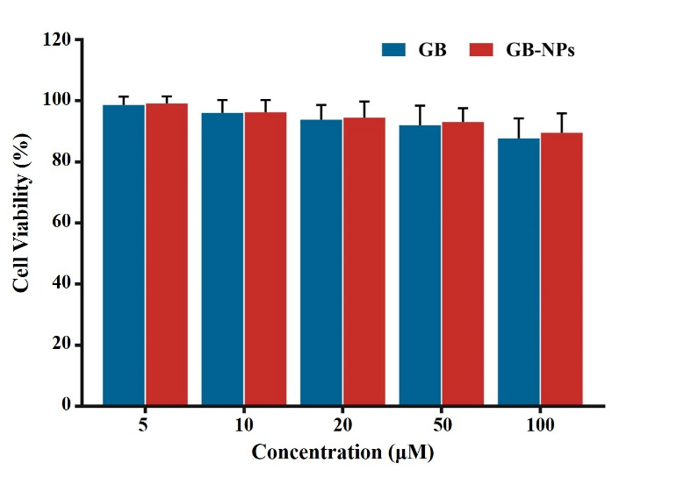
Figure S4. Evaluation of cell viability by MTT assay (n=3).
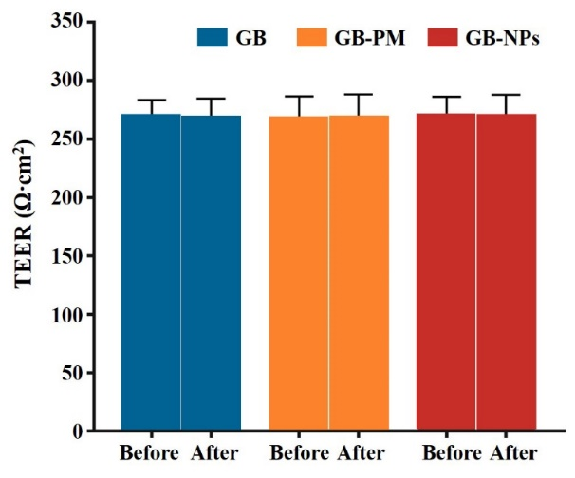
Figure S5. TEER before (E) and after (F) transport (n=3).
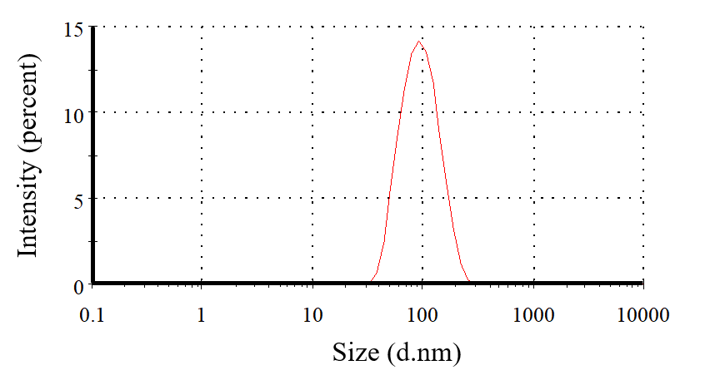
Figure S6. Size of C6-NPs
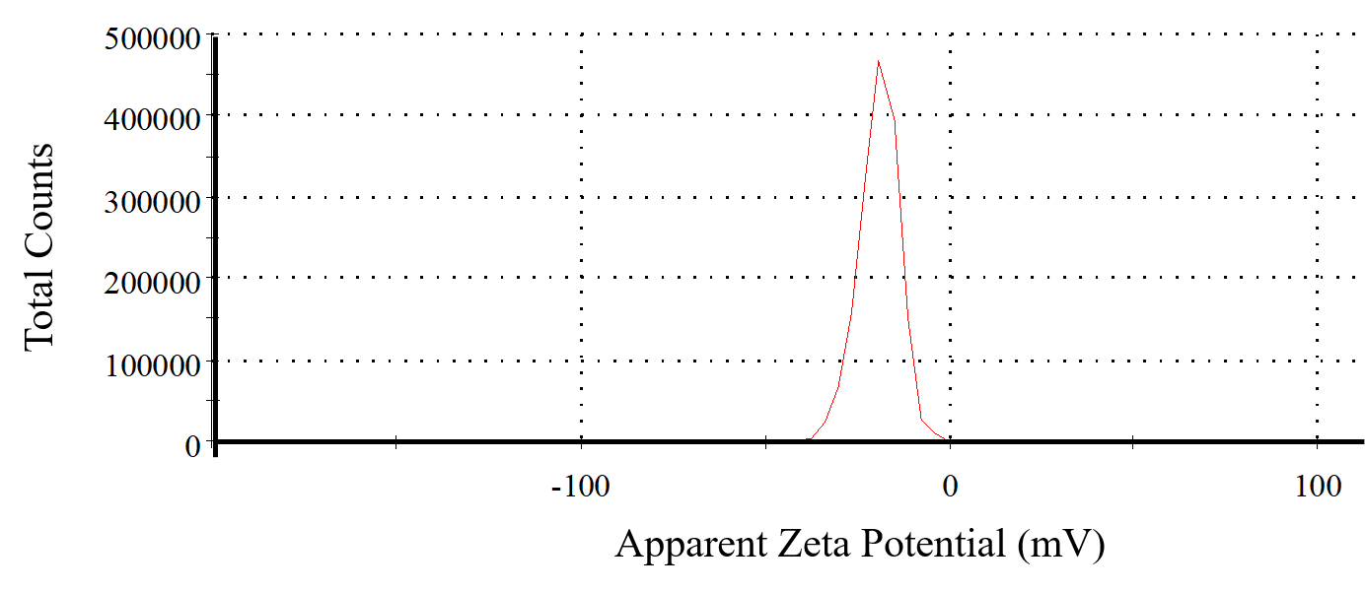
Figure S7. Zeta Potential of C6-NPs

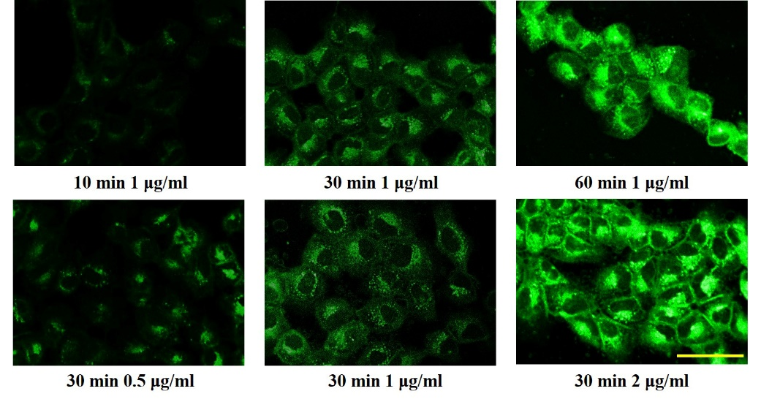
Figure S8. Cellular uptake of C6-NPs on MDCK cells. Scale bar: 50 μm.
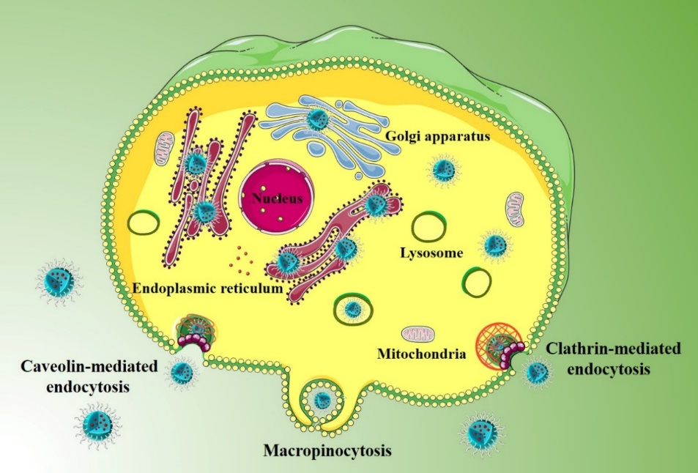
Figure S9. Schematic overview of endocytic mechanisms of NPs.
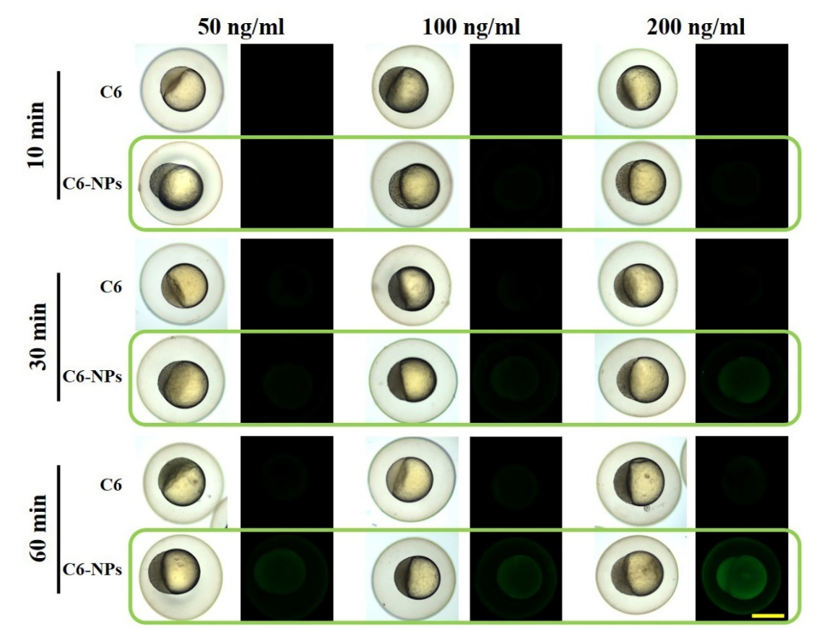
Figure S10. C6- and C6-NPs-related fluorescence in 3 hpf zebrafish embryos following a 10, 30, or 60 min incubation. Scale bar: 500 μm.

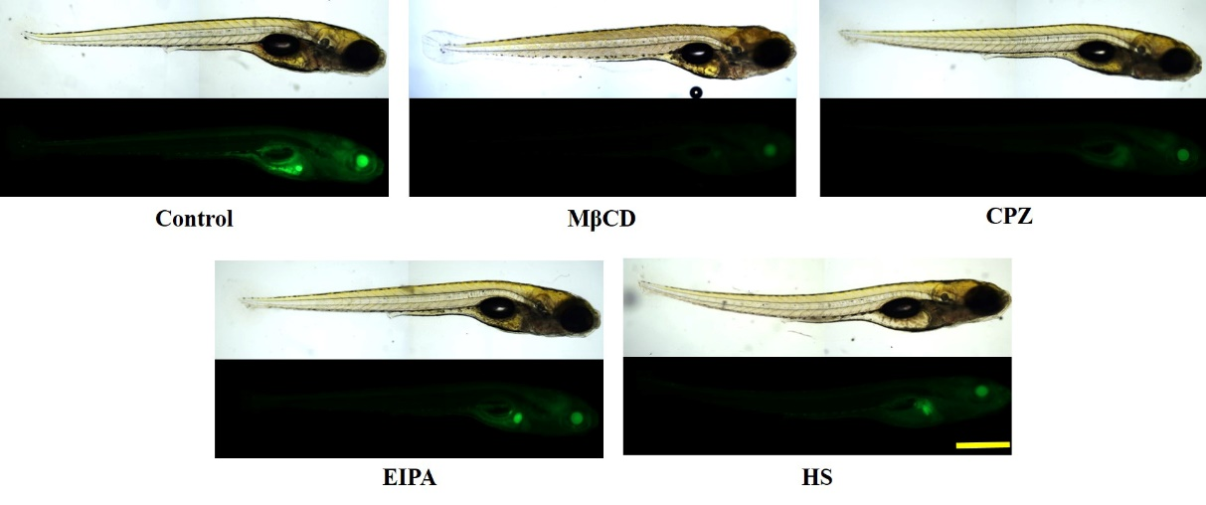
Figure S11. Images of larval zebrafish after preincubation with MβCD, HS, EIPA, and CPZ as inhibitors. Scale bar: 500 μm.
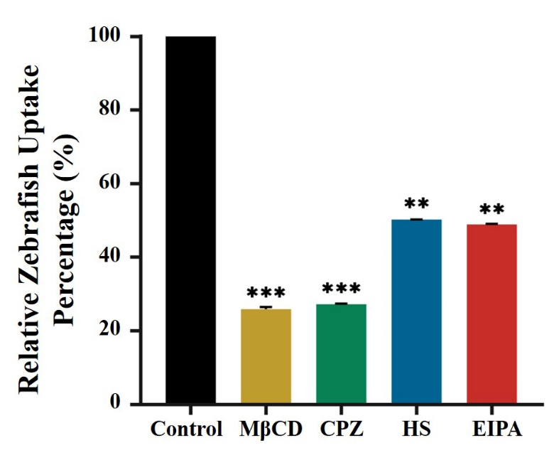
Figure S12. Quantification of the uptake of larval zebrafish based on Figure S7 (n=3). **p<0.01 and ***p<0.001 vs the control group.

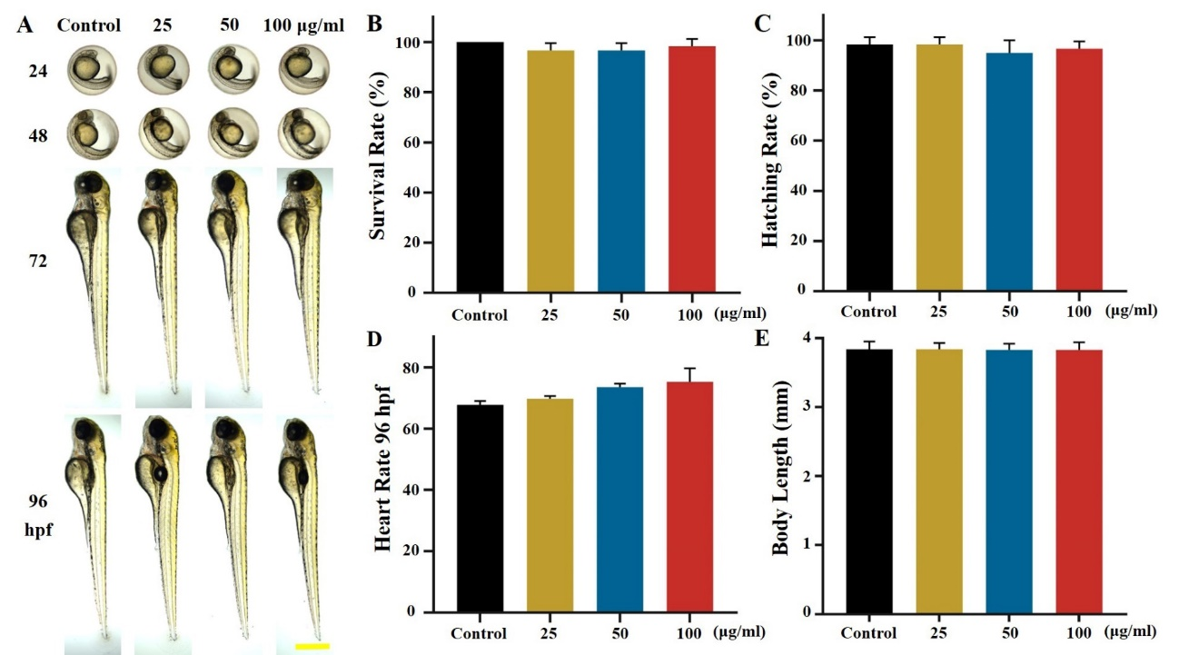
Figure S13. In vivo toxicity analysis. (A) The phenotypes of GB-NPs-treated zebrafish embryos were monitored at 24, 48, 72, and 96 hpf. Scale bar: 500 μm. Survival rate (B), hatching rate (C), heart rate (D), and body length (E) of zebrafish larvae following GB-NPs treatment at the indicated dose (n=20).
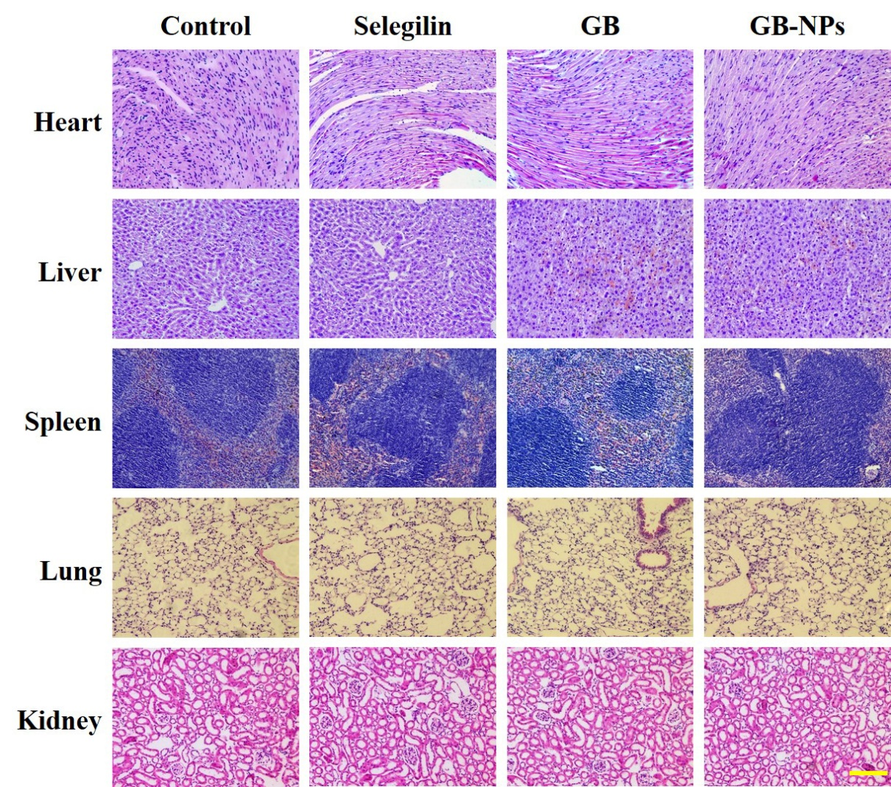
Figure S14. Heart, liver, spleen, lung, and kidney samples from differently treated mice were H&E stained. Scale bar: 100 μm
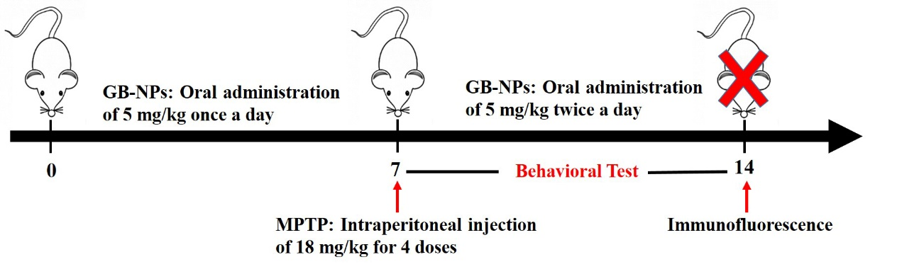
Figure S15. Schematic overview of pharmacodynamic study.

