Supplementary Materials
Supplementary Figure Legends:
Figure S1. (A) The correction between HOXA-AS2 expression level and liver cirrhosis. (B) Kaplan-Meier survival curve assessing the recurrence-free survival (RFS) of HCC patients with different HOXA-AS2 expression levels.

Figure S2. Heatmap of differentially expressed genes in HCC patients with High/Low HOXA-AS2 expression.

Figure S3. (A) The integrative SPADE clustering plot and t-SNE map of CD133 with high and low HOXA-AS2 expression. (B) The integrative SPADE clustering plot and t-SNE map of CD44 with high and low HOXA-AS2 expression. (C) The integrative SPADE clustering plot and t-SNE map of ALDH with high and low HOXA-AS2 expression.

Figure S1.

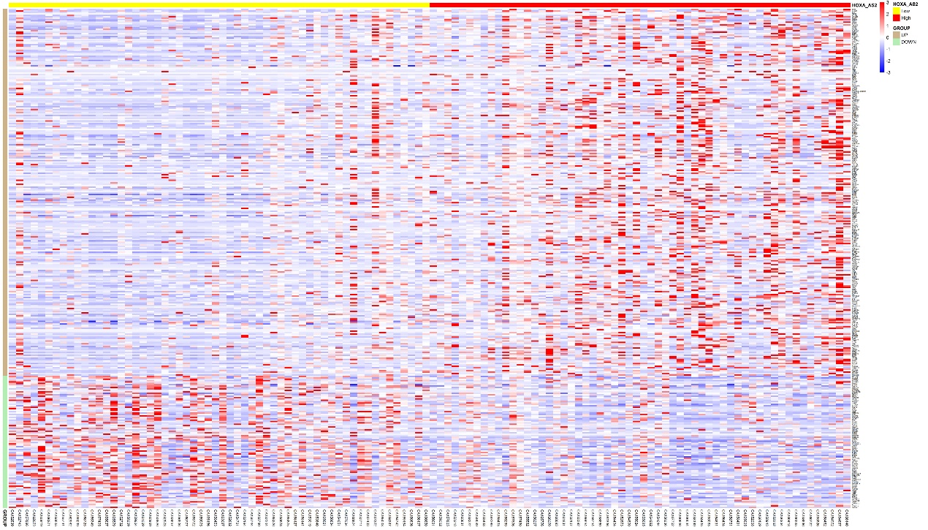
Figure S2.

Figure S3.

