Supplementary Information

Efficacy of combination therapy with linalool and doxorubicin encapsulated by liposomes as a two-in-one hybrid carrier system for epithelial ovarian carcinoma

Tae In Wi^{1,4}, Ji Eun Won^{1,4}, Chan Mi Lee¹, Jeong-Won Lee², Tae Heung Kang¹, Byung Cheol Shin³, Hee Dong Han^{1,*}, and Yeong-Min Park^{1,**}

Corresponding Authors:
*Hee Dong Han, Department of Immunology, School of Medicine, Konkuk University, 268 Chungwondae-Ro, Chungju, Chungcheongbuk-Do 380-701, South Korea, Phone: 82-2-2030-7848, Fax: 82-2-2049-6192, E-mail: hanhd@kku.ac.kr

**Yeong-Min Park, Department of Immunology, School of Medicine, Konkuk University, 268 Chungwondae-Ro, Chungju, Chungcheongbuk-Do 380-701, South Korea, Phone: 82-2-2049-6330, Fax: 82-2-2049-6192, E-mail: immun3023@kku.ac.kr

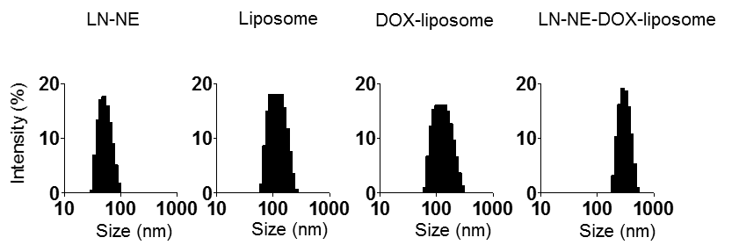
Supplementary Figure S1. The size distribution of liposomal formulations.

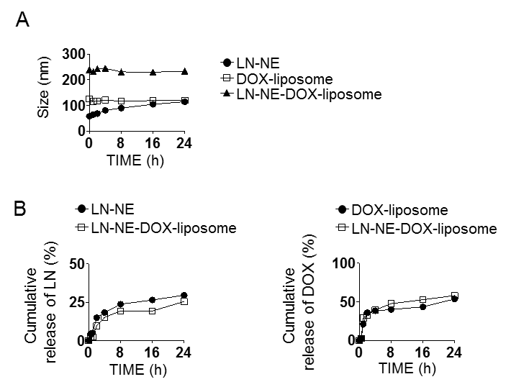

Supplementary Figure S2. Stability and drug release. (A) Size change of liposomes in 10% FBS. (B) Release of DOX or LN from liposomes in PBS was measured by UV-vis spectrophotometry (LN; 295 nm and DOX; 490 nm). The data are presented as the mean ± S.D. (n = 3).

