Association Between glutathione peroxidase-1 (GPx-1) Polymorphisms and Schizophrenia in the Chinese-Han Population

Supplementary Material
Figure S1. Agarose gel electrophoretograms for rs1800668.
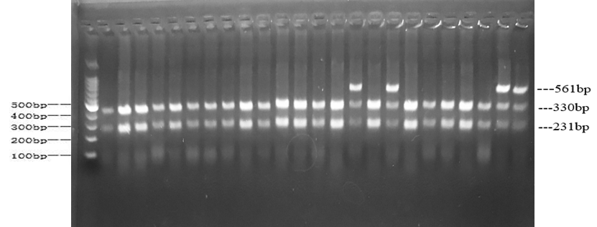

Figure S2. Agarose gel electrophoretograms for rs1050450.
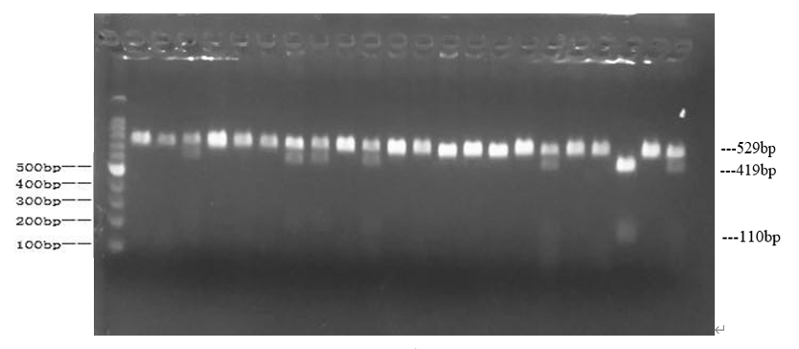

Table S1. Genotype and Allele Distributions of Rs1050450 in SCZ Group and Controls.
SNP | Case, n (%) | Controls, n (%) | X² | p
CC | 295(81.9) | 365(85.7)
CT | 60(16.7) | 57(13.4)
TT | 5 (1.4) | 4(0.9) | 2.085 | 0.326
Allele
C | 650(90.3) | 787(92.4)
T | 70(9.7) | 65(7.6) | 2.178 | 0.140
Dominant Model
CC | 295(81.9) | 365(85.7)
CT+TT | 65(18.1) | 61(14.3) | 2.024 | 0.155
Recessive Model
TT | 5 (1.4) | 4 (0.9)
CT+CC | 355(98.6) | 422(99.1) | 0.065 | 0.799

Table S2. Genotype and allele distributions of GPx-1 (rs1050450) in the SCZ group and controls separated by gender.
SNP (Rs1050450) | Male Cases,  n (%) | Male Controls,  n (%) | X² | P | Female Cases,  n (%) | Female Controls,  n (%) | X² | P
genotypes
CC | 170(86.7) | 181(89.2) |  |  | 125(76.2) | 184(82.5)
CT | 24(12.2) | 22(10.8) |  |  | 36(22.0) | 35(15.7)
TT | 2 (1.1) | 0(0.0) | 1.946 | 0.397 | 3 (1.8) | 4(1.8) | 2.555 | 0. 281
Allele
C | 364(92.9) | 384(94.6) |  |  | 286(87.2) | 403(90.4)
T | 28(7.1) | 22(5.4) | 1.009 | 0.315 | 42(12.8) | 43(9.6) | 1.935 | 0.164
Dominant Model
CC | 170(86.7) | 181(89.2) |  |  | 125(76.2) | 184(82.5)
CT+TT | 26(13.3) | 22(10.8) | 0.555 | 0.456 | 39(23.8) | 39(17.5) | 2.325 | 0.127
Recessive Model
TT | 2 (1.0) | 0 (0.0) |  |  | 3 (1.8) | 4 (1.8)
CT+CC | 194(99.0) | 203(100.0) | - | 0.241 | 161(98.2) | 219(98.2) | 0.000 | 1.000

