Supplementary materials for
Deciphering age differences in experience-based decision making: The role of sleep

Table S1. The p values of the age × condition × session repeated-measure ANOVA analysis of model-free behavioral performance, taken education and circadian chronotype as covariates.
 | Covariates | Age | Condition | Session | Age× Session | Age×Condition | Age×Condition×Session
Net score | None | 0.67 | 0.12 | 1.00×10⁻⁸ | 0.006 | 0.10 | 0.35
Net score | Education | 0.91 | 0.12 | 0.35 | 0.09 | 0.12 | 0.34
Net score | MEQ | 0.87 | 0.12 | 0.18 | 0.15 | 0.83 | 0.40
Deck A | None | 0.002 | 0.79 | 1.70×10⁻⁸ | 0.42 | 0.87 | 0.76
Deck A | Education | 0.03 | 0.79 | 0.15 | 0.76 | 0.88 | 0.72
Deck A | MEQ | 0.02 | 0.79 | 0.07 | 0.19 | 0.84 | 0.65
Deck B | None | 0.28 | 0.11 | 5.22×10⁻⁴ | 2.61×10⁻⁴ | 0.05 | 0.20
Deck B | Education | 0.23 | 0.10 | 0.82 | 0.03 | 0.07 | 0.19
Deck B | MEQ | 0.17 | 0.11 | 0.61 | 0.01 | 0.04 | 0.21
Deck C | None | 9.30×10⁻⁵ | 0.51 | 1.10×10⁻⁵ | 3.20×10⁻⁵ | 0.69 | 0.50
Deck C | Education | 0.06 | 0.54 | 0.35 | 0.11 | 0.81 | 0.35
Deck C | MEQ | 0.01 | 0.51 | 0.99 | 0.001 | 0.67 | 0.45
Deck D | None | 0.004 | 0.02 | 0.001 | 0.57 | 0.09 | 0.60
Deck D | Education | 0.08 | 0.02 | 0.04 | 0.51 | 0.09 | 0.75
Deck D | MEQ | 0.02 | 0.02 | 0.09 | 0.18 | 0.08 | 0.73
Note. The results indicated that when these covariates were controlled respectively, the significance of the main results, especially the main effect of age in deck B and deck C change. None, without covariates; MEQ, Morningness-Eveningness Questionnaire. Bold font indicates statistically significant result (p < 0.05).
Table S2. Correlation between behavioral performance changes (session 2 – session 1) and sleep characteristics.
 | Group | Deck A  r (p) | Deck B  r (p) | Deck C  r (p) | Deck D  r (p)
TST | YS | 0.20(0.26) | -0.09(0.60) | 0.12(0.50) | -0.10(0.57)
TST | OS | -0.29(0.11) | -0.19(0.29) | -0.17(0.36) | 0.53(0.002)
Sleep efficiency | YS | 0.06(0.76) | -0.19(0.30) | 0.23(0.19) | -0.01(0.95)
Sleep efficiency | OS | -0.24(0.19) | -0.24(0.19) | -0.03(0.87) | 0.41(0.02)
Sleep latency | YS | 0.17(0.34) | -0.04(0.81) | -0.09(0.62) | 0.02 (0.89)
Sleep latency | OS | 0.06(0.73) | 0.11(0.53) | -0.10(0.59) | -0.07(0.72)
Note. MEQ, Morningness-Eveningness Questionnaire; None, without covariates; OS, old adults in the sleep condition; OW, old adults in the wake condition; TST, total sleep time; YS, young adults in the sleep condition; YW, young adults in the wake condition. Bold font indicates significant without Bonferroni correction (p < 0.05), bold font and italics indicates significant with Bonferroni correction (p < 0.003).

Table S3. Group-level parameter estimates of the VPP Model.
 | Session 1 |  |  |  |  | Session 2
 | YS  M (SD) | YW  M (SD) | OS  M (SD) | OW  M (SD) |  | YS  M (SD) | YW  M (SD) | OS  M (SD) | OW  M (SD)
A | 0.06(0.02) | 0.04(0.04) | 0.05(0.04) | 0.01(0.00) |  | 0.07(0.03) | 0.07(0.04) | 0.08(0.06) | 0.03(0.01)
α | 0.07(0.01) | 0.56(0.08) | 0.04(0.02) | 0.02(0.00) |  | 0.10(0.08) | 0.09(0.02) | 0.12(0.05) | 0.02(0.00)
c | 1.27(0.32) | 1.60(0.15) | 1.74(0.13) | 2.38(0.25) |  | 1.51(0.32) | 1.49(0.38) | 1.60(0.29) | 1.83(0.34)
λ | 0.32(0.02) | 0.73(0.46) | 0.02(0.00) | 0.12(0.00) |  | 0.34(0.17) | 0.05(0.00) | 0.27(0.18) | 0.09(0.01)
ε_{p} | 0.48(1.33) | 0.01(1.24) | -0.21(0.84) | 0.18(0.93) |  | 0.41(1.47) | 0.65(1.35) | 0.07(1.00) | 0.20(0.90)
ε_{n} | -0.66(0.97) | -0.95(1.21) | -1.20(0.97) | -1.06(0.98) |  | 0.17(1.43) | 0.05(1.52) | -1.11(1.02) | -1.14(0.84)
k | 0.50(0.08) | 0.41(0.12) | 0.35(0.17) | 0.29(0.13) |  | 0.47(0.16) | 0.38(0.19) | 0.22(0.15) | 0.23(0.15)
ω | 0.66(0.02) | 0.78(0.01) | 0.68(0.03) | 0.82(0.01) |  | 0.70(0.08) | 0.70(0.03) | 0.61(0.05) | 0.66(0.03)
Note. A, the learning rate; c, the choice sensitivity; k, the perseverance decay rate; α, the feedback sensitivity; ε_{n}, the loss impact; ε_{p}, the gain impact; λ, the loss aversion; ω, the reinforcement learning weight. OS, older adults in the sleep condition; OW, older adults in the wake condition; YS, young adults in the sleep condition; YW, young adults in the wake condition. M, mean; SD, standard deviation.

Table S4. Group-level parameter estimates from the PVL models.
 | Session 1 |  |  |  |  | Session 2
 | YS  M (SD) | YW  M (SD) | OS  M (SD) | OW  M (SD) |  | YS  M (SD) | YW  M (SD) | OS  M (SD) | OW  M (SD)
PVL-decay
A | 0.76(0.10) | 0.80(0.14) | 0.75(0.19) | 0.47(0.23) |  | 0.78(0.21) | 0.73(0.22) | 0.64(0.30) | 0.55(0.33)
α | 0.08(0.00) | 0.10(0.01) | 0.16(0.01) | 0.17(0.01) |  | 0.02(0.00) | 0.03(0.00) | 0.11(0.01) | 0.16(0.02)
Cons | 0.34(0.22) | 0.32(0.24) | 0.31(0.27) | 0.45(0.34) |  | 0.40(0.34) | 0.41(0.30) | 0.42(0.35) | 0.48(0.41)
λ | 1.00(0.51) | 1.16(0.86) | 1.36(0.98) | 2.09(1.68) |  | 0.05(0.01) | 0.02(0.01) | 1.48(0.94) | 1.72(1.30)
PVL-delta
A | 0.22(0.22) | 0.12(0.10) | 0.15(0.22) | 0.22(0.24) |  | 0.14(0.16) | 0.11(0.08) | 0.23(0.23) | 0.42(0.34)
α | 0.03(0.01) | 0.45(0.17) | 0.10(0.04) | 0.46(0.14) |  | 0.00(0.00) | 0.01(0.00) | 0.12(0.05) | 0.23(0.13)
Cons | 1.12(0.21) | 1.23(0.22) | 1.29(0.09) | 1.06(0.34) |  | 1.42(0.20) | 1.38(0.25) | 1.20(0.17) | 1.13(0.38)
λ | 0.07(0.00) | 0.66(0.44) | 0.18(0.00) | 0.56(0.37) |  | 0.01(0.00) | 0.01(0.00) | 0.05(0.01) | 0.10(0.11)
Note. A, learning rate; Cons, choice sensitivity; α, feedback sensitivity; λ, loss aversion. OS, old adults in the sleep condition; OW, old adults in the wake condition; YS, young adults in the sleep condition; YW, young adults in the wake condition. M, mean; SD, standard deviation.

Table S5. The p values of the age × condition × session repeated-measure ANOVA analysis of model-based parameters, taken education and circadian chronotype as covariates.
 | Covariates | Age | Condition | Session | Age×Condition | Age×Condition×Session
A | None | 1.77×10⁻⁴ | 7.36×10⁻⁹ | 4.00×10⁻⁶ | 2.00×10⁻⁶ | 0.28
A | Education | 0.006 | 9.36×10⁻⁹ | 0.93 | 3.00×10⁻⁶ | 0.23
A | MEQ | 0.07 | 7.41×10⁻⁹ | 0.25 | 4.00×10⁻⁶ | 0.31
α | None | 3.59×10⁻⁵⁷ | 1.39×10⁻³⁴ | 7.71×10⁻³² | 1.35×10⁻⁵⁵ | 3.85×10⁻³⁹
α | Education | 2.83×10⁻³⁹ | 2.75×10⁻³⁴ | 1.05×10⁻⁴ | 1.10×10⁻⁵⁴ | 2.83×10⁻³⁸
α | MEQ | 1.59×10⁻³⁸ | 2.08×10⁻³⁴ | 0.02 | 1.28×10⁻⁵⁴ | 2.48×10⁻³⁸
c | None | 2.48×10⁻¹⁹ | 1.08×10⁻¹¹ | 10⁻⁵ | 4.7×10⁻⁴ | 0.64
c | Education | 5.44×10⁻¹⁰ | 1.11×10⁻¹¹ | 0.94 | 4.0×10⁻⁴ | 0.73
c | MEQ | 1.79×10⁻¹¹ | 1.31×10⁻¹¹ | 0.23 | 0.001 | 0.58
λ | None | 1.48×10⁻¹⁸ | 0.82 | 7.00×10⁻⁶ | 0.03 | 1.20×10⁻⁵
λ | Education | 1.60×10⁻¹⁰ | 0.82 | 0.12 | 0.04 | 2.30×10⁻⁵
λ | MEQ | 1.63×10⁻⁸ | 0.82 | 0.75 | 0.06 | 1.40×10⁻⁵
ε_{p} | None | 0.07 | 0.70 | 0.02 | 0.30 | 0.01
ε_{p} | Education | 0.47 | 0.70 | 0.48 | 0.35 | 0.01
ε_{p} | MEQ | 0.04 | 0.67 | 0.13 | 0.38 | 0.02
ε_{n} | None | 7.00×10⁻⁶ | 0.66 | 3.00×10⁻⁵ | 0.43 | 0.43
ε_{n} | Education | 0.02 | 0.62 | 0.80 | 0.53 | 0.39
ε_{n} | MEQ | 0.003 | 0.66 | 0.91 | 0.42 | 0.40
k | None | 4.62×10⁻¹⁴ | 0.004 | 1.43×10⁻⁴ | 0.15 | 0.20
k | Education | 3.24×10⁻⁹ | 0.004 | 0.06 | 0.12 | 0.26
k | MEQ | 4.74×10⁻¹⁰ | 0.004 | 0.31 | 0.21 | 0.23
ω | None | 0.001 | 6.61×10⁻³⁰ | 7.26×10⁻²² | 0.001 | 0.52
ω | Education | 0.04 | 1.17×10⁻²⁹ | 6.70×10⁻⁵ | 0.001 | 0.61
ω | MEQ | 0.12 | 7.75×10⁻³⁰ | 0.13 | 0.001 | 0.48
Note. The results indicated that when these covariates were controlled respectively, the significance of the main results, especially the interaction of age × condition × session of feedback sensitivity and loss aversion did not change. A, the learning rate; c, the choice sensitivity; k, the perseverance decay rate; MEQ, Morningness-Eveningness Questionnaire; None, without covariates; α, the feedback sensitivity; ε_{n}, the loss impact; ε_{p}, the gain impact; λ, the loss aversion; ω, the reinforcement learning weight. Bold font indicates age × condition × session interaction significant without Bonferroni correction (p < 0.05), bold font and italics indicates significant with Bonferroni correction (p < 0.006).
Table S6. The mainly daily activity of young and older adults.
Types of Activity | Young adults | Older adults
Academic | 86.67% | 2.94%
Play computer/mobile game | 52.94% | 2.94%
Watch TV / movies / videos | 32.35% | 23.53%
Housework | 2.94% | 79.41%
Exercise | 11.76% | 32.35%
Social activity | 17.65% | 29.41%
Health lecture | - | 11.76%
Watch news | - | 11.76%
Note. The proportion of participants taking part in such types of activity. The academic event includes taking class, doing homework, taking part in the seminar, etc.; housework includes cooking, washing clothes, clean the house, etc.; the main kind of exercise is walking.

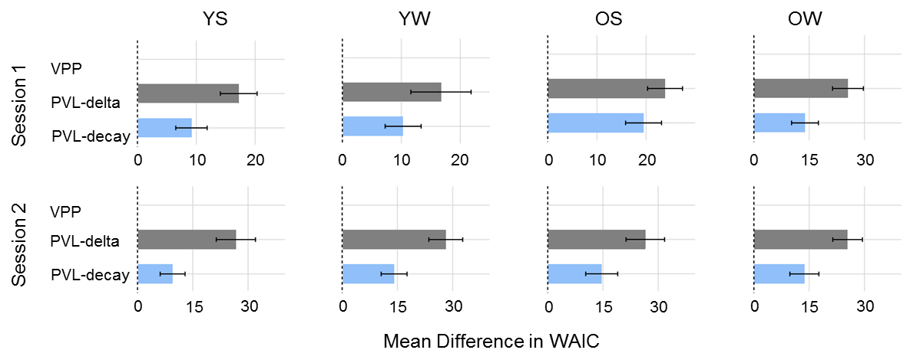
Figure S1. Average widely applicable information criterion (WAIC) values of each model for each group among two sessions. Lower WAIC values indicate better model performance. WAIC values were baselined by the best model in each comparison. The dashed line represents the zero point (i.e., best model mean WAIC = 0), and any deviations from the zero point represent competing model WAIC values. Error bars represent standard errors on the difference between the best model and the respective competing model.

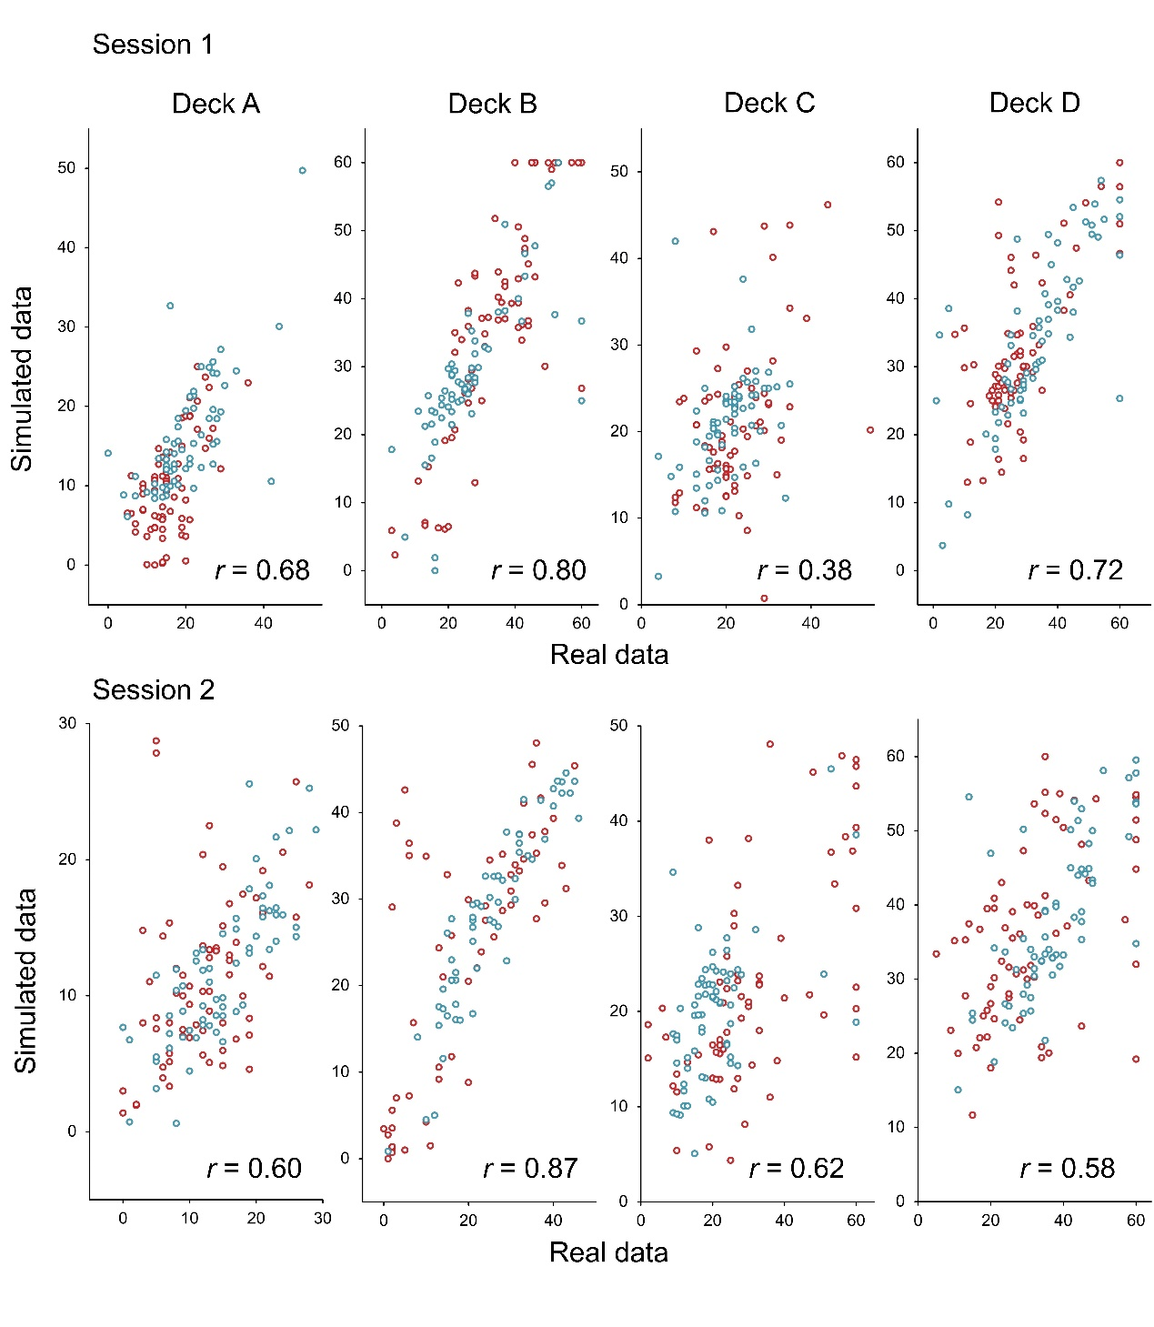
Figure S2. For the VPP model, simulated data for each participant (N = 133) show close correspondence with real data in number of each deck selection of each session. Young adults (N = 67) are plotted in red and older adults in blue (N = 66).

