Supporting information
Figure-1
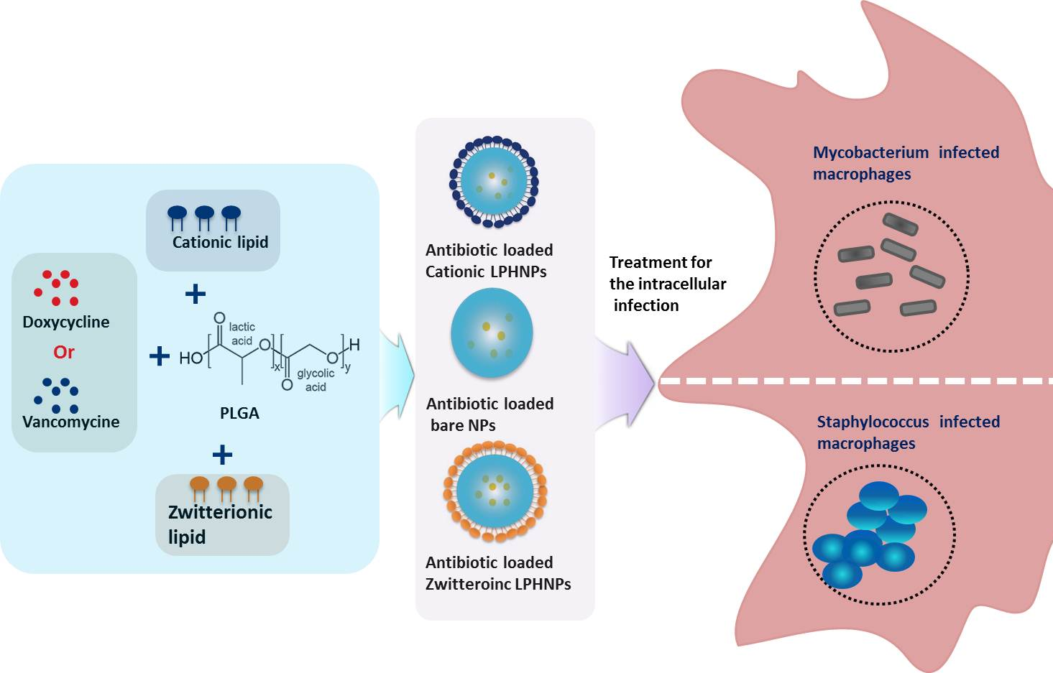The figure S1 outlines the schematic diagram of the experimental design and displays the production of different hybrid nano-formulations of drug-loaded cationic or zwitterionic LPHNPs and non-lipid layered bare BNPs using modified emulsion solvent-evaporation process
Supporting information Figure -2
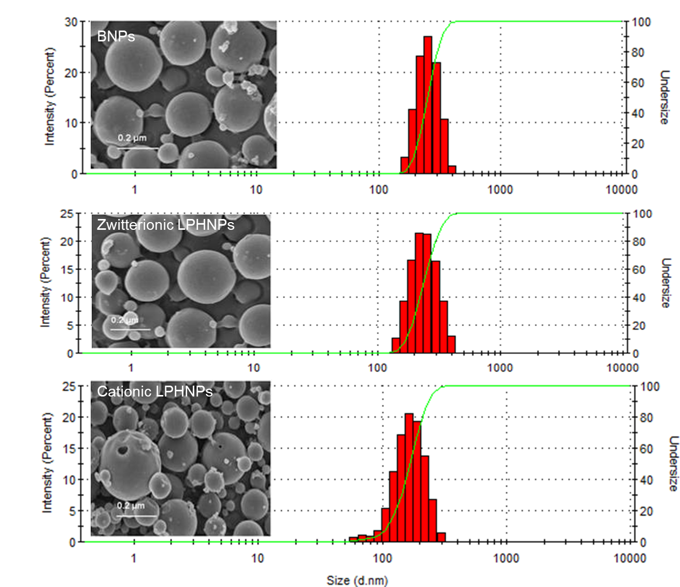 Figure S2 displays the physiochemical characterization (Size and Shape) of formulated nanohybrids.

Supporting information Figure- 3
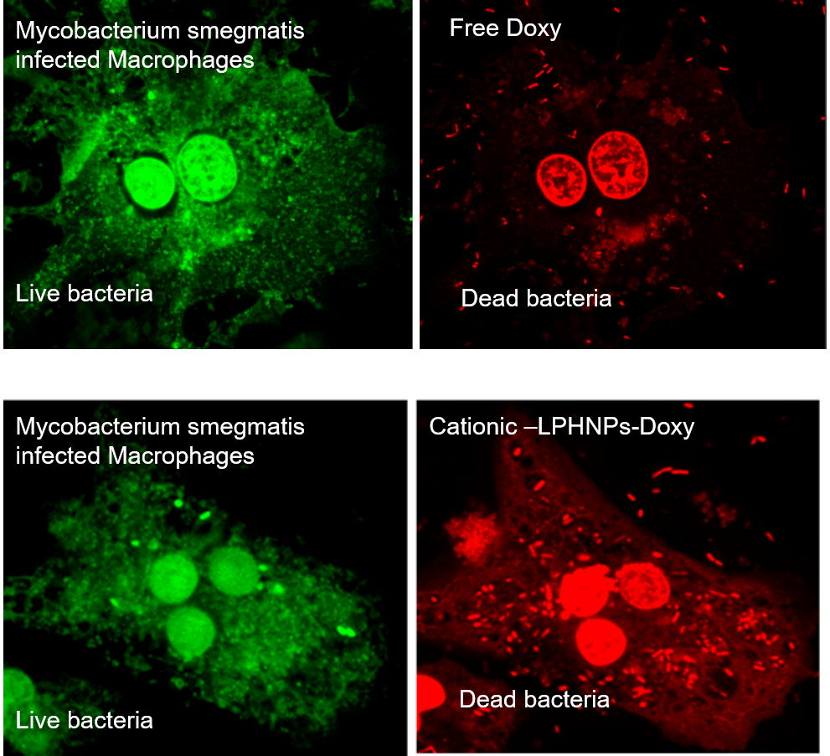
The figure S3 shows the LIVE/DEAD BacLight bacterial viability assays to distinguish between dead (labeled in red) and live (labeled in red-green) after the treatment of LPHNPs loaded with doxycycline

Supporting information Figure- 4
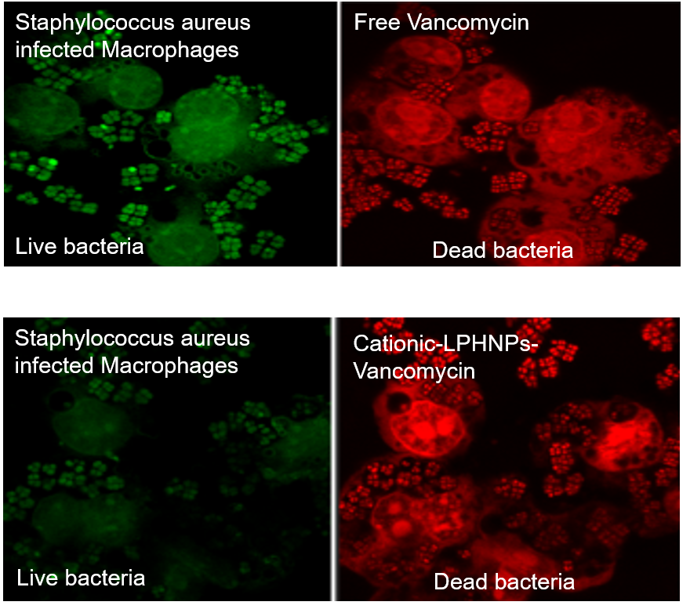
The figure S4 shows the LIVE/DEAD BacLight bacterial viability assays to distinguish between dead (labeled in red) and live (labeled in red-green) after the treatment of LPHNPs loaded with vancomycin.

Supporting information Figure- 5
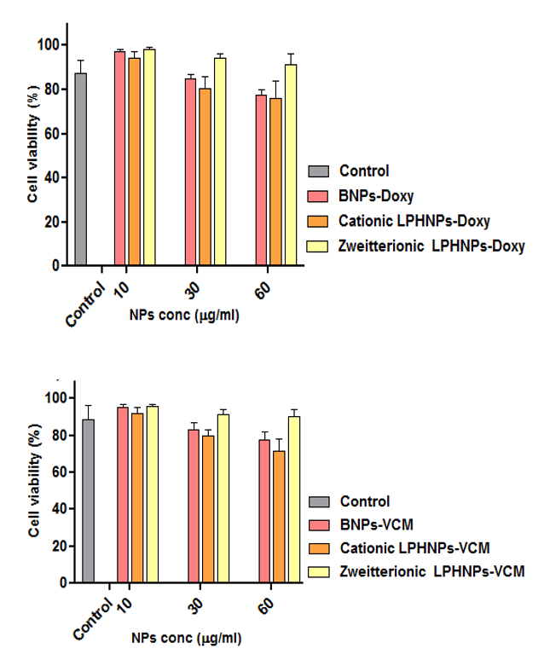
The figure S5 shows the results of cytotoxicity of BNPs and different LPHNPs formulation loaded with Doxycycline or Vancomycin treatment on macrophages.

Supporting information Figure- 6

The figure S6 shows the stability of BNPs and different LPHNPs formulation loaded with Doxycycline or Vancomycin up to 2 weeks analyzed by DLS

