Supplementary Figure 1 MiR-182 agomir control had no effect on apoptosis and migration of TE-9 cells. (A) TE-9 cells were treated with LOC441178-OE plasmids or/and miR-182 agomir control. Apoptotic cells were measured by flow cytometry. (B) TE-9 cells were infected with LOC441178-OE plasmids for 24 h in the absence or presence of miR-182 agomir control. Cell migration was assessed using transwell assay. **P<0.01.
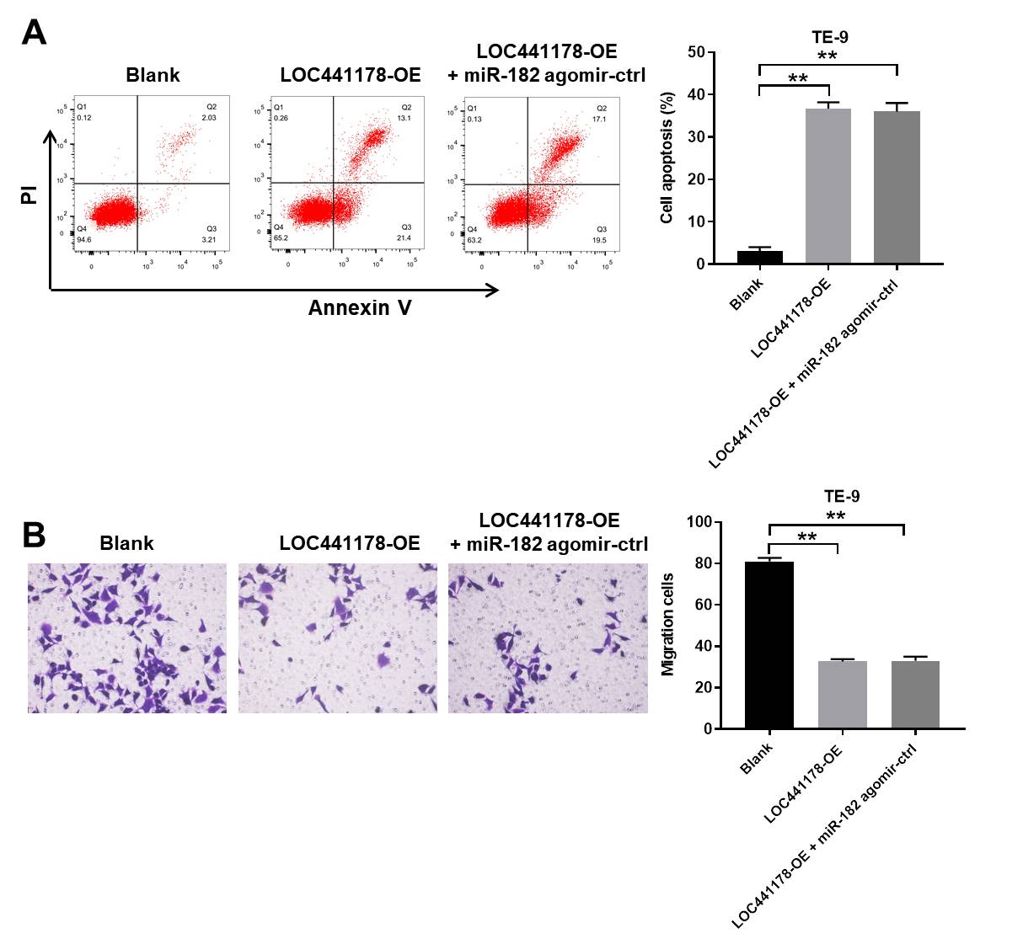
Supplementary Figure 2 Anti-tumor effect of LOC441178 OE on Eca-109 subcutaneous xenografts in vivo was reserved by miR-182 agomir. Xenografts were treated with 50 nM miR-182 agomir (intra-tumor injection) twice weekly. (A) Xenograft tumor volume was monitored weekly. (B, C) Xenografts tumors were photographed and weighted. **P<0.01.
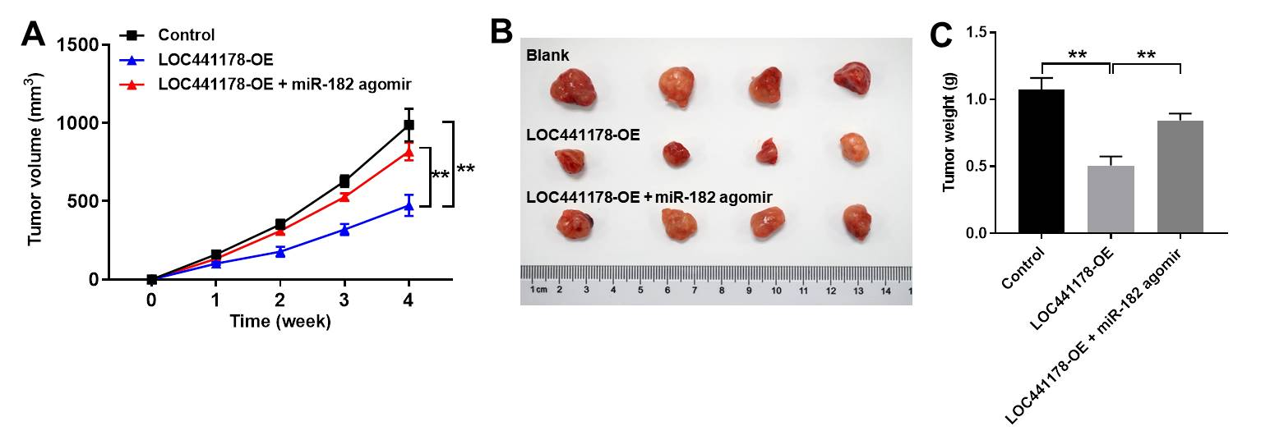

Supplementary Figure 2 Anti-tumor effect of LOC441178 OE on Eca-109 subcutaneous xenografts in vivo was reserved by miR-182 agomir. Xenografts were treated with 50 nM miR-182 agomir (intra-tumor injection) twice weekly. (A) Xenograft tumor volume was monitored weekly. (B, C) Xenografts tumors were photographed and weighted. **P<0.01.

