Supplementary data

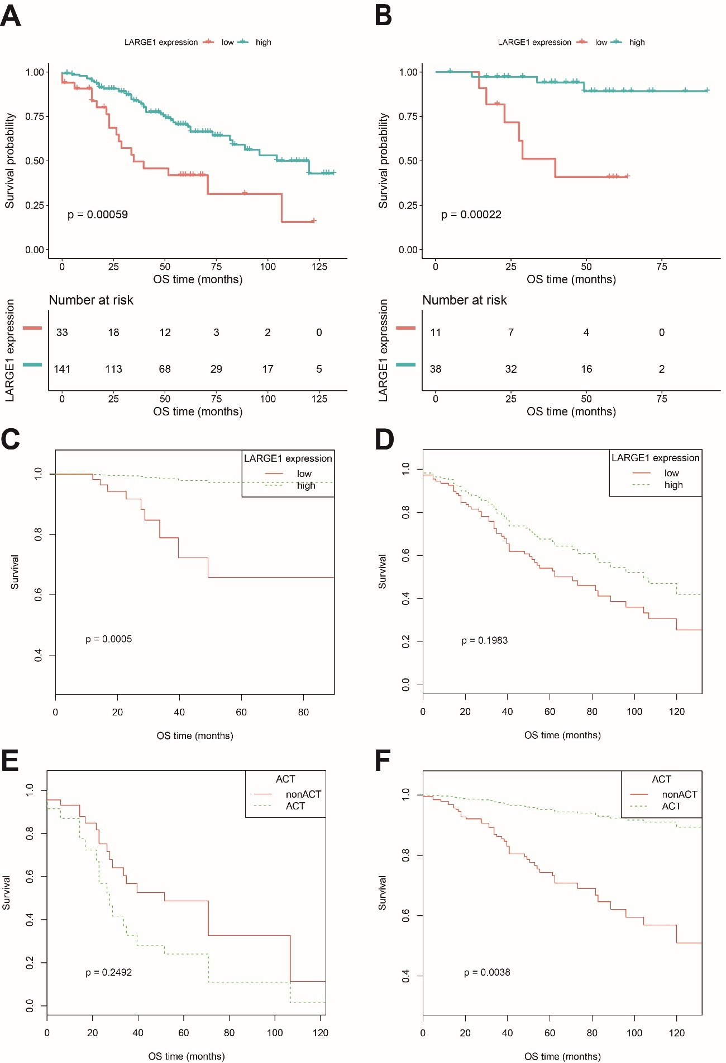
Figure S1 OS difference between TNM I-III NSCLC patients with high and low LARGE1 expression in subgroups stratified by adjuvant chemotherapy treatment (ACT) and between NSCLC patients with and without ACT in subgroups stratified by LARGE1 expression, demonstrated by Kaplan-Meier curves in GSE42127 cohort. (A) OS difference between NSCLC patients with high and low LARGE1 expression in entire cohort. (B) OS difference between NSCLC patients with high and low LARGE1 expression in subgroup of ACT. (C) OS difference between NSCLC patients with high and low LARGE1 expression in subgroup of ACT adjusted by the confounding factors. (D) OS difference between NSCLC patients with high and low LARGE1 expression in subgroup of non-ACT adjusted by the confounding factors. (E) OS difference between NSCLC patients with and without ACT in subgroup of low LARGE1 expression adjusted by the confounding factors. (F) OS difference between NSCLC patients with and without ACT in subgroup of high LARGE1 expression adjusted by the confounding factors.

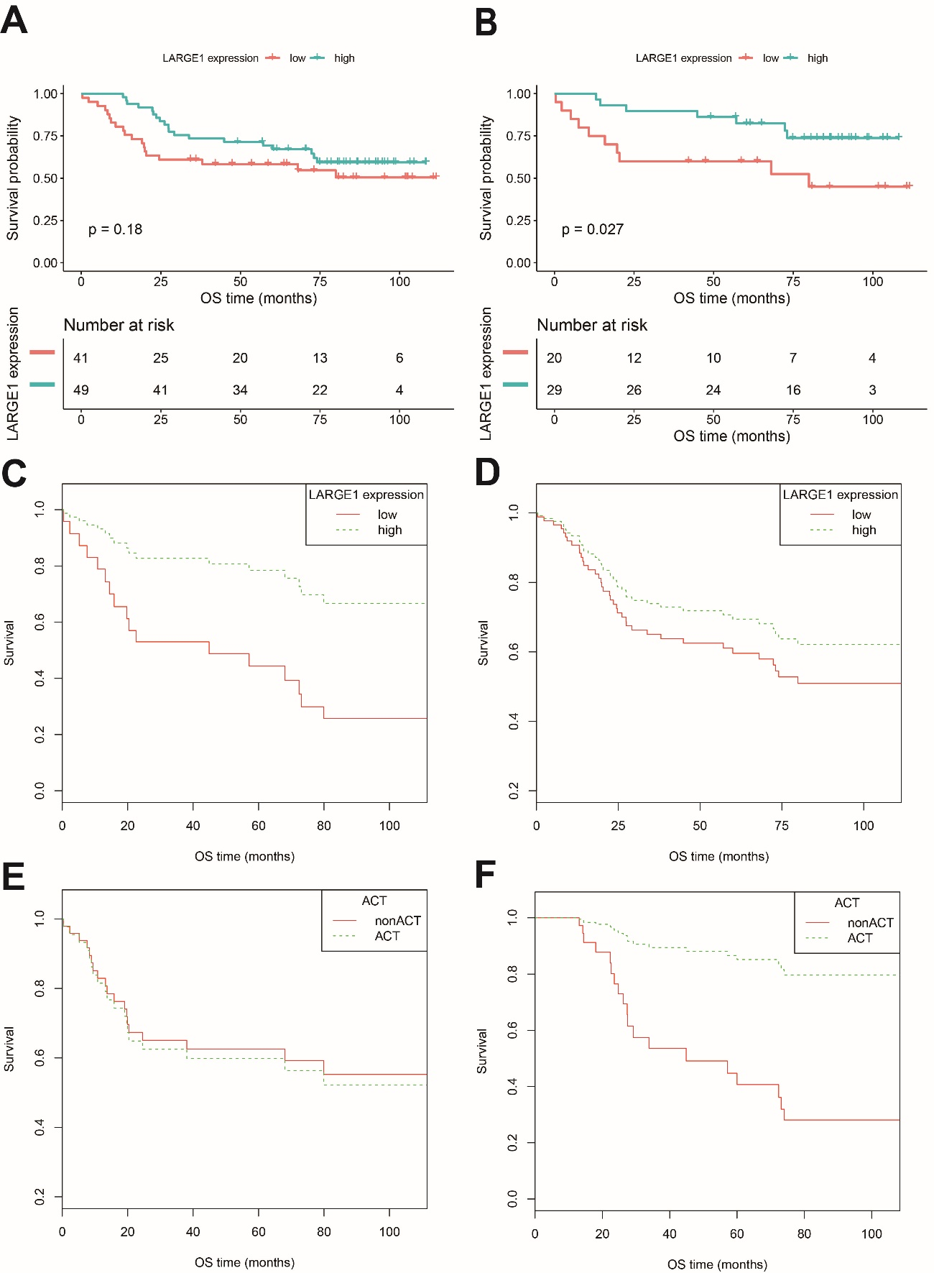Figure S2 OS difference between TNM I-III NSCLC patients with high and low LARGE1 expression in subgroups stratified by adjuvant chemotherapy treatment (ACT) and between NSCLC patients with and without ACT in subgroups stratified by LARGE1 expression, demonstrated by Kaplan-Meier curves in GSE14814cohort. (A) OS difference between NSCLC patients with high and low LARGE1 expression in entire cohort. (B) OS difference between NSCLC patients with high and low LARGE1 expression in subgroup of ACT. (C) OS difference between NSCLC patients with high and low LARGE1 expression in subgroup of ACT adjusted by the confounding factors. (D) OS difference between NSCLC patients with high and low LARGE1 expression in subgroup of non-ACT adjusted by the confounding factors. (E) OS difference between NSCLC patients with and without ACT in subgroup of low LARGE1 expression adjusted by the confounding factors. (F) OS difference between NSCLC patients with and without ACT in subgroup of high LARGE1 expression adjusted by the confounding factors.

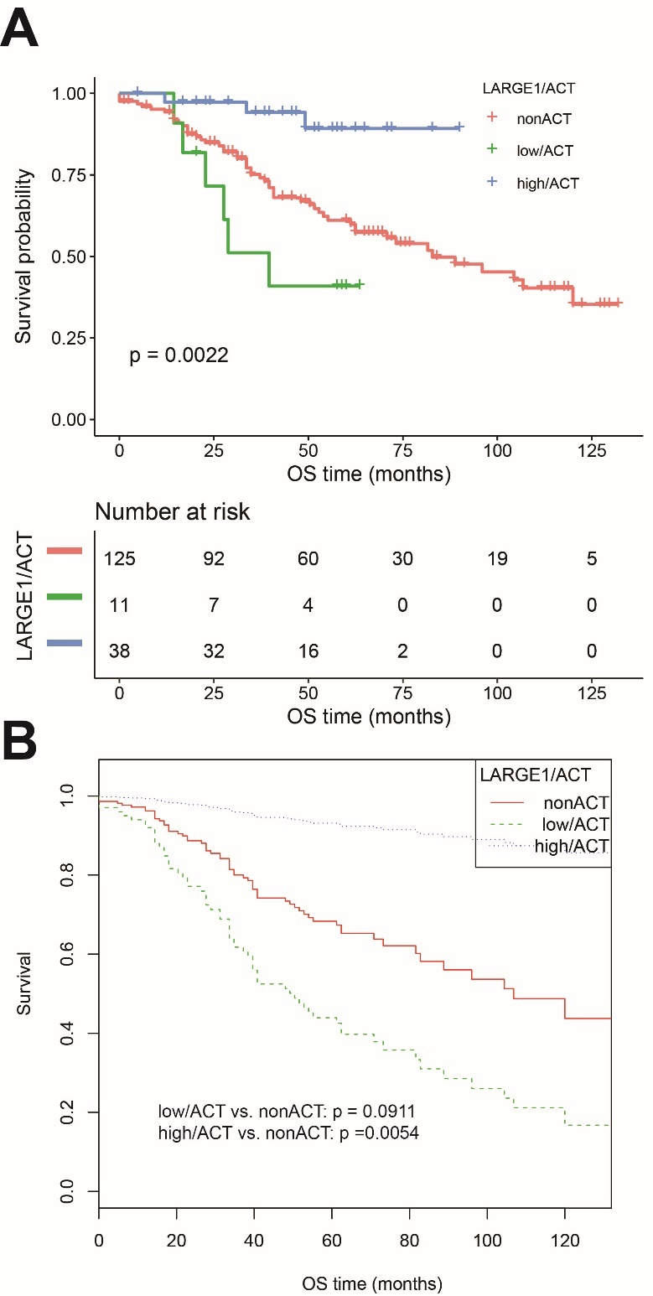
Figure S3 OS difference in TNM I-III NSCLC patients from GSE42127 cohort stratified by combining LARGE1 expression and adjuvant chemotherapy (ACT), i.e. non-ACT, low LARGE1/ACT, and high LARGE1/ACT. (A) OS difference of patients with non-ACT, low LARGE1/ACT, and high LARGE1/ACT was analyzed by Kaplan-Meier curve. (B) OS difference of patients with non-ACT, low LARGE1/ACT, and high LARGE1/ACT was analyzed by Kaplan-Meier curve adjusting the confounding factors.

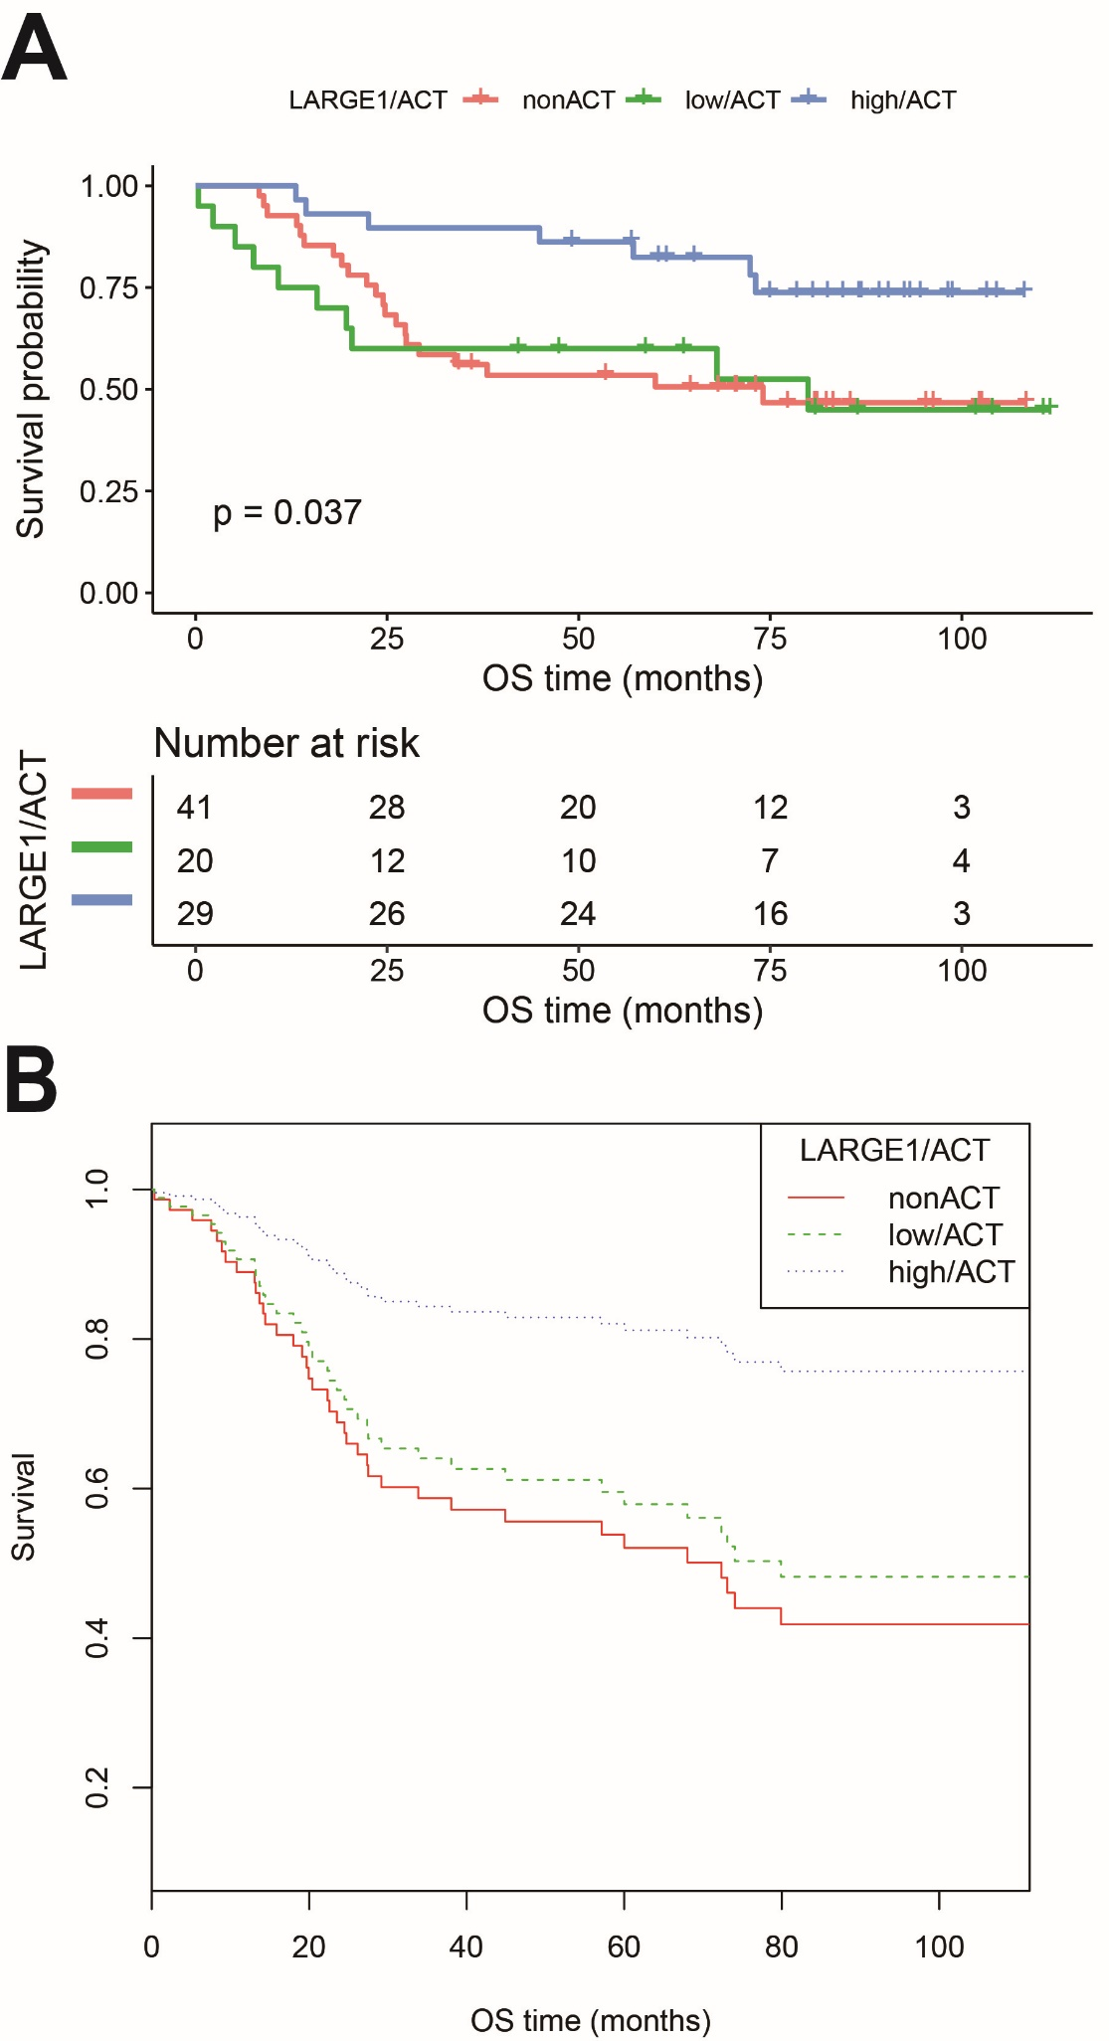
Figure S4 OS difference in TNM I-III NSCLC patients from GSE42127 cohort stratified by combining LARGE1 expression and adjuvant chemotherapy (ACT), i.e. non-ACT, low LARGE1/ACT, and high LARGE1/ACT. (A) OS difference of patients with non-ACT, low LARGE1/ACT, and high LARGE1/ACT was analyzed by Kaplan-Meier curve. (B) OS difference of patients with non-ACT, low LARGE1/ACT, and high LARGE1/ACT was analyzed by Kaplan-Meier curve adjusting the confounding factors.

Table S1 Baseline characteristics of the patients with TNM I-III NSCLC from TCGA cohort and GEO cohorts
Clinical features | TCGA | GSE42127 | GSE14814 | GSE29013 | GSE68465-DFCI | GSE68465-HLM | GSE68465-MI | GSE68465-MSKCC
N | 981 | 174 | 90 | 55 | 82 | 79 | 178 | 104
Age (years) | 66.408 ± 9.219 | 66.245 ± 9.751 | 62.070 ± 8.485 | 63.582 ± 8.726 | 61.146 ± 9.721 | 67.127 ± 10.168 | 64.455 ± 10.180 | 64.885 ± 9.635
Gender
Female | 394 (40.163%) | 83 (47.701%) | 23 (25.556%) | 17 (30.909%) | 36 (43.902%) | 39 (49.367%) | 78 (43.820%) | 67 (64.423%)
Male | 587 (59.837%) | 91 (52.299%) | 67 (74.444%) | 38 (69.091%) | 46 (56.098%) | 40 (50.633%) | 100 (56.180%) | 37 (35.577%)
Histology
Lung adenocarcinoma | 487 (49.643%) | 131 (75.287%) | 28 (31.111%) | 30 (54.545%) | 82 (100%) | 79 (100%) | 178 (100%) | 104 (100%)
Lung squamous cell carcinoma | 494 (50.357%) | 43 (24.713%) | 52 (57.778%) | 25 (45.455%)
Others |  |  | 10 (11.111%)
Pathological TNM stages
I | 523 (53.313%) | 112 (64.368%) | 45 (50.000%) | 24 (43.636%) | NA | NA | NA | NA
II | 289 (29.460%) | 32 (18.391%) | 45 (50.000%) | 14 (25.455%)
III | 169 (17.227%) | 30 (17.241%) |  | 17 (30.909%)
Pathological T stages
T1 | 279 (28.440%) | NA | NA | NA | 17 (20.732%) | 12 (15.584%) | 88 (49.438%) | 33 (31.731%)
T2 | 551 (56.167%) |  |  |  | 63 (76.829%) | 51 (66.234%) | 70 (39.326%) | 67 (64.423%)
T3-4 | 151 (15.392%) |  |  |  | 2 (2.439%) | 10 (12.987%) | 12 (6.742%) | 4 (3.846%)
Pathological N stages |  |  |  |  | 0 (0.000%) | 4 (5.195%) | 8 (4.494%) | 0 (0.000%)
N0 | 635 (65.531%) | NA | NA | NA | 58 (70.732%) | 50 (65.789%) | 127 (71.348%) | 64 (61.538%)
N1 | 218 (22.497%) |  |  |  | 24 (29.268%) | 14 (18.421%) | 30 (16.854%) | 20 (19.231%)
N2 | 116 (11.971%) |  |  |  | 0 (0.000%) | 12 (15.789%) | 21 (11.798%) | 20 (19.231%)
Residual tumor
R0 | 721 (73.496%) | 174 (100%) | 90 (100%) | 55 (100%) | 82 (100.000%) | 74 (93.671%) | 174 (97.753%) | 103 (99.038%)
R1-2 | 28 (2.854%) |  |  |  | 0 (0.000%) | 3 (3.797%) | 4 (2.247%) | 1 (0.962%)
NA | 232 (23.649%) |  |  |  | 0 (0.000%) | 2 (2.532%) | 0 (0.000%) | 0 (0.000%)
Adjuvant chemotherapy
No | 545 (68.381%) | 125 (71.839%) | 41 (45.556%) | 21 (38.182%) | 52 (67.532%) | 63 (79.747%) | 153 (90.000%) | 73 (70.192%)
Yes | 252 (31.619%) | 49 (28.161%) | 49 (54.444%) | 34 (61.818%) | 25 (32.468%) | 16 (20.253%) | 17 (10.000%) | 31 (29.808%)
Adjuvant radiotherapy
No | 695 (87.531%) | 174 (100%) | 90 (100%) | NA | 76 (98.701%) | 59 (75.641%) | 153 (90.000%) | 76 (73.077%)
Yes | 99 (12.469%) |  |  |  | 1 (1.299%) | 19 (24.359%) | 17 (10.000%) | 28 (26.923%)

Table S2 Effects of adjuvant chemotherapy on overall survival of NSCLC patients from TCGA cohort and GEO cohorts
Cohorts | HR | 95%CI |  | P-value
TCGA | 0.539 | 0.395 | 0.737 | 0.000
GSE42127 | 0.454 | 0.216 | 0.958 | 0.038
GSE14814 | 0.502 | 0.260 | 0.970 | 0.040
GSE29013 | 1.646 | 0.568 | 4.771 | 0.359
GSE68465-DFCI | 2.382 | 1.049 | 5.407 | 0.038
GSE68465-HLM | 1.755 | 0.754 | 4.087 | 0.192
GSE68465-MI | 1.887 | 0.978 | 3.640 | 0.058
GSE68465-MSKCC | 2.999 | 1.375 | 6.542 | 0.006

