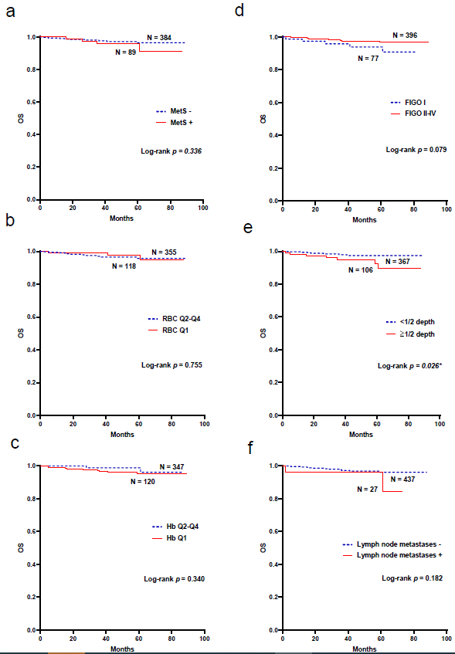
Supplementary Figure 1 Kaplan-Meier analysis of survival curves for EEC patients (a-f).
Notes: *P ˂ 0.05.
Abbreviations: OS, overall survival; MetS, metabolic syndrome; FIGO, International Federation of Gynecology and Obstetrics; RBC, red blood cell count; Hb, hemoglobin. The vertical axis represents the cumulative survival rate.

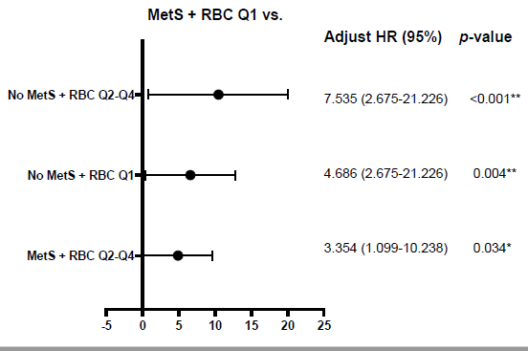
Supplementary Figure 2 Risk of deep myometrial invasion in EEC patients with different MetS status and RBC quartiles.
Notes: *P ˂ 0.05; **P ˂ 0.01.
Abbreviations: MetS, metabolic syndrome; RBC, red blood cell count; Hb, hemoglobin; Q1, 1st quartile; Q2, 2nd quartile; Q3, 3rd quartile; Q4, 4th quartile; HR: hazard ratio.

