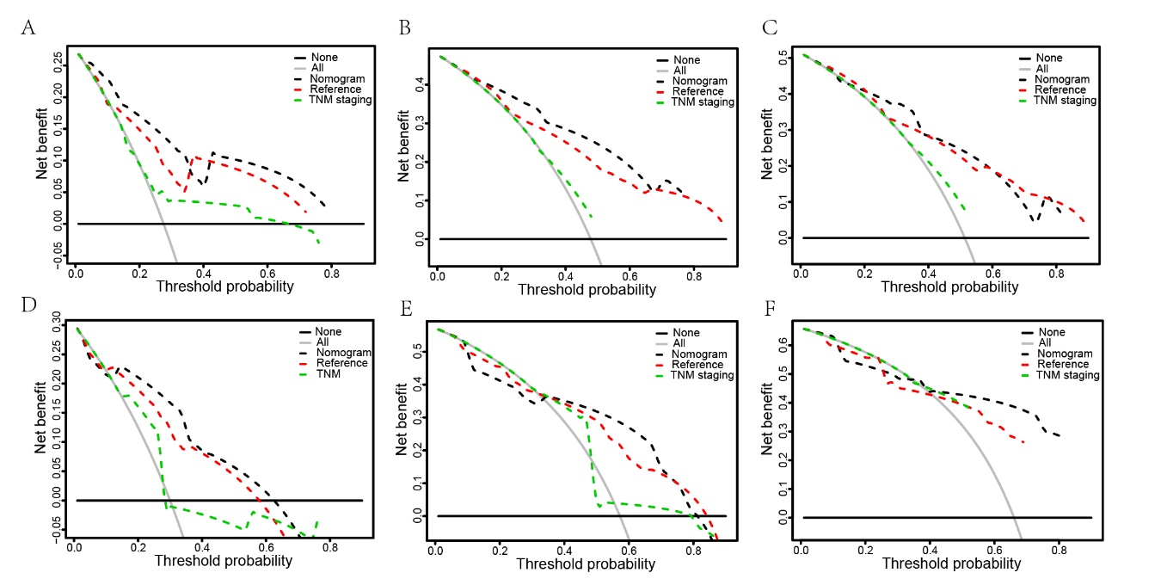
Supplement figure 1. Decisive Curve Analysis. A-C: DCA for the clinical net benefit of the nomogram, a nomogram without IPI (reference) and TNM stage for 1-year (A), 3-year (B) and 5-year(C) OS in training set. D-E: DCA for the clinical net benefit of the nomogram, a nomogram without IPI (reference) and TNM stage for 1-year (D), 3-year (E) and 5-year(F) OS in validation set. The horizontal black line represents all patients are negative and the net benefit is 0; the grey line represents all patients are positive.
Abbreviations: DCA, decisive curve analysis; OS, overall survival.
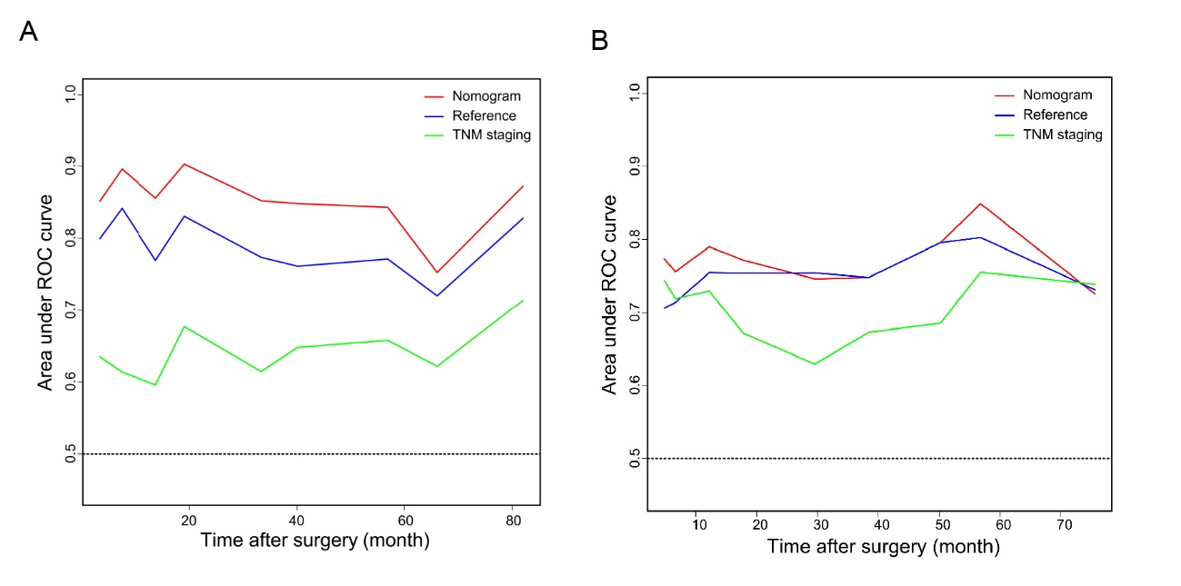
Supplement figure 2. Time-dependent receiver operating characteristic curves. ROC of nomogram, reference and TNM staging in training set(A) and validation(B). The red line represented the nomogram. The blue line represented the nomogram without IPI (reference). The green line represented TNM staging.
Abbreviations: ROC, receiver operating characteristic; OS, overall survival.
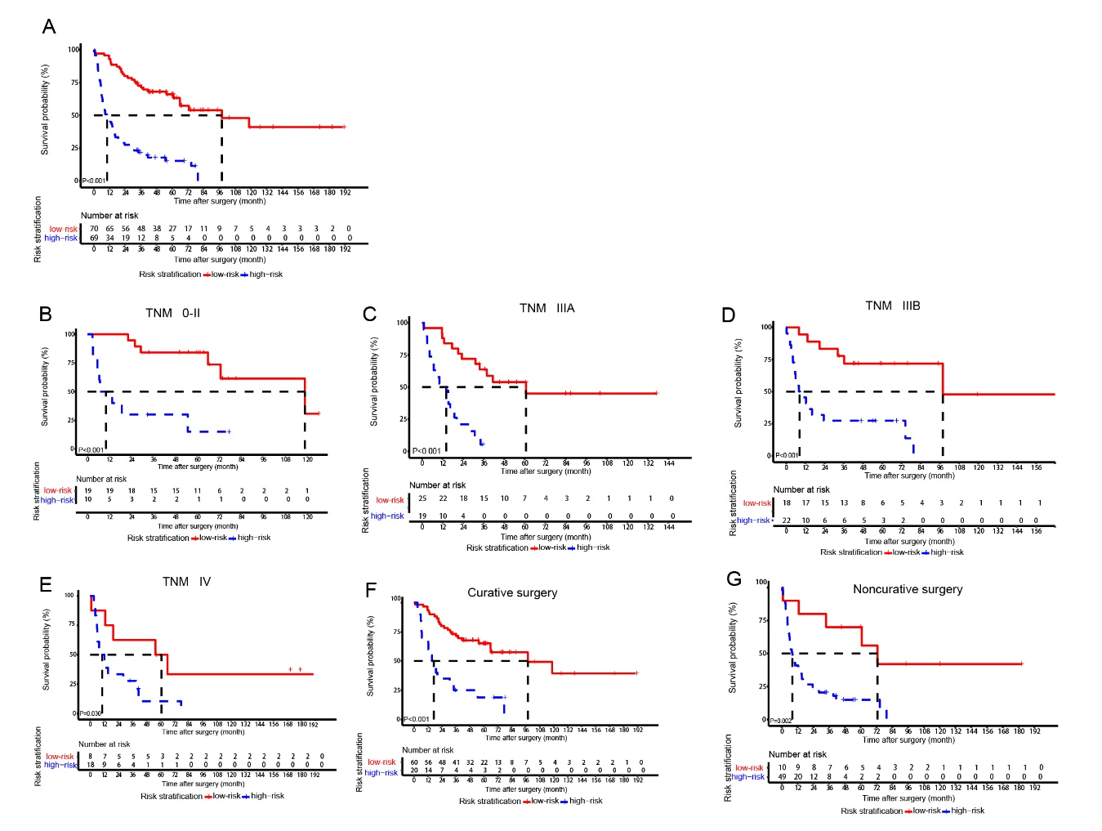
Supplement figure 3. Kaplan-Meier(K-M) survival curves for overall survival rate stratified according to the nomogram. A: Kaplan-Meier survival curves shows the overall survival rate in total gallbladder cancer patients; B: K-M curves shows the overall survival rate in the gallbladder cancer patient graded ≤ stage IIA; C: K-M curves shows the overall survival rate in the gallbladder cancer patient graded stage IIIA. D: K-M curves shows the overall survival rate in the gallbladder cancer patient graded stage IIIB. E: K-M curves shows the overall survival rate in the gallbladder cancer patient graded stage IV. F: K-M curves shows the overall survival rate in the gallbladder cancer patients underwent curative surgery. G: K-M curves shows the overall survival rate in the gallbladder cancer patients underwent noncurative surgery.

