Supplementary Data

High PD-L1 expression is associated with unfavorable clinical outcome in EGFR-mutated lung adenocarcinomas treated with targeted therapy

Table S1 List of uncommon or compound mutations (n=15)
Mutations | No. (%)
L816Q | 3 (20)
G719A | 4 (27)
G719S | 2 (13)
G719A + L858R | 2 (13)
Exon 20 insertion | 2 (13)
Exon 20 insertion + L858R | 1 (7)
T790M + L858R | 1 (7)

Table S2 Response rate according to the PD-L1 TPS and EGFR mutational subtypes
 | Overall  (n=131) | EGFR mutational subtypes
 | Overall  (n=131) | 19del (n=64) | L858R (n=52) | others (n=15)
PD-L1 TPS <1% (n=65) | 51/65 (78.5%) | 30/37 (81.1%) | 18/23 (78.3%) | 3/5 (60.0%)
PD-L1 TPS 1-49% (n=43) | 31/43 (72.1%) | 13/18 (72.2%) | 13/18 (72.2%) | 5/7 (71.4%)
PD-L1 TPS ≥50% (n=23) | 10/23 (43.5%) | 4/9 (44.4%) | 5/11 (45.5%) | 1/3 (33.3%)

Table S3 Progression-free survival analyses results according to clinicopathological parameters for the patients with exon 19 deletion (n=64)
 | Median PFS  (months) | Univariate |  | Multivariate
 | Median PFS  (months) | HR (95% CI) | p-value | HR (95% CI) | p-value
All | 16.3
Age (years) |  |  | 0.773 | NA
<70 | 14.0 | reference
≥70 | 18.9 | 0.91 (0.52-1.68)
Sex |  |  | 0.035 |  | 0.045
Female | 19.1 | reference |  | reference
Male | 12.1 | 1.96 (1.05-3.68) |  | 1.91 (1.02-3.71)
Smoking history |  |  | 0.354 | NA
Never | 18.7 | reference
Ever | 12.3 | 1.37 (0.7-2.67)
Smoking intensity |  |  | 0.463 | NA
< 30 pack-year | 15.3 | reference
≥30 pack-year | 18.9 | 1.39 (0.64-2.69)
ECOG PS |  |  | 0.214 |  | 0.569
0,1 | 18.7 | reference |  | reference
≥2 | 12.9 | 1.56 (0.77-3.14) |  | 1.23 (0.61-2.63)
Stage |  |  | 0.082 |  | 0.151
III | 17.7 | reference |  | reference
IV | 13.2 | 1.68 (0.84-7.55) |  | 1.78 (0.85-4.14)
Organ involved |  |  | 0.017 |  | 0.077
≤3 | 18.9 | reference |  | reference
>3 | 11.1 | 2.74 (1.32-6.25) |  | 1.98 (0.58-3.20)
Brain metastasis |  |  | 0.194 |  | 0.299
No | 19.1 | reference |  | reference
Yes | 12.3 | 1.53 (0.83-2.92) |  | 1.42 (0.72-2.91)
Liver metastasis |  |  | 0.355 | NA
No | 18.7 | reference
Yes | 12.0 | 1.52 (0.63-3.65)
First line TKI |  |  | 0.068 |  | 0.125
Gefitinib/erlotinib | 12.1 | 1.72 (0.63-3.65) |  | 1.83 (0.81-3.79)
Afatinib | 18.6 | reference |  | reference
PD-L1 TPS |  |  | 0.002 |  | 0.036
<50% | 18.9 | reference |  | reference
≥50% | 8.9 | 4.33 (1.76-10.63) |  | 3.85 (1.23-11.92)
ECOG PS, Eastern Cooperative Oncology Group Performance Status; EGFR, epidermal growth factor receptor; TKI, tyrosine kinase inhibitor; PD-L1 TPS, programmed death ligand-1 tumor proportional score; HR, hazard ratio; CI, confidence interval; NA, not analyzed

Table S4 Progression-free survival analyses results according to clinicopathological parameters for the patients with L858R (n=52)
 | Median PFS  (months) | Univariate |  |  | Multivariate
 | Median PFS  (months) | HR (95% CI) | *p-value |  | HR (95% CI) |  | †p-value
All | 12.8
Age (years) |  |  | 0.839 |  | NA
<70 | 12.6 | reference
≥70 | 12.3 | 1.08 (0.51-2.27)
Sex |  |  | 0.684 |  | NA
Male | 10.4 | reference
Female | 11.9 | 1.17 (0.55-2.50)
Smoking history |  |  | 0.566 |  | NA
Never | 13.4 | reference
Ever | 12.3 | 0.80 0.36-1.74)
ECOG PS |  |  | 0.347 |  | NA
0,1 | 12.6 | reference
≥2 | 12.3 | 0.65 (0.26-1.61)
Stage |  |  | 0.622 |  | NA
III | 15.2 | reference
IV | 12.3 | 1.44 (0.34-6.11)
Organ involved |  |  | 0.035 |  |  |  | 0.089
≤3 | 16.1 | reference |  |  | reference
>3 | 13.3 | 2.14 (0.94-5.18) |  |  | 1.43 (0.64-6.27)
Brain metastasis |  |  | 0.756
No | 13.2 | reference |  |  | NA
Yes | 12.3 | 1.14 (0.50-2.60)
Liver metastasis |  |  | 0.151 |  |  |  | 0.241
No | 13.2 | reference |  |  | reference
Yes | 11.9 | 1.82 (0.79-4.52) |  |  | 1.69 (0.86-3.17)
First line TKI |  |  | 0.068 |  |  | 0.125
Gefitinib/erlotinib | 12.1 | 1.72 (0.63-3.65) |  | 1.83 (0.81-3.79)
Afatinib | 17.5 | reference |  | reference
PD-L1 TPS |  |  | 0.007 |  |  |  | 0.010
<50% | 14.4 | reference |  |  | reference
≥50% | 8.0 | 3.29 (1.43-8.35) |  |  | 2.15 (1.12-6.98)
ECOG PS, Eastern Cooperative Oncology Group Performance Status; EGFR, epidermal growth factor receptor; TKI, tyrosine kinase inhibitor; PD-L1 TPS, programmed death ligand-1 tumor proportional score; HR, hazard ratio; CI, confidence interval; NA, not analyzed

Table S5 Overall survival analyses results according to clinicopathological parameters of all study subjects (n=131)
 | Median OS  (months) | Univariate |  |  | Multivariate
 | Median OS  (months) | HR (95% CI) |  | p-value |  | HR (95% CI) | p-value
All | 36.8
Age (years) |  |  |  | 0.360 |  | NA
<70 | 35.4 | reference
≥70 | 37.6 | 1.42 (0.77-2.61)
Sex |  |  |  | 0.009 |  |  | 0.098
Female | 47.7 | reference |  |  |  | reference
Male | 30.3 | 2.26 (1.22-4.18) |  |  |  | 2.13 (0.87-5.11)
Smoking history |  |  |  | 0.044 |  |  | 0.534
Never | 38.0 | reference |  |  |  | reference
Ever | 35.4 | 1.88 (1.02-3.49) |  |  |  | 1.54 (0.45-0.53)
ECOG PS |  |  |  | 0.358 |  | NA
0,1 | 36.6 | reference
≥2 | 38.0 | 1.4 (0.68-2.89)
Stage |  |  |  | 0.472 |  | NA
III | 38.6 | reference
IV | 37.4 | 1.68 (0.41-6.97)
Organ involved |  |  |  | 0.002 |  |  | 0.007
≤3 | 38.8 | reference |  |  |  | reference
>3 | 20.6 | 3.62 (1.82-7.2) |  |  |  | 3.05 (1.36-6.72)
Brain metastasis |  |  |  | 0.104 |  |  | 0.456
No | 36.7 | reference |  |  |  | reference
Yes | 33.8 | 1.68 (0.9-3.16) |  |  |  | 1.34 (0.64-2.71)
Liver metastasis |  |  |  | 0.033 |  |  | 0.049
No | 38.8 | reference |  |  |  | reference
Yes | 21.2 | 2.19 (1.07-4.49) |  |  |  | 2.46 (1.10-5.76)
EGFR-mutation subtypes |  |  |  | 0.345 |  | NA
19del | 35.5 | reference
L858R | 33.9 | 1.21 (0.51-2.96)
Others | 30.0 | 1.33 (0.78-3.27)
First-line TKI |  |  |  | 0.145 |  |  | 0.214
Gefitinib/erlotinib | 31.0 | 1.33 (0.98-3.45) |  |  |  | 1.41 (0.88-3.19)
Afatinib | 36.4 | reference |  |  |  | reference
PD-L1 TPS |  |  |  | 0.194 |  |  | 0.181
<50% | 33.7 | reference |  |  |  | reference
≥50% | 24.3 | 1.44 (0.62-3.37) |  |  |  | 1.35 (0.59-3.15)
ECOG PS, Eastern Cooperative Oncology Group Performance Status; EGFR, epidermal growth factor receptor; TKI, tyrosine kinase inhibitor; PD-L1 TPS, programmed death ligand-1 tumor proportional score; HR, hazard ratio; CI, confidence interval; NA, not analyzed

Table S6 Overall survival analyses results according to clinicopathological parameters for the patients with exon 19 deletion (n=64)
 | Median OS  (months) | Univariate |  | Multivariate
 | Median OS  (months) | HR (95% CI) | p-value | HR (95% CI) | p-value
All | 36.5
Age (years) |  |  | 0.241 |  | 0.110
<70 | 37.6 | reference |  | reference
≥70 | 31.5 | 1.59 (0.73-3.45) |  | 2.32 (0.83-6.21)
Sex |  |  | 0.041 |  | 0.187
Female | 42.8 | reference |  | reference
Male | 31.5 | 2.37(1.05-5.34) |  | 1.35 (0.34-4.72)
Smoking history |  |  | 0.095 |  | 0.165
Never | 37.7 | reference |  | reference
Ever | 36.5 | 2.31 (0.89-4.54) |  | 2.60 (0.64-10.70)
ECOG PS |  |  | 0.045 |  | 0.256
0,1 | 39.5 | reference |  | reference
≥2 | 32.6 | 2.42 (1.02-5.73) |  | 1.81 (0.66-4.81)
Stage |  |  | 0.361 | NA
III | 38.6 | reference
IV | 34.5 | 1.38 (0.85-3.16)
Organ involved |  |  | 0.001 |  | 0.036
≤3 | 37.7 | reference |  | reference
>3 | 20.3 | 5.75 (2.18-15.15) |  | 2.90 (1.07-9.23)
Brain metastasis |  |  | 0.186 |  | 0.487
No | 37.6 | reference |  | reference
Yes | 31.5 | 1.96 (0.72-5.32) |  | 1.41 (0.51-4.10)
Liver metastasis |  |  | 0.013 |  | 0.048
No | 37.6 | reference |  | reference
Yes | 23.5 | 4.11 (0.98-12.53) |  | 3.70 (1.01-10.86)
First-line TKI |  |  | 0.168 |  | 0.251
Gefitinib/erlotinib | 31.5 | 1.38 (0.98-3.66) |  | 1.65 (0.89-3.45)
Afatinib | 36.9 | reference |  | reference
PD-L1 TPS |  |  | 0.006 |  | 0.041
<50% | 37.7 | reference |  | reference
≥50% | 19.5 | 4.02 (1.57-10.69) |  | 2.55 (1.17-6.40)
ECOG PS, Eastern Cooperative Oncology Group Performance Status; EGFR, epidermal growth factor receptor; TKI, tyrosine kinase inhibitor; PD-L1 TPS, programmed death ligand-1 tumor proportional score; HR, hazard ratio; CI, confidence interval; NA, not analyzed

Table S7 Overall survival analyses results according to clinicopathological parameters for the patients with L858R (n=52)
 | Median OS  (months) | Univariate |  |  | Multivariate
 | Median OS  (months) | HR (95% CI) | p-value |  | HR (95% CI) |  | p-value
All | 26.5
Age (years) |  |  | 0.063 |  |  |  | 0.106
<70 | 28.8 | reference |  |  | reference
≥70 | 24.1 | 2.28 (0.94-8.52) |  |  | 1.68 (0.59-4.75)
Sex |  |  | 0.036 |  |  |  | 0.048
Female | 32.8 | reference |  |  | Reference
Male | 26.9 | 2.37 (1.03-5.35) |  |  | 2.11 (1.02-4.17)
Smoking history |  |  | 0.088 |  |  |  | 0.241
Never | 31.9 | reference |  |  | reference
Ever | 25.6 | 1.99 (0.66-4.89) |  |  | 1.82 (0.48-3.65)
ECOG PS |  |  | 0.068 |  |  |  | 0.179
0,1 | 30.6 | reference |  |  | reference
≥2 | 26.8 | 2.40 (1.03-4.84) |  |  | 2.24 (0.86-4.90)
Stage |  |  | 0.363 |  | NA
III | 32.9 | Reference
IV | 27.7 | 1.37 (0.17-5.81)
Organ involved |  |  | 0.008 |  |  |  | 0.017
≤3 | 31.9 | reference |  |  | reference
>3 | 24.7 | 4.16 (1.28-12.04) |  |  | 3.19 (1.12-10.21)
Brain metastasis |  |  | 0.264 |  |  |  | 0.419
No | 30.6 | reference |  |  | reference
Yes | 24.9 | 2.11 (0.91-4.93) |  |  | 1.53 (0.11-3.50)
Liver metastasis |  |  | 0.257 |  |  |  | 0.157
No | 31.9 | reference |  |  | reference
Yes | 25.6 | 2.04 (0.59-7.00) |  |  | 2.20 (0.77-8.12)
First-line TKI |  |  | 0.216 |  |  | 0.251
Gefitinib/erlotinib | 24.5 | 1.38 (0.78-4.10) |  | 1.65 (0.89-4.45)
Afatinib | 32.9 | reference |  | reference
PD-L1 TPS |  |  | 0.214 |  |  |  | 0.232
<50% | 29.4 | reference |  |  | reference
≥50% | 24.1 | 2.19 (0.89-6.15) |  |  | 2.08 (0.84-5.79)
ECOG PS, Eastern Cooperative Oncology Group Performance Status; EGFR, epidermal growth factor receptor; TKI, tyrosine kinase inhibitor; PD-L1 TPS, programmed death ligand-1 tumor proportional score; HR, hazard ratio; CI, confidence interval; NA, not analyzed

(A) (B)
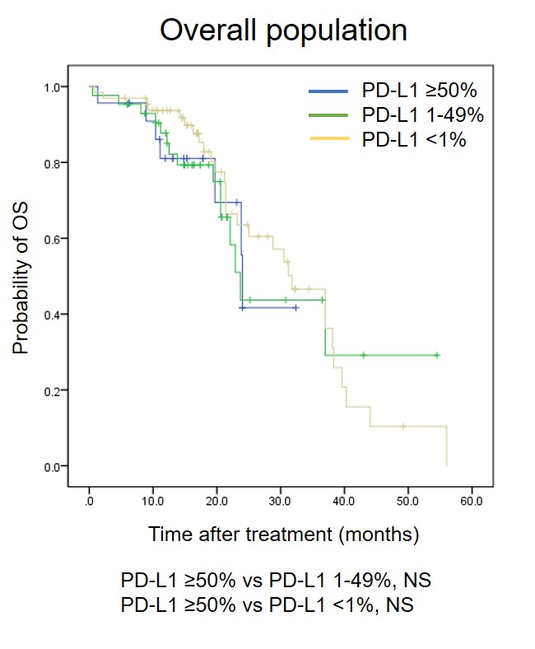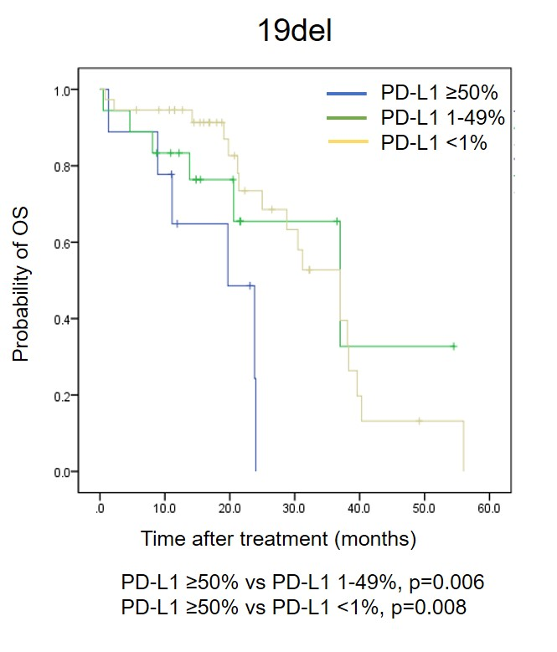
(C) (D)
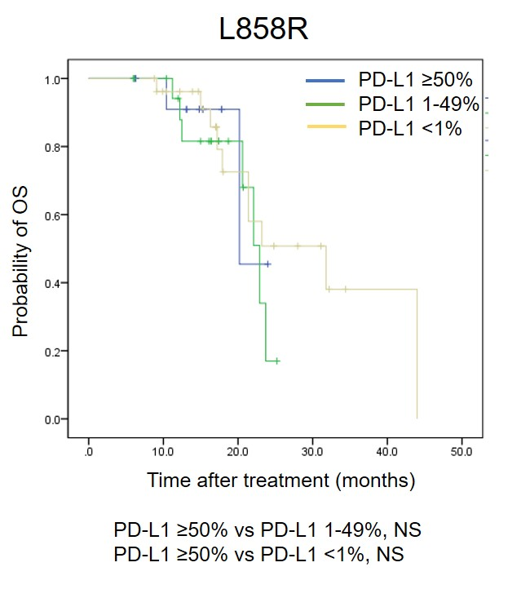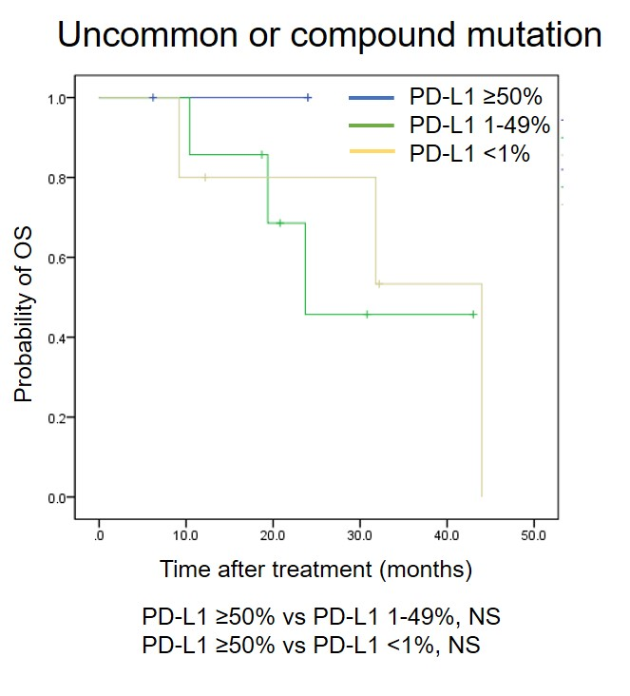

Figure S1. Kaplan-Meier curves of overall survival (OS) according to different PD-L1 TPS. (A) Overall population, (B) for the patients with exon 19 deletion, (C) for the patients with L858R mutation, and (D) for the patients with uncommon of compound mutation. P-values were determined using the log-rank test. NS, not significant

