Table S1 Traditional Chinese Medicine Pattern Differentiation.
Diagnostic patterns | Items
Stagnation of Qi and blood | Pain: distended, stabbing abdominal pain before or during the period aggravated by pressure.  Menstruation: dark purplish in color, clotty and hesitant or scanty in flow, pain relieved after clots discharged.  Accompanying symptoms: distending in breasts, mood swings. Tongue: purplish.  Pulse: wiry.
Retention of cold-damp coagulation | Pain: distended, stabbing abdominal pain before or during the period, favorably to warmth, lower back pain.  Menstruation: dark purplish in color, clotty and hesitant in flow, pain relieved after clots discharged.  Accompanying symptoms: distending in breasts, mood swings, and aversion to cold.  Tongue: pale and white greasy tongue coating.  Pulse: deep and slow.

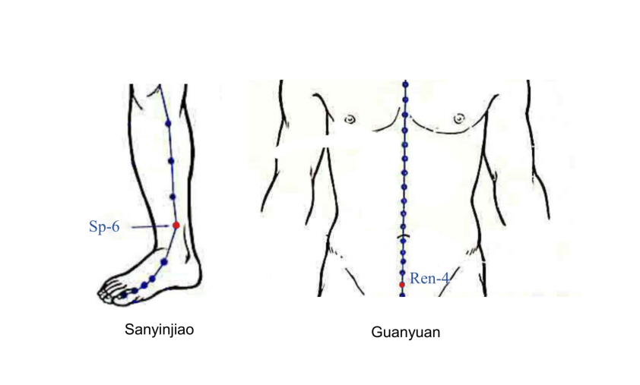
Supplementary Figure 1: Location of Sanyinjiao and Guanyuan.

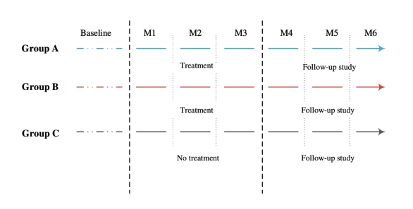
Supplementary Figure 2: Timeline of Baseline, Treatment, and Follow-up. For Group A and Group B, the treatment course took 3 months (M1–M3). After the completion of treatment, there was a 3-month follow-up stage (M4–M6). Group C, the waiting-list group, received no treatment over 3 months (M1–M3).

Supplement 1: Protocol for this study.
