The impact of lung function on extra-pulmonary diseases and all-cause mortality in U.S. adult population with and without COPD

Kai Yang^{1†}, Ying Wu^{2†}, Dandan Chen¹, Shengming Liu^{3*}, Rongchang Chen^{1*}
¹Shenzhen Institute of Respiratory Diseases, Shenzhen People’s Hospital (the Second Clinical Medical College, Jinan University; the First Affiliated Hospital, Southern University of Science and Technology), Shenzhen, Guangdong, China.
²Department of Biostatistics, School of Public Health, Southern Medical University, Guangzhou, Guangdong, China.
³Department of Respiratory Medicine, the First Affiliated Hospital, Jinan University, Guangzhou, Guangdong, China.
*Correspondence:
Rongchang Chen, chenrc@vip.163.com; Shenzhen Institute of Respiratory Diseases, Shenzhen People’s Hospital (the Second Clinical Medical College, Jinan University; the First Affiliated Hospital, Southern University of Science and Technology), Shenzhen 518055, China.
Shengming Liu, tlsm@jnu.edu.cn; Department of Respiratory Medicine, the First Affiliated Hospital, Jinan University, Guangzhou 510000, China.
†These authors contributed equally to this work.

Supplementary Method
Spirometry Test in NHANES
The National Health and Nutrition Examination Survey (NHANES) is designed to evaluate the health and nutritional status of adults and children in the USA. It uses a multistage, stratified and cluster sampling design to collect and analyze data representative of the national, noninstitutionalized population of the USA. Those who agreed to participate were interviewed in their homes and asked to have an examination in the mobile examination center. The interview and examination included demographic information, daily dietary data, examination data, laboratory data, and questionnaire data. In 2007-2012, pre-bronchodilator spirometry test were conducted for the survey participants aged 6 to 79 years. Examinees with an FEV1/FVC% less than the Lower Limit of Normal (LLN) or a FEV1/FVC% less than 70% were considered eligible for post-bronchodilator test.
Patient Health Questionnaire (PHQ-9) for Depression
Depression was measured using the PHQ-9, a nine-item screening instrument that asked questions about the frequency of symptoms of depression over the past 2 weeks. Response categories for the nine-item instrument "not at all," "several days," "more than half the days" and "nearly every day" were given a point ranging from 0 to 3. These points were summed and divided into 5 groups to define the severity of depression: none (≤ 4), mild (5 ~ 9), moderate (10 ~ 14), moderately-severe (15 ~ 19) and severe (≥ 20).
The items included: ①have little interest in doing things; ②feeling down, depressed, or hopeless; ③trouble sleeping or sleeping too much; ④feeling tired or having little energy; ⑤poor appetite or overeating; ⑥feeling bad about yourself; ⑦feeling bad about yourself; ⑧moving or speaking slowly or too fast; ⑨thought you would be better off dead.
Cancer Category
The cancer in the analysis included cancer from blood, bone, brain, breast, cervix (cervical), colon, esophagus (esophageal), gallbladder, kidney, larynx/ windpipe, leukemia, liver, lung, lymphoma/hodgkin's disease, melanoma, mouth/tongue/lip, nervous system, ovary (ovarian), pancreas (pancreatic), prostate, rectum (rectal), skin (non-melanoma), skin (don't know what kind), soft tissue (muscle or fat), stomach, testis (testicular), thyroid, uterus (uterine).

Supplementary Figure 1. Sub-group analysis for the effects of lung function on 14 diseases in non-COPD population. (A) FVC% predicted in subjects aged < 40. (B) FVC predicted in subjects aged < 40. (C) FVC% predicted in subjects aged ≥ 40. (D) FVC predicted in subjects aged ≥ 40. Note: the following variables were removed from the logistic regression models to avoid collinearity because they are included in the definition of the corresponding diseases: MS: hypertension, DM, dyslipidemia; dyslipidemia: gender; obesity: BMI; CKD: gender, race; anemia: gender.

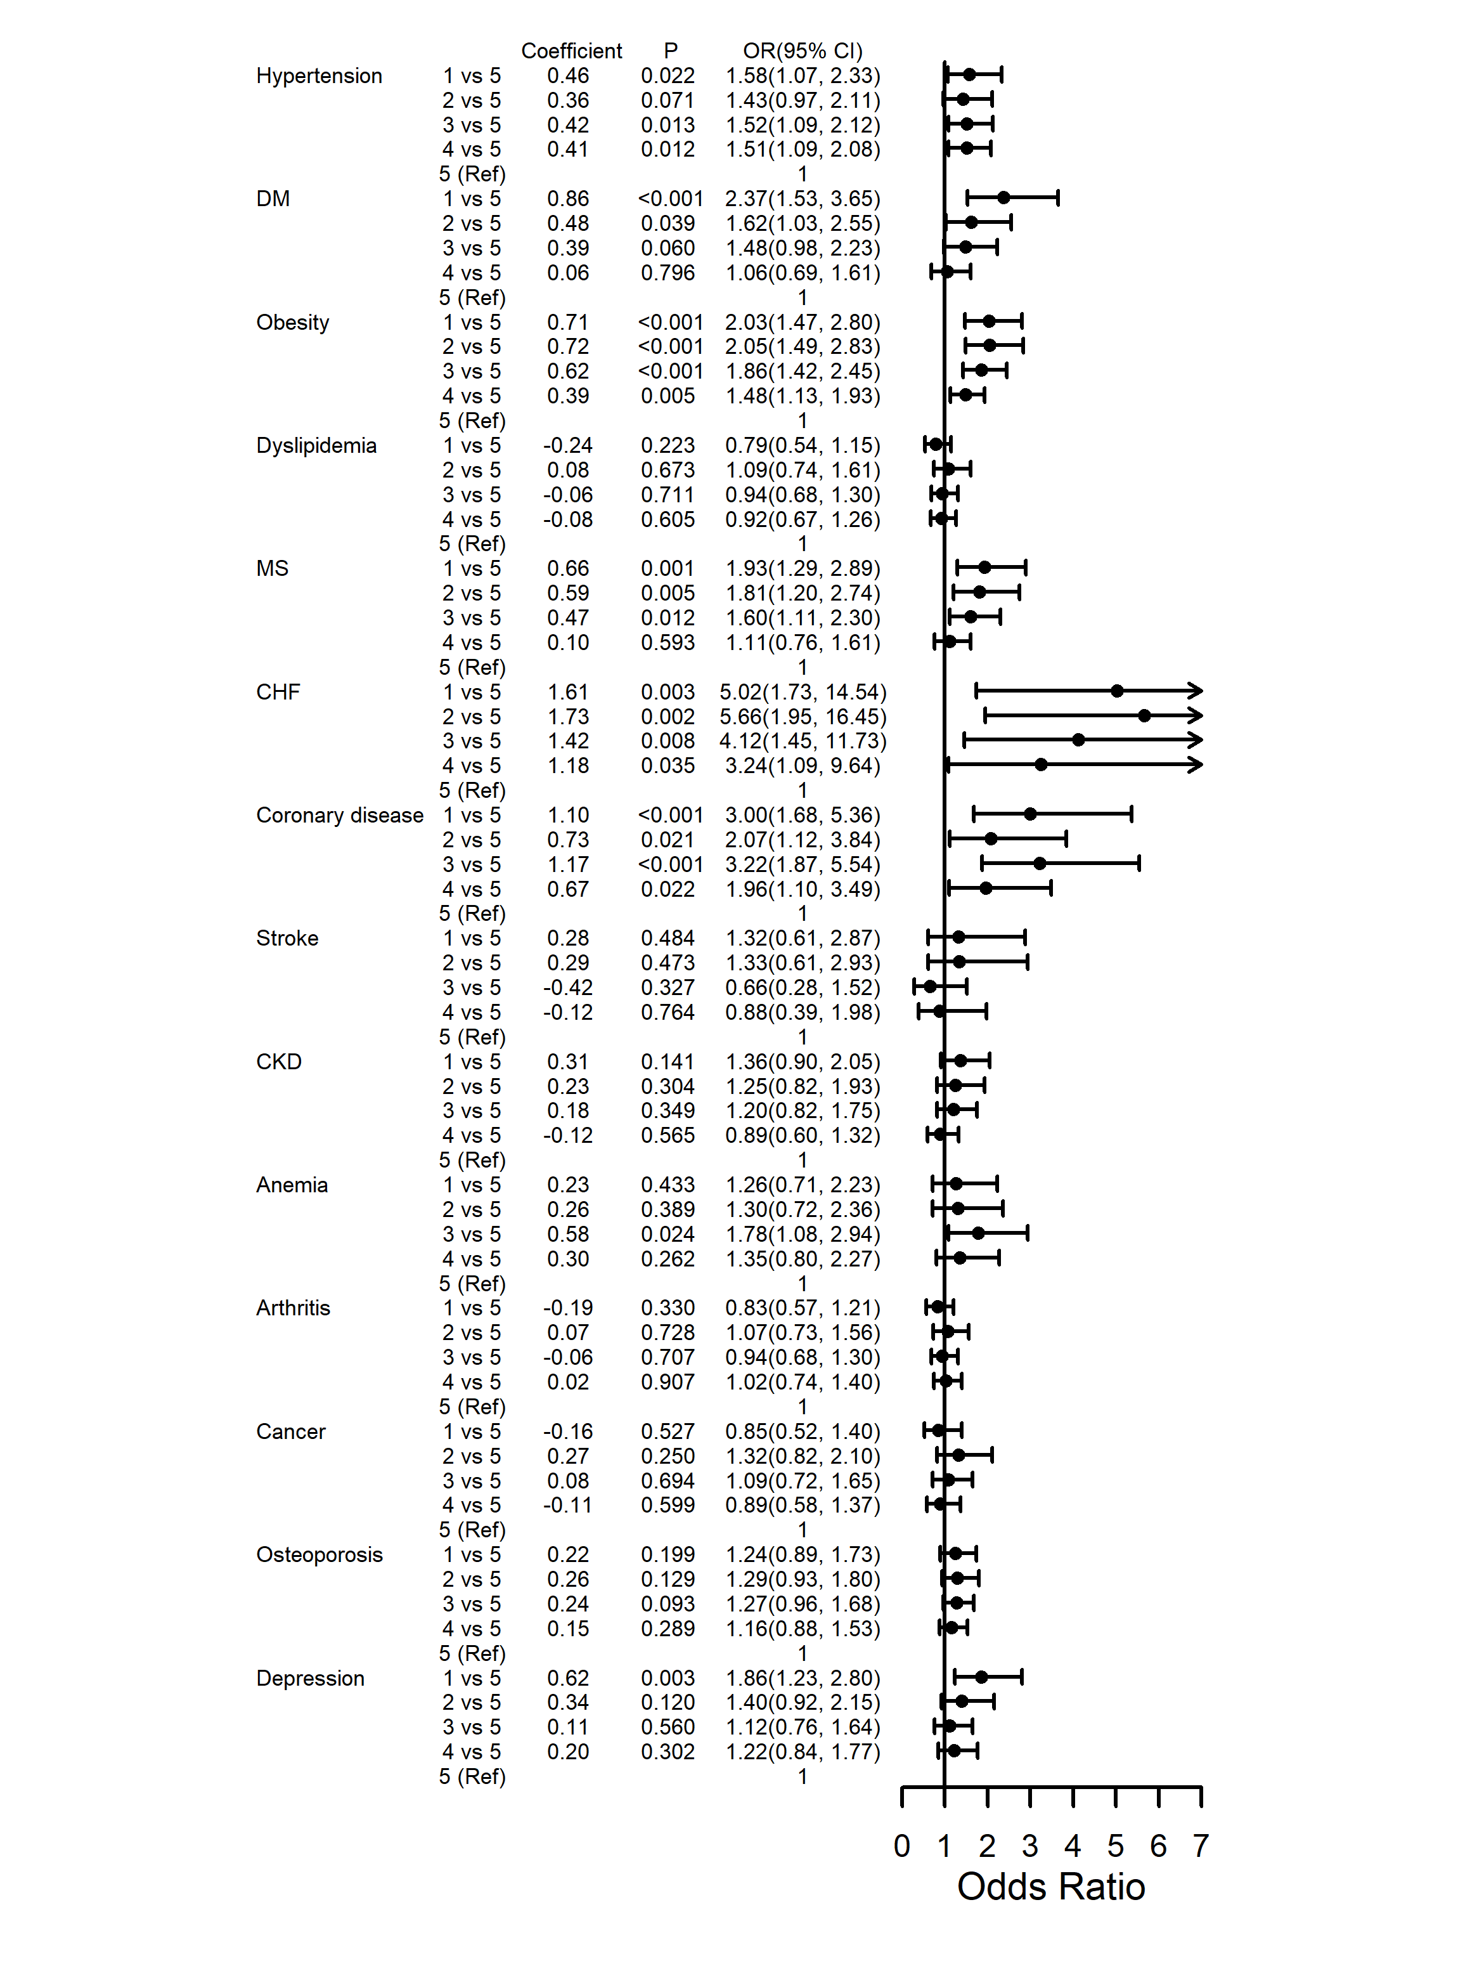
Supplementary Figure 2. Comparisons of the effects of different FEV₁% predicted groups on 14 diseases in COPD subjects after adjusting for multiple factors. Note: the following variables were removed from the logistic regression models to avoid collinearity because they are included in the definition of the corresponding diseases: MS: hypertension, DM, dyslipidemia; dyslipidemia: gender; obesity: BMI; CKD: gender, race; anemia: gender. 1: < 60%, 2: 60% ~ 70%, 3: 70% ~ 80%, 4: 80% ~ 90%, 5: ≥ 90%;
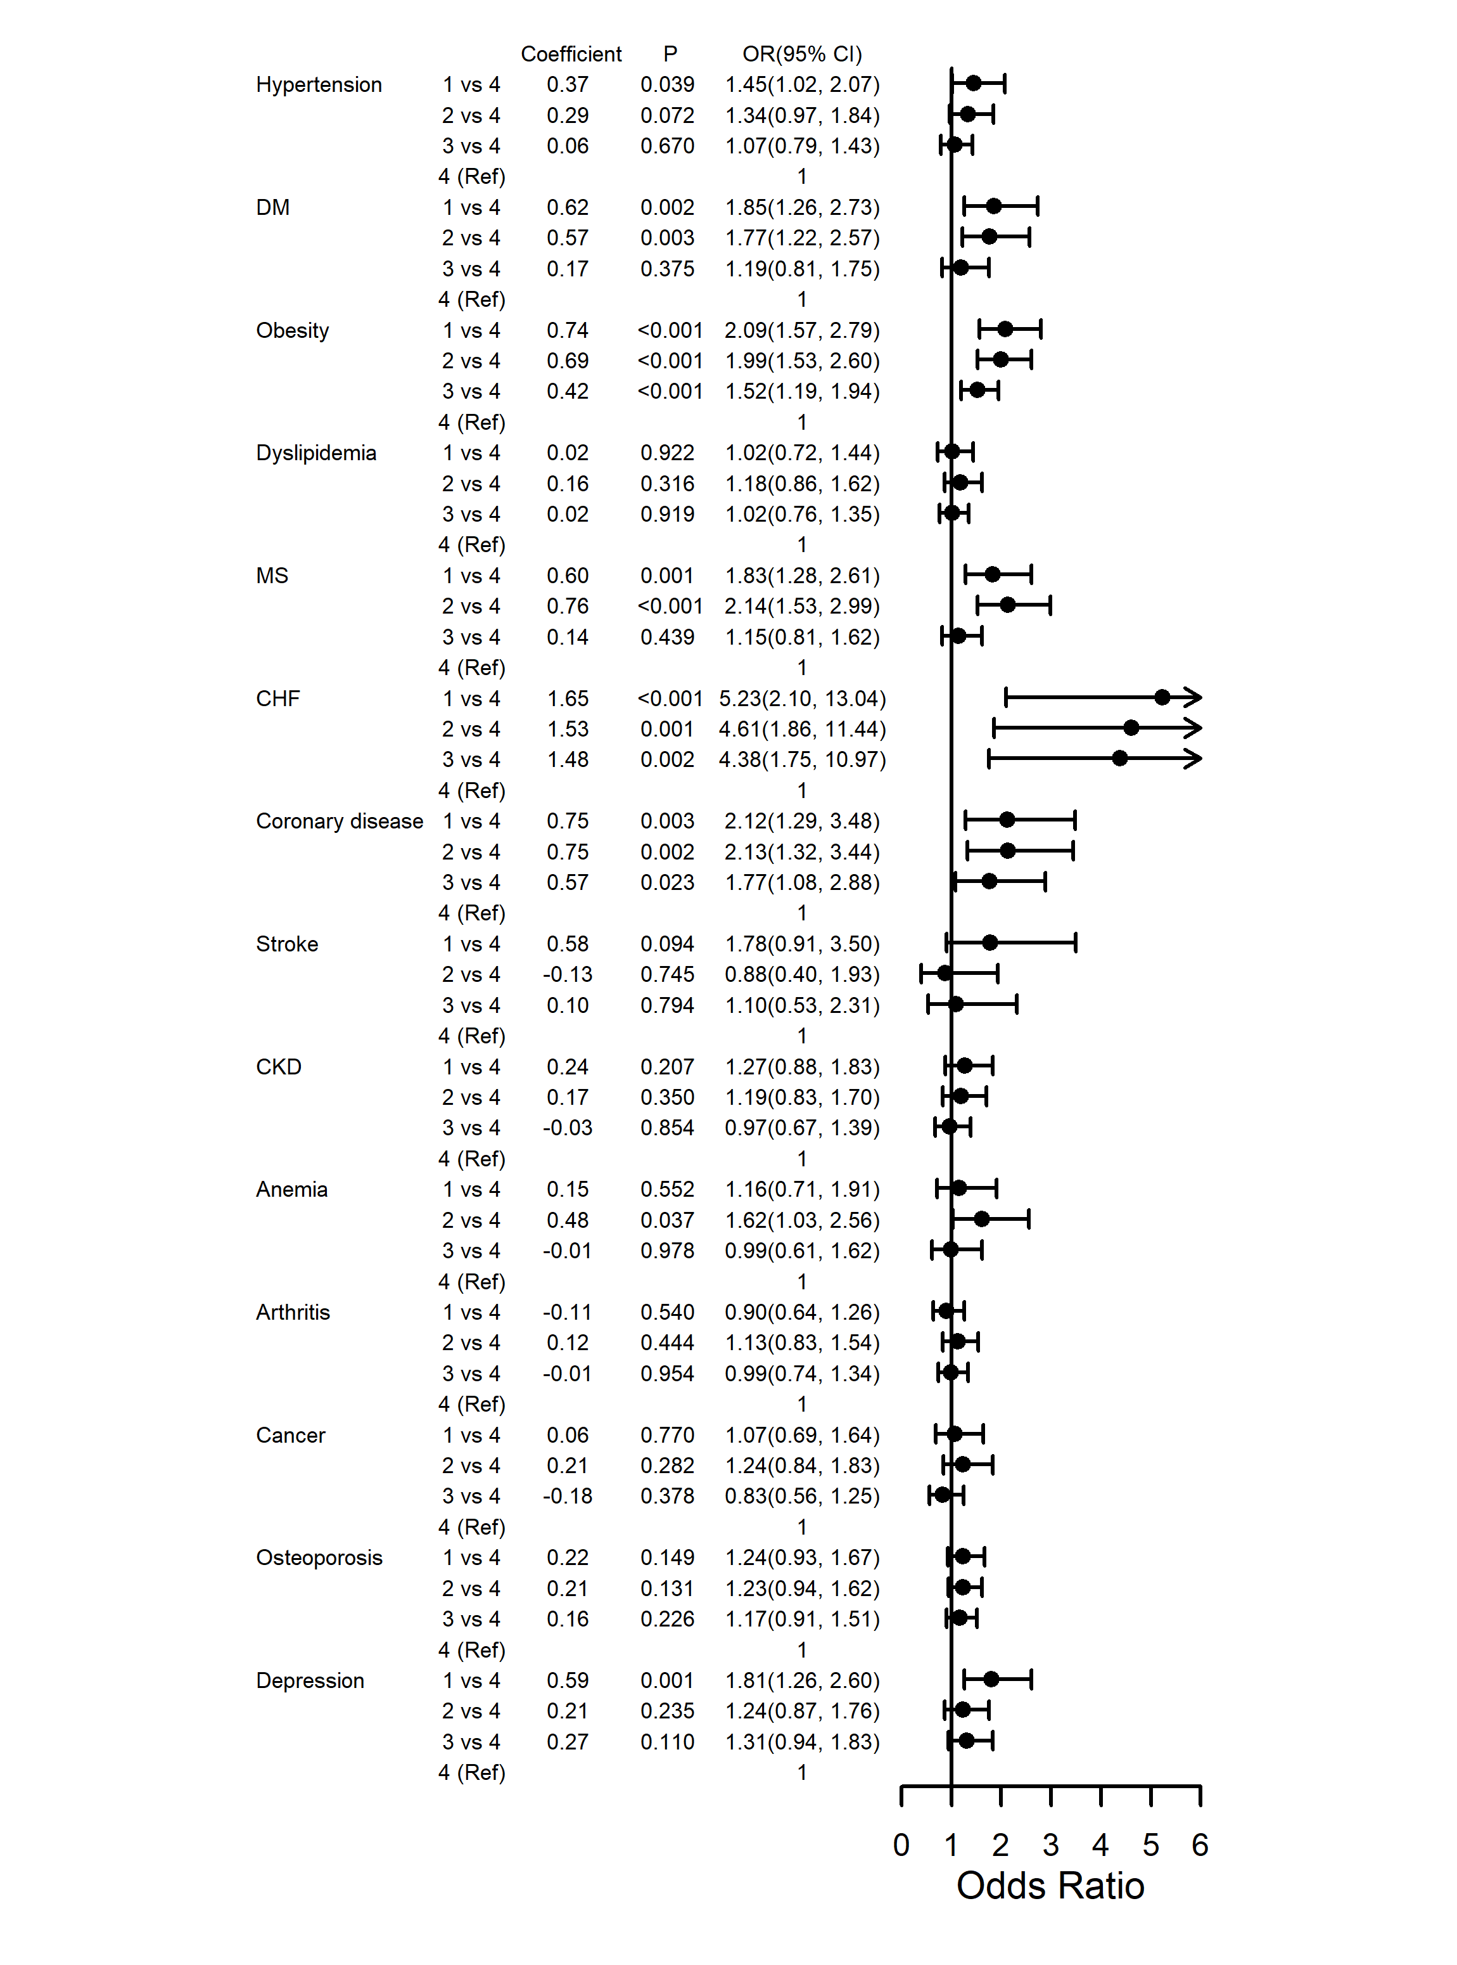
Supplementary Figure 3. Comparisons of the effects of different FVC% predicted groups on 14 diseases in COPD subjects after adjusting for multiple factors. Note: the following variables were removed from the logistic regression models to avoid collinearity because they are included in the definition of the corresponding diseases: MS: hypertension, DM, dyslipidemia; dyslipidemia: gender; obesity: BMI; CKD: gender, race; anemia: gender. 1: < 80%, 2: 80% ~ 90%, 3: 90% ~ 100%, 4: ≥ 100%.
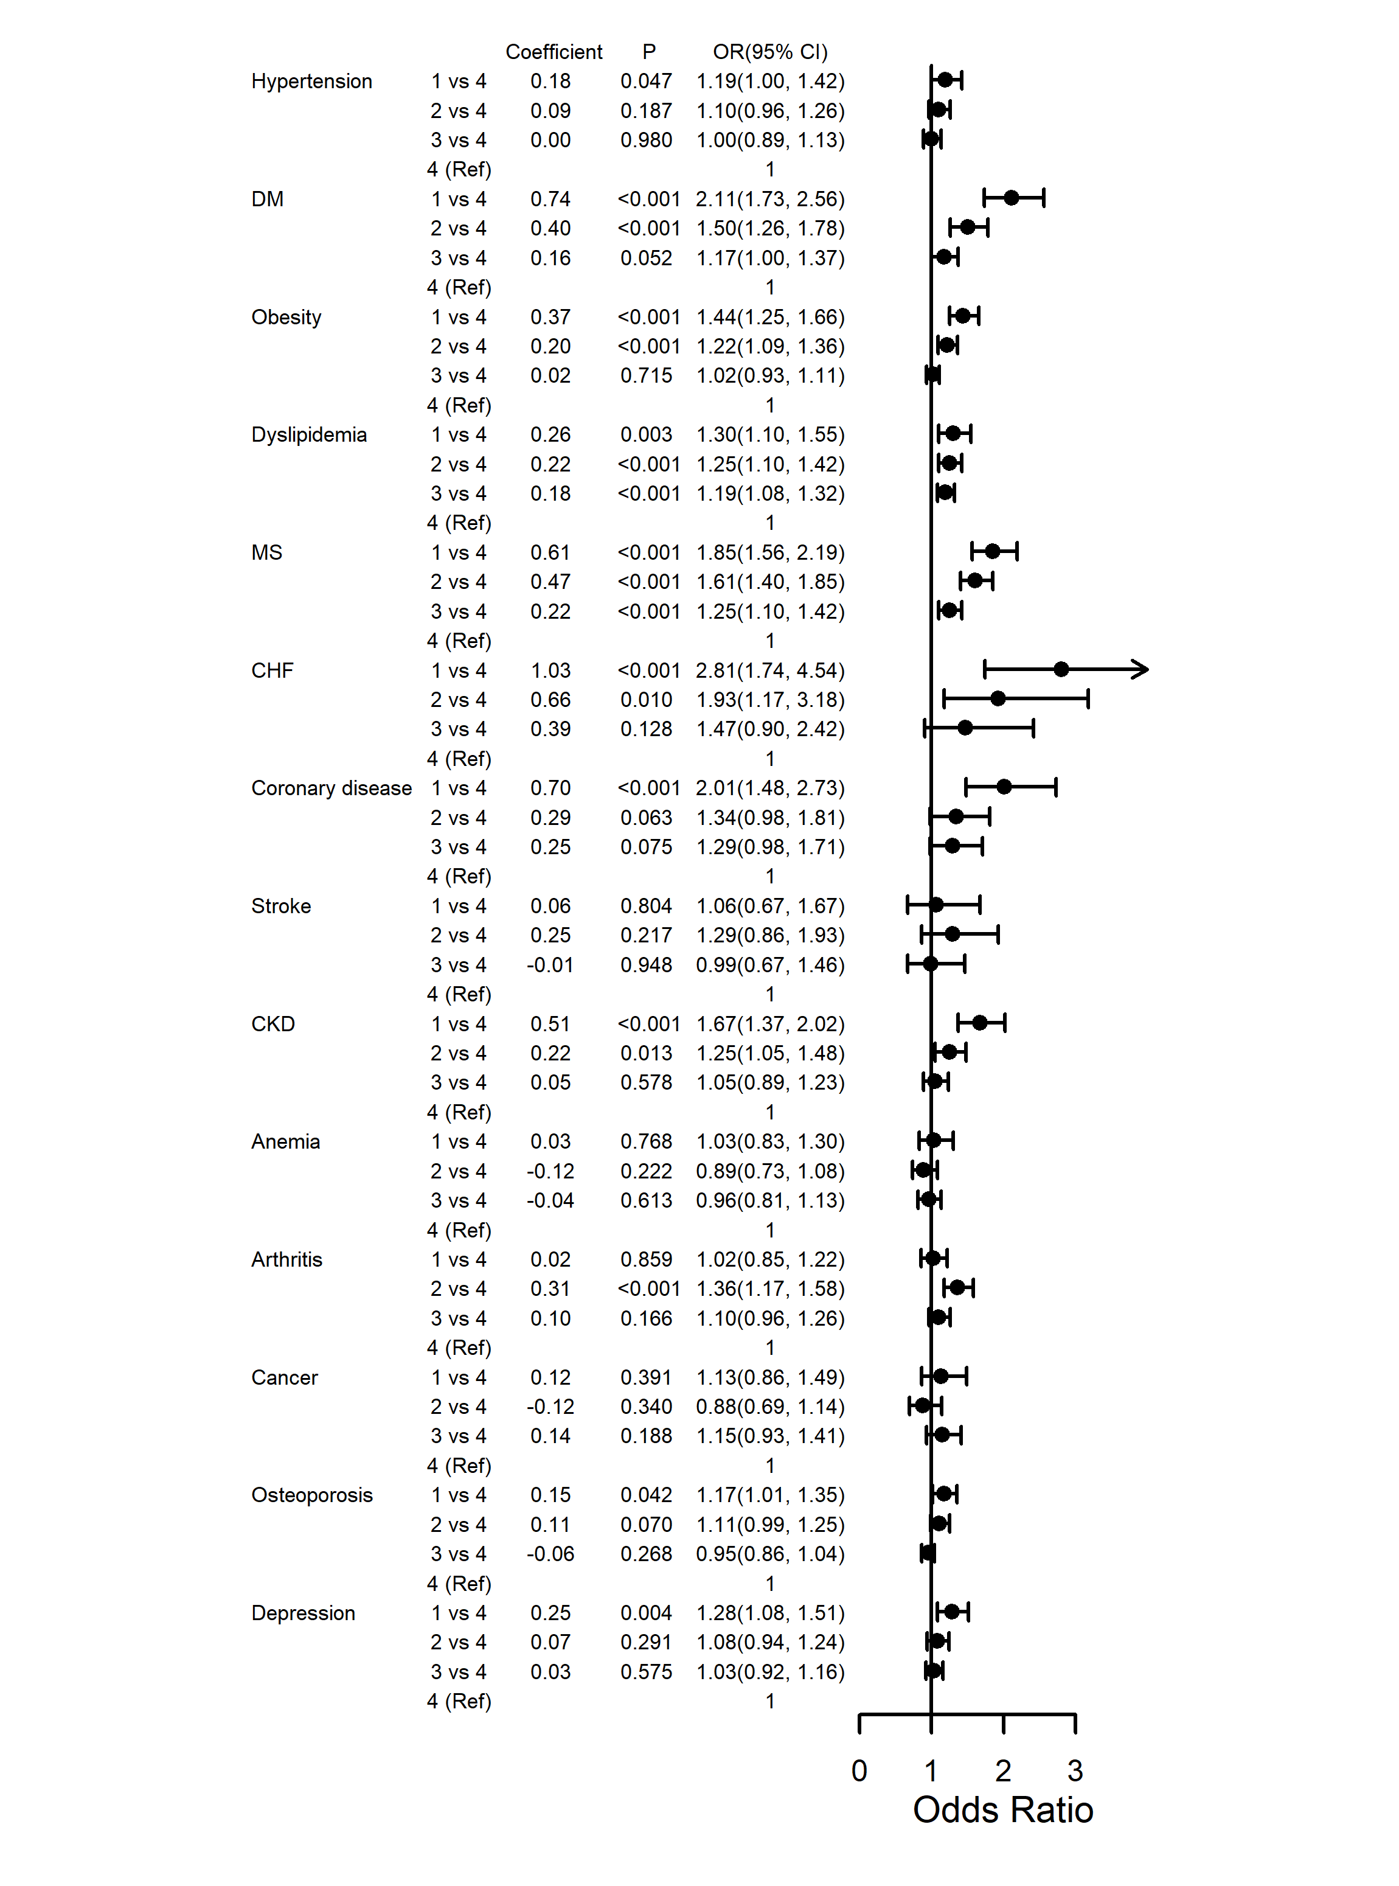
Supplementary Figure 4. Comparisons of the effects of different FEV₁% predicted groups on 14 diseases in non-COPD subjects after adjusting for multiple factors. Note: the following variables were removed from the logistic regression models to avoid collinearity because they are included in the definition of the corresponding diseases: MS: hypertension, DM, dyslipidemia; dyslipidemia: gender; obesity: BMI; CKD: gender, race; anemia: gender. 1: < 80%, 2: 80% ~ 90%, 3: 90% ~ 100%, 4: ≥ 100%.
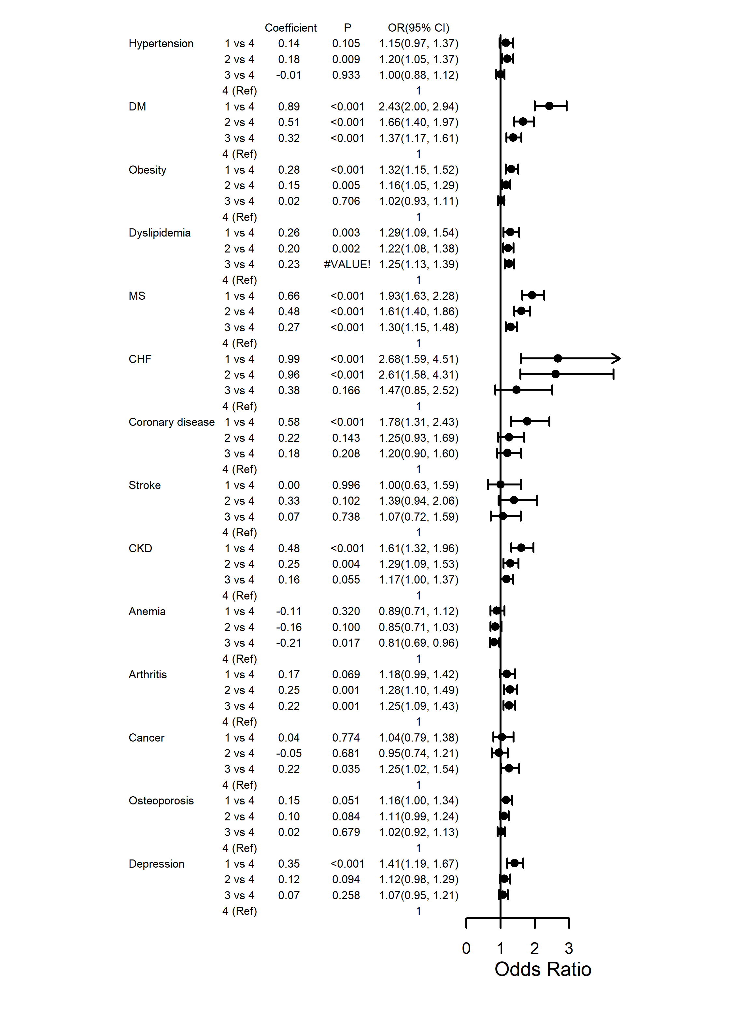
Supplementary Figure 5. Comparisons of the effects of different FVC% predicted groups on diseases 14 in non-COPD subjects after adjusting for multiple factors. Note: the following variables were removed from the logistic regression models to avoid collinearity because they are included in the definition of the corresponding diseases: MS: hypertension, DM, dyslipidemia; dyslipidemia: gender; obesity: BMI; CKD: gender, race; anemia: gender. 1: < 80%, 2: 80% ~ 90%, 3: 90% ~ 100%, 4: ≥ 100%.
Supplementary Figure 6. Overall survival of subjects with different lung function (P < 0.001). (A) FEV₁% predicted in COPD population. (B) FVC% predicted in COPD population. (C) FEV₁% predicted in non-COPD population. (D) FVC% predicted in non-COPD population.

