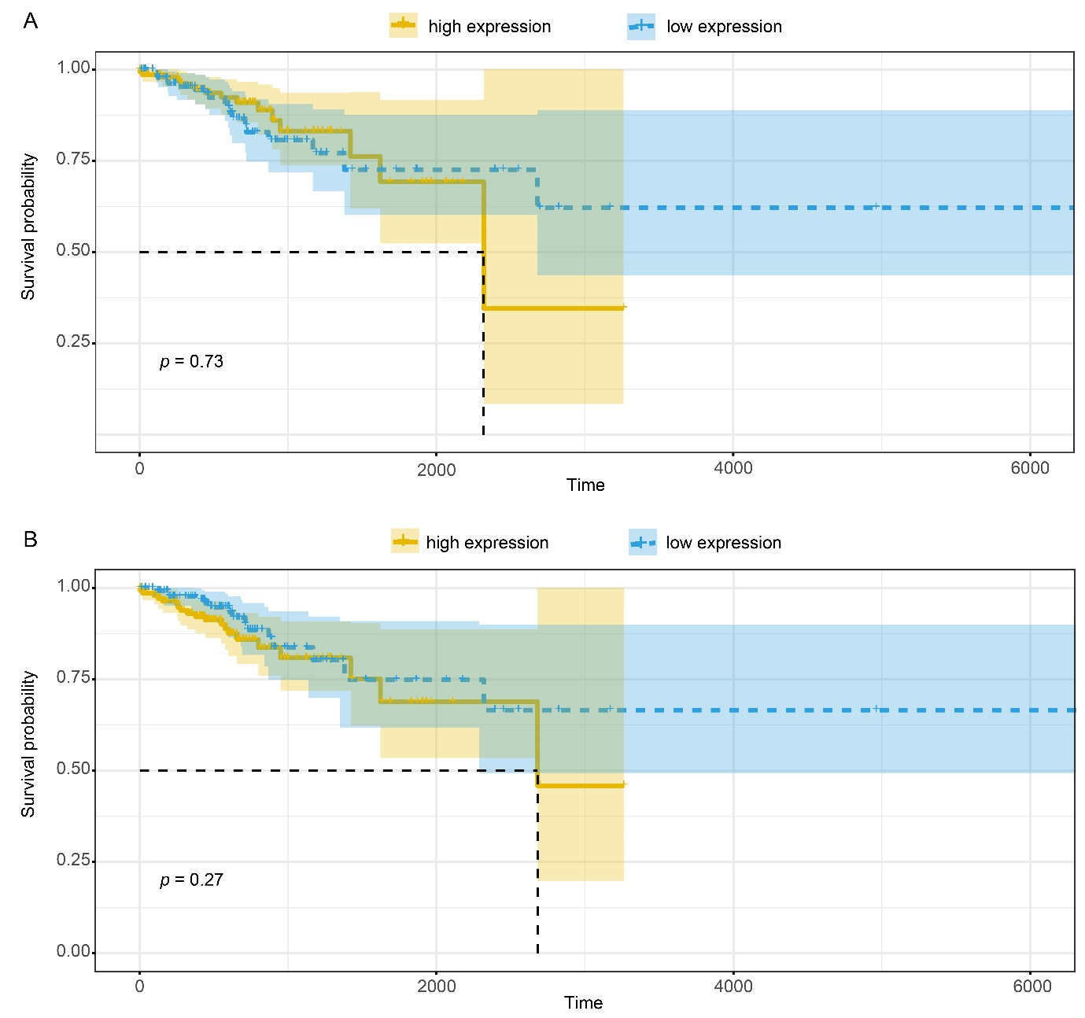
Figure S1: Kaplan-Meier analysis of DSG3(A) and KRT14(B) in LUAD samples in TCGA database. The high expression level of DSG3 and KRT14 had no connection with the prognosis in LUAD samples. (P > 0.05)

