Supplementary materials
Supplementary text S1
Packages used in R software
A lasso regression [1] was perfomed by using the “glmnet” package in R software (version 3.5.1, http://www.R-project.org/). The final results of multivariate analysis and lasso regression were integrated into the R software to formulate a logistic regression based-nomogram model by using the “rms” package. The ROC curves were plotted using the “pROC” package and the area of the ROC curves were calculated for predicting LMN. NRI and IDI were calculated by using the “PredictABEL” package.
Code for Neural Netwrok in the MATLAB
x=xlsread('training_data.xls',['B2:G734']);
y=xlsread('training_data.xls',['I2:I734']);
inputs = x';
targets = y';

hiddenLayerSize = 20;
net = patternnet(hiddenLayerSize);

net.divideFcn = 'dividerand'; % Divide data randomly
net.divideMode = 'sample'; % Divide up every sample
net.divideParam.trainRatio = 70/100;
net.divideParam.valRatio = 15/100;
net.divideParam.testRatio = 15/100;

net.trainFcn = 'trainlm'; % Levenberg-Marquardt
net.performFcn = 'mse'; % Mean squared error
net.plotFcns = {'plotperform','plottrainstate','ploterrhist', ...
'plotregression', 'plotfit'};

[net,tr] = train(net,inputs,targets);
outputs = net(inputs);
errors = gsubtract(targets,outputs);
performance = perform(net,targets,outputs);

trainTargets = targets .* tr.trainMask{1};
valTargets = targets .* tr.valMask{1};
testTargets = targets .* tr.testMask{1};
trainPerformance = perform(net,trainTargets,outputs);
valPerformance = perform(net,valTargets,outputs);
testPerformance = perform(net,testTargets,outputs);

view(net)

figure, plotperform(tr)
figure, plottrainstate(tr)
figure, plotconfusion(targets,outputs)
figure, ploterrhist(errors)
figure,plotroc(targets,outputs)
figure,plotroc(trainTargets,outputs)
figure,plotroc(valTargets,outputs)
figure,plotroc(testTargets,outputs)

save('training_net.mat','net','tr');

new_input = xlsread('training_data.xls',['B2:G734']);
new_output = round(net(new_input'));
xlswrite('training_data.xls',new_output','dj','K2');

Supplementary figure S1. best validation performance
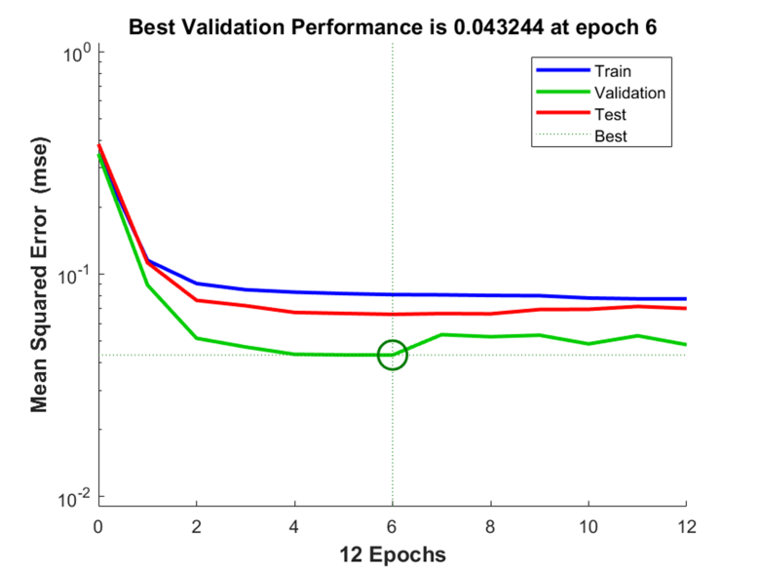
Notes: the performance plot of the ANN model. The blue, green, and red curves represent the mean squared error of the training group, the validation group, the testing group, respectively. The green circle represents the best validation performance at epoch 6 with a mean squared error of 0.043244, which indicates the excellent performance of the ANN model.

Reference
- Tibshirani R. Regression shrinkage and selection via the lasso. Journal of the Royal Statistical Society Series B (Methodological) 1996;267-88.

