Supplementary information
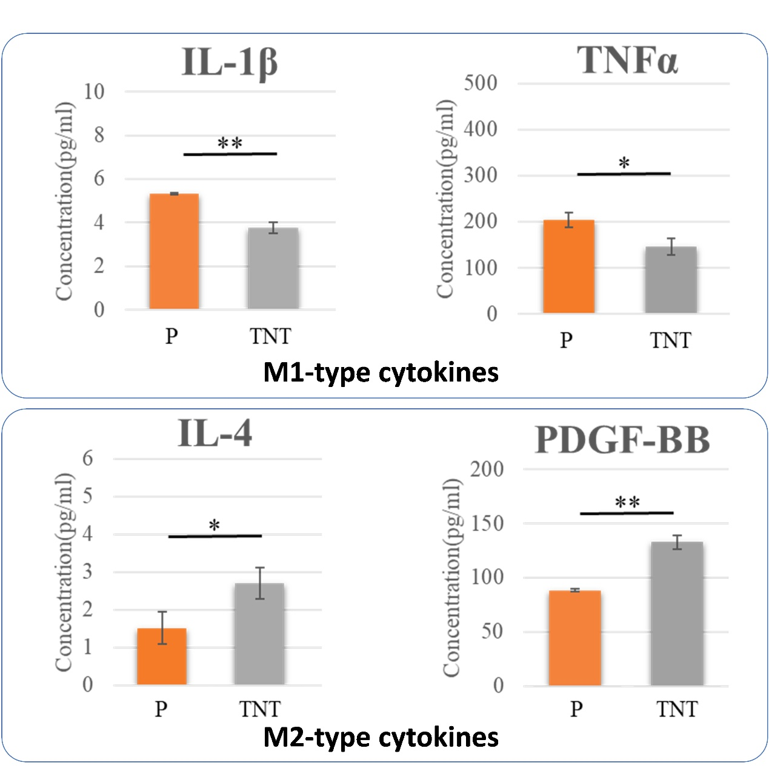
Figure S1. The cytokines measurements by ELISA. The RAW264.7 was cultured on two different surfaces for 7 days and the supernatants were collected for the measurements. *P<0.05, **P<0.01.

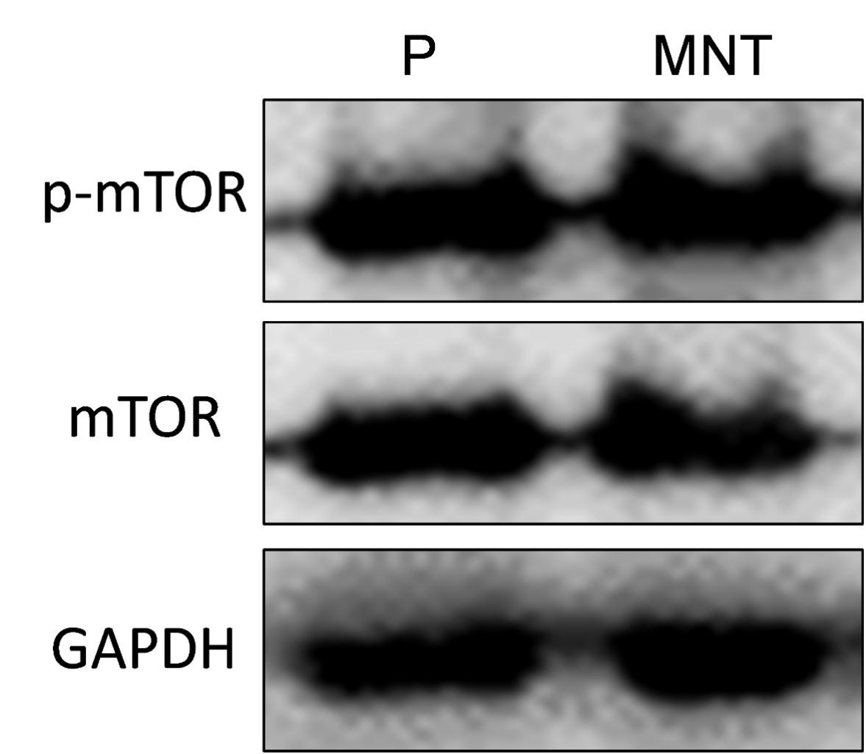
Figure S2. The western blot analysis of mTOR activity. The RAW264.7 was cultured on two different surface for 7 days and total protein was extracted for western blot analysis of both total and phosphorylation level of mTOR.

