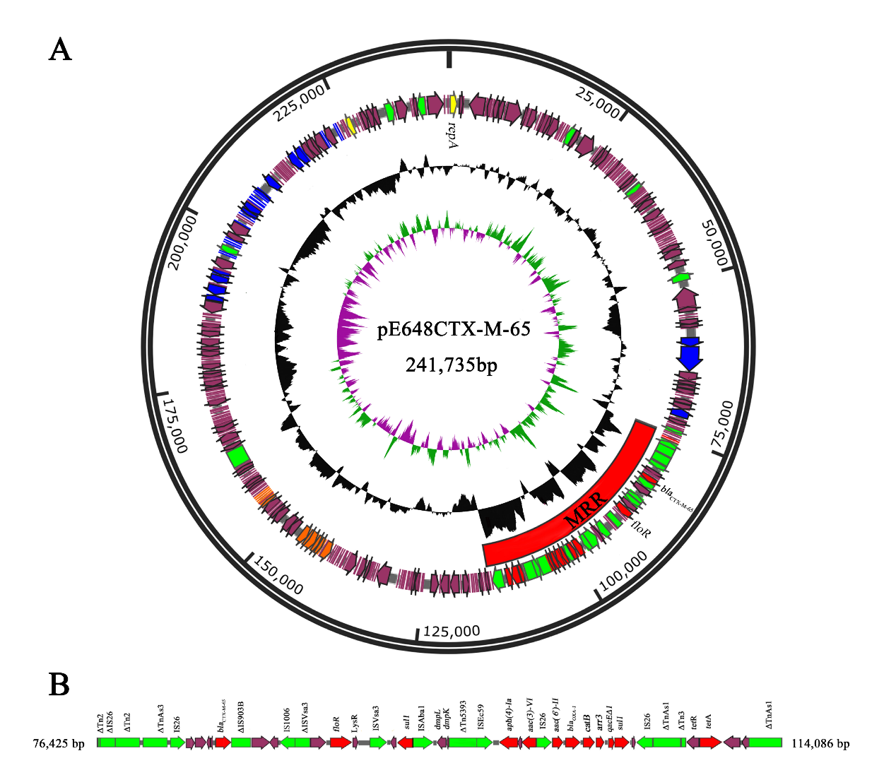
Figure S1 (A) Schematic map of the pE648CTX-M-65 | The innermost circle presents GC-Skew [Green,GC skew+/Violet, GC skew -]. Starting from the inside, the second circle (black) presents GC content. The open reading frames are annotated in the third circle with arrows representing the direction of transcription and colored based on gene function classification [red, antibiotic resistance genes; yellow, replication initiation protein genes; blue, plasmid partition and conjugal transfer genes; green, transposon genes; orange, heavy-metal resistance genes]. (B) MRR region of the pE648CTX-M-65. The annotated genes of MRR in Fig.S1 are provided as supplementary in the PDF file.

Figure S2 Schematic map of pE648NDM-5 | The innermost circle presents GC-Skew [Green,GC skew+/Violet, GC skew -]. Starting from the inside, the second circle (black) presents GC content. The open reading frames (ORFs) are annotated in the third circle with arrows representing the direction of transcription and colored based on gene function classification [red, antibiotic resistance genes; yellow, replication initiation protein genes; blue, plasmid partition and conjugal transfer genes; green, transposon genes]. The annotated genes of Fig.S2 are provided as supplementary in the PDF file.

Figure S3 Schematic map of pE648MCR-1 | The innermost circle presents GC-Skew [Green,GC skew+/Violet, GC skew -]. Starting from the inside, the second circle (black) presents GC content. The open reading frames (ORFs) are annotated in the third circle and colored based on gene function classification [red, antibiotic resistance genes; yellow, replication initiation protein genes; blue, plasmid partition and conjugal transfer genes; green, transposon genes]. The annotated genes of Fig.S3 are provided as supplementary in the PDF file.

Table S1 The Primers for PCR detection of carbapenemase, ESBLs and MCR-1 genes
 | MCR-1 |  | 309 bp | MCR-1-F: CGGTCAGTCCGTTTGTTC  MCR-1-R: CTTGGTCGGTCTGTAGGG
Carbapenemases
A | GES | GES-2, GES-4 to GES-6, GES-11, GES-14, GES-18 | 323 bp | GES-F: GCTTCATTCACGCACTATT  GES-R: CGATGCTAGAAACCGCTC
A | KPC | KPC-1 to KPC-15 | 638 bp | KPC-F: GTATCGCCGTCTAGTTCTGC  KPC-R: GGTCGTGTTTCCCTTTAGCC
A | SME | SME-1 to SME-3 | 334 bp | SME-F1: GAGGAAGACTTTGATGGGAGGAT  SME-R1: TCCCCTCAGGACCGCCAAG
A | IMI  (NMC-A) | IMI-1 to IMI-3 | 399 bp | IMI-F: TGCGGTCGATTGGAGATAAA  IMI-R: CGATTCTTGAAGCTTCTGCG
A | BIC | BIC-1 | 537 bp | BIC-F: TATGCAGCTCCTTTAAGGGC  BIC-R: TCATTGGCGGTGCCGTACAC
B1 | IMP | IMP-1 to IMP-44 | 232 bp | IMP-F: GGAATAGAGTGGCTTAAYTCTC  IMP-R: GGTTTAAYAAAACAACCACC
B1 | VIM | VIM-1 to VIM-37 | 390 bp | VIM-F: GATGGTGTTTGGTCGCATA  VIM-R: CGAATGCGCAGCACCAG
B1 | NDM | NDM-1 to NDM-8 | 621 bp | NDM-F: GGTTTGGCGATCTGGTTTTC  NDM-R: CGGAATGGCTCATCACGATC
B1 | TMB | TMB-1 to TMB-2 | 213 bp | TMB-F: CAAGGAGCTCATTCAAAGG  TMB-R: TTCTAGCGGATTGTGGCCAC
B1 | FIM | FIM-1 | 432 bp | FIM-F: GAAGCACATGGAAAACTGGG  FIM-R: GATGGGCGAATGAGACAGC
B1 | SPM | SPM-1 | 271 bp | SPM-F: AAAATCTGGGTACGCAAACG  SPM-R: ACATTATCCGCTGGAACAGG
B1 | DIM | DIM-1 | 699 bp | DIM-F: GCTTGTCTTCGCTTGCTAACG  DIM-R: CGTTCGGCTGGATTGATTTG
B1 | GIM | GIM-1 | 477 bp | GIM-F: TCGACACACCTTGGTCTGAA  GIM-R: AACTTCCAACTTTGCCATGC
B1 | SIM | SIM-1 | 570 bp | SIM-F: TACAAGGGATTCGGCATCG  SIM-R: TAATGGCCTGTTCCCATGTG
B3 | AIM | AIM-1 | 322 bp | AIM-F: CTGAAGGTGTACGGAAACAC  AIM-R: GTTCGGCCACCTCGAATTG
B3 | SMB | SMB-1 | 492 bp | SMB-F: CAGCAGCCATTCACCATCTA  SMB-R: GAAGACCACGTCCTTGCACT
D | OXA | OXA-23-like | 501 bp | OXA-23-F: GATCGGATTGGAGAACCAGA  OXA-23-R: ATTTCTGACCGCATTTCCAT
D | OXA | OXA-24-like | 246 bp | OXA-24-F: GGTTAGTTGGCCCCCTTAAA  OXA-24-R: AGTTGAGCGAAAAGGGGATT
D | OXA | OXA-48-like | 744 bp | OXA-48-F: TTGGTGGCATCGATTATCGG  OXA-48-R: GAGCACTTCTTTTGTGATGGC
D | OXA | OXA-58-like | 599 bp | OXA-58-F: AAGTATTGGGGCTTGTGCTG  OXA-58-R: CCCCTCTGCGCTCTACATAC
D | OXA | OXA-143-like | 149 bp | OXA-143-F: TGGCACTTTCAGCAGTTCCT  OXA-143-R: TAATCTTGAGGGGGCCAACC
D | OXA | OXA-235-like | 768 bp | OXA-235-F: TTGTTGCCTTTACTTAGTTGC  OXA-235-R: CAAAATTTTAAGACGGATCG
D | OXA | OXA-114 | 509 bp | OXA-114-F: CGCATCCTGTTCCAGCA  OXA-114-R: GTGCCGGTCTTGCCATAC
ESBL
A | CTX-M | CTX-M universal | 593 bp | CTX-M-UF: ATGTGCAGYACCAGTAARGT  CTX-M-UR: TGGGTRAARTARGTSACCAGA
A | CTX-M | CTX-M-1 group | 415 bp | CTX-M-1GF: AAAAATCACTGCGCCAGTTC  CTX-M-1GR: AGCTTATTCATCGCCACGTT
A | CTX-M | CTX-M-2 group | 552 bp | CTX-M-2GF: CGACGCTACCCCTGCTATT  CTX-M-2GR: CCAGCGTCAGATTTTTCAGG
A | CTX-M | CTX-M-8 group | 666 bp | CTX-M-8GF: TCGCGTTAAGCGGATGATGC  CTX-M-8GR: AACCCACGATGTGGGTAGC
A | CTX-M | CTX-M-9 group | 205 bp | CTX-M-9GF: CAAAGAGAGTGCAACGGATG  CTX-M-9GR: ATTGGAAAGCGTTCATCACC
A | CTX-M | CTX-M-25 group | 327 bp | CTX-M-25GF: GCACGATGACATTCGGG  CTX-M-25GR: AACCCACGATGTGGGTAGC
A | TEM |  | 800 bp | TEM-F: CATTTCCGTGTCGCCCTTATTC  TEM-R: CGTTCATCCATAGTTGCCTGAC
A | SHV |  | 713 bp | SHV-F: AGCCGCTTGAGCAAATTAAAC  SHV-R: ATCCCGCAGATAAATCACCAC
A | GES |  | 399 bp | GES-ESBL-F: AGTCGGCTAGACCGGAAAG  GES-ESBL-R: TTTGTCCGTGCTCAGGAT
A | PER |  | 520 bp | PER-F: GCTCCGATAATGAAAGCGT  PER-R: TTCGGCTTGACTCGGCTGA
A | VEB |  | 648 bp | VEB-F: CATTTCCCGATGCAAAGCGT  VEB-R: CGAAGTTTCTTTGGACTCTG
D | OXA | OXA-1 group | 564 bp | OXA-1-F: GGCACCAGATTCAACTTTCAAG  OXA-1-R: GACCCCAAGTTTCCTGTAAGTG

