Supplementary Figure 1. ROC curves for different predictive models. a. ROC curves for three tumor markers (CA 19-9, CEA and CA 125), the AUC values of 0.675 (combine), 0.651 (CA 19-9), 0.625 (CA 125) and 0.596 (CEA). b. ROC curves of four markers (CA 19-9, CA 125, LDH and N), AUC values of 0.645 (combine), 0.636 (CA 19-9), 0.602 (CA 125), 0.594 (N), and 0.561 (LDH).
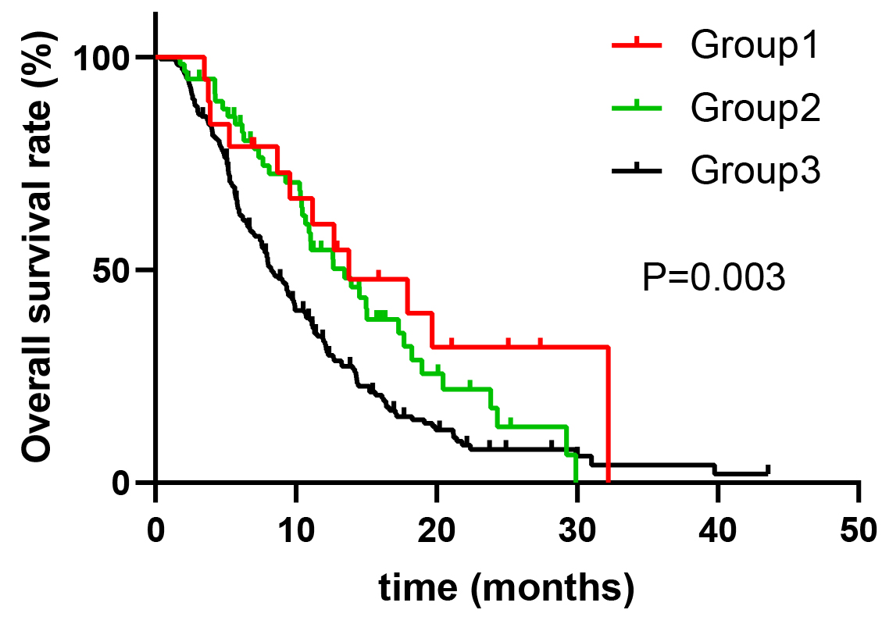
Supplementary Figure 2. The red line represents group 1 (patients in the 0 group in Figure 4), the green line represents group 2 (patients in the negative group in Figure 3) and the black line represents group 3 (other patients).

