Supplementary material
Thermosensitive Betulinic Acid-Loaded Magnetoliposomes: A Promising Potential On Highly Aggressive Human Breast Adenocarcinoma Cells Under Hyperthermic Conditions
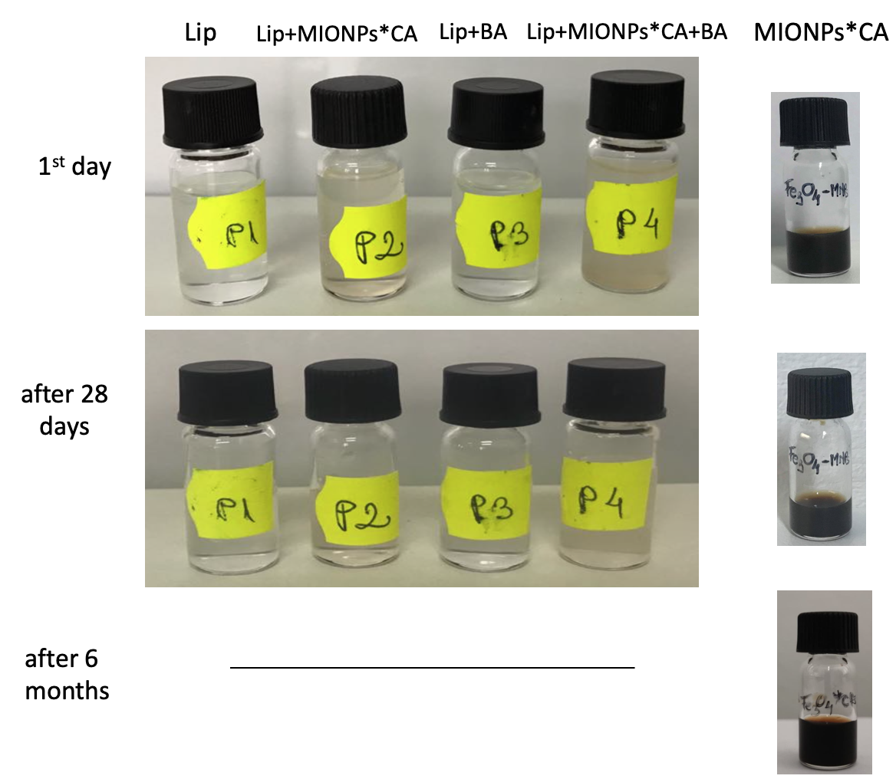
Figure S1 Representative images showing the physical stability of the liposome samples and MIONPs*CA colloidal suspension (P1 = Lip, P2 = Lip+MIONPs*CA, P3 = Lip+BA and P4 = Lip+MIONPs*CA+BA).

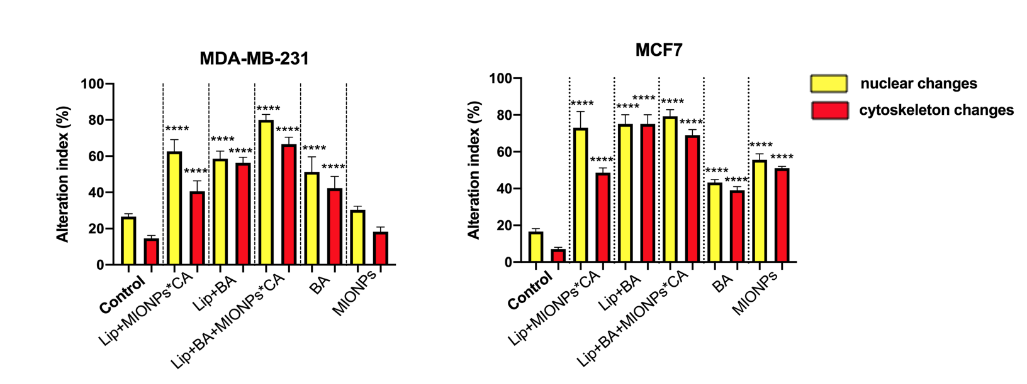
Figure S2 Alteration index (%) of breast adenocarcinoma - MDA-MB-231 and MCF-7 cells exposed for 24h to the highest concentration (25 µM) of test samples, under hyperthermic conditions (43 $℃$). One-way analysis of variance (ANOVA) analysis was applied to determine the statistical differences followed by Tukey’s multiple comparisons test (* p < 0.05; ** p < 0.01; *** p < 0.001, **** p < 0.0001). The data represent the mean values ± SD of three independent experiments (n=3).

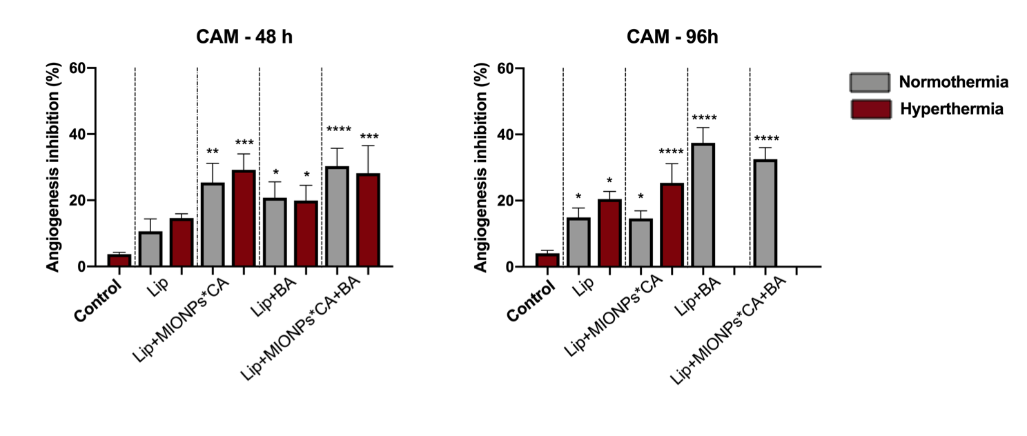
Figure S3 Angiogenesis inhibition (%) induced by liposomal samples (25 µM) after 48h and 96h stimulation time, compared to hyperthermia control (miliQ-H₂O). One-way analysis of variance (ANOVA) analysis was applied to determine the statistical differences followed by Tukey’s multiple comparisons test (* p < 0.05; ** p < 0.01; *** p < 0.001, **** p < 0.0001). The data represent the mean values ± SD of three independent experiments (n=3).

Table S1 Elemental composition of BA-loaded magnetoliposomes
Element | Wt% | At% | K-Ratio | Z | A | F
C k | 76.25 | 82.43 | 0.4136 | 1.0063 | 0.5389 | 1.0001
O k | 19.75 | 16.03 | 0.0249 | 0.9911 | 0.1273 | 1.0000
P k | 2.63 | 1.10 | 0.0219 | 0.9233 | 0.9018 | 1.0007
K k | 1.20 | 0.40 | 0.0116 | 0.8986 | 1.0688 | 1.0001
Fe k | 0.16 | 0.04 | 0.0015 | 0.8464 | 1.0618 | 1.0000
Total | 100.00 | 100.00

