Online supplementary material

Methods – Effect modification for subgroup analyses
For subgroups 1 and 2, effect modification by eosinophil count was assessed in stratified analyses using datasets with different blood eosinophil count cut-off values. For each cut-off value (ranging from 100 to 450 cells/µL with increments of 50 cells/µL) a separate dataset containing only patients with a baseline blood eosinophil count of at least that value was generated, and the association between exposure (extrafine BDP/FF versus LABA/LAMA) and the rate of exacerbations (primary outcome), acute respiratory events, acute OCS courses, and antibiotics courses were assessed in IPTW models. For subgroup 3, effect modification was assessed for the primary outcome and for the number of short-acting beta-2 agonists (SABA) inhalers (another measure of COPD control) during follow-up by using an interaction term between exposure and the blood eosinophil count, separately for the continuous variable and the categorical representation.

Results – Effect modification for subgroup analyses
In subgroup analyses, a general effect in favor of extrafine BDP/FF was visible with increasing eosinophil count for rate of antibiotics courses in severity subgroups 1 and 2 (Figure e2A and e2B; see Table e5 for the number of patients in each strata of blood eosinophil count by COPD severity subgroup). In the subgroup based on prior monotherapy (subgroup 3), statistically insignificant results were obtained; however, visually exacerbations appeared to increase in the LABA/LAMA group and decrease slightly in the extrafine BDP/FF group with increasing blood eosinophil count. When SABA inhaler count was used as the outcome (interaction term p=0.051), a clear trend towards fewer inhalers in favor of extrafine BDP/FF was observed when visualizing the marginal effects (Figure e3A). A trend of fewer SABA inhalers during follow-up with higher baseline eosinophil counts was visible in patients in the extrafine BDP/FF only group (Figure e3B).
Table e1. Baseline characterization of IPT-weighted population
Variable |  | LABA/LAMA  (N=2,450) | Extrafine BDP/FF  (N=1,735) | SMD
Age (years) | Median (IQR) | 71.0 (64.0;78.0) | 70.0 (63.0;78.0) | 1.9
Age (years) | ≥40 <60, n (%) | 355 (14.5) | 302 (17.4) | 0.8
Age (years) | ≥60 <80, n (%) | 1,619 (66.1) | 1,101 (63.5)
Age (years) | ≥80, n (%) | 476 (19.4) | 332 (19.1)
Prior therapy | None, n (%) | 1,330 (54.3) | 1,111 (64.0) | 12.8
Prior therapy | LAMA, n (%) | 763 (31.1) | 445 (25.6)
Prior therapy | ICS, n (%) | 0 (0.0) | 138 (8.0)
Prior therapy | LABA, n (%) | 357 (14.6) | 41 (2.4)
Index year | ≦2008, n (%) | 282 (11.5) | 7 (0.4) | 12.6
Index year | 2009, n (%) | 69 (2.8) | 27 (1.6)
Index year | 2010, n (%) | 72 (2.9) | 33 (1.9)
Index year | 2011, n (%) | 107 (4.4) | 69 (4.0)
Index year | 2012, n (%) | 84 (3.4) | 79 (4.6)
Index year | 2013, n (%) | 114 (4.7) | 77 (4.4)
Index year | 2014, n (%) | 153 (6.2) | 237 (13.7)
Index year | 2015, n (%) | 255 (10.4) | 382 (22.0)
Index year | 2016, n (%) | 376 (15.3) | 300 (17.3)
Index year | 2017, n (%) | 482 (19.7) | 285 (16.4)
Index year | ≥2018, n (%) | 456 (18.6) | 239 (13.8)
Season of index date | Spring, n (%) | 634 (25.9) | 469 (27.0) | 1.0
Season of index date | Summer, n (%) | 583 (23.8) | 416 (24.0)
Season of index date | Autumn, n (%) | 620 (25.3) | 421 (24.3)
Season of index date | Winter, n (%) | 613 (25.0) | 429 (24.7)
Availability of EMR data < IDX | 1 yr, n (%) | 69 (2.8) | 64 (3.7) | 1.1
Availability of EMR data < IDX | 2 yr, n (%) | 62 (2.5) | 58 (3.3)
Availability of EMR data < IDX | 3 yr, n (%) | 75 (3.1) | 63 (3.6)
Availability of EMR data < IDX | 4 yr, n (%) | 62 (2.5) | 48 (2.8)
Availability of EMR data < IDX | 5 yr, n (%) | 56 (2.3) | 40 (2.3)
Availability of EMR data < IDX | 6-9 yr, n (%) | 226 (9.2) | 167 (9.6)
Availability of EMR data < IDX | 10-15 yr, n (%) | 323 (13.2) | 254 (14.6)
Availability of EMR data < IDX | >15 yr, n (%) | 1,577 (64.4) | 1,041 (60.0)
Anxiety/depression | Yes, n (%) | 1,024 (41.8) | 775 (44.7) | 1.5
Mental disorder | Yes, n (%) | 37 (1.5) | 41 (2.4) | 1.8
Allergic / non-allergic rhinitis | No, n (%) | 2,134 (87.1) | 1,481 (85.4) | 0.3
Allergic / non-allergic rhinitis | Yes, inactive, n (%) | 153 (6.2) | 110 (6.3)
Allergic / non-allergic rhinitis | Yes, active, n (%) | 163 (6.7) | 144 (8.3)
Eczema | No, n (%) | 1,747 (71.3) | 1,250 (72.0) | 0.8
Eczema | Yes, inactive, n (%) | 622 (25.4) | 434 (25.0)
Eczema | Yes, active, n (%) | 81 (3.3) | 51 (2.9)
Gastro-esophageal reflux disease | No, n (%) | 1,999 (81.6) | 1,408 (81.2) | 0.7
Gastro-esophageal reflux disease | Yes, inactive, n (%) | 398 (16.2) | 286 (16.5)
Gastro-esophageal reflux disease | Yes, active, n (%) | 53 (2.2) | 41 (2.4)
Sinusitis | Yes, n (%) | 207 (8.4) | 157 (9.0) | 0.1
Nasal polyps, ever before | Yes, n (%) | 43 (1.8) | 34 (2.0) | 0.2
Nasal polyps in baseline | Yes, n (%) | 8 (0.3) | 4 (0.2) | 0.3
Bronchiectasis | Yes, n (%) | 86 (3.5) | 99 (5.7) | 1.1
Glaucoma | Yes, n (%) | 97 (4.0) | 71 (4.1) | 0.0
Cataract | Yes, n (%) | 421 (17.2) | 296 (17.1) | 0.3
Hypertension | Yes, n (%) | 1,030 (42.0) | 740 (42.7) | 0.5
Cardiovascular disease | Yes, n (%) | 1,000 (40.8) | 623 (35.9) | 0.9
Coronary heart disease | Yes, n (%) | 510 (20.8) | 315 (18.2) | 1.5
Myocardial infarction | Yes, n (%) | 265 (10.8) | 170 (9.8) | 0.7
Cerebrovascular accident | Yes, n (%) | 212 (8.7) | 123 (7.1) | 0.4
Heat failure | Yes, n (%) | 182 (7.4) | 104 (6.0) | 0.2
Ischemic heart disease | Yes, n (%) | 550 (22.4) | 340 (19.6) | 1.2
Atrial fibrillation | Yes, n (%) | 244 (10.0) | 185 (10.7) | 0.6
Chronic kidney disease diagnosis | Yes, n (%) | 276 (11.3) | 230 (13.3) | 0.7
Chronic Kidney Disease diagnosis, or eGFR < 60 | Yes, n (%) | 545 (22.2) | 387 (22.3) | 1.5
Diabetes diagnosis or medication | Yes, n (%) | 343 (14.0) | 276 (15.9) | 1.3
Multiple sclerosis | Yes, n (%) | 10 (0.4) | 5 (0.3) | 0.3
Osteoporosis | Yes, n (%) | 160 (6.5) | 161 (9.3) | 1.4
Parkinson disease | Yes, n (%) | 8 (0.3) | 12 (0.7) | 1.8
Pneumonia in baseline | Yes, n (%) | 100 (4.1) | 65 (3.7) | 0.0
Sleep disorder | Yes, n (%) | 59 (2.4) | 39 (2.2) | 0.0
Charlson comorbidity index | ≦1, n (%) | 912 (37.2) | 640 (36.9) | 0.1
Charlson comorbidity index | 2-4, n (%) | 547 (22.3) | 476 (27.4)
Charlson comorbidity index | 5-9, n (%) | 349 (14.2) | 197 (11.4)
Charlson comorbidity index | ≧10, n (%) | 642 (26.2) | 422 (24.3)
LAMA before index date | No LAMA, n (%) | 860 (35.1) | 745 (42.9) | 1.9
LAMA before index date | Glycopyrronium, n (%) | 155 (6.3) | 70 (4.0)
LAMA before index date | Tiotropium, n (%) | 1,071 (43.7) | 821 (47.3)
LAMA before index date | Aclidinium, n (%) | 127 (5.2) | 56 (3.2)
LAMA before index date | Umeclidinium, n (%) | 237 (9.7) | 43 (2.5)
ICS, prescriptions | 0, n (%) | 1,735 (70.8) | 971 (56.0) | 25.3
ICS, prescriptions | 1-2, n (%) | 247 (10.1) | 205 (11.8)
ICS, prescriptions | 3-5, n (%) | 210 (8.6) | 229 (13.2)
ICS, prescriptions | 6-9, n (%) | 223 (9.1) | 245 (14.1)
ICS, prescriptions | ≥10, n (%) | 35 (1.4) | 85 (4.9)
LABA (mono or FDC) prescriptions | 0, n (%) | 1,370 (55.9) | 1,111 (64.0) | 15.6
LABA (mono or FDC) prescriptions | 1-2, n (%) | 252 (10.3) | 147 (8.5)
LABA (mono or FDC) prescriptions | 3-5, n (%) | 258 (10.5) | 186 (10.7)
LABA (mono or FDC) prescriptions | 6-9, n (%) | 340 (13.9) | 209 (12.0)
LABA (mono or FDC) prescriptions | ≥10, n (%) | 230 (9.4) | 82 (4.7)
LAMA prescriptions | 0, n (%) | 1,043 (42.6) | 956 (55.1) | 13.2
LAMA prescriptions | 1-2, n (%) | 276 (11.3) | 179 (10.3)
LAMA prescriptions | 3-5, n (%) | 340 (13.9) | 189 (10.9)
LAMA prescriptions | 6-9, n (%) | 444 (18.1) | 222 (12.8)
LAMA prescriptions | ≥10, n (%) | 347 (14.2) | 189 (10.9)
SABA prescriptions | 0, n (%) | 361 (14.7) | 211 (12.2) | 1.5
SABA prescriptions | 1-2, n (%) | 541 (22.1) | 364 (21.0)
SABA prescriptions | 3-5, n (%) | 526 (21.5) | 366 (21.1)
SABA prescriptions | 6-9, n (%) | 570 (23.3) | 413 (23.8)
SABA prescriptions | ≥10, n (%) | 452 (18.4) | 381 (22.0)
SAMA prescriptions | ≥1, n (%) | 248 (10.1) | 180 (10.4) | 1.7
Theophylline prescriptions | ≥1, n (%) | 58 (2.4) | 59 (3.4) | 1.4
Macrolides prescriptions | 0, n (%) | 1,891 (77.2) | 1,310 (75.5) | 0.6
Macrolides prescriptions | 1, n (%) | 267 (10.9) | 185 (10.7)
Macrolides prescriptions | ≥2, n (%) | 292 (11.9) | 240 (13.8)
Macrolides, average daily dose (mg) | 0, n (%) | 1,891 (77.2) | 1,310 (75.5) | 0.8
Macrolides, average daily dose (mg) | >0 <20, n (%) | 93 (3.8) | 52 (3.0)
Macrolides, average daily dose (mg) | 20 <40, n (%) | 235 (9.6) | 170 (9.8)
Macrolides, average daily dose (mg) | 40 <80, n (%) | 121 (4.9) | 105 (6.1)
Macrolides, average daily dose (mg) | 80 <2000, n (%) | 110 (4.5) | 98 (5.6)
Mucolytics prescriptions | 0, n (%) | 2,175 (88.8) | 1,483 (85.5) | 0.6
Mucolytics prescriptions | 1, n (%) | 79 (3.2) | 86 (5.0)
Mucolytics prescriptions | 2, n (%) | 30 (1.2) | 28 (1.6)
Mucolytics prescriptions | ≥3, n (%) | 166 (6.8) | 138 (8.0)
Maintenance OCS prescriptions | ≥1, n (%) | 74 (3.0) | 40 (2.3) | 2.0
Oral corticosteroids, average daily dose (mg) | 0, n (%) | 978 (39.9) | 653 (37.6) | 0.1
Oral corticosteroids, average daily dose (mg) | >0 <2.5, n (%) | 1,210 (49.4) | 842 (48.5)
Oral corticosteroids, average daily dose (mg) | ≥2.5 <7.5, n (%) | 153 (6.2) | 154 (8.9)
Oral corticosteroids, average daily dose (mg) | ≥7.5, n (%) | 47 (1.9) | 47 (2.7)
Oral corticosteroids, average daily dose (mg) | 7.5 <50, n (%) | 62 (2.5) | 39 (2.2)
All medication, excluding respiratory use | 0, n (%) | 8 (0.3) | 1 (0.1) | 1.3
All medication, excluding respiratory use | 1 <4, n (%) | 153 (6.2) | 105 (6.1)
All medication, excluding respiratory use | 4 <7, n (%) | 386 (15.8) | 251 (14.5)
All medication, excluding respiratory use | 7 <10, n (%) | 470 (19.2) | 291 (16.8)
All medication, excluding respiratory use | 10 <14, n (%) | 558 (22.8) | 383 (22.1)
All medication, excluding respiratory use | 14 <20, n (%) | 560 (22.9) | 388 (22.4)
All medication, excluding respiratory use | ≧20, n (%) | 315 (12.9) | 316 (18.2)
Influenza vaccination | Yes, n (%) | 1,478 (60.3) | 1,006 (58.0) | 1.1
Pneumococcal vaccination | Yes, n (%) | 126 (5.1) | 53 (3.1) | 3.5
Leucocyte count (10⁹/L) | <4.0, n (%) | 28 (1.1) | 14 (0.8) | 1.1
Leucocyte count (10⁹/L) | 4 <11, n (%) | 1,904 (77.7) | 1,368 (78.8)
Leucocyte count (10⁹/L) | ≧11, n (%) | 221 (9.0) | 169 (9.7)
Leucocyte count (10⁹/L) | Missing, n (%) | 297 (12.1) | 184 (10.6)
Lymphocyte count (10⁹/L) | <1.0, n (%) | 102 (4.2) | 72 (4.1) | 2.4
Lymphocyte count (10⁹/L) | 1 <4.5, n (%) | 1,821 (74.3) | 1,223 (70.5)
Lymphocyte count (10⁹/L) | ≧4.5, n (%) | 34 (1.4) | 19 (1.1)
Lymphocyte count (10⁹/L) | Missing, n (%) | 493 (20.1) | 421 (24.3)
Neutrophil count (10⁹/L) | <2.0, n (%) | 28 (1.1) | 10 (0.6) | 2.6
Neutrophil count (10⁹/L) | 2 <7.5, n (%) | 1,739 (71.0) | 1,171 (67.5)
Neutrophil count (10⁹/L) | ≧7.5, n (%) | 191 (7.8) | 133 (7.7)
Neutrophil count (10⁹/L) | Missing, n (%) | 492 (20.1) | 421 (24.3)
Acute respiratory events | 0, n (%) | 88 (3.6) | 58 (3.3) | 3.6
Acute respiratory events | 1, n (%) | 309 (12.6) | 170 (9.8)
Acute respiratory events | 2, n (%) | 512 (20.9) | 369 (21.3)
Acute respiratory events | 3, n (%) | 529 (21.6) | 314 (18.1)
Acute respiratory events | 4, n (%) | 405 (16.5) | 280 (16.1)
Acute respiratory events | ≥5, n (%) | 607 (24.8) | 544 (31.4)
Days since last exacerbation | 0, n (%) | 311 (12.7) | 316 (18.2) | 4.7
Days since last exacerbation | 15-30, n (%) | 265 (10.8) | 260 (15.0)
Days since last exacerbation | 31-90, n (%) | 268 (10.9) | 248 (14.3)
Days since last exacerbation | 91-180, n (%) | 570 (23.3) | 376 (21.7)
Days since last exacerbation | 181-365, n (%) | 425 (17.3) | 234 (13.5)
Days since last exacerbation | 366-729, n (%) | 611 (24.9) | 301 (17.3)
Days since last acute OCS course | 0, n (%) | 142 (5.8) | 192 (11.1) | 3.9
Days since last acute OCS course | 15-30, n (%) | 164 (6.7) | 181 (10.4)
Days since last acute OCS course | 31-90, n (%) | 189 (7.7) | 187 (10.8)
Days since last acute OCS course | 91-180, n (%) | 444 (18.1) | 296 (17.1)
Days since last acute OCS course | 181-365, n (%) | 325 (13.3) | 229 (13.2)
Days since last acute OCS course | 366-729, n (%) | 340 (13.9) | 193 (11.1)
Days since last acute OCS course | ≧730, n (%) | 846 (34.5) | 457 (26.3)
Days since last antibiotics course | 0, n (%) | 242 (9.9) | 188 (10.8) | 1.9
Days since last antibiotics course | 15-30, n (%) | 137 (5.6) | 112 (6.5)
Days since last antibiotics course | 31-90, n (%) | 148 (6.0) | 129 (7.4)
Days since last antibiotics course | 91-180, n (%) | 426 (17.4) | 301 (17.3)
Days since last antibiotics course | 181-365, n (%) | 382 (15.6) | 227 (13.1)
Days since last antibiotics course | 366-729, n (%) | 1,115 (45.5) | 778 (44.8)
mMRC score | 1, n (%) | 165 (6.7) | 164 (9.5) | 3.3
mMRC score | 2, n (%) | 882 (36.0) | 586 (33.8)
mMRC score | 3, n (%) | 734 (30.0) | 459 (26.5)
mMRC score | 4, n (%) | 327 (13.3) | 249 (14.4)
mMRC score | 5, n (%) | 68 (2.8) | 63 (3.6)
mMRC score | Missing, n (%) | 274 (11.2) | 214 (12.3)
GP consultations | <5, n (%) | 44 (1.8) | 50 (2.9) | 2.1
GP consultations | 5 <10, n (%) | 205 (8.4) | 166 (9.6)
GP consultations | 10 <15, n (%) | 445 (18.2) | 286 (16.5)
GP consultations | 15 <20, n (%) | 455 (18.6) | 297 (17.1)
GP consultations | 20 <30, n (%) | 612 (25.0) | 452 (26.1)
GP consultations | ≧30, n (%) | 689 (28.1) | 484 (27.9)
GP consultations with respiratory indication | 0, n (%) | 106 (4.3) | 126 (7.3) | 2.2
GP consultations with respiratory indication | 1, n (%) | 441 (18.0) | 365 (21.0)
GP consultations with respiratory indication | 2, n (%) | 570 (23.3) | 395 (22.8)
GP consultations with respiratory indication | 3, n (%) | 480 (19.6) | 313 (18.0)
GP consultations with respiratory indication | 4-5, n (%) | 497 (20.3) | 318 (18.3)
GP consultations with respiratory indication | ≧6, n (%) | 356 (14.5) | 218 (12.6)
Abbreviations: Extrafine BDP/FF, Extrafine beclometasone dipropionate/formoterol fumarate; eGFR, Estimated glomerular filtration rate; EMR, Electronic medical record; FDC, Fixed-dose combination; GP, General practice; ICS, Inhaled corticosteroids; IDX, Index date; IPT, Inverse probability of treatment; IQR, Interquartile range; LABA, Long-acting beta-agonist; LAMA, Long-acting muscarinic antagonist; mMRC, Modified Medical Research Council; OCS, Oral corticosteroids; SABA, Short-acting beta-2 agonists; SAMA, Short-acting muscarinic antagonist; SMD, Standardized mean difference; Yr, Year
Table e2. Baseline characterization of unweighted study population
Variable |  | LABA/LAMA  (N= 2,450) | Extrafine BDP/FF  (N= 1,735) | SMD
Age (years) | Mean (SD) | 70.4 (10.0) | 69.8 (10.5) | 5.8
Age (years) | Median (IQR) | 71.0 (64.0;78.0) | 70.0 (63.0;78.0)
Age (years) | ≥40 <60, n (%) | 355 (14.5) | 302 (17.4) | 5.4
Age (years) | ≥60 <80, n (%) | 1,619 (66.1) | 1,101 (63.5)
Age (years) | ≥80, n (%) | 476 (19.4) | 332 (19.1)
Male gender | Yes, n (%) | 1,299 (53.0) | 822 (47.4) | 11.3
Prior therapy | None, n (%) | 1,330 (54.3) | 1,111 (64.0) | 29.2
Prior therapy | LAMA, n (%) | 763 (31.1) | 445 (25.6)
Prior therapy | ICS, n (%) | 0 (0.0) | 138 (8.0)
Prior therapy | LABA, n (%) | 357 (14.6) | 41 (2.4)
Smoking status | N (% non-missing) | 2,433 (99.3) | 1,729 (99.7) | 7.6
Smoking status | Former, n (%) | 1,389 (57.1) | 1,052 (60.8)
Index year | ≦2008, n (%) | 282 (11.5) | 7 (0.4) | 22.4
Index year | 2009, n (%) | 69 (2.8) | 27 (1.6)
Index year | 2010, n (%) | 72 (2.9) | 33 (1.9)
Index year | 2011, n (%) | 107 (4.4) | 69 (4.0)
Index year | 2012, n (%) | 84 (3.4) | 79 (4.6)
Index year | 2013, n (%) | 114 (4.7) | 77 (4.4)
Index year | 2014, n (%) | 153 (6.2) | 237 (13.7)
Index year | 2015, n (%) | 255 (10.4) | 382 (22.0)
Index year | 2016, n (%) | 376 (15.3) | 300 (17.3)
Index year | 2017, n (%) | 482 (19.7) | 285 (16.4)
Index year | ≥2018, n (%) | 456 (18.6) | 239 (13.8)
Season of index date | Spring, n (%) | 634 (25.9) | 469 (27.0) | 2.5
Season of index date | Summer, n (%) | 583 (23.8) | 416 (24.0)
Season of index date | Autumn, n (%) | 620 (25.3) | 421 (24.3)
Season of index date | Winter, n (%) | 613 (25.0) | 429 (24.7)
BMI (kg/m²) | N (% non-missing) | 2,342 (95.6) | 1,668 (96.1) | 1.3
BMI (kg/m²) | <18.5, n (%) | 115 (4.9) | 78 (4.7)
BMI (kg/m²) | ≥18.5 <25, n (%) | 750 (32.0) | 525 (31.5)
BMI (kg/m²) | ≥25 <30, n (%) | 764 (32.6) | 555 (33.3)
BMI (kg/m²) | ≥30, n (%) | 713 (30.4) | 510 (30.6)
Availability of EMR data < IDX | 1 yr, n (%) | 69 (2.8) | 64 (3.7) | 9.2
Availability of EMR data < IDX | 2 yr, n (%) | 62 (2.5) | 58 (3.3)
Availability of EMR data < IDX | 3 yr, n (%) | 75 (3.1) | 63 (3.6)
Availability of EMR data < IDX | 4 yr, n (%) | 62 (2.5) | 48 (2.8)
Availability of EMR data < IDX | 5 yr, n (%) | 56 (2.3) | 40 (2.3)
Availability of EMR data < IDX | 6-9 yr, n (%) | 226 (9.2) | 167 (9.6)
Availability of EMR data < IDX | 10-15 yr, n (%) | 323 (13.2) | 254 (14.6)
Availability of EMR data < IDX | >15 yr, n (%) | 1,577 (64.4) | 1,041 (60.0)
Asthma diagnosis ever | Yes, n (%) | 481 (19.6) | 496 (28.6) | 21.0
Anxiety/depression | Yes, n (%) | 1,024 (41.8) | 775 (44.7) | 5.8
Mental disorder | Yes, n (%) | 37 (1.5) | 41 (2.4) | 6.2
Allergic / non-allergic rhinitis | No, n (%) | 2,134 (87.1) | 1,481 (85.4) | 6.0
Allergic / non-allergic rhinitis | Yes, inactive, n (%) | 153 (6.2) | 110 (6.3)
Allergic / non-allergic rhinitis | Yes, active, n (%) | 163 (6.7) | 144 (8.3)
Eczema | No, n (%) | 1,747 (71.3) | 1,250 (72.0) | 2.1
Eczema | Yes, inactive, n (%) | 622 (25.4) | 434 (25.0)
Eczema | Yes, active, n (%) | 81 (3.3) | 51 (2.9)
Gastro-esophageal reflux disease | No, n (%) | 1,999 (81.6) | 1,408 (81.2) | 1.4
Gastro-esophageal reflux disease | Yes, inactive, n (%) | 398 (16.2) | 286 (16.5)
Gastro-esophageal reflux disease | Yes, active, n (%) | 53 (2.2) | 41 (2.4)
Sinusitis | Yes, n (%) | 207 (8.4) | 157 (9.0) | 2.1
Nasal polyps, ever before | Yes, n (%) | 43 (1.8) | 34 (2.0) | 1.5
Nasal polyps in baseline | Yes, n (%) | 8 (0.3) | 4 (0.2) | 1.8
Bronchiectasis | Yes, n (%) | 86 (3.5) | 99 (5.7) | 10.5
Glaucoma | Yes, n (%) | 97 (4.0) | 71 (4.1) | 0.7
Cataract | Yes, n (%) | 421 (17.2) | 296 (17.1) | 0.3
Hypertension | Yes, n (%) | 1,030 (42.0) | 740 (42.7) | 1.2
Cardiovascular disease | Yes, n (%) | 1,000 (40.8) | 623 (35.9) | 10.1
Coronary heart disease | Yes, n (%) | 510 (20.8) | 315 (18.2) | 6.7
Myocardial infarction | Yes, n (%) | 265 (10.8) | 170 (9.8) | 3.3
Cerebrovascular accident | Yes, n (%) | 212 (8.7) | 123 (7.1) | 5.8
Heart failure | Yes, n (%) | 182 (7.4) | 104 (6.0) | 5.7
Ischemic heart disease | Yes, n (%) | 550 (22.4) | 340 (19.6) | 7.0
Atrial fibrillation | Yes, n (%) | 244 (10.0) | 185 (10.7) | 2.3
Chronic kidney disease diagnosis | Yes, n (%) | 276 (11.3) | 230 (13.3) | 6.1
Chronic Kidney Disease diagnosis, or eGFR < 60 | Yes, n (%) | 545 (22.2) | 387 (22.3) | 0.1
Diabetes diagnosis or medication | Yes, n (%) | 343 (14.0) | 276 (15.9) | 5.4
Multiple sclerosis | Yes, n (%) | 10 (0.4) | 5 (0.3) | 2.0
Osteoporosis | Yes, n (%) | 160 (6.5) | 161 (9.3) | 10.2
Parkinson disease | Yes, n (%) | 8 (0.3) | 12 (0.7) | 5.1
Pneumonia in baseline | Yes, n (%) | 100 (4.1) | 65 (3.7) | 1.7
Sleep disorder | Yes, n (%) | 59 (2.4) | 39 (2.2) | 1.1
Charlson comorbidity index | ≦1, n (%) | 912 (37.2) | 640 (36.9) | 5.3
Charlson comorbidity index | 2-4, n (%) | 547 (22.3) | 476 (27.4)
Charlson comorbidity index | 5-9, n (%) | 349 (14.2) | 197 (11.4)
Charlson comorbidity index | ≧10, n (%) | 642 (26.2) | 422 (24.3)
LAMA before index date | No LAMA, n (%) | 860 (35.1) | 745 (42.9) | 24.9
LAMA before index date | Glycopyrronium, n (%) | 155 (6.3) | 70 (4.0)
LAMA before index date | Tiotropium, n (%) | 1,071 (43.7) | 821 (47.3)
LAMA before index date | Aclidinium, n (%) | 127 (5.2) | 56 (3.2)
LAMA before index date | Umeclidinium, n (%) | 237 (9.7) | 43 (2.5)
ICS, prescriptions | 0, n (%) | 1,735 (70.8) | 971 (56.0) | 33.6
ICS, prescriptions | 1-2, n (%) | 247 (10.1) | 205 (11.8)
ICS, prescriptions | 3-5, n (%) | 210 (8.6) | 229 (13.2)
ICS, prescriptions | 6-9, n (%) | 223 (9.1) | 245 (14.1)
ICS, prescriptions | ≥10, n (%) | 35 (1.4) | 85 (4.9)
LABA (mono or FDC) prescriptions | 0, n (%) | 1,370 (55.9) | 1,111 (64.0) | 18.8
LABA (mono or FDC) prescriptions | 1-2, n (%) | 252 (10.3) | 147 (8.5)
LABA (mono or FDC) prescriptions | 3-5, n (%) | 258 (10.5) | 186 (10.7)
LABA (mono or FDC) prescriptions | 6-9, n (%) | 340 (13.9) | 209 (12.0)
LABA (mono or FDC) prescriptions | ≥10, n (%) | 230 (9.4) | 82 (4.7)
LAMA prescriptions | 0, n (%) | 1,043 (42.6) | 956 (55.1) | 24.1
LAMA prescriptions | 1-2, n (%) | 276 (11.3) | 179 (10.3)
LAMA prescriptions | 3-5, n (%) | 340 (13.9) | 189 (10.9)
LAMA prescriptions | 6-9, n (%) | 444 (18.1) | 222 (12.8)
LAMA prescriptions | ≥10, n (%) | 347 (14.2) | 189 (10.9)
SABA prescriptions | 0, n (%) | 361 (14.7) | 211 (12.2) | 10.4
SABA prescriptions | 1-2, n (%) | 541 (22.1) | 364 (21.0)
SABA prescriptions | 3-5, n (%) | 526 (21.5) | 366 (21.1)
SABA prescriptions | 6-9, n (%) | 570 (23.3) | 413 (23.8)
SABA prescriptions | ≥10, n (%) | 452 (18.4) | 381 (22.0)
SAMA prescriptions | ≥1, n (%) | 248 (10.1) | 180 (10.4) | 0.8
Theophylline prescriptions | ≥1, n (%) | 58 (2.4) | 59 (3.4) | 6.2
Macrolides prescriptions | 0, n (%) | 1,891 (77.2) | 1,310 (75.5) | 5.1
Macrolides prescriptions | 1, n (%) | 267 (10.9) | 185 (10.7)
Macrolides prescriptions | ≥2, n (%) | 292 (11.9) | 240 (13.8)
Macrolides, average daily dose (mg) | 0, n (%) | 1,891 (77.2) | 1,310 (75.5) | 6.5
Macrolides, average daily dose (mg) | >0 <20, n (%) | 93 (3.8) | 52 (3.0)
Macrolides, average daily dose (mg) | 20 <40, n (%) | 235 (9.6) | 170 (9.8)
Macrolides, average daily dose (mg) | 40 <80, n (%) | 121 (4.9) | 105 (6.1)
Macrolides, average daily dose (mg) | 80 <2000, n (%) | 110 (4.5) | 98 (5.6)
Mucolytics prescriptions | 0, n (%) | 2,175 (88.8) | 1,483 (85.5) | 7.4
Mucolytics prescriptions | 1, n (%) | 79 (3.2) | 86 (5.0)
Mucolytics prescriptions | 2, n (%) | 30 (1.2) | 28 (1.6)
Mucolytics prescriptions | ≥3, n (%) | 166 (6.8) | 138 (8.0)
Maintenance OCS prescriptions | ≥1, n (%) | 74 (3.0) | 40 (2.3) | 4.4
Oral corticosteroids, average daily dose (mg) | 0, n (%) | 978 (39.9) | 653 (37.6) | 6.6
Oral corticosteroids, average daily dose (mg) | >0 <2.5, n (%) | 1,210 (49.4) | 842 (48.5)
Oral corticosteroids, average daily dose (mg) | ≥2.5 <7.5, n (%) | 153 (6.2) | 154 (8.9)
Oral corticosteroids, average daily dose (mg) | ≥7.5, n (%) | 47 (1.9) | 47 (2.7)
Oral corticosteroids, average daily dose (mg) | 7.5 <50, n (%) | 62 (2.5) | 39 (2.2)
All medication, excluding respiratory use | 0, n (%) | 8 (0.3) | 1 (0.1) | 11.4
All medication, excluding respiratory use | 1 <4, n (%) | 153 (6.2) | 105 (6.1)
All medication, excluding respiratory use | 4 <7, n (%) | 386 (15.8) | 251 (14.5)
All medication, excluding respiratory use | 7 <10, n (%) | 470 (19.2) | 291 (16.8)
All medication, excluding respiratory use | 10 <14, n (%) | 558 (22.8) | 383 (22.1)
All medication, excluding respiratory use | 14 <20, n (%) | 560 (22.9) | 388 (22.4)
All medication, excluding respiratory use | ≧20, n (%) | 315 (12.9) | 316 (18.2)
Influenza vaccination | Yes, n (%) | 1,478 (60.3) | 1,006 (58.0) | 4.8
Pneumococcal vaccination | Yes, n (%) | 126 (5.1) | 53 (3.1) | 10.5
Eosinophil count (10⁹/L) | N (% non-missing) | 2,139 (87.3) | 1,541 (88.8) | 6.1
Eosinophil count (10⁹/L) | <0.05, n (%) | 80 (3.7) | 67 (4.3)
Eosinophil count (10⁹/L) | 0.05 <0.15, n (%) | 593 (27.7) | 407 (26.4)
Eosinophil count (10⁹/L) | 0.15 <0.25, n (%) | 682 (31.9) | 455 (29.5)
Eosinophil count (10⁹/L) | 0.25 <0.35, n (%) | 396 (18.5) | 288 (18.7)
Eosinophil count (10⁹/L) | 0.35 <0.45, n (%) | 180 (8.4) | 147 (9.5)
Eosinophil count (10⁹/L) | 0.45 <0.55, n (%) | 95 (4.4) | 84 (5.5)
Eosinophil count (10⁹/L) | 0.55 <0.65, n (%) | 50 (2.3) | 31 (2.0)
Eosinophil count (10⁹/L) | ≧0.65, n (%) | 63 (2.9) | 62 (4.0)
Leucocyte count (10⁹/L) | N (% non-missing) | 2,153 (87.9) | 1,551 (89.4) | 3.1
Leucocyte count (10⁹/L) | <4.0, n (%) | 28 (1.3) | 14 (0.9)
Leucocyte count (10⁹/L) | 4 <11, n (%) | 1,904 (88.4) | 1,368 (88.2)
Leucocyte count (10⁹/L) | ≧11, n (%) | 221 (10.3) | 169 (10.9)
Lymphocyte count (10⁹/L) | N (% non-missing) | 1,957 (79.9) | 1,314 (75.7) | 2.1
Lymphocyte count (10⁹/L) | <1.0, n (%) | 102 (5.2) | 72 (5.5)
Lymphocyte count (10⁹/L) | 1 <4.5, n (%) | 1,821 (93.1) | 1,223 (93.1)
Lymphocyte count (10⁹/L) | ≧4.5, n (%) | 34 (1.7) | 19 (1.4)
Neutrophil count (10⁹/L) | N (% non-missing) | 1,958 (79.9) | 1,314 (75.7) | 3.2
Neutrophil count (10⁹/L) | <2.0, n (%) | 28 (1.4) | 10 (0.8)
Neutrophil count (10⁹/L) | 2 <7.5, n (%) | 1,739 (88.8) | 1,171 (89.1)
Neutrophil count (10⁹/L) | ≧7.5, n (%) | 191 (9.8) | 133 (10.1)
Exacerbations | 0, n (%) | 216 (8.8) | 114 (6.6) | 23.8
Exacerbations | 1, n (%) | 608 (24.8) | 306 (17.6)
Exacerbations | 2, n (%) | 796 (32.5) | 560 (32.3)
Exacerbations | 3, n (%) | 364 (14.9) | 296 (17.1)
Exacerbations | 4, n (%) | 204 (8.3) | 175 (10.1)
Exacerbations | ≥5, n (%) | 262 (10.7) | 284 (16.4)
Acute respiratory events | 0, n (%) | 88 (3.6) | 58 (3.3) | 12.6
Acute respiratory events | 1, n (%) | 309 (12.6) | 170 (9.8)
Acute respiratory events | 2, n (%) | 512 (20.9) | 369 (21.3)
Acute respiratory events | 3, n (%) | 529 (21.6) | 314 (18.1)
Acute respiratory events | 4, n (%) | 405 (16.5) | 280 (16.1)
Acute respiratory events | ≥5, n (%) | 607 (24.8) | 544 (31.4)
Acute OCS courses | 0, n (%) | 1,051 (42.9) | 700 (40.3) | 12.3
Acute OCS courses | 1, n (%) | 554 (22.6) | 346 (19.9)
Acute OCS courses | 2, n (%) | 379 (15.5) | 272 (15.7)
Acute OCS courses | 3, n (%) | 170 (6.9) | 145 (8.4)
Acute OCS courses | 4, n (%) | 111 (4.5) | 80 (4.6)
Acute OCS courses | ≥5, n (%) | 185 (7.6) | 192 (11.1)
Antibiotics courses | 0, n (%) | 717 (29.3) | 505 (29.1) | 3.4
Antibiotics courses | 1, n (%) | 825 (33.7) | 557 (32.1)
Antibiotics courses | 2, n (%) | 541 (22.1) | 386 (22.2)
Antibiotics courses | 3, n (%) | 215 (8.8) | 171 (9.9)
Antibiotics courses | 4, n (%) | 87 (3.6) | 65 (3.7)
Antibiotics courses | ≥5, n (%) | 65 (2.7) | 51 (2.9)
Days since last exacerbation | 0, n (%) | 311 (12.7) | 316 (18.2) | 27.2
Days since last exacerbation | 15-30, n (%) | 265 (10.8) | 260 (15.0)
Days since last exacerbation | 31-90, n (%) | 268 (10.9) | 248 (14.3)
Days since last exacerbation | 91-180, n (%) | 570 (23.3) | 376 (21.7)
Days since last exacerbation | 181-365, n (%) | 425 (17.3) | 234 (13.5)
Days since last exacerbation | 366-729, n (%) | 395 (16.1) | 187 (10.8)
Days since last exacerbation | ≧730, n (%) | 216 (8.8) | 114 (6.6)
Days since last acute OCS course | 0, n (%) | 142 (5.8) | 192 (11.1) | 28.7
Days since last acute OCS course | 15-30, n (%) | 164 (6.7) | 181 (10.4)
Days since last acute OCS course | 31-90, n (%) | 189 (7.7) | 187 (10.8)
Days since last acute OCS course | 91-180, n (%) | 444 (18.1) | 296 (17.1)
Days since last acute OCS course | 181-365, n (%) | 325 (13.3) | 229 (13.2)
Days since last acute OCS course | 366-729, n (%) | 340 (13.9) | 193 (11.1)
Days since last acute OCS course | ≧730, n (%) | 846 (34.5) | 457 (26.3)
Days since last antibiotics course | 0, n (%) | 242 (9.9) | 188 (10.8) | 5.0
Days since last antibiotics course | 15-30, n (%) | 137 (5.6) | 112 (6.5)
Days since last antibiotics course | 31-90, n (%) | 148 (6.0) | 129 (7.4)
Days since last antibiotics course | 91-180, n (%) | 426 (17.4) | 301 (17.3)
Days since last antibiotics course | 181-365, n (%) | 382 (15.6) | 227 (13.1)
Days since last antibiotics course | 366-729, n (%) | 398 (16.2) | 273 (15.7)
Days since last antibiotics course | ≧730, n (%) | 717 (29.3) | 505 (29.1)
GOLD group | N (% non-missing) | 2,176 (88.8) | 1,521 (87.7) | 17.8
GOLD group | A, n (%) | 358 (16.5) | 175 (11.5)
GOLD group | B, n (%) | 348 (16.0) | 170 (11.2)
GOLD group | C, n (%) | 689 (31.7) | 575 (37.8)
GOLD group | D, n (%) | 781 (35.9) | 601 (39.5)
FEV₁ % predicted in 2-year period | N (% non-missing) | 2,080 (84.9) | 1,358 (78.3) | 12.3
FEV₁ % predicted in 2-year period | <30, n (%) | 84 (4.0) | 92 (6.8)
FEV₁ % predicted in 2-year period | 30 <50, n (%) | 513 (24.7) | 385 (28.4)
FEV₁ % predicted in 2-year period | 50 <80, n (%) | 1,164 (56.0) | 676 (49.8)
FEV₁ % predicted in 2-year period | ≧80, n (%) | 319 (15.3) | 205 (15.1)
mMRC score | N (% non-missing) | 2,176 (88.8) | 1,521 (87.7) | 1.0
mMRC score | 1, n (%) | 165 (7.6) | 164 (10.8)
mMRC score | 2, n (%) | 882 (40.5) | 586 (38.5)
mMRC score | 3, n (%) | 734 (33.7) | 459 (30.2)
mMRC score | 4, n (%) | 327 (15.0) | 249 (16.4)
mMRC score | 5, n (%) | 68 (3.1) | 63 (4.1)
GP consultations | <5, n (%) | 44 (1.8) | 50 (2.9) | 2.4
GP consultations | 5 <10, n (%) | 205 (8.4) | 166 (9.6)
GP consultations | 10 <15, n (%) | 445 (18.2) | 286 (16.5)
GP consultations | 15 <20, n (%) | 455 (18.6) | 297 (17.1)
GP consultations | 20 <30, n (%) | 612 (25.0) | 452 (26.1)
GP consultations | ≧30, n (%) | 689 (28.1) | 484 (27.9)
GP consultations with respiratory indication | 0, n (%) | 106 (4.3) | 126 (7.3) | 13.8
GP consultations with respiratory indication | 1, n (%) | 441 (18.0) | 365 (21.0)
GP consultations with respiratory indication | 2, n (%) | 570 (23.3) | 395 (22.8)
GP consultations with respiratory indication | 3, n (%) | 480 (19.6) | 313 (18.0)
GP consultations with respiratory indication | 4-5, n (%) | 497 (20.3) | 318 (18.3)
GP consultations with respiratory indication | ≧6, n (%) | 356 (14.5) | 218 (12.6)
Smoking status - missing data | Yes, n (%) | 17 (0.7) | 6 (0.3) | 4.8
BMI (kg/m²) - missing data | Yes, n (%) | 108 (4.4) | 67 (3.9) | 2.7
Eosinophil count (10^9/L) - missing data | Yes, n (%) | 311 (12.7) | 194 (11.2) | 4.7
Leucocyte count (10^9/L) - missing data | Yes, n (%) | 297 (12.1) | 184 (10.6) | 4.8
Lymphocyte count (10^9/L) - missing data | Yes, n (%) | 493 (20.1) | 421 (24.3) | 10.0
Neutrophil count (10^9/L) - missing data | Yes, n (%) | 492 (20.1) | 421 (24.3) | 10.1
GOLD group - missing data | Yes, n (%) | 274 (11.2) | 214 (12.3) | 3.6
FEV₁ % predicted in 2-years period - missing data | Yes, n (%) | 370 (15.1) | 377 (21.7) | 17.2
mMRC score - missing data | Yes, n (%) | 274 (11.2) | 214 (12.3) | 3.6
Abbreviations: Extrafine BDP/FF, extrafine beclometasone dipropionate/formoterol fumarate; BMI, Body mass index; eGFR, Estimated glomerular filtration rate; EMR, Electronic medical record; FEV₁, Forced expiratory volume in one second; FDC, Fixed-dose combination; GOLD, Global Initiative for Chronic Obstructive Lung Disease; GP, General practice; ICS, Inhaled corticosteroids; IDX, Index date; IQR, Interquartile range; LABA, Long-acting beta-agonist; LAMA, Long-acting muscarinic antagonist; mMRC, Modified Medical Research Council; OCS, Oral corticosteroids; SABA, Short-acting beta-2 agonists; SAMA, Short-acting muscarinic antagonist; SD, Standard deviation; SMD, Standardized mean difference; Yr, Year

Table e3. Follow-up and outcomes (unadjusted numbers)
 | Exacerbations |  | Acute respiratory events
Statistic | Extrafine BDP/FF | LABA/LAMA | Extrafine BDP/FF | LABA/LAMA
Number of patients | 1,735 | 2,450 | 1,735 | 2,450
Number of Patient-years | 2,493.3 | 3,642.2 | 2,493.3 | 3,642.2
Patient-years, Mean (SD) | 1.44 (1.12) | 1.49 (1.25) | 1.44 (1.12) | 1.49 (1.25)
Number of events | 5,274 | 6,268 | 7,124 | 9,235
 | Acute OCS courses |  | Antibiotics courses
Statistic | Extrafine BDP/FF | LABA/LAMA | Extrafine BDP/FF | LABA/LAMA
Number of patients | 1,735 | 2,450 | 1,735 | 2,450
Number of Patient-years | 2,493.3 | 3,642.2 | 2,493.3 | 3,642.2
Patient-years, Mean (SD) | 1.44 (1.12) | 1.49 (1.25) | 1.44 (1.12) | 1.49 (1.25)
Number of events | 4,046 | 4,582 | 2,037 | 2,803
 | Treatment failure* |  | Pneumonia
Statistic | Extrafine BDP/FF | LABA/LAMA | Extrafine BDP/FF | LABA/LAMA
Number of patients | 1,735 | 2,450 | 1,735 | 2,450
Number of Patient-years | 615.9 | 1584.0 | 2489.6 | 3625.5
Patient-years, Mean (SD) | 0.36 (0.53) | 0.65 (0.73) | 1.44 (1.12) | 1.49 (1.25)
Number of first events | 1,523 | 1,903 | 4 | 11
*This outcome is only included in the appendix as the reasons for treatment failure between the study arms were skewed and patients in the two arms were not comparable with regards to where they are in the treatment pathway (patients initiating extrafine BDP/FF were much more likely to step up to triple therapy than those initiating LABA/LAMA).

Abbreviations: Extrafine BDP/FF, extrafine beclometasone dipropionate/formoterol fumarate; LABA, Long-acting beta-agonist; LAMA, Long-acting muscarinic antagonist; OCS, Oral corticosteroids; SD, Standard deviation

Table e4. Effect modification, corrected p-values*
 | Rates |  |  |  | Time until event
 | Exac | ARE | aOCS | Antibx | Treatment failure** | mMRC ≥2
Primary effect modification candidates
Blood eosinophil count | 1.000 | 0.661 | 1.000 | 1.000 | 0.117 | 1.000
Exacerbations | 1.000 | 0.755 | 1.000 | 0.671 | 0.464 | 1.000
GOLD group | 1.000 | 1.000 | 1.000 | 1.000 | 0.106 | 1.000
FEV₁ % predicted | 0.447 | 1.000 | 0.424 | 1.000 | 0.750 | 1.000
Other medication burden | 1.000 | 1.000 | 1.000 | 1.000 | 0.799 | 0.758
*All obtained from IPT-weighted models in all eligible patients. Presented are the p-values (corrected for multiple testing) for the interaction term with exposure (extrafine BDP/FF vs. LABA/LAMA). All candidate modifiers were introduced as categorical variable.
**This outcome is only included in the appendix as the reasons for treatment failure between the study arms were skewed and patients in the two arms were not comparable with regards to where they are in the treatment pathway (patients initiating extrafine BDP/FF were much more likely to step up to triple therapy than those initiating LABA/LAMA).

Abbreviations: Extrafine BDP/FF, Extrafine beclometasone dipropionate/formoterol fumarate; Antibx, Antibiotics courses; aOCS, Acute OCS courses; ARE, Acute respiratory events; Exac, Exacerbations; FEV₁, Forced expiratory volume in one second; GOLD, Global Initiative for Chronic Obstructive Lung Disease; LABA, Long-acting beta-agonist; LAMA, Long-acting muscarinic antagonist; mMRC, Modified Medical Research Council; OCS, Oral corticosteroids; SD, Standard deviation
Table e5. Number of patients in each stratum of blood eosinophil count by COPD severity subgroup
Blood eosinophil count cut-off (cells/µL) | ≥1 severe or ≥2 moderate exacerbations* |  | ≥3 moderate/severe exacerbations*
Blood eosinophil count cut-off (cells/µL) | LABA/LAMA  (N=1,597) | Extrafine BDP/FF  (N=1,244) | LABA/LAMA  (N=734) | Extrafine BDP/FF  (N=681)
>100 | 1,439 | 1,121 | 664 | 608
>150 | 1,095 | 846 | 529 | 464
>200 | 973 | 762 | 476 | 417
>250 | 578 | 467 | 283 | 260
>300 | 514 | 426 | 255 | 232
>350 | 297 | 261 | 150 | 153
>400 | 265 | 236 | 137 | 137
>450 | 159 | 143 | 82 | 83
*In one-year baseline period
Abbreviations: Extrafine BDP/FF, Extrafine beclometasone dipropionate/formoterol fumarate; LABA, Long-acting beta-agonist; LAMA, Long-acting muscarinic antagonist

Figure e1. Model results, sensitivity analysis, excluding patients with history of asthma and rhinitis
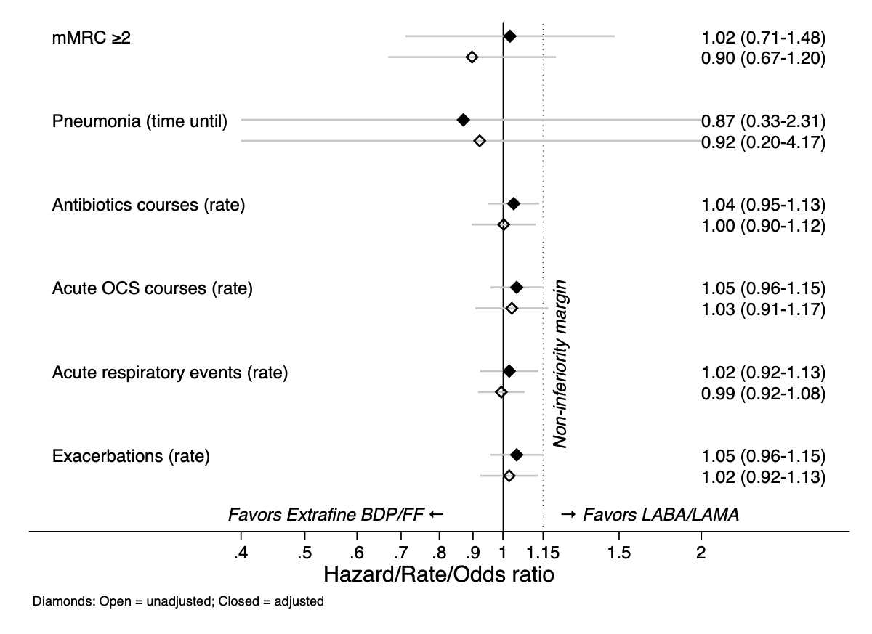

Figure e2A. Effect modification by blood eosinophil count - Model results from IPT-weighted analyses in patients with ≥1 severe or ≥2 moderate exacerbations in one-year baseline period
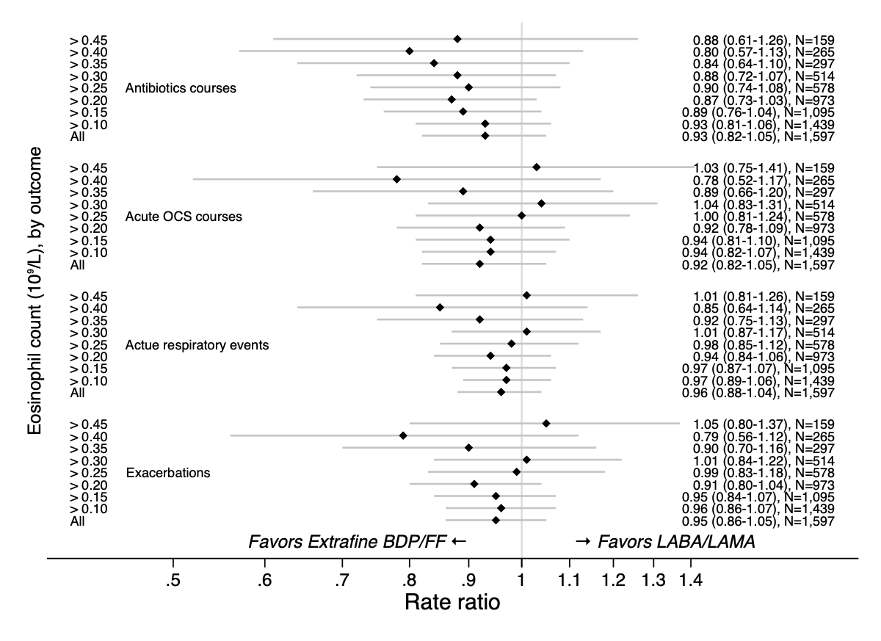

Figure e2B. Effect modification by blood eosinophil count - Model results from IPT-weighted analyses in patients with ≥3 moderate/severe exacerbations in one-year baseline period
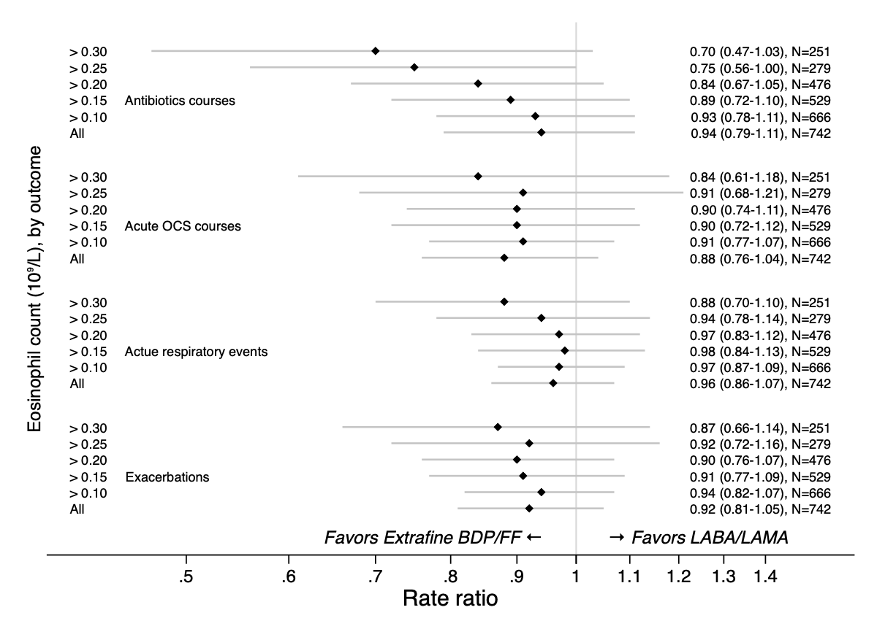
Figure e3A. Effect modification by eosinophil count (continuous variable) - comparative predicted number of SABA inhalers
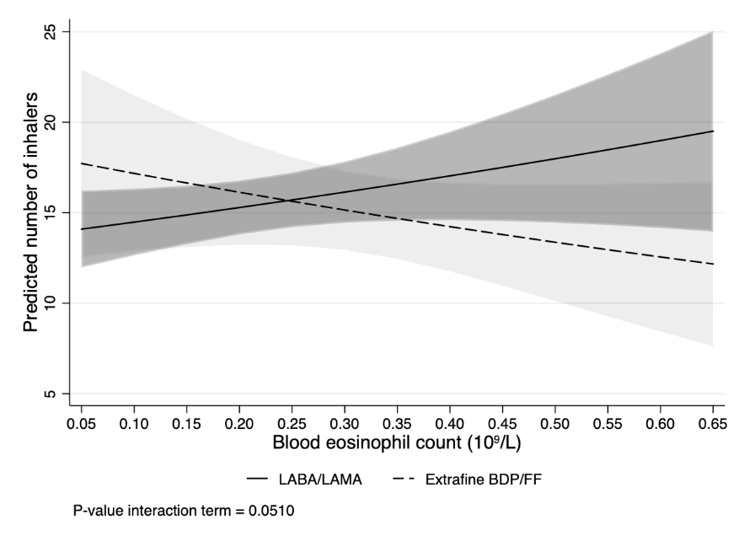

Figure e3B. Effect modification by eosinophil count (continuous variable) predicted number of SABA inhalers in the extrafine BDP/FF group only
