Supplementary information
ZIF-8 modified polypropylene membrane: A biomimetic cell culture platform with a view to the improvement of guided bone regeneration

Fatemeh Ejeian ¹, Amir Razmjou ^{1, 2} *, Mohammad Hossein Nasr-Esfahani ³ *, Munirah Mohammad ², Fereshteh Karamali ³, Majid Ebrahimi Warkiani ⁴, Mohsen Asadnia ⁵, Vicki Chen ⁶

1 Department of Biotechnology, Faculty of Biological Science and Technology, University of Isfahan, Isfahan 73441-81746, Iran
2 UNESCO Centre for Membrane Science and Technology, School of Chemical Science and Engineering, University of New South Wales, Sydney 2052, Australia
3 Department of Cellular Biotechnology, Cell Science Research Center, Royan Institute for Biotechnology, ACECR, Isfahan, Iran
4 School of Biomedical Engineering, University of Technology Sydney, Sydney 2007, Australia
5 School of Engineering, Macquarie University, Sydney, New South Wales 2109, Australia
6 School of Chemical Engineering, University of Queensland, Brisbane, 4072, Australia

Corresponding Authors
* Amir Razmjou
Email: amirr@unsw.edu.au
Postal address: Faculty of Engineering, School of Chemical Engineering, UNSW Australia, UNSW NSW 2052 Australia, T+61 (2) 9385 4341, F +61 (2) 9385 5966

* Mohammad Hossein Nasr-Esfahani
Email: mh.nasr-esfahani@royaninstitute.org
Postal address: Cell Science Research Center, Royan Institute for Biotechnology, Isfahan, Iran, Tel +98 31 95015680, F +98 31 95015687

Supplementary material
Analysis the specific surface area
The N2 adsorption–desorption isotherm was measured for TCP, PP, PP/PDA, PP/PDA/ZIF-8 modified membrane. Specific surface area was assessed by applying the Brunauer–Emmett–Teller (BET) model. The Barrett–Joyner–Halenda (BJH) method was applied to calculate the pore size and pore size distributions from the adsorption isotherm curve. The samples were degassed at 50^{oC} in vacuum for overnight and weighted prior to measurement for further normalization. BET surface area data summarized in Table S1 confirmed the almost high level of surface area along with suitable pore volume in the range of nanometer. The pore-size profile (Figure S. 1) show narrow distribution without any hysteresis between adsorption and desorption curve.

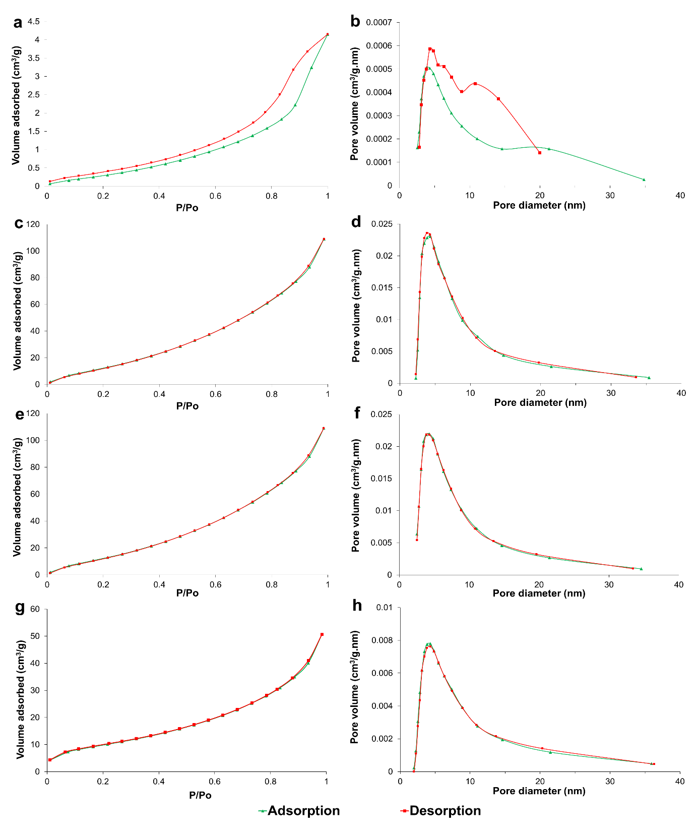
Supplementary Figure 1. BJH analysis of membranes. N₂ sorption isotherm curves, and BJH pore-size distribution of (a, b) TCP, (c, d) PP, (e, f) PP/PDA, and (g, h) PP/PDA/ZIf-8 membranes.

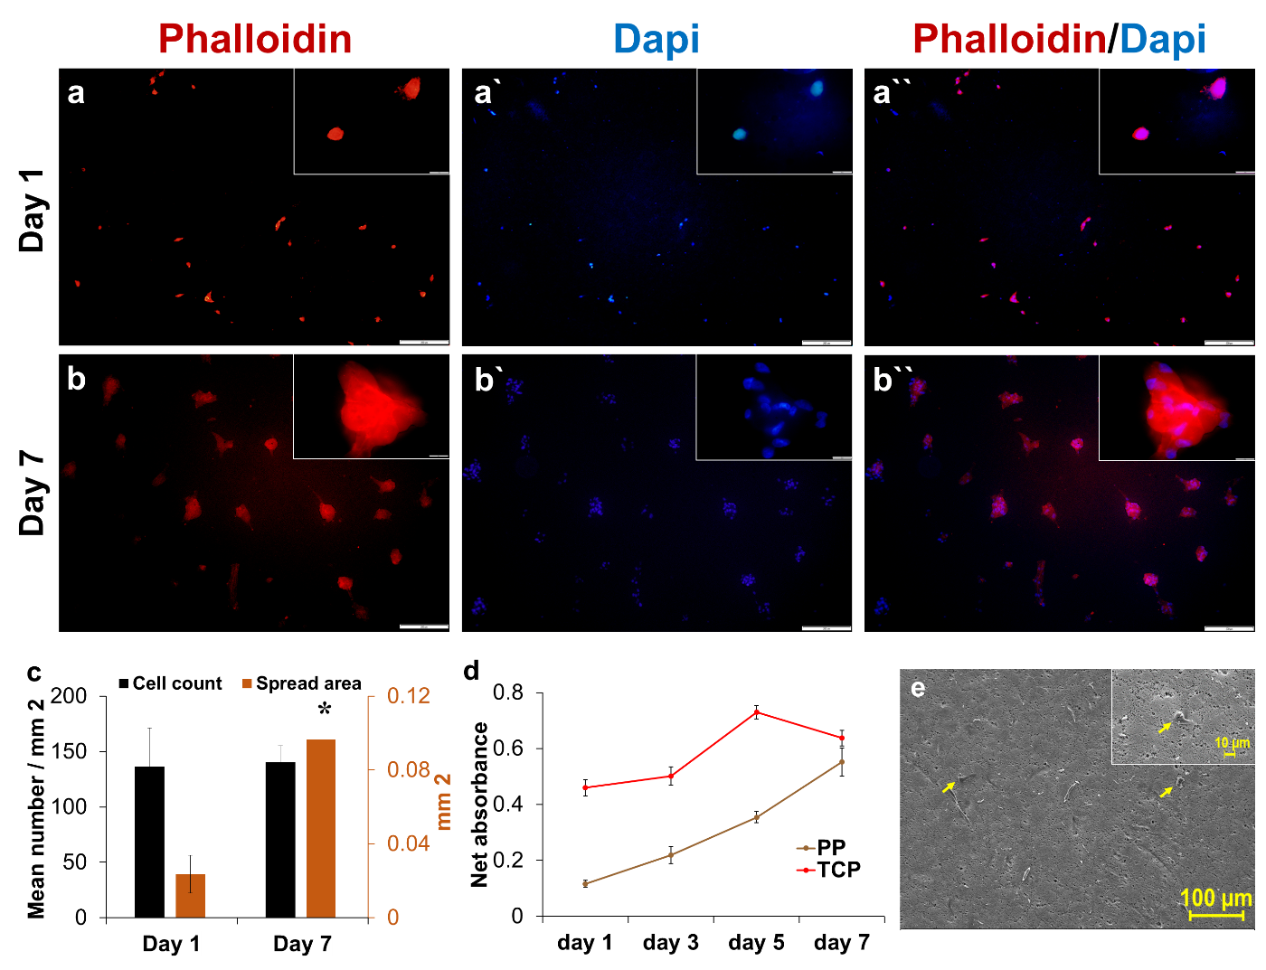
Supplementary Figure 2. Behavior of DPSCs on intact PP membrane. Cytoskeletal visualizing of DPSCs on PP membrane at (a) day1 and (b) day7. F-actin filaments were labeled in red using phalloidin-TRITC and nuclei were stained with dapi (blue). Scale bar is 200 µm for larger images and is 20 µm for higher magnified inserts. (c) Quantification analysis of images for measuring cell number and cell spread area on PP membrane after 1 and 7 days. (d) Rate of metabolic activity of cultured cells on PP, in compare to TCP, over a 7-day period. (e) SEM imaging of cultured DPSCs on the PP membrane after a day. Yellow arrows show cells on substrate and insert display morphological feature of attached cells in higher magnification.

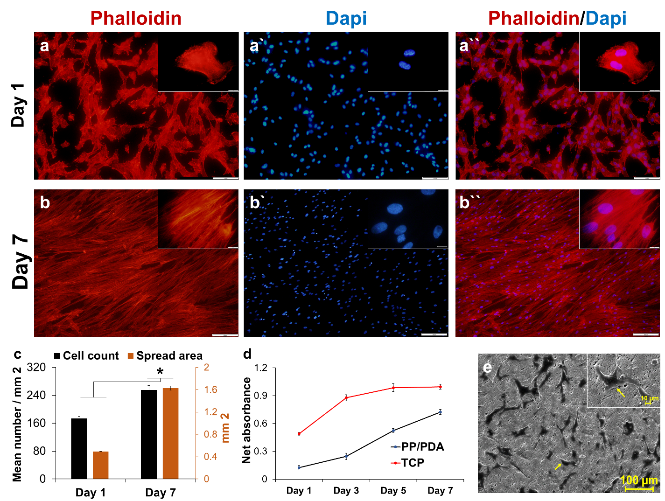
Supplementary Figure 3. Behavior of DPSCs on PP/PDA membrane. Cytoskeletal visualizing of DPSCs on PP/PDA substrate at (a) day1 and (b) day7. F-actin filaments were labeled in red using phalloidin-TRITC and nuclei were stained with dapi (blue). Scale bar is 200 µm for larger images and is 20 µm for higher magnified inserts. (c) Quantification analysis of images for measuring cell number and cell spread area on PP/PDA membrane after 1 and 7 days. (d) Rate of metabolic activity of cultured cells on PP/PDA, in compare to TCP, over a 7-day period. (e) SEM imaging of cultured DPSCs on the PP/PDA membrane after a day. Yellow arrows show cells on substrate and insert display morphological feature of attached cells in higher magnification.

Supplementary Table 1. BET surface areas and BJH desorption average pore size of membranes
Sample | BET surface area (m²/g) | BJH adsorption pore volume (cm³/g) | BJH Adsorption average pore size (nm)
TCP | 1.3 | 0.007620 | 10.0074
PP | 61.4258 | 0.209345 | 7.3327
PP/PDA | 57.9019 | 0.207050 | 7.6013
PP/PDA/ZIF-8 | 37.4646 | 0.085643 | 7.9688

Supplementary Table 2. Primer sequence details for analyzed genes
Gene symbol | Accession number | Sequence
GAPDH | NM_002046.5 | F 5`-CCACTCCTCCACCTTTGACG-3`  R 5`-CCACCACCCTGTTGCTGTAG-3`
SPP1/BSP1 | NM_001251830.1 | F 5`-TTCGCAGACCTGACATCCA-3`  R 5`-CCATTCAACTCCTCGCTTTCC-3`
BMP2 | NM_001200.4 | F 5`-TAGCAGTTTCCATCACCGAA-3`  R 5`-CACTTCCACCACGAATCCATG-3`
PPARG | NM_015869.4 | F 5`-AGCGATTCCTTCACTGATAC-3`  R 5`-GGAGTGGGAGTGGTCTTC-3`
FABP4 | NM_001442.3 | F TCGCATTGAACTCTACAAC  R AAGAATACATCATAAGCACA
COL2A1 | NM_001844.5 | F 5`-GCAAGAGCAAGGAGAAGAA-3`  R 5`-AGGCGTAGGAAGGTCATC-3`
ACAN | NM_001135.4 | F 5`-CAGCACCACCAATGTAAG-3`  R 5`-CCTCCACGAACTCAGAAG-3`

Supplementary Table 3. General characters of specific primary and secondary antibodies
Antibody name | Host | Company | Cat. NO.
Anti-Brdu | Mouse | Sigma | B2531
Anti-BSP2 | Mouse | Santa Cruz | Sc73497
Anti-PPARG | Mouse | Santa Cruz | Sc7273
Anti-COL2A1 | Mouse | Millipore | MAB8887

Supplementary Table 4. Comparison of attachment of MSCs on PP/PDA/ZIF-8 substrate to a number of engineered substrates.
Substrate material | Cell type | Days of assessment | Cells/mm ² | Reference
PP/PDA/ZIF-8 | DPSCs | Day 1 | 280 | This work
Keratin-based microparticles | BMSCs | Day 1 | 40 | ^{[1]}
FN- grafted Lipid bilayers | ADSCs | Day 1 | 40 | ^{[2]}
TNFα-immobilized plate | BMSCs | Day 1 | 50 | ^{[3]}
HEP-GAGs functionalized substrate | ADSCs | Day 1 | 50 | ^{[4]}
APTES-treated pSi | DPSCs | Day 1 | 130 | ^{[5]}
Na-Alg/MC | DPSCs | Day 1 | 80 | ^{[6]}
peptide-anti STRO1-coated pSi | DPSCs | Day 2 | 204 | ^{[7]}
TiO2-filld PI film | DPSCs | Day 3 | 70 | ^{[8]}
Nanostructured-PCL surface | C2C12 | Day 4 | 700 | ^{[9]}
TiO2-filld PI film | DPSCs | Day 6 | 170 | ^{[8]}
PP/PDA/ZIF-8 | DPSCs | Day 7 | 1000 | This work
SIS-grafted bone ceramic | BMSCs | Day 7 | 400 | ^{[10]}
ADSCs; Adipose stem cells, APTES; Aminopropyltriethoxysilane, BMSCs; bone marrow mesenchymal stem cells, DPSCs; Dental pulp stem cells, FN; Fibronectin, GAG; Glycosaminoglycan, MC; methylcellulose, Na-Alg; Sodium alginate, PCL; polycarbonate, PDA; polydopamine, PI; Polyisoprene, PP; polypropylene, pSi; Porous silicon, SIS; small intestinal submucosa,
-to-

Supplementary Table 5. Comparison of the expression of lineage-specific markers after differentiation induction in DPSCs on PP/PDA/ZIF-8 substrate to a number of engineered substrates.
Substrate material | Cell type | Days of assessment | Lineage-specific marker | Fold of expression | Reference
PP/PDA/ZIF-8 | DPSCs | Day 21 | BSP1 | 641 | This work
PP/PDA/ZIF-8 | DPSCs | Day 21 | PPARG | 6 | This work
GO-modified cover glass | DPSCs | Day 14 | DSPP | 8 | ^{[11]}
FA substrate | DPSCs | Day 3 | BSP1 | 4 | ^{[12]}
IB-decorated PCL | MSC | Day 14 | BSP1 | 3 | ^{[13]}
SIS-grafted bone ceramic | BMSCs | Day 14 | OCN | 28 | ^{[10]}
PIC-based hydrogel | BMSCs | Day 21 | RUNX2 | 3.5 | ^{[14]}
MeHA hydrogel | MSCs | Day 14 | OCN | 100 | ^{[15]}
Nano-patterned PCL | BMSCs | Day 21 | BSP1 | 3 | ^{[16]}
nano-patterned titanium | BMSCs | Day 27 | BSP2 | 200 | ^{[17]}
Micropatterned hydrogels | BMSCs | Day 10 | RUNX2 | 2 | ^{[18]}
RGD-coated cover glass | BMSCs | Day 21 | BSP1 | 200 | ^{[19]}
BMP2- grafted pACAA | MSCs | Day 4 | RUNX2 | 8 | ^{[20]}
IB-decorated PCL | MSC | Day 14 | PPARG | 2 | ^{[13]}
MeHA hydrogel | MSC | Day 14 | PPARG | 200 | ^{[15]}
PIC-based hydrogel | BMSCs | Day 21 | PPARG | 8 | ^{[14]}
BMP; Bone morphogenic protein, BSP; Bone sialoprotein, FA; Fluorapatite, MeHA; methacrylated HA, OCN; Osteocalcin, pACAA; Poly (acrylamide-co-acrylic acid), PIC; Polyisocyanopeptide, PCL; Polycaprolactone, PPARG; Peroxisome proliferator-activated receptor gamma, (RGD; tripeptide of arginine, glycine, aspartic acid, IBs; Inclusion bodies
Supplemental references
1. Chooi, W. H.; Chew, S. Y., Modulation of cell-cell interactions for neural tissue engineering: Potential therapeutic applications of cell adhesion molecules in nerve regeneration. Biomaterials 2019, 197, 327-344.
2. Lutolf, M. P.; Hubbell, J. A., Synthetic biomaterials as instructive extracellular microenvironments for morphogenesis in tissue engineering. Nature Biotechnology 2005, 23 (1), 47-55.
3. Fan, H.; Wang, J.; Zhang, Q.; Jin, Z., Tannic Acid-Based Multifunctional Hydrogels with Facile Adjustable Adhesion and Cohesion Contributed by Polyphenol Supramolecular Chemistry. ACS Omega 2017, 2 (10), 6668-6676.
4. Moulay, S., Dopa/Catechol-Tethered Polymers: Bioadhesives and Biomimetic Adhesive Materials. Polymer Reviews 2014, 54 (3), 436-513.
5. Collart-Dutilleul, P.-Y.; Secret, E.; Panayotov, I.; Deville de Périère, D.; Martín-Palma, R. J.; Torres-Costa, V.; Martin, M.; Gergely, C.; Durand, J.-O.; Cunin, F.; Cuisinier, F. J., Adhesion and Proliferation of Human Mesenchymal Stem Cells from Dental Pulp on Porous Silicon Scaffolds. ACS Applied Materials & Interfaces 2014, 6 (3), 1719-1728.
6. Resende, M.; Martinez, E., Topographic characterization and in vitro biofilm adhesion to titanium and polypropylene membranes used for alveolar preservation. 2020, 24 (4), 316-321.
7. Soussi, I.; Mazouz, Z.; Collart-Dutilleul, P. Y.; Echabaane, M.; Martin, M.; Cloitre, T.; M'Ghaieth, R.; Cuisinier, F. J. G.; Cunin, F.; Gergely, C.; Othmane, A., Electrochemical and optical investigation of dental pulp stem cell adhesion on modified porous silicon scaffolds. Colloids and Surfaces B: Biointerfaces 2019, 181, 489-497.
8. Chuang, Y.-C.; Yu, Y.; Wei, M.-T.; Chang, C.-C.; Ricotta, V.; Feng, K.-C.; Wang, L.; Bherwani, A. K.; Ou-Yang, H. D.; Simon, M.; Zhang, L.; Rafailovich, M., Regulating substrate mechanics to achieve odontogenic differentiation for dental pulp stem cells on TiO2 filled and unfilled polyisoprene. Acta Biomaterialia 2019, 89, 60-72.
9. Kord Forooshani, P.; Lee, B. P., Recent approaches in designing bioadhesive materials inspired by mussel adhesive protein. Journal of Polymer Science Part A: Polymer Chemistry 2017, 55 (1), 9-33.
10. Huang, B.; Wu, Z.; Ding, S.; Yuan, Y.; Liu, C., Localization and promotion of recombinant human bone morphogenetic protein-2 bioactivity on extracellular matrix mimetic chondroitin sulfate-functionalized calcium phosphate cement scaffolds. Acta Biomaterialia 2018, 71, 184-199.
11. Rosa, V.; Xie, H.; Dubey, N.; Madanagopal, T. T.; Rajan, S. S.; Morin, J. L. P.; Islam, I.; Castro Neto, A. H., Graphene oxide-based substrate: physical and surface characterization, cytocompatibility and differentiation potential of dental pulp stem cells. Dental Materials 2016, 32 (8), 1019-1025.
12. Liu, J.; Jin, T. C.; Chang, S.; Czajka-Jakubowska, A.; Clarkson, B. H., Adhesion and growth of dental pulp stem cells on enamel-like fluorapatite surfaces. Journal of Biomedical Materials Research Part A 2011, 96A (3), 528-534.
13. Mehrabi, Z.; Taheri-Kafrani, A.; Asadnia, M.; Razmjou, A., Bienzymatic modification of polymeric membranes to mitigate biofouling. Separation and Purification Technology 2020, 237, 116464.
14. Atacan, K.; Özacar, M.; Özacar, M., Investigation of antibacterial properties of novel papain immobilized on tannic acid modified Ag/CuFe2O4 magnetic nanoparticles. International Journal of Biological Macromolecules 2018, 109, 720-731.
15. Zhao, C.; Nguyen, N. S.; Li, X.; McCarthy, D.; Wang, H., Tannic acid coating and in situ deposition of silver nanoparticles to improve the antifouling properties of an ultrafiltration membrane. Journal of Applied Polymer Science 2019, 136 (14), 47314.
16. Perini, J. A. L.; Torquato, L. D. M.; Irikura, K.; Zanoni, M. V. B., Ag/polydopamine-modified Ti/TiO2 nanotube arrays: A platform for enhanced CO2 photoelectroreduction to methanol. Journal of CO2 Utilization 2019, 34, 596-605.
17. Wang, X.-p.; Hou, J.; Chen, F.-s.; Meng, X.-m., In-situ growth of metal-organic framework film on a polydopamine-modified flexible substrate for antibacterial and forward osmosis membranes. Separation and Purification Technology 2020, 236, 116239.
18. Tao, A. R.; Habas, S.; Yang, P., Shape Control of Colloidal Metal Nanocrystals. Small 2008, 4 (3), 310-325.
19. Han, Y.; Yang, H.; Guo, X., Synthesis Methods and Crystallization of MOFs. In Synthesis methods and Crystallization, IntechOpen: 2020.
20. Shamsaei, E.; Lin, X.; Low, Z.-X.; Abbasi, Z.; Hu, Y.; Liu, J. Z.; Wang, H., Aqueous Phase Synthesis of ZIF-8 Membrane with Controllable Location on an Asymmetrically Porous Polymer Substrate. ACS Applied Materials & Interfaces 2016, 8 (9), 6236-6244.

