Supplementary materials
TABLE S1. Search strategy in PubMed
Date of search: 2018-9-19
Number of hits: 533
1. | "Stroke"[Mesh] | 118408
2. | stroke[Title/Abstract] OR Strokes[Title/Abstract] OR "Cerebrovascular Accident"[Title/Abstract] OR "Cerebrovascular Accidents"[Title/Abstract] OR CVA [Title/Abstract] OR CVAs[Title/Abstract] OR "Cerebrovascular Apoplexy"[Title/Abstract] OR "Apoplexy, Cerebrovascular"[Title/Abstract] OR "Vascular Accident, Brain"[Title/Abstract] OR "Brain Vascular Accident"[Title/Abstract] OR "Brain Vascular Accidents"[Title/Abstract] OR "Vascular Accidents, Brain"[Title/Abstract] OR "Cerebrovascular Stroke"[Title/Abstract] OR "Cerebrovascular Strokes"[Title/Abstract] OR "Stroke, Cerebrovascular"[Title/Abstract] OR "Strokes, Cerebrovascular"[Title/Abstract] OR Apoplexy[Title/Abstract] OR "Cerebral Stroke"[Title/Abstract] OR "Cerebral Strokes"[Title/Abstract] OR "Stroke, Cerebral"[Title/Abstract] OR "Strokes, Cerebral"[Title/Abstract] | 230024
3. | #1 OR #2 | 261696
4. | "Cerebrovascular Disorders"[Mesh] | 339976
5. | "Cerebrovascular Disorder"[Title/Abstract] OR "Vascular Diseases, Intracranial"[Title/Abstract] OR "Intracranial Vascular Disease"[Title/Abstract] OR "Intracranial Vascular Diseases"[Title/Abstract] OR "Vascular Disease, Intracranial"[Title/Abstract] OR "Intracranial Vascular Disorders"[Title/Abstract] OR "Intracranial Vascular Disorder"[Title/Abstract] OR "Vascular Disorder, Intracranial"[Title/Abstract] OR "Vascular Disorders, Intracranial"[Title/Abstract] OR "Cerebrovascular Diseases"[Title/Abstract] OR "Cerebrovascular Disease"[Title/Abstract] OR "Disease, Cerebrovascular"[Title/Abstract] OR "Diseases, Cerebrovascular"[Title/Abstract] OR "Brain Vascular Disorders"[Title/Abstract] OR "Brain Vascular Disorder"[Title/Abstract] OR "Vascular Disorder, Brain"[Title/Abstract] OR "Vascular Disorders, Brain"[Title/Abstract] OR "Cerebrovascular Occlusion"[Title/Abstract] OR "Cerebrovascular Occlusions"[Title/Abstract] OR "Occlusion, Cerebrovascular"[Title/Abstract] OR "Occlusions, Cerebrovascular"[Title/Abstract] OR "Cerebrovascular Insufficiency"[Title/Abstract] OR "Cerebrovascular Insufficiencies"[Title/Abstract] OR "Insufficiencies, Cerebrovascular"[Title/Abstract] OR "Insufficiency, Cerebrovascular"[Title/Abstract] | 20285
6. | #4 OR #5 | 348576
7. | #3 OR #6 | 456371
8. | "Adrenergic Beta-Antagonists"[Mesh] OR "Adrenergic beta-Antagonists" [Pharmacological Action] | 83174
9. | "Adrenergic beta-Antagonists"[Title/Abstract] OR "Adrenergic beta Antagonists"[Title/Abstract] OR "beta-Antagonists, Adrenergic"[Title/Abstract] OR "beta-Adrenergic Receptor Blockaders"[Title/Abstract] OR "Blockaders, beta-Adrenergic Receptor"[Title/Abstract] OR "Receptor Blockaders, beta-Adrenergic"[Title/Abstract] OR "beta Adrenergic Receptor Blockaders"[Title/Abstract] OR "beta-Adrenergic Blockers"[Title/Abstract] OR "Blockers, beta-Adrenergic"[Title/Abstract] OR "beta Adrenergic Blockers"[Title/Abstract] OR "beta-Blockers, Adrenergic"[Title/Abstract] OR "Adrenergic beta-Blockers"[Title/Abstract] OR "beta Blockers, Adrenergic"[Title/Abstract] OR "Adrenergic beta-Receptor Blockaders"[Title/Abstract] OR "Adrenergic beta Receptor Blockaders"[Title/Abstract] OR "Blockaders, Adrenergic beta-Receptor"[Title/Abstract] OR "beta-Receptor Blockaders, Adrenergic"[Title/Abstract] OR "beta-Adrenergic Blocking Agents"[Title/Abstract] OR "Agents, beta-Adrenergic Blocking"[Title/Abstract] OR "Blocking Agents, beta-Adrenergic"[Title/Abstract] OR "beta Adrenergic Blocking Agents"[Title/Abstract] | 2019
10. | #8 OR #9 | 83818
11. | "Treatment Outcome"[Mesh] | 946198
12. | "Treatment Outcome"[Title/Abstract] OR "Outcome, Treatment"[Title/Abstract] OR "Clinical Effectiveness"[Title/Abstract] OR "Clinical Effectivenesses"[Title/Abstract] OR "Effectiveness, Clinical"[Title/Abstract] OR "Effectivenesses, Clinical"[Title/Abstract] OR "Patient-Relevant Outcome"[Title/Abstract] OR "Outcome, Patient-Relevant"[Title/Abstract] OR "Outcomes, Patient-Relevant"[Title/Abstract] OR "Patient Relevant Outcome"[Title/Abstract] OR "Patient-Relevant Outcomes"[Title/Abstract] OR "Clinical Efficacy"[Title/Abstract] OR "Efficacy, Clinical"[Title/Abstract] OR "Treatment Effectiveness"[Title/Abstract] OR "Effectiveness, Treatment"[Title/Abstract] OR "Treatment Efficacy"[Title/Abstract] OR "Efficacy, Treatment"[Title/Abstract] OR "Rehabilitation Outcome"[Title/Abstract] OR "Outcome, Rehabilitation"[Title/Abstract] | 81079
13. | #11 OR #12 | 1001538
14. | "Mortality"[Mesh] | 351228
15. | Mortality[Title/Abstract] OR Mortalities[Title/Abstract] OR "Case Fatality Rate"[Title/Abstract] OR "Case Fatality Rates"[Title/Abstract] OR "Rate, Case Fatality"[Title/Abstract] OR "Rates, Case Fatality"[Title/Abstract] OR "Mortality, Excess"[Title/Abstract] OR "Excess Mortalities"[Title/Abstract] OR "Mortalities, Excess"[Title/Abstract] OR "Excess Mortality"[Title/Abstract] OR "Decline, Mortality"[Title/Abstract] OR "Declines, Mortality"[Title/Abstract] OR "Mortality Declines"[Title/Abstract] OR "Mortality Decline"[Title/Abstract] OR "Mortality Determinants"[Title/Abstract] OR "Determinant, Mortality"[Title/Abstract] OR "Mortality Determinant"[Title/Abstract] OR "Determinants, Mortality"[Title/Abstract] OR "Mortality, Differential"[Title/Abstract] OR "Differential Mortalities"[Title/Abstract] OR "Mortalities, Differential"[Title/Abstract] OR "Differential Mortality"[Title/Abstract] OR "Age-Specific Death Rate"[Title/Abstract] OR "Age-Specific Death Rates"[Title/Abstract] OR "Death Rate, Age-Specific"[Title/Abstract] OR "Death Rates, Age-Specific"[Title/Abstract] OR "Rate, Age-Specific Death"[Title/Abstract] OR "Rates, Age-Specific Death"[Title/Abstract] OR "Age Specific Death Rate"[Title/Abstract] OR "Death Rate"[Title/Abstract] OR "Death Rates"[Title/Abstract] OR "Rate, Death"[Title/Abstract] OR "Rates, Death"[Title/Abstract] OR "Mortality Rate"[Title/Abstract] OR "Mortality Rates"[Title/Abstract] OR "Rate, Mortality"[Title/Abstract] OR "Rates, Mortality"[Title/Abstract] | 682931
16. | #14 OR #15 | 913588
17. | #13 OR #16 | 1779016
18. | #7 AND #10 AND #17 | 533

TABLE S2. Search strategy in Medline
Date of search: 2018-9-19
Number of hits: 1042
1. | Stroke OR Strokes OR (Cerebrovascular Accident) OR (Cerebrovascular Accidents) OR CVA OR CVAs OR (Cerebrovascular Apoplexy) OR (Apoplexy, Cerebrovascular) OR (Vascular Accident, Brain) OR (Brain Vascular Accident) OR (Brain Vascular Accidents) OR (Vascular Accidents, Brain) OR (Cerebrovascular Stroke) OR (Cerebrovascular Strokes) OR (Stroke, Cerebrovascular) OR (Strokes, Cerebrovascular) OR Apoplexy OR (Cerebral Stroke) OR (Cerebral Strokes) OR (Stroke, Cerebral) OR (Strokes, Cerebral) | 285653
2. | (Cerebrovascular Disorder) OR (Vascular Diseases, Intracranial) OR (Intracranial Vascular Disease)OR (Intracranial Vascular Diseases) OR (Vascular Disease, Intracranial) OR (Intracranial Vascular Disorders) OR "Intracranial Vascular Disorder) OR (Vascular Disorder, Intracranial) OR (Vascular Disorders, Intracranial) OR (Cerebrovascular Diseases) OR (Cerebrovascular Disease) OR (Disease, Cerebrovascular) OR (Diseases, Cerebrovascular) OR (Brain Vascular Disorders) OR (Brain Vascular Disorder) OR (Vascular Disorder, Brain) OR (Vascular Disorders, Brain) OR (Cerebrovascular Occlusion) OR (Cerebrovascular Occlusions) OR (Occlusion, Cerebrovascular) OR (Occlusions, Cerebrovascular) OR (Cerebrovascular Insufficiency) OR (Cerebrovascular Insufficiencies) OR (Insufficiencies, Cerebrovascular) OR (Insufficiency, Cerebrovascular) | 103256
3. | #1 OR #2 | 350829
4. | (Adrenergic beta-Antagonists) OR (Adrenergic beta Antagonists) OR (beta-Antagonists, Adrenergic) OR (beta-Adrenergic Receptor Blockaders) OR (Blockaders, beta-Adrenergic Receptor) OR (Receptor Blockaders, beta-Adrenergic) OR (beta Adrenergic Receptor Blockaders) OR (beta-Adrenergic Blockers) OR (Blockers, beta-Adrenergic) OR (beta Adrenergic Blockers) OR (beta-Blockers, Adrenergic) OR (Adrenergic beta-Blockers) OR (beta Blockers, Adrenergic) OR (Adrenergic beta-Receptor Blockaders) OR (Adrenergic beta Receptor Blockaders) OR (Blockaders, Adrenergic beta-Receptor) OR (beta-Receptor Blockaders, Adrenergic) OR (beta-Adrenergic Blocking Agents) OR (Agents, beta-Adrenergic Blocking) OR (Blocking Agents, beta-Adrenergic) OR (beta Adrenergic Blocking Agents) | 54190
5. | (Treatment Outcome) OR (Outcome, Treatment) OR (Clinical Effectiveness) OR (Clinical Effectivenesses) OR (Effectiveness, Clinical) OR (Effectivenesses, Clinical) OR (Patient-Relevant Outcome) OR (Outcome, Patient-Relevant) OR (Outcomes, Patient-Relevant) OR (Patient Relevant Outcome) OR (Patient-Relevant Outcomes) OR (Clinical Efficacy) OR (Efficacy, Clinical) OR (Treatment Effectiveness) OR (Effectiveness, Treatment) OR (Treatment Efficacy) OR (Efficacy, Treatment) OR (Rehabilitation Outcome) OR (Outcome, Rehabilitation) | 1752763
6. | Mortality OR Mortalities OR (Case Fatality Rate) OR (Case Fatality Rates) OR (Rate, Case Fatality) OR (Rates, Case Fatality) OR (Mortality, Excess) OR (Excess Mortalities) OR (Mortalities, Excess) OR (Excess Mortality) OR (Decline, Mortality) OR (Declines, Mortality) OR (Mortality Declines) OR (Mortality Decline) OR (Mortality Determinants) OR (Determinant, Mortality) OR (Mortality Determinant) OR (Determinants, Mortality) OR (Mortality, Differential) OR (Differential Mortalities) OR (Mortalities, Differential) OR (Differential Mortality) OR (Age-Specific Death Rate) OR (Age-Specific Death Rates) OR (Death Rate, Age-Specific) OR (Death Rates, Age-Specific) OR (Rate, Age-Specific Death) OR (Rates, Age-Specific Death) OR (Age Specific Death Rate) OR (Death Rate) OR (Death Rates) OR (Rate, Death) OR (Rates, Death) OR (Mortality Rate) OR (Mortality Rates) OR (Rate, Mortality) OR (Rates, Mortality) | 1118253
7. | #5 OR #6 | 2606116
8. | #3 AND #4 AND #7 | 1042

TABLE S3. Search strategy in Scopus
Date of search: 2018-9-19
Number of hits: 3477
1. | stroke OR Strokes OR "Cerebrovascular Accident" OR "Cerebrovascular Accidents" OR CVA OR CVAs OR "Cerebrovascular Apoplexy" OR "Apoplexy, Cerebrovascular" OR "Vascular Accident, Brain" OR "Brain Vascular Accident" OR "Brain Vascular Accidents" OR "Vascular Accidents, Brain" OR "Cerebrovascular Stroke" OR "Cerebrovascular Strokes" OR "Stroke, Cerebrovascular" OR "Strokes, Cerebrovascular" OR Apoplexy OR "Cerebral Stroke" OR "Cerebral Strokes" OR "Stroke, Cerebral" OR "Strokes, Cerebral" | 1104917
2. | "Cerebrovascular Disorder" OR "Vascular Diseases, Intracranial" OR "Intracranial Vascular Disease" OR "Intracranial Vascular Diseases" OR "Vascular Disease, Intracranial" OR "Intracranial Vascular Disorders" OR "Intracranial Vascular Disorder" OR "Vascular Disorder, Intracranial" OR "Vascular Disorders, Intracranial" OR "Cerebrovascular Diseases" OR "Cerebrovascular Disease" OR "Disease, Cerebrovascular" OR "Diseases, Cerebrovascular" OR "Brain Vascular Disorders" OR "Brain Vascular Disorder" OR "Vascular Disorder, Brain" OR "Vascular Disorders, Brain" OR "Cerebrovascular Occlusion" OR "Cerebrovascular Occlusions" OR "Occlusion, Cerebrovascular" OR "Occlusions, Cerebrovascular" OR "Cerebrovascular Insufficiency" OR "Cerebrovascular Insufficiencies" OR "Insufficiencies, Cerebrovascular" OR "Insufficiency, Cerebrovascular" | 213337
3. | #1 OR #2 | 1164052
4. | "Adrenergic beta-Antagonists" OR "Adrenergic beta Antagonists" OR "beta-Antagonists, Adrenergic" OR "beta-Adrenergic Receptor Blockaders" OR "Blockaders, beta-Adrenergic Receptor" OR "Receptor Blockaders, beta-Adrenergic" OR "beta Adrenergic Receptor Blockaders" OR "beta-Adrenergic Blockers" OR "Blockers, beta-Adrenergic" OR "beta Adrenergic Blockers" OR "beta-Blockers, Adrenergic" OR "Adrenergic beta-Blockers" OR "beta Blockers, Adrenergic" OR "Adrenergic beta-Receptor Blockaders" OR "Adrenergic beta Receptor Blockaders" OR "Blockaders, Adrenergic beta-Receptor" OR "beta-Receptor Blockaders, Adrenergic" OR "beta-Adrenergic Blocking Agents" OR "Agents, beta-Adrenergic Blocking" OR "Blocking Agents, beta-Adrenergic" OR "beta Adrenergic Blocking Agents" | 47435
5. | "Treatment Outcome" OR "Outcome, Treatment" OR "Clinical Effectiveness" OR "Clinical Effectivenesses" OR "Effectiveness, Clinical" OR "Effectivenesses, Clinical" OR "Patient-Relevant Outcome" OR "Outcome, Patient-Relevant" OR "Outcomes, Patient-Relevant" OR "Patient Relevant Outcome" OR "Patient-Relevant Outcomes" OR "Clinical Efficacy" OR "Efficacy, Clinical" OR "Treatment Effectiveness" OR "Effectiveness, Treatment" OR "Treatment Efficacy" OR "Efficacy, Treatment" OR "Rehabilitation Outcome" OR "Outcome, Rehabilitation" | 1678803
6. | Mortality OR Mortalities OR "Case Fatality Rate" OR "Case Fatality Rates" OR "Rate, Case Fatality" OR "Rates, Case Fatality" OR "Mortality, Excess" OR "Excess Mortalities" OR "Mortalities, Excess" OR "Excess Mortality" OR "Decline, Mortality" OR "Declines, Mortality" OR "Mortality Declines" OR "Mortality Decline" OR "Mortality Determinants" OR "Determinant, Mortality" OR "Mortality Determinant" OR "Determinants, Mortality" OR "Mortality, Differential" OR "Differential Mortalities" OR "Mortalities, Differential" OR "Differential Mortality" OR "Age-Specific Death Rate" OR "Age-Specific Death Rates" OR "Death Rate, Age-Specific" OR "Death Rates, Age-Specific" OR "Rate, Age-Specific Death" OR "Rates, Age-Specific Death" OR "Age Specific Death Rate" OR "Death Rate" OR "Death Rates" OR "Rate, Death" OR "Rates, Death" OR "Mortality Rate" OR "Mortality Rates" OR "Rate, Mortality" OR "Rates, Mortality" | 2947434
7. | #5 OR #6 | 4258533
8. | #3 AND #4 AND #7 | 4196
8. | #3 AND #4 AND #7 limited to journals in source type, medicine in subject area and English language | 3477

TABLE S4. Search strategy in Cochrane
Date of search: 2018-9-19
Number of hits: 37 reviews, 55 trials
1. | MeSH Stroke | 7850
2. | stroke OR Strokes OR "Cerebrovascular Accident" OR "Cerebrovascular Accidents" OR CVA OR CVAs OR "Cerebrovascular Apoplexy" OR "Apoplexy, Cerebrovascular" OR "Vascular Accident, Brain" OR "Brain Vascular Accident" OR "Brain Vascular Accidents" OR "Vascular Accidents, Brain" OR "Cerebrovascular Stroke" OR "Cerebrovascular Strokes" OR "Stroke, Cerebrovascular" OR "Strokes, Cerebrovascular" OR Apoplexy OR "Cerebral Stroke" OR "Cerebral Strokes" OR "Stroke, Cerebral" OR "Strokes, Cerebral" | 56511
3. | #1 OR #2 | 56779
4. | MeSH Cerebrovascular disorders | 12795
5. | "Cerebrovascular Disorder" OR "Vascular Diseases, Intracranial" OR "Intracranial Vascular Disease" OR "Intracranial Vascular Diseases" OR "Vascular Disease, Intracranial" OR "Intracranial Vascular Disorders" OR "Intracranial Vascular Disorder" OR "Vascular Disorder, Intracranial" OR "Vascular Disorders, Intracranial" OR "Cerebrovascular Diseases" OR "Cerebrovascular Disease" OR "Disease, Cerebrovascular" OR "Diseases, Cerebrovascular" OR "Brain Vascular Disorders" OR "Brain Vascular Disorder" OR "Vascular Disorder, Brain" OR "Vascular Disorders, Brain" OR "Cerebrovascular Occlusion" OR "Cerebrovascular Occlusions" OR "Occlusion, Cerebrovascular" OR "Occlusions, Cerebrovascular" OR "Cerebrovascular Insufficiency" OR "Cerebrovascular Insufficiencies" OR "Insufficiencies, Cerebrovascular" OR "Insufficiency, Cerebrovascular" | 5354
6. | #4 OR #5 | 17102
7. | #3 OR #6 | 60485
8. | MeSH Adrenergic Beta-Antagonists Mesh | 4402
9. | "Adrenergic beta-Antagonists" OR "Adrenergic beta Antagonists" OR "beta-Antagonists, Adrenergic" OR "beta-Adrenergic Receptor Blockaders" OR "Blockaders, beta-Adrenergic Receptor" OR "Receptor Blockaders, beta-Adrenergic" OR "beta Adrenergic Receptor Blockaders" OR "beta-Adrenergic Blockers" OR "Blockers, beta-Adrenergic" OR "beta Adrenergic Blockers" OR "beta-Blockers, Adrenergic" OR "Adrenergic beta-Blockers" OR "beta Blockers, Adrenergic" OR "Adrenergic beta-Receptor Blockaders" OR "Adrenergic beta Receptor Blockaders" OR "Blockaders, Adrenergic beta-Receptor" OR "beta-Receptor Blockaders, Adrenergic" OR "beta-Adrenergic Blocking Agents" OR "Agents, beta-Adrenergic Blocking" OR "Blocking Agents, beta-Adrenergic" OR "beta Adrenergic Blocking Agents" | 4446
10. | #8 OR #9 | 4615
11. | MeSH Treatment outcome | 122523
12. | "Treatment Outcome" OR "Outcome, Treatment" OR "Clinical Effectiveness" OR "Clinical Effectivenesses" OR "Effectiveness, Clinical" OR "Effectivenesses, Clinical" OR "Patient-Relevant Outcome" OR "Outcome, Patient-Relevant" OR "Outcomes, Patient-Relevant" OR "Patient Relevant Outcome" OR "Patient-Relevant Outcomes" OR "Clinical Efficacy" OR "Efficacy, Clinical" OR "Treatment Effectiveness" OR "Effectiveness, Treatment" OR "Treatment Efficacy" OR "Efficacy, Treatment" OR "Rehabilitation Outcome" OR "Outcome, Rehabilitation" | 168067
13. | #11 OR #12 | 170526
14. | MeSH Mortality | 12376
15 | Mortality OR Mortalities OR "Case Fatality Rate" OR "Case Fatality Rates" OR "Rate, Case Fatality" OR "Rates, Case Fatality" OR "Mortality, Excess" OR "Excess Mortalities" OR "Mortalities, Excess" OR "Excess Mortality" OR "Decline, Mortality" OR "Declines, Mortality" OR "Mortality Declines" OR "Mortality Decline" OR "Mortality Determinants" OR "Determinant, Mortality" OR "Mortality Determinant" OR "Determinants, Mortality" OR "Mortality, Differential" OR "Differential Mortalities" OR "Mortalities, Differential" OR "Differential Mortality" OR "Age-Specific Death Rate" OR "Age-Specific Death Rates" OR "Death Rate, Age-Specific" OR "Death Rates, Age-Specific" OR "Rate, Age-Specific Death" OR "Rates, Age-Specific Death" OR "Age Specific Death Rate" OR "Death Rate" OR "Death Rates" OR "Rate, Death" OR "Rates, Death" OR "Mortality Rate" OR "Mortality Rates" OR "Rate, Mortality" OR "Rates, Mortality" | 72839
16. | #14 OR #15 | 75261
17. | #13 OR #16 | 226588
18. | #7 AND #10 AND #17 | 309
19. | #18 limited to Cochrane reviews | 37
20. | #18 limited to Cochrane EMBASE trials | 55

TABLE S5. Characteristics of studies included in the meta-analysis
1st Author (Publication year) | Study design | Study population | Mortality |  |  |  | Functional outcome |  |  |  |  | Infection
1st Author (Publication year) | Study design | Study population | Intervention | Comparison | OR/RR/HR  (95% CI) | Follow-up time | Intervention | Comparison | OR/RR (95% CI) | Definition poor functional outcome | Follow-up time | Intervention | Comparison | OR/RR (95%CI) | Definition infection | Follow-up infection
1st Author (Publication year) | Study design | Study population | N intervention (N dead) | N comparison (N dead) | OR/RR/HR  (95% CI) | Follow-up time | N intervention (N poor functional outcome) | N comparison (N poor functional outcome) | OR/RR (95% CI) | Definition poor functional outcome | Follow-up time | N intervention (N with infection) | N comparison (N with infection) | OR/RR (95%CI) | Definition infection | Follow-up infection
Barer DH (1988) [31] | RCT | stroke | 202 (52) | 100 (14) |  | 1-month from ictus
Dziedzik T (2007) [30] | Observational, retrospective | Ischemic stroke | 88 (6) | 745 (141) | 0.37 (0.16-0.84)ª | 30-days from ictus |  |  |  |  |  | 88 (4) | 745 (85) |  | Pneumonia | In-hospital
Dowlatshahi D (2009) [32] | cohort | Ischemic stroke | 1591 | 3977 | 1.24 (0.97-1.58)ª | In-hospital | 1591 | 3977 | 1.00 (0.84-1.19)ª | mRS 4-6 | At discharge
Potter J (2009) [33] | RCT | Ischemic or haemorrhagic stroke | 56 (4) | 116 (19) |  | 3-moths from ictus | 56 (34) | 116 (70) |  | mRS >3 | At 2 weeks from ictus
Fuentes B (2010) [45] | Observational, retrospective | Ischemic stroke |  |  |  |  | 195 | 1773 | 0.980 (0.728-1.318)^{d} | mRS > 2 | At discharge
De Raedt S (2012) [46] | Cohort | Ischemic stroke |  |  |  |  | 103 (52) | 1080 (589) | 0.85 (0.57-1.27)^{d} | mRS >3 | At 3-months from ictus
Kalita J (2013) [34] | observational | Haemorrhagic stroke | 79 (9) | 59 (22) | 0.83 (0.006-1.09)ª | 1-month from ictus | 55 (28) | 47 (32) |  | BI ≤ 12 | At 3-months from ictus | 79 (7) | 59 (18) |  | Pneumonia | In-hospital
Shoup JP (2014) [35] | Observational, retrospective | Haemorrhagic stroke | 275 (75) | 151 (76) | 0.21 (0.07-0.59)ª | In-hospital |  |  |  |  |  | 275 (88) | 151 (24) |  | Infection | In-hospital
Maier IL (2015) [36] | Historical cohort | Ischemic or haemorrhagic stroke | 301 (42) | 324 (22) | 1.93 (1.20-3.10)ª | 30-day from ictus |  |  |  |  |  | 301 (114) | 324 (123) | 1.00 (0.77-1.30)ª | Pneumonia | Within 7 days from ictus
Phelan C (2015) [37] | Observational, retrospective | Ischemic stroke | 436 (66) | 2368 (343) | 0.657 (0.655-0.658)ª | In-hospital |  |  |  |  |  | 436 (139) | 2368 (633) |  | Infection | In-hospital
Sundbøll J (2015) [29] | cohort | Ischemic stroke | 17189 (2389) | 63402 (6213) | 1.01 (0.96- 1.07)^{b} | 30-days from ictus
Sundbøll J (2015) [29] | cohort | Haemorrhagic stroke | 1913 (802) | 9494 (3162) | 0.95 (0.87-1.04)^{b} | 30-days from ictus
Sykora M (2015) [38] | Observational | Ischemic stroke | 244 (23) | 4968 (891) | 0.63 (0.42-0.96)^{c} | 3-months from ictus | 234 (105) | 4846 (2016) | 0.96 (0.8-1.15)^{e} | mRS 3-6 | At 3-months from ictus | 244 (9) | 4968 (418) | 0.49 (0.25-0.95)^{c} | Pneumonia | Within 10 days from ictus
Tziomalos K (2015) [39] | observational | Ischemic stroke | 183 (18) | 299 (28) |  | In-hospital | 188 (109) | 294 (201) |  | mRS ≥ 2 | At discharge
Westendorp WF (2016) [40] | Observational, exploratory analysis | Ischemic or haemorrhagic stroke | 880 (123) | 1639 (144) | 1.14 (0.84-1.53)ª | 3-months from ictus | 880 (392) | 1629 (592) | 1.10 (0.89-1.35)ª | mRS 3-6 | At 3-months from ictus | 885 (168) | 1648 (179) | 1.61 (1.19-2.18)ª | Infection | In-hospital
Koton S (2017) [27] | Observational | Ischemic stroke | 1470 (141) | 1327 (116) | 0.99 (0.74-1.31)ª | 1-month mortality | 2026 (1375) | 1866 (1272) | 0.87 (0.73-1.03)ª | mRS ≥ 2 | At discharge
Starr JB (2017a) [41] | Observational | Haemorrhagic stroke | 418 (164) | 107 (47) |  | In-hospital | 345 (268) | 94 (71) |  | mRS > 2 | At discharge | 365 (65) | 92 (7) |  | Infection | In-hospital
Starr JB (2017b) [42] | Observational | Ischemic stroke | 424 (54) | 424 (52) |  | In-hospital | 339 (221) | 319 (193) |  | mRS > 2 | At discharge | 384 (63) | 384 (41) |  | Infection | In-hospital
Eizenberg Y (2018) [28] | Observational | Ischemic or haemorrhagic stroke | 615 (41) | 511 (29) | 0.86 (0.49-1.52)ª | 3-months from ictus | 517 (182) | 444 (154) | 1.07 (0.76-1.50)ª | BI ≤ 60 |  | 109 (19) | 94 (29) |  | Infection | Until 3 months from ictus
Maier IL (2018) [43] | Observational | Ischemic stroke | 158 (38) | 148 (26) | 0.59 (0.16-2.17)ª | In-hospital |  |  |  |  |  | 158 (44) | 148 (40) | 0.78 (0.31-1.92)^{e} | Pneumonia | In-hospital
Sykora M (2018) [44] | Observational, retrospective | Haemorrhagic stroke | 279 (111) | 706 (206) | 1.2 (0.8-1.7)ª | 3-months from ictus
N number, OR odds ratio, RR rate ratio, ª – adjusted for age and stroke severity, ^{b} – adjusted for age, ^{c} – adjusted for stroke severity, ^{d} – unadjusted, ^{e} – adjusted for confounders, RCT randomised clinical trial, mRS modified Rankin scale, BI Barthel Index

TABLE S6. Quality assessment
SBU´s checklist for observational studies[26] | Selection bias | Treatment bias | Assessment bias | Fall-out bias | Reporting bias | Conflict of interest bias | Risk of bias
Dziedzik T (2007) [30] | Low risk | Low risk | Low risk | Not applicable | Moderate risk | Low risk | Low risk
Dowlatshahi D (2009) [32] | Moderate risk | Moderate risk | Moderate risk | Not applicable | Low risk | Low risk | Moderate risk
Fuentes B (2010) [45] | Moderate risk | Moderate risk | Moderate risk | Not applicable | Low risk | Low risk | Moderate risk
De Raedt S (2012) [46] | Moderate risk | Moderate risk | Moderate risk | Not applicable | Low risk | Low risk | Moderate risk
Kalita J (2013) [34] | Moderate risk | Low risk | Moderate risk | Not applicable | Moderate risk | Low risk | Moderate risk
Shoup JP (2014) [35] | Low risk | Low risk | Low risk | Not applicable | Low risk | Low risk | Low risk
Maier IL (2015) [36] | Low risk | Low risk | Low risk | Not applicable | Low risk | Low risk | Low risk
Phelan C (2015) [37] | Low risk | Low risk | Low risk | Not applicable | Low risk | Low risk | Low risk
Sundbøll J (2015) [29] | Low risk | Low risk | Low risk | Low risk | Low risk | Low risk | Low risk
Sykora M (2015) [38] | Low risk | Low risk | Low risk | Low risk | Low risk | Low risk | Low risk
Tziomalos K (2015) [39] | Low risk | Moderate risk | Low risk | Not applicable | Low risk | Low risk | Moderate risk
Westendorp WF (2016) [40] | Low risk | Low risk | Low risk | Low risk | Low risk | Low risk | Low risk
Koton S (2017) [27] | Low risk | Low risk | Low risk | Moderate risk | Low risk | Low risk | Moderate risk
Starr JB (2017a) [41] | Low risk | Low risk | Low risk | Low risk | Low risk | Low risk | Low risk
Starr JB (2017b) [42] | Low risk | Low risk | Low risk | Not applicable | Low risk | Low risk | Low risk
Eizenberg Y (2018) [28] | Low risk | Low risk | Low risk | Moderate risk | Low risk | Low risk | Moderate risk
Maier IL (2018) [43] | Low risk | Moderate risk | Low risk | Not applicable | Low risk | Low risk | Moderate risk
Sykora M (2018) [44] | Low risk | Moderate risk | Low risk | Not applicable | Low risk | Low risk | Low risk
SBU´s checklist for observational studies [26]
Barer DH (1988) [31] | Moderate risk | Low risk | Low risk | Moderate risk | Low risk | Low risk | Moderate risk
Potter J (2009) [33] | Low risk | Low risk | Low risk | Moderate risk | Low risk | Low risk | Moderate risk
SBU - Swedish Agency For Health Technology Assessment And Assessment Of Social Services

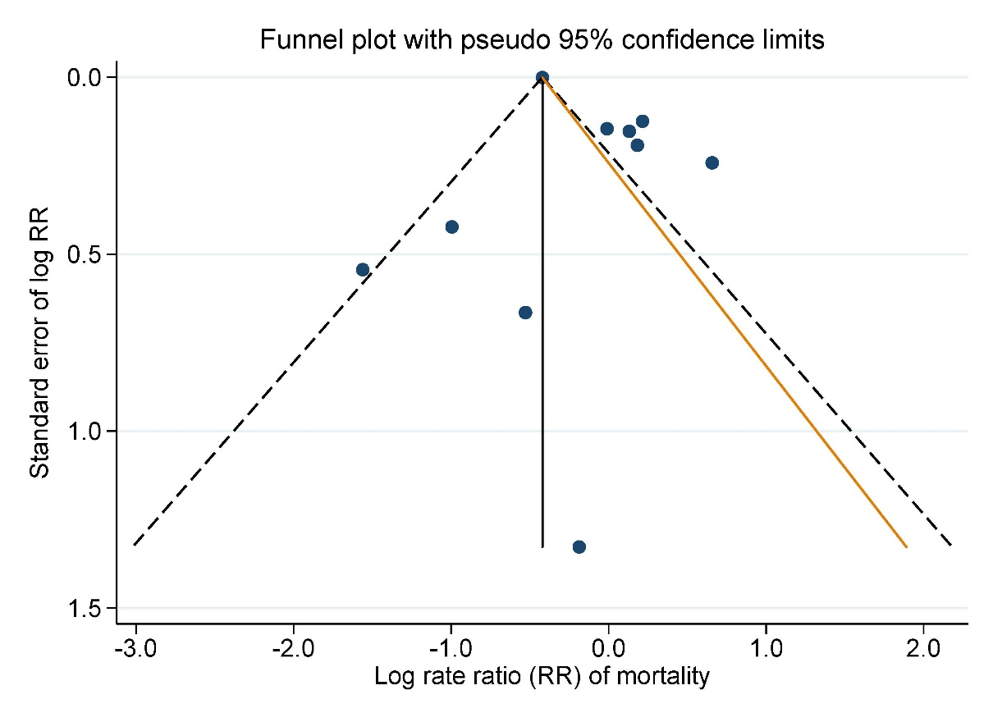
FIGURE S1. Funnel plot visualizing the risk of publication bias among the studies presenting adjusted (for stroke severity and age) rate ratio (RR) for the outcome on mortality.

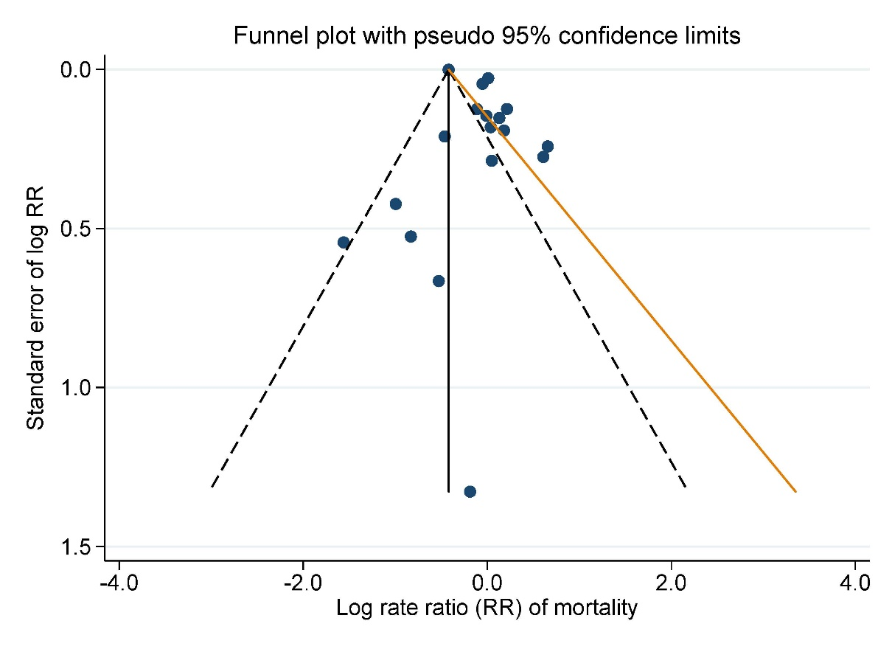
FIGURE S2. Funnel plot visualizing the risk of publication bias among the studies analyzed for the mortality outcome, rate ratio (RR).

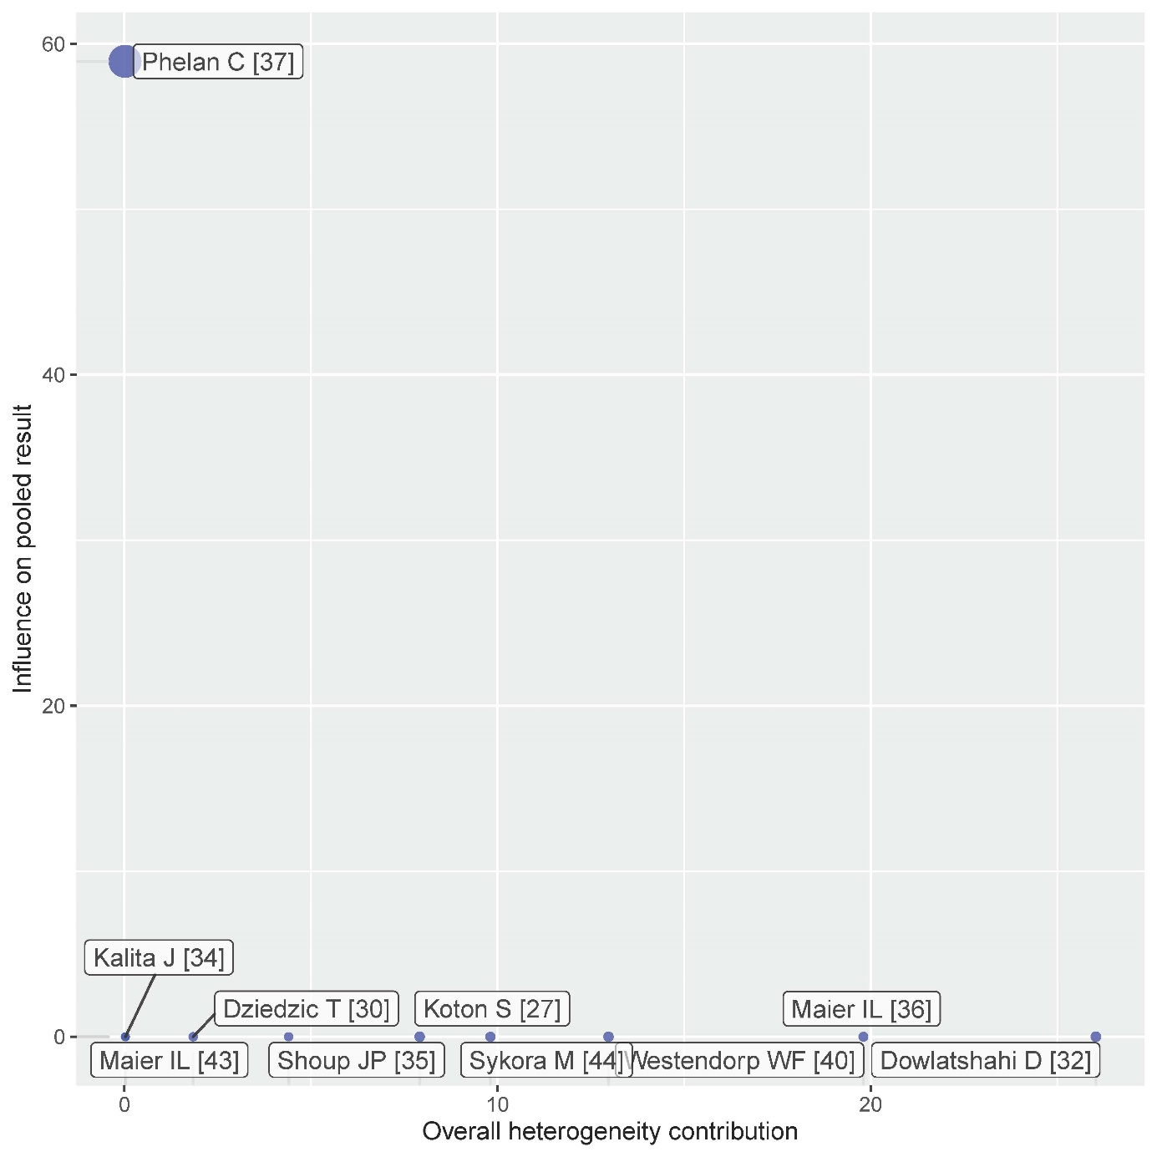
Figure S3. Baujat plot demonstrating the source of heterogeneity among the studies presenting adjusted (for stroke severity and age).

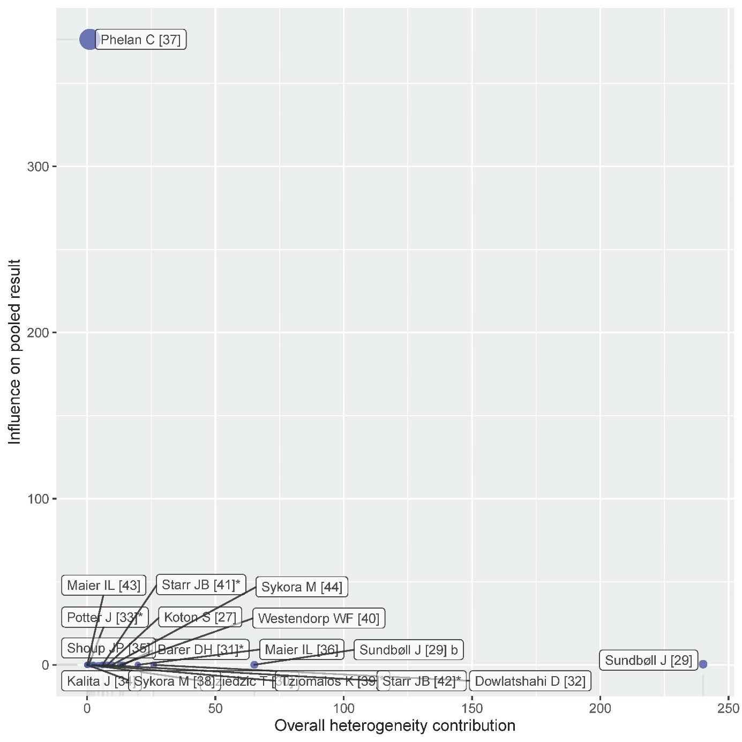
Figure S4. Baujat plot demonstrating the source of heterogeneity among the studies analyzed for the mortality outcome.

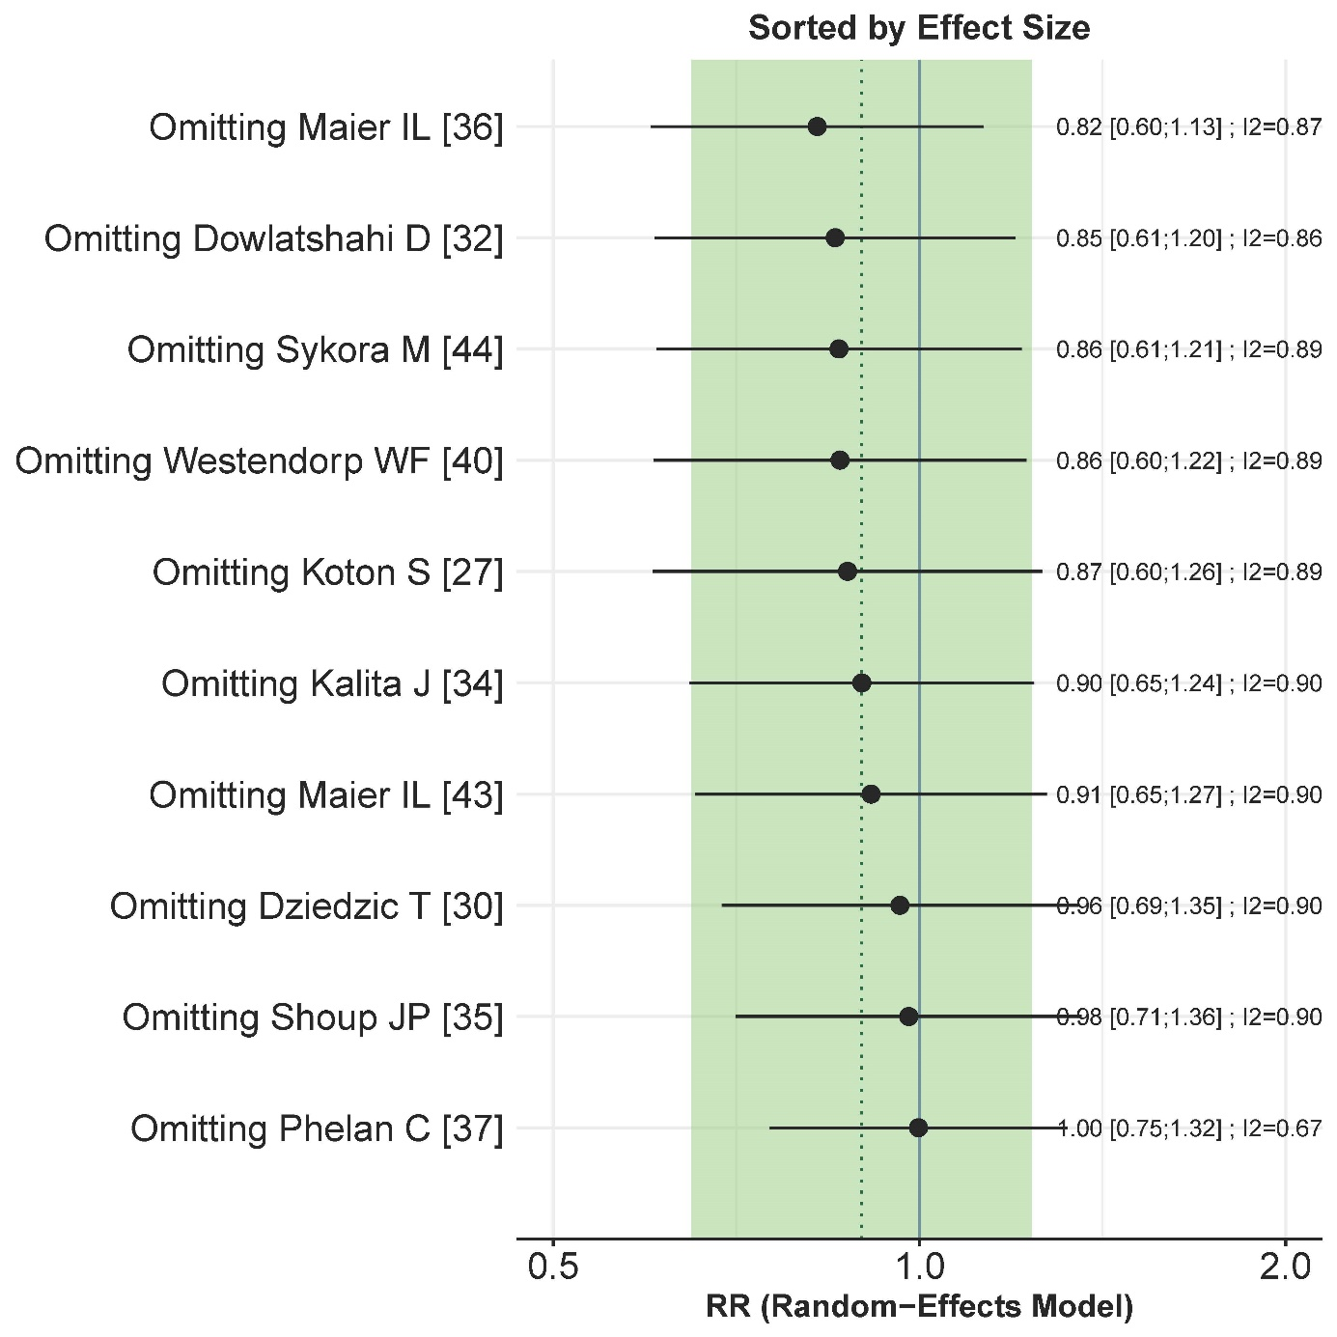
Figure S5. LOO (leave_one_out) method for sensitivity analysis for the studies presenting adjusted (for stroke severity and age) rate ratio (RR) for the outcome on mortality.

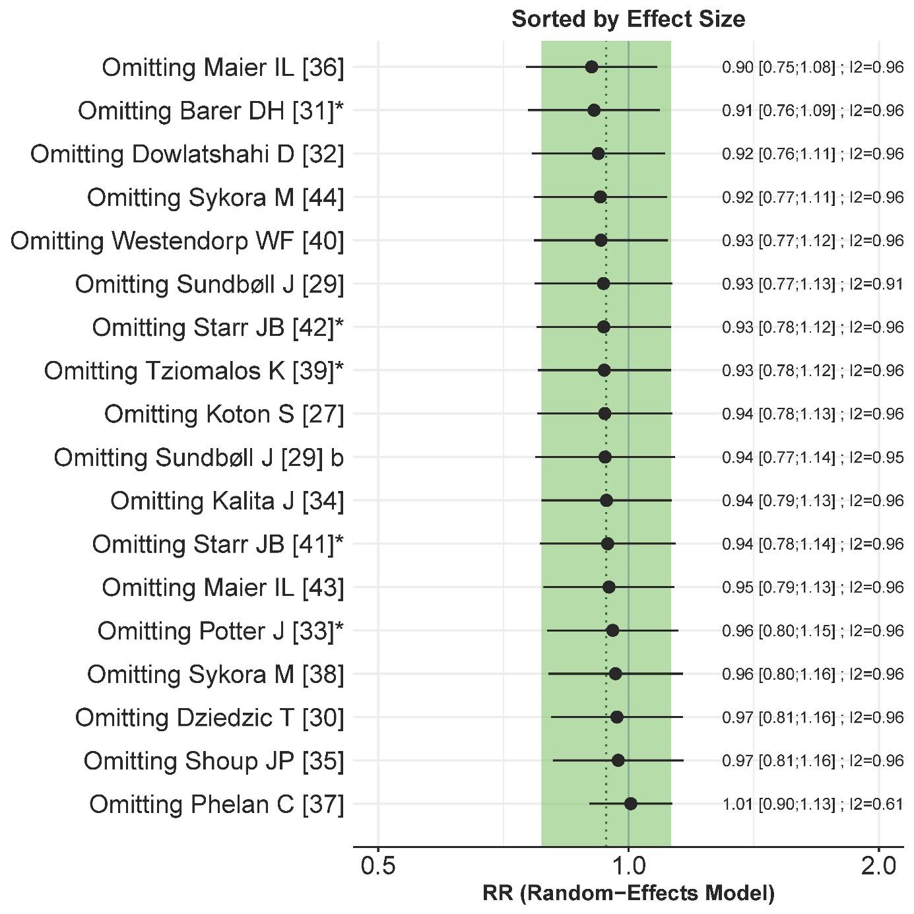
Figure S6. LOO (leave_one_out) method for sensitivity analysis for the studies analyzed for the mortality outcome.

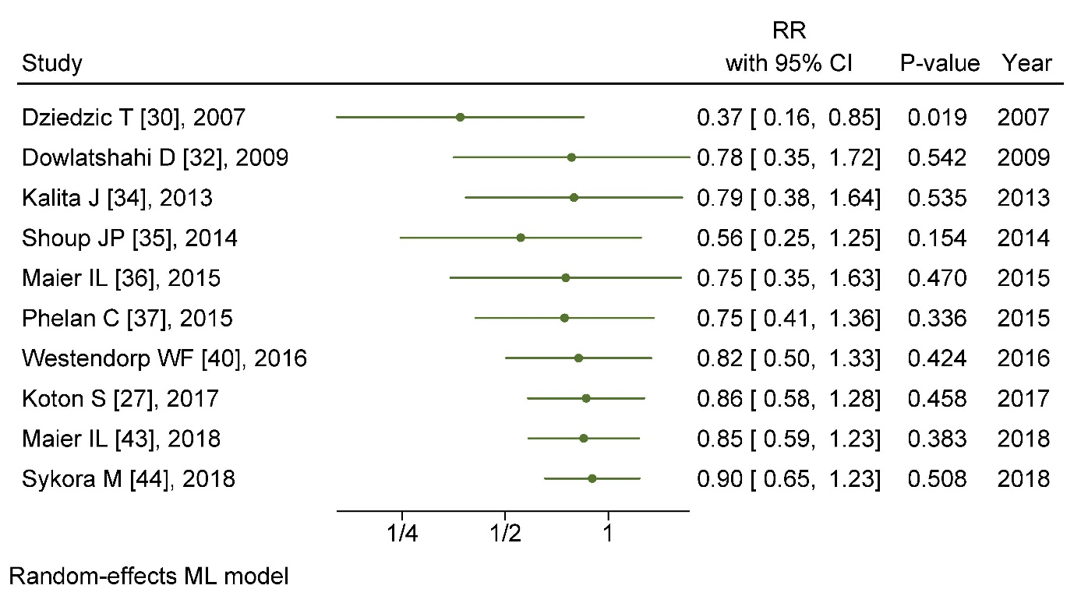
Figure S7. Cumulative meta-analysis for the studies presenting adjusted (for stroke severity and age) rate ratio (RR) for the outcome on mortality

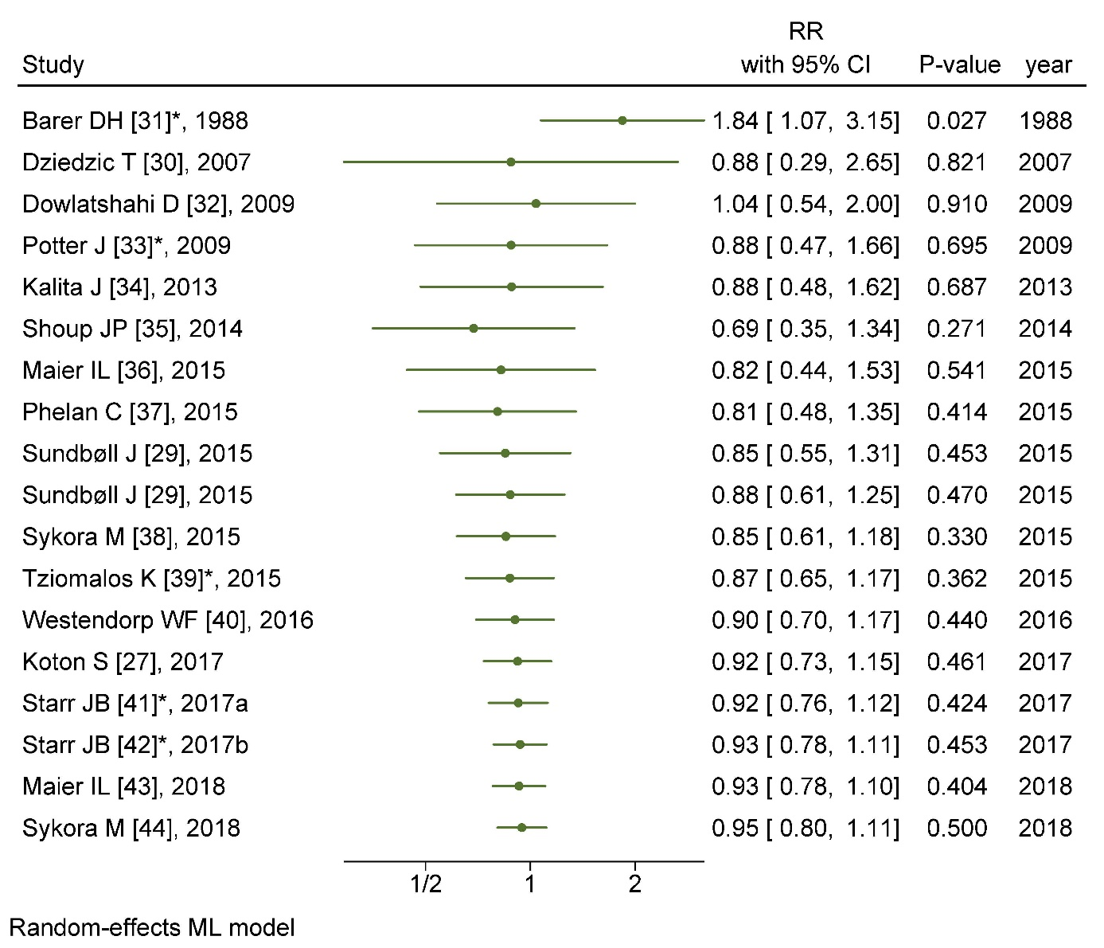
Figure S8. Cumulative meta-analysis for the studies analyzed for the mortality outcome, rate ratio (RR)

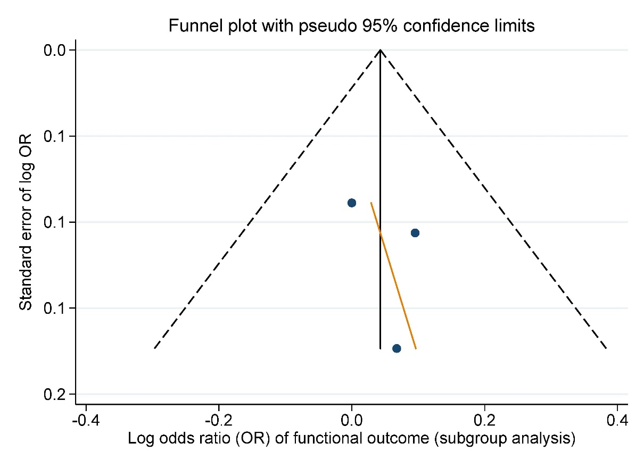
FIGURE S9. Funnel plot visualizing the risk of publication bias among the studies presenting adjusted (for stroke severity and age) odds ratio (OR) for the outcome functional outcome.

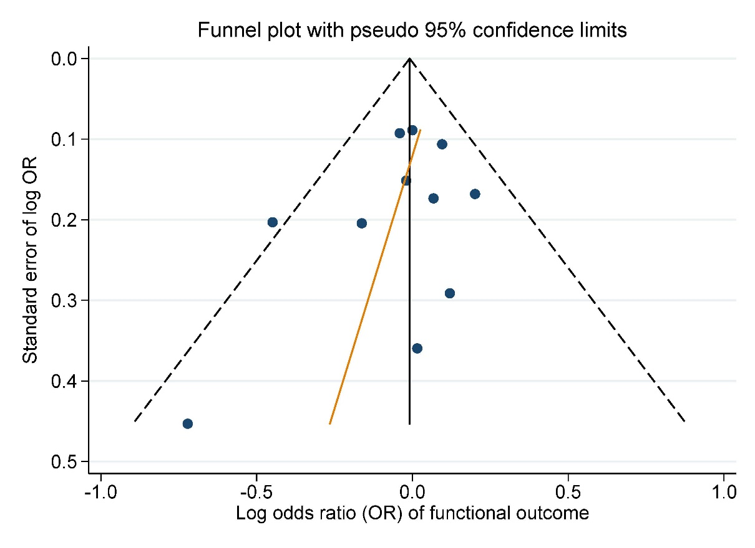
FIGURE S10. Funnel plot visualizing the risk of publication bias among the studies analyzed on functional outcome, odds ratio (OR).

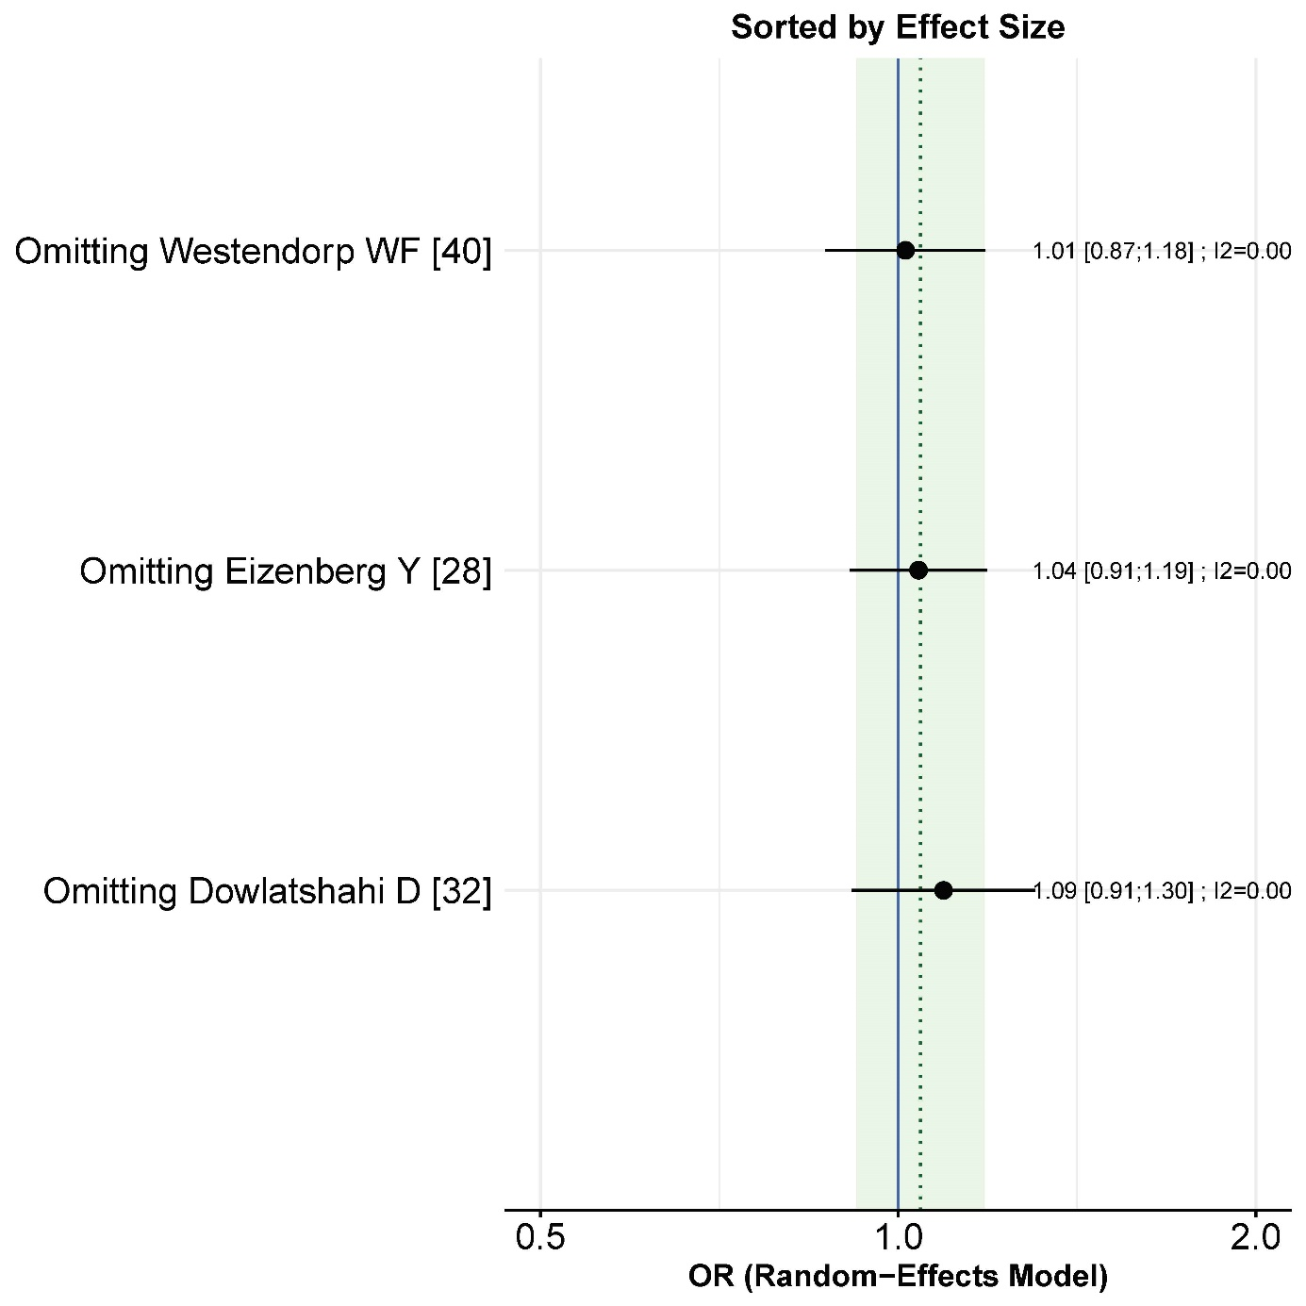
Figure S11. LOO (leave_one_out) method for sensitivity analysis for the studies presenting adjusted (for stroke severity and age) odds ratio (OR) for the outcome functional outcome.

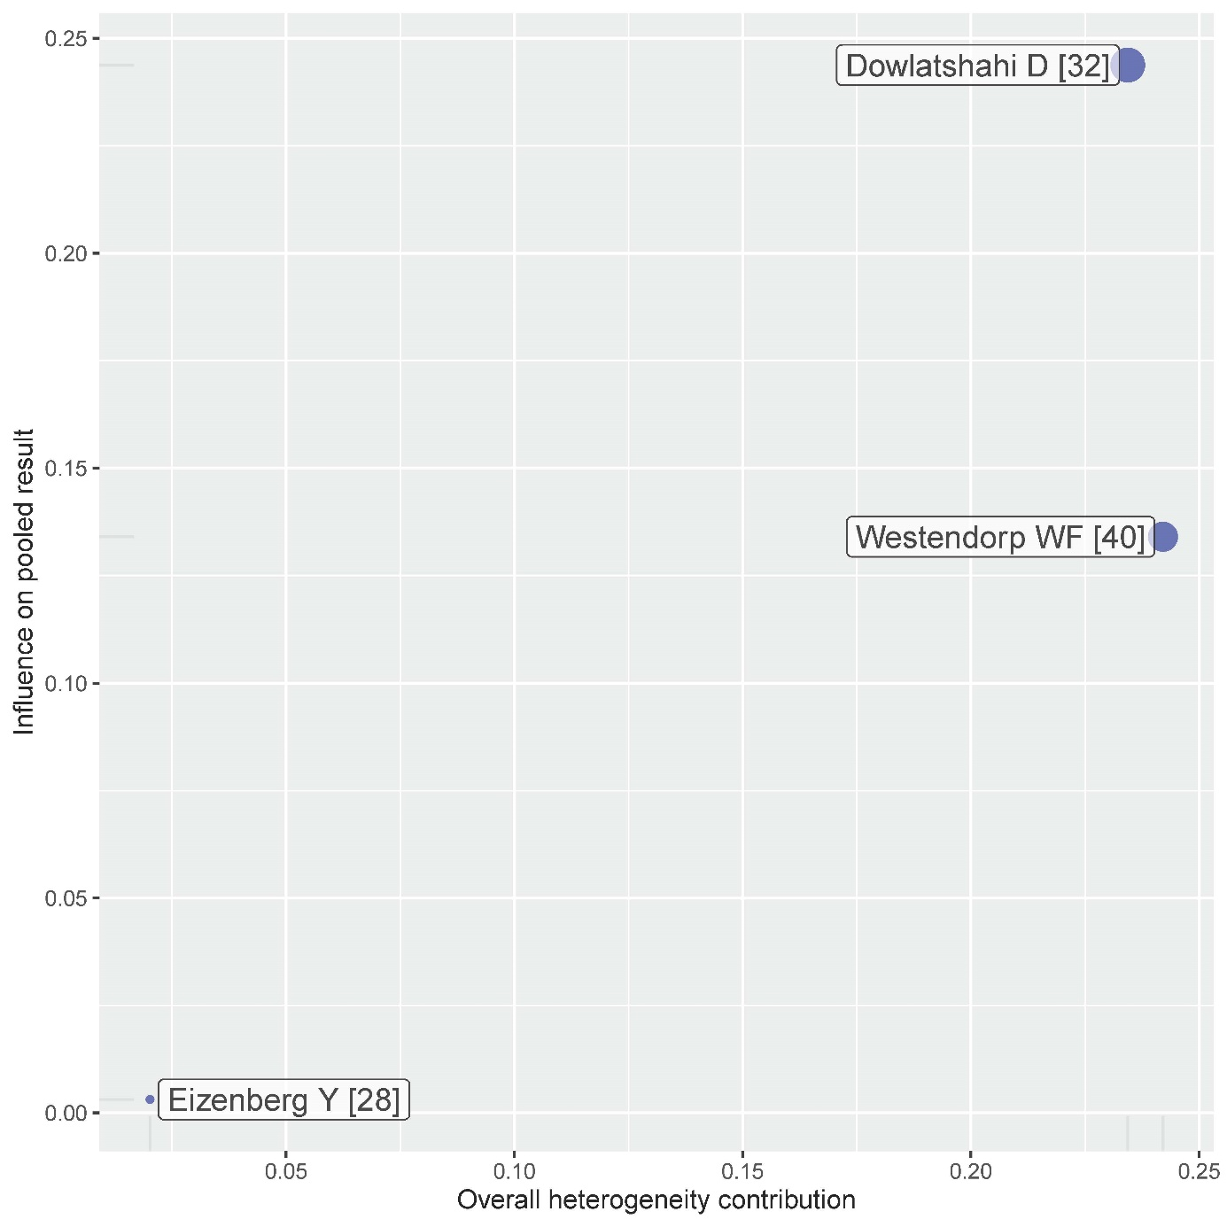
Figure S12. Baujat plot demonstrating the source of heterogeneity for the studies presenting adjusted (for stroke severity and age) odds ratio (OR) for the outcome functional outcome.

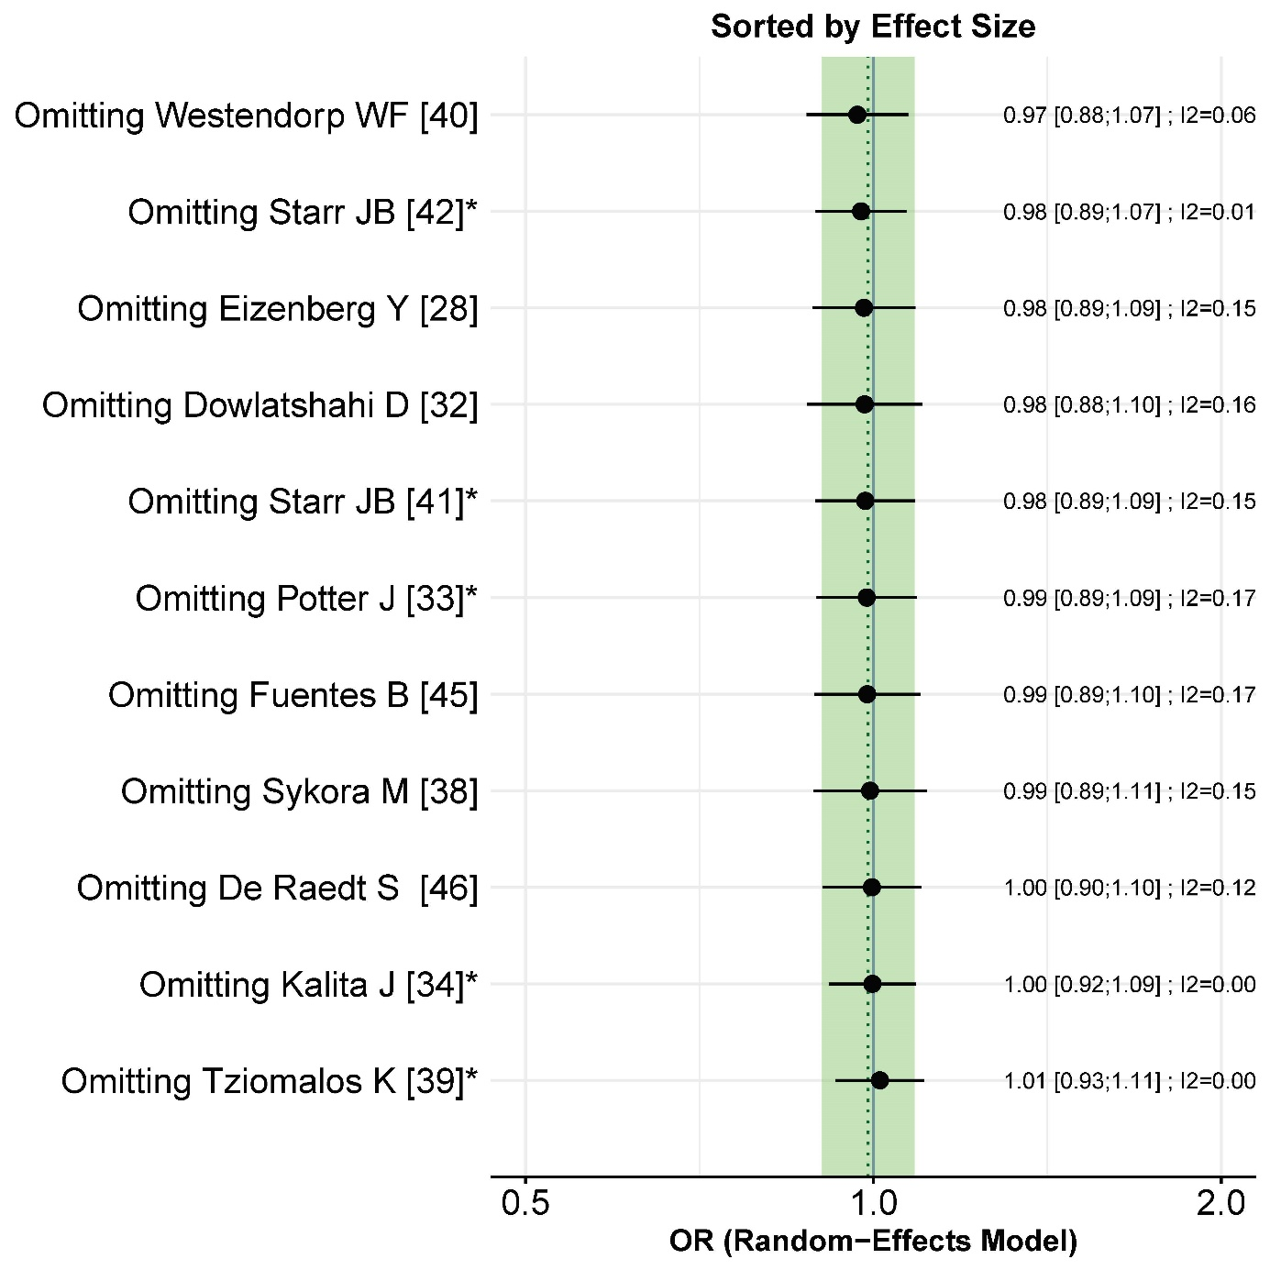Figure S13. LOO (leave_one_out) method for sensitivity analysis for the studies analyzed on functional outcome, odds ratio (OR).

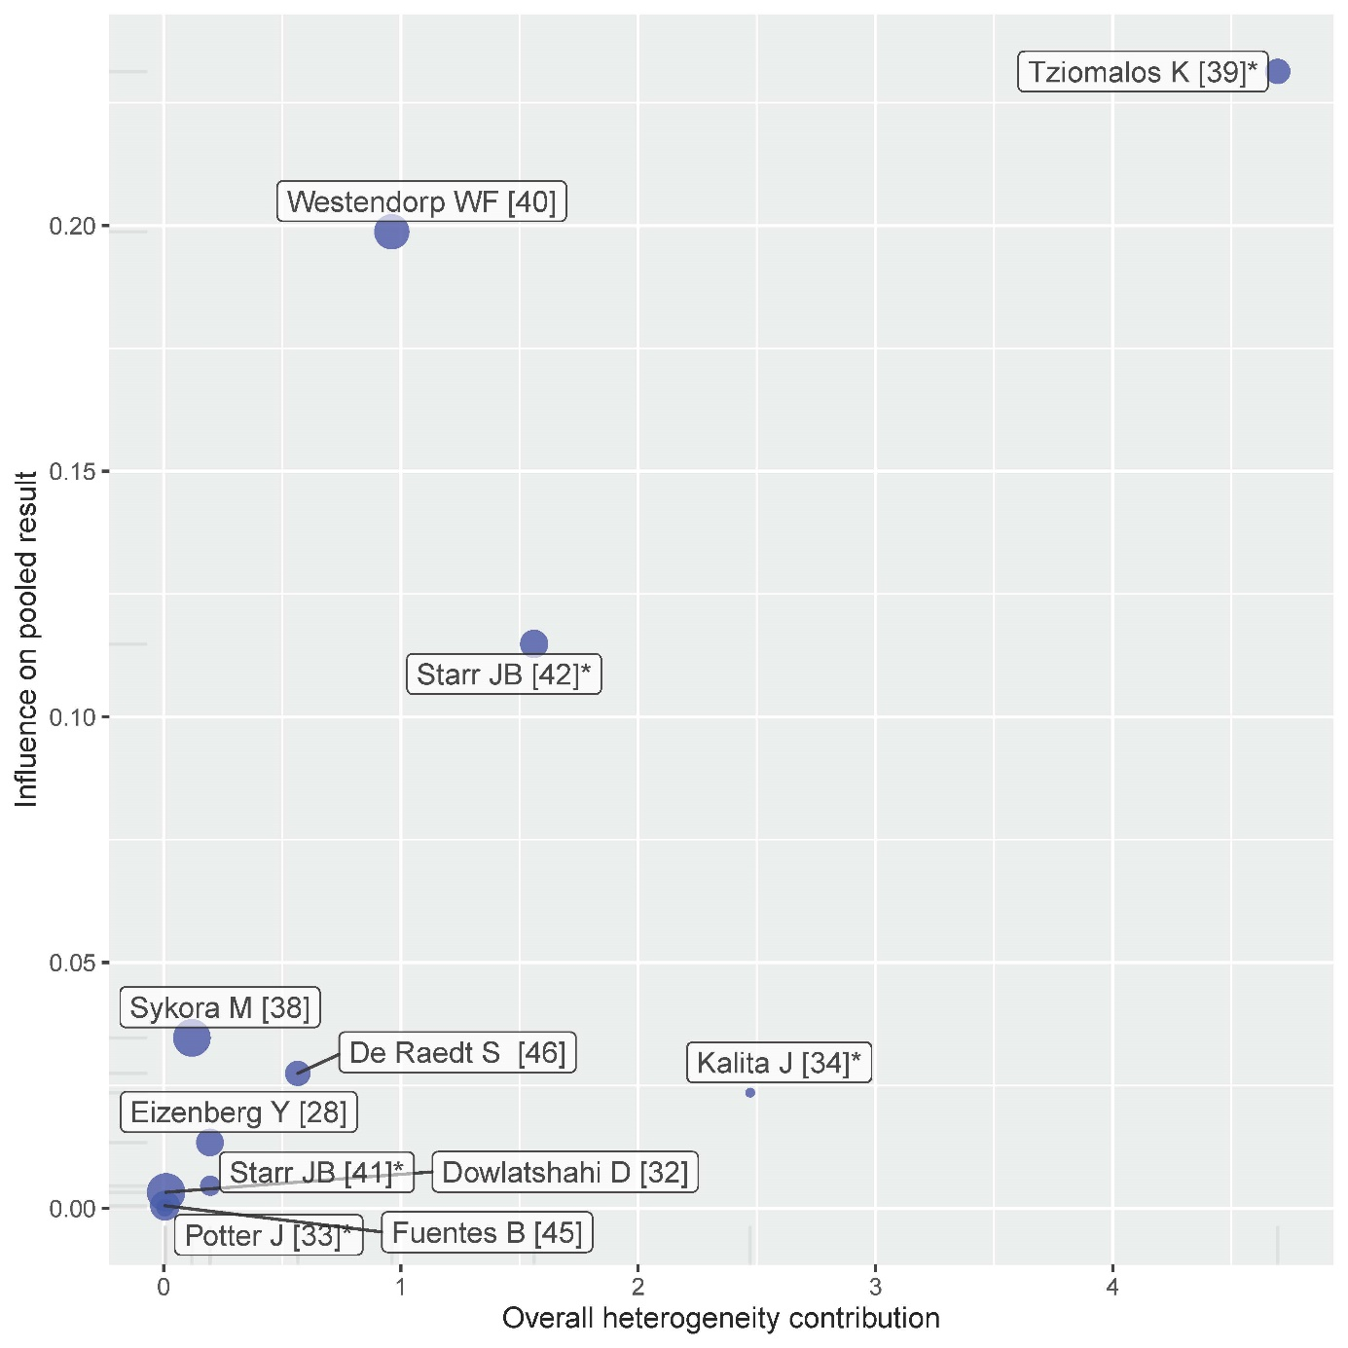
Figure S14. Baujat plot demonstrating the source of heterogeneity for the studies analyzed on functional outcome, odds ratio (OR).

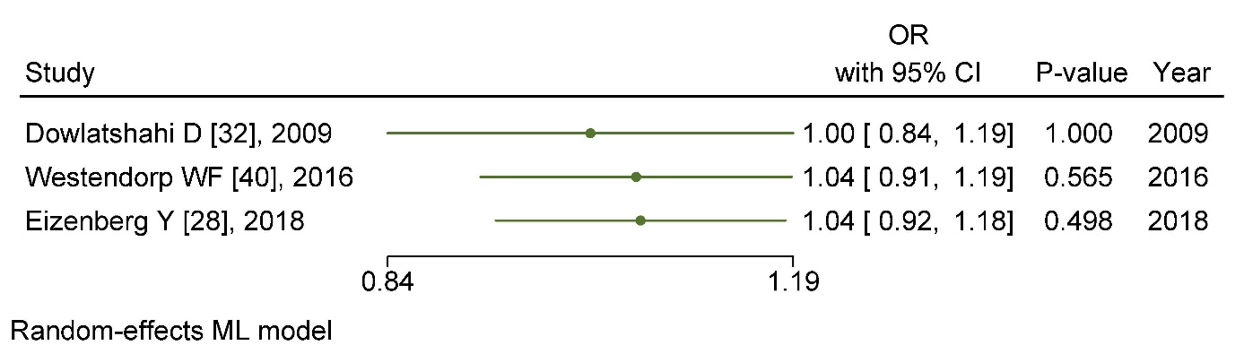
Figure S15. Cumulative meta-analysis for the studies presenting adjusted (for stroke severity and age) odds ratio (OR) for the outcome functional outcome.

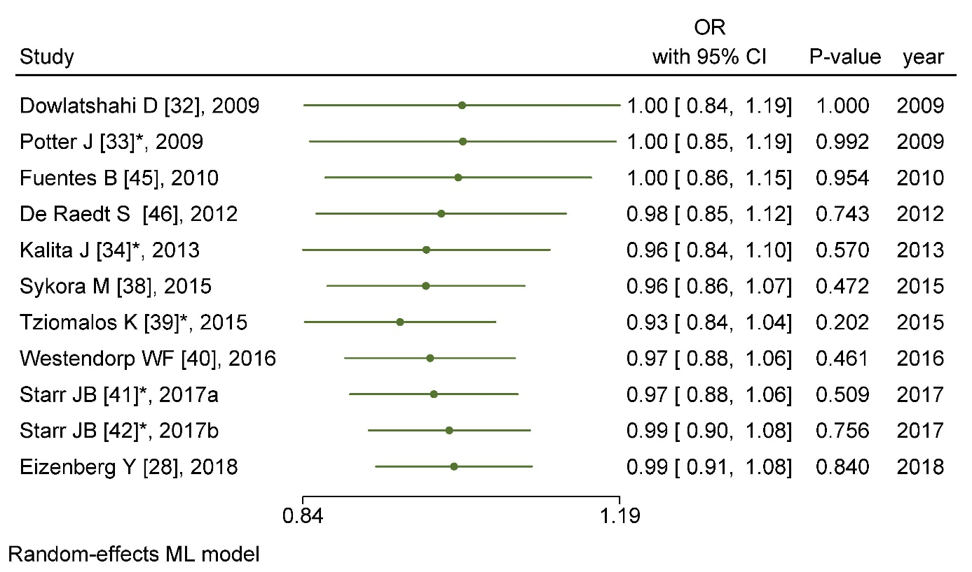
Figure S16. Cumulative meta-analysis for the studies analyzed on functional outcome, odds ratio (OR).

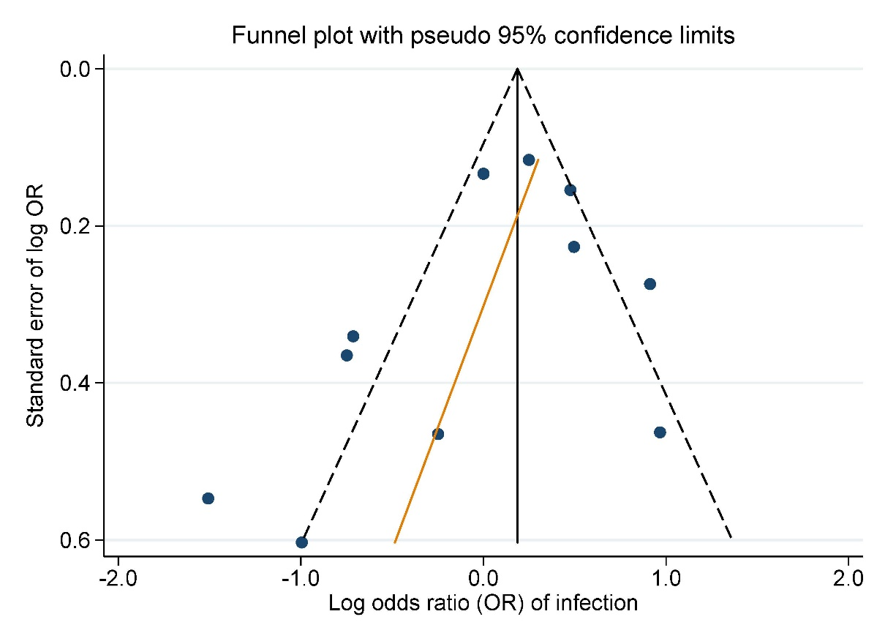
FIGURE S17. Funnel plot visualizing the risk of publication bias among the studies analyzed on the infection outcome, odds ratio (OR).

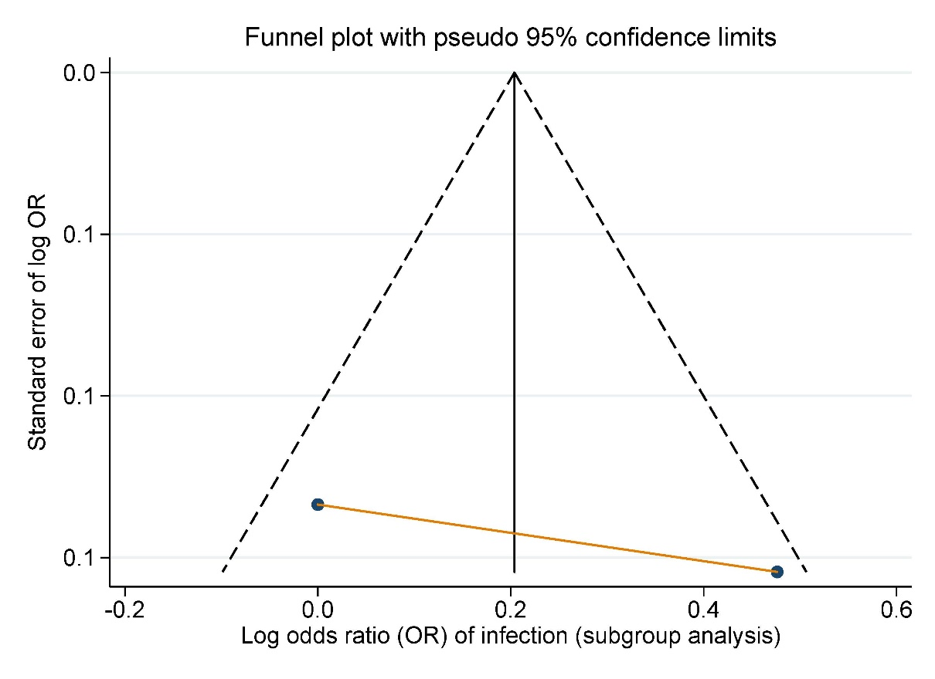
FIGURE S18. Funnel plot visualizing the risk of publication bias among the studies presenting adjusted (for stroke severity and age) odds ratio (OR) for the infection outcome.

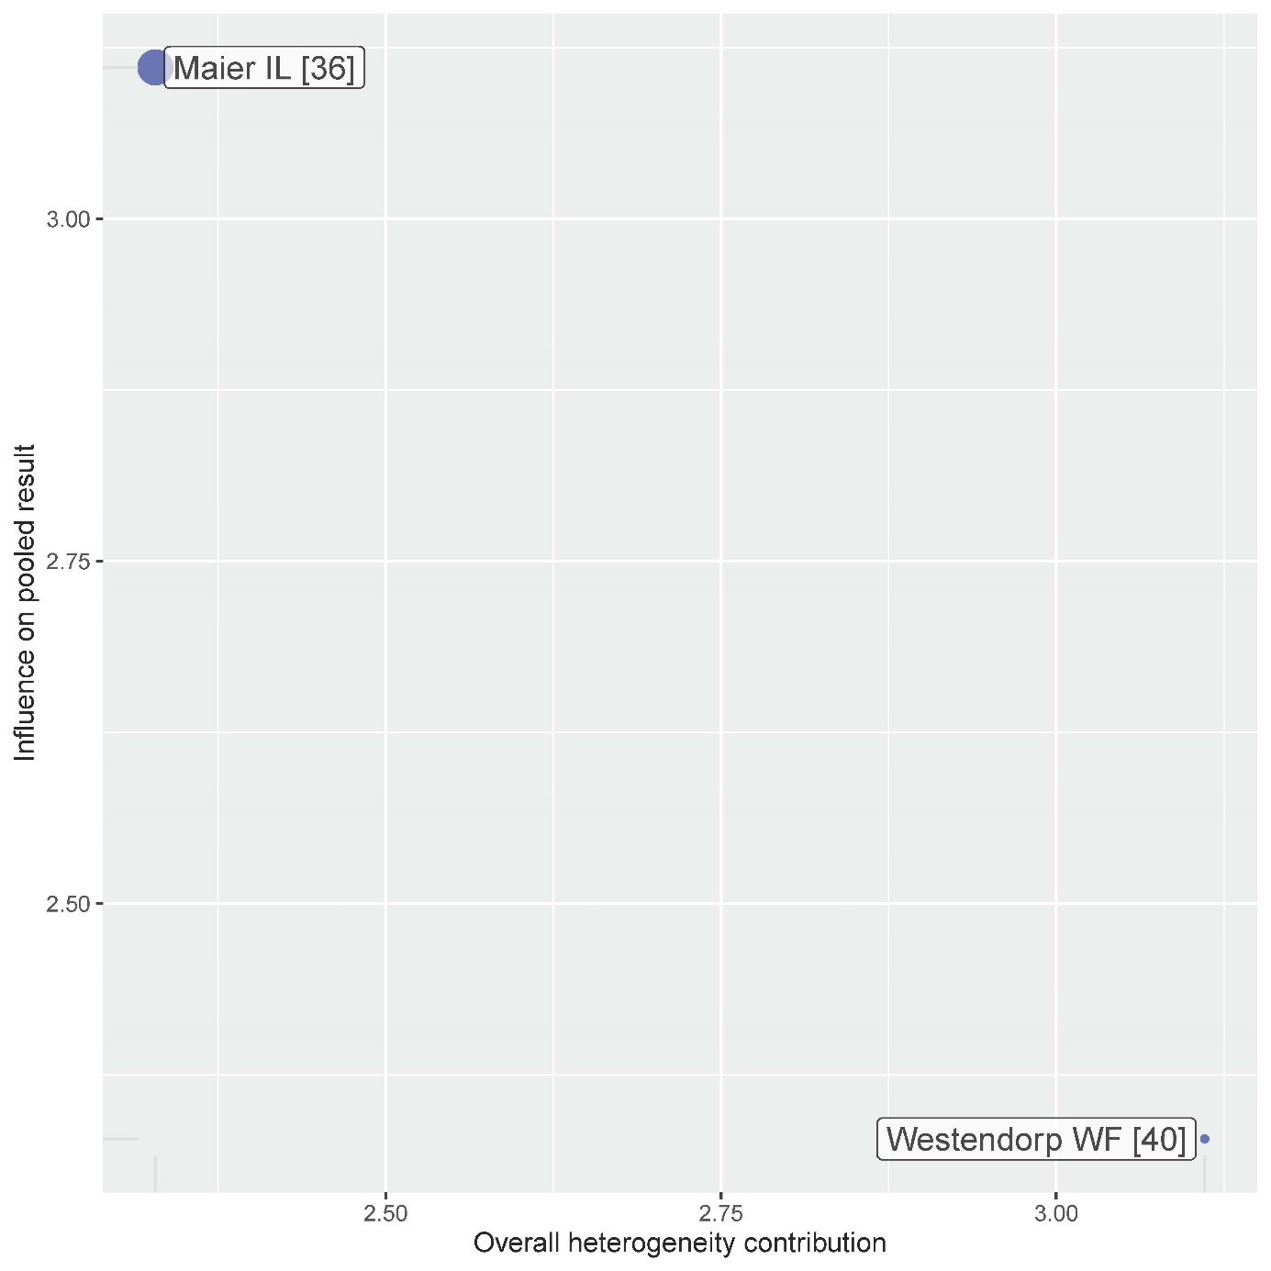
Figure S19. Baujat plot demonstrating the source of heterogeneity for the studies presenting adjusted (for stroke severity and age) odds ratio (OR) for the infection outcome.

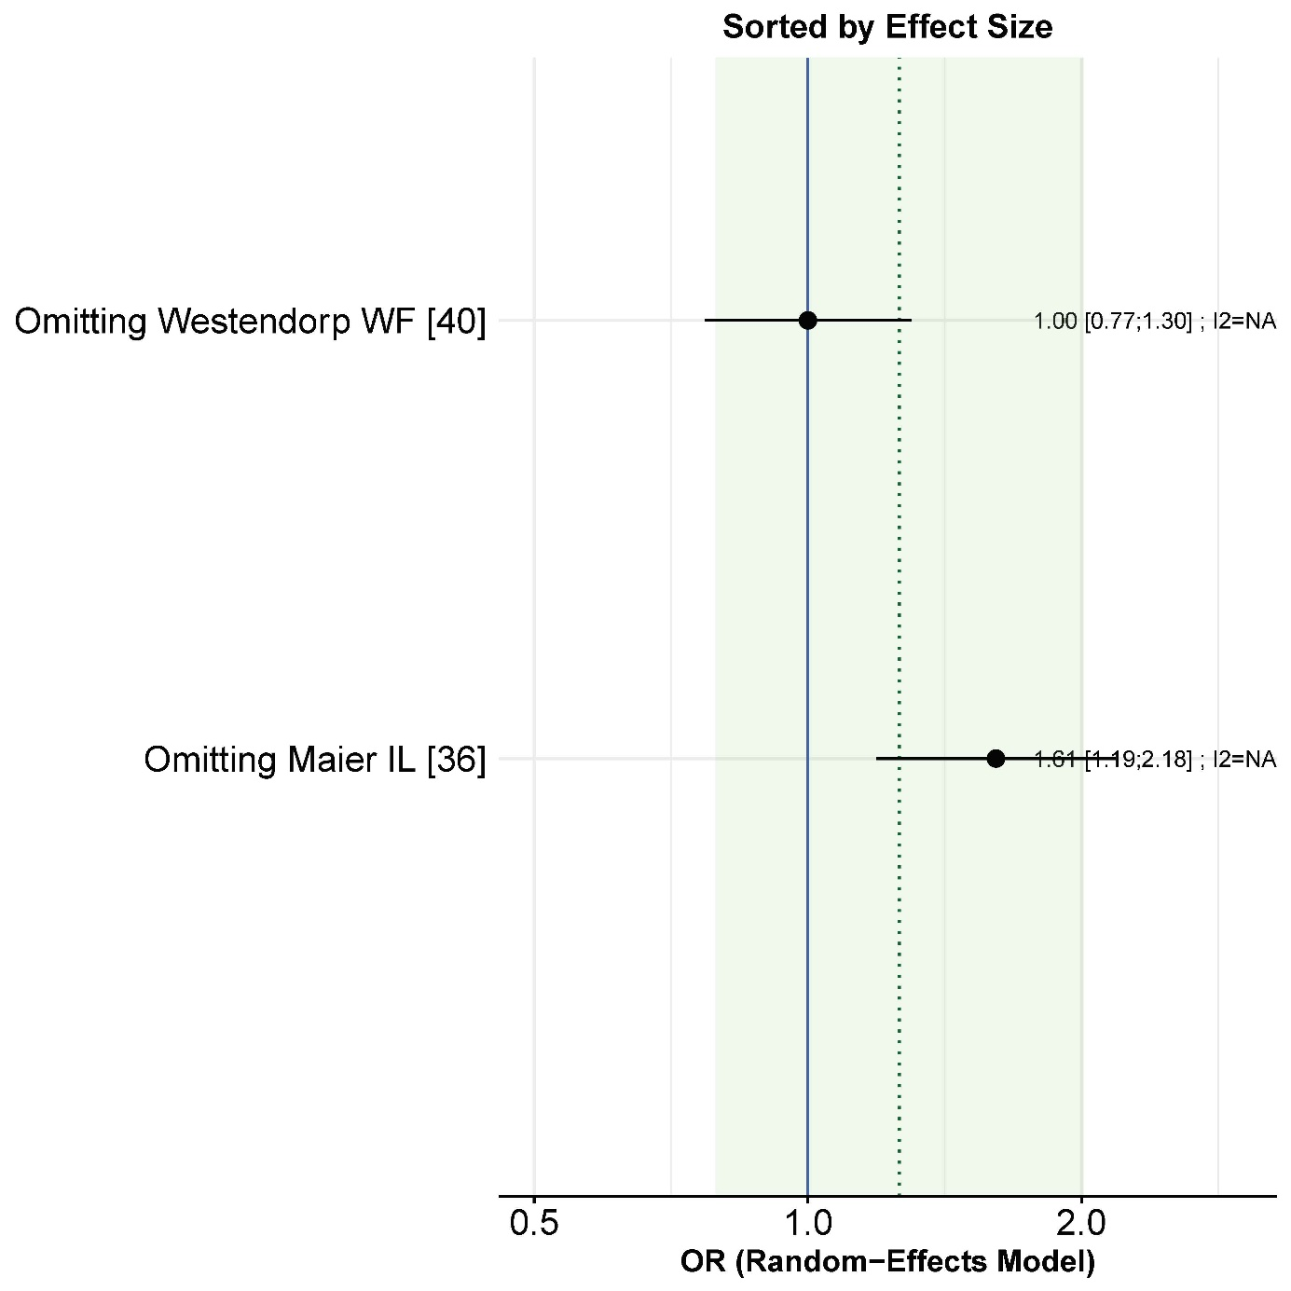
Figure S20. LOO (leave_one_out) method for sensitivity analysis for the studies presenting adjusted (for stroke severity and age) odds ratio (OR) for the infection outcome.

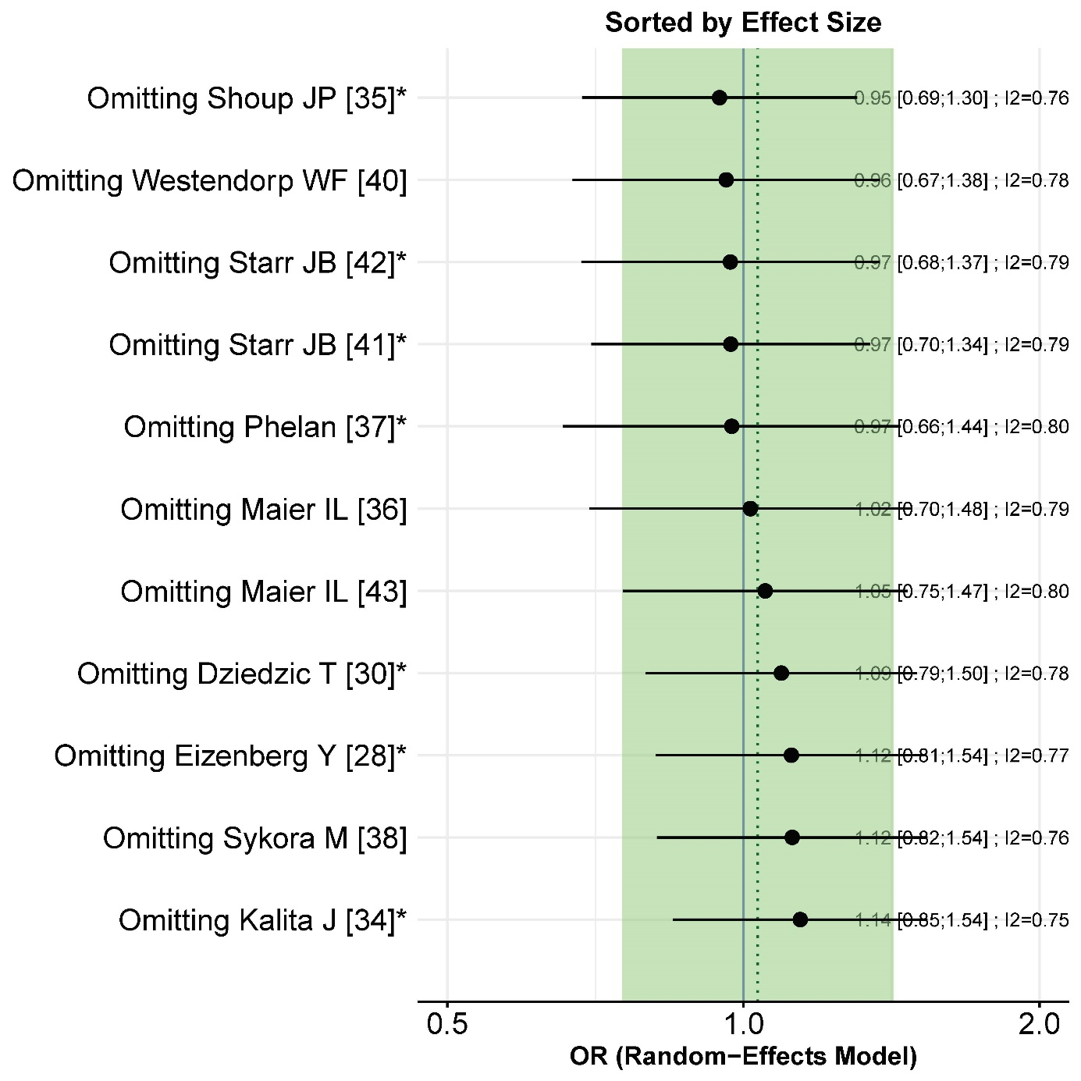
Figure S21. LOO (leave_one_out) method for sensitivity analysis the studies analyzed on functional outcome, odds ratio (OR).

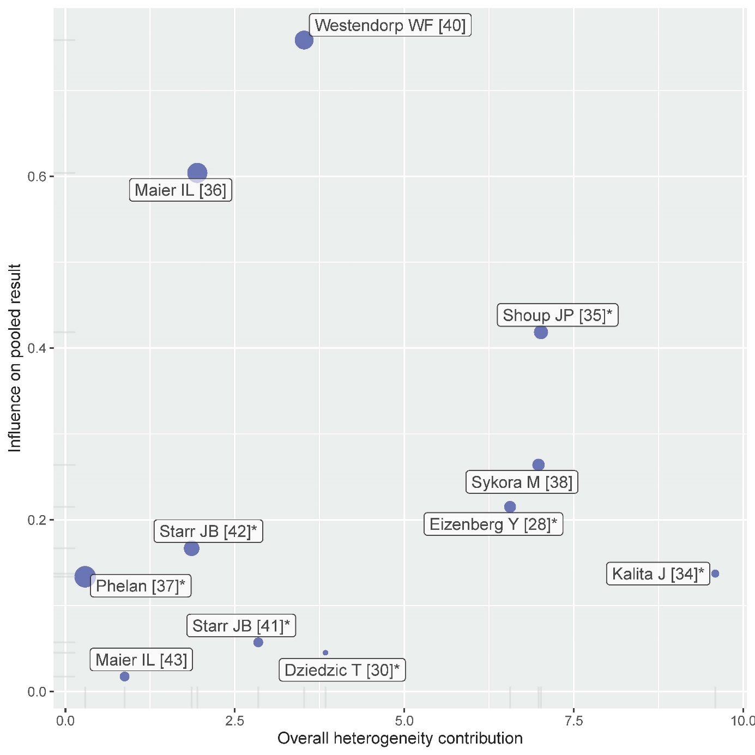
Figure S22. Baujat plot demonstrating the source of heterogeneity the studies analyzed on functional outcome, odds ratio (OR).

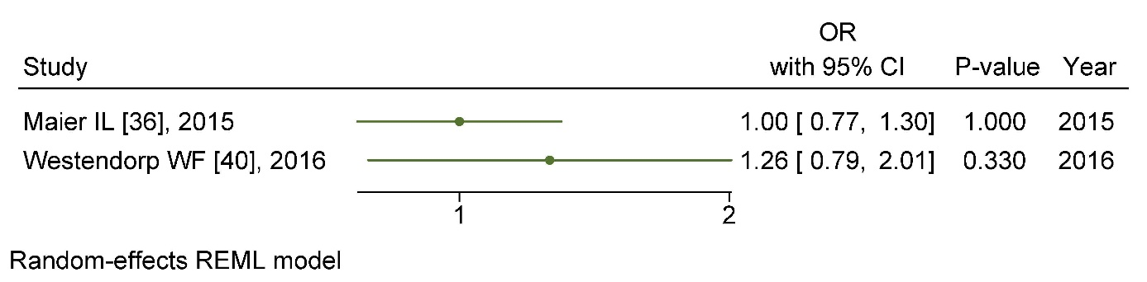
Figure S23. Cumulative meta-analysis the studies presenting adjusted (for stroke severity and age) odds ratio (OR) for the outcome functional outcome.

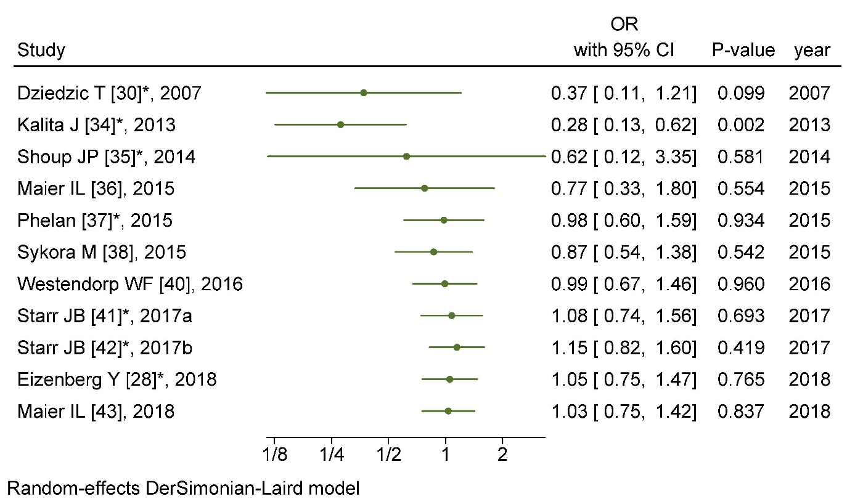
Figure S24. Cumulative meta-analysis the studies analyzed on functional outcome, odds ratio (OR).

TABLE S7. Summary of findings table
Certainty assessment |  |  |  |  |  |  | № of patients |  | Effect |  | Certainty | Importance
№ of studies | Study design | Risk of bias | Inconsistency | Indirectness | Imprecision | Other considerations | Beta-blockers | Non-beta-blockers | Relative  (95% CI) | Absolute  (95% CI) | Certainty | Importance
Mortality
18 | observational studies | serious ª | serious ^{b} | not serious | not serious | publication bias strongly suspected ^{c} | 26186/116540 (22.5%) | 90354/116540 (77.5%) | RR 0.94  (0.79 to 1.12) | 47 fewer per 1 000  (from 163 fewer to 93 more) | ⨁◯◯◯  VERY LOW | NOT IMPORTANT
Mortality subanalysis
10 | observational studies | not serious | serious ^{d} | not serious | not serious | none | 5557/17001 (32.7%) | 11444/17001 (67.3%) | RR 0.90  (0.65 to 1.24) | 67 fewer per 1 000  (from 236 fewer to 162 more) | ⨁◯◯◯  VERY LOW | IMPORTANT
Functional outcome
11 | observational studies | serious ^{e} | not serious | not serious | not serious | none | 4503/19122 (23.5%) | 14619/19122 (76.5%) | OR 0.99  (0.91 to 1.08) | 2 fewer per 1 000  (from 17 fewer to 14 more) | ⨁◯◯◯  VERY LOW | NOT IMPORTANT
Functional outcome subanalysis
3 | observational studies | not serious | not serious | not serious | not serious | none | 2988/9038 (33.1%) | 6050/9038 (66.9%) | OR 1.04  (0.92 to 1.18) | 9 more per 1 000  (from 19 fewer to 36 more) | ⨁⨁◯◯  LOW | IMPORTANT
Infection
11 | observational studies | serious ^{f} | serious ^{g} | not serious | not serious | publication bias strongly suspected | 3324/14305 (23.2%) | 10981/14305 (76.8%) | OR 1.03  (0.75 to 1.42) | 5 more per 1 000  (from 55 fewer to 57 more) | ⨁◯◯◯  VERY LOW | NOT IMPORTANT
Infection subanalysis
2 | observational studies | not serious | serious ^{h} | not serious | not serious | none | 1186/3158 (37.6%) | 1972/3158 (62.4%) | OR 1.26  (0.79 to 2.01) | 52 more per 1 000  (from 57 fewer to 145 more) | ⨁◯◯◯  VERY LOW | IMPORTANT
CI: Confidence interval; RR: Risk ratio; OR: Odds ratio
Explanations
a. 8 of the 18 assessed studies didn´t present adjusted data for age and stroke severity for our analysis, se Table S5
b. The studies proved to be heterogeneous (I2 95.9% p = 0.000 )
c. Egger’s test showed significant (p = 0.014; funnel plot in Figure S8) risk for publication bias
d. The studies proved to be heterogeneous (I2=89.1% ORs; p = 0.000)
e. 8 of the 11 assessed studies didn´t present adjusted data for age and stroke severity for our analysis, se Table S5
f. 9 of the 11 assessed studies didn´t present adjusted data for age and stroke severity for our analysis, se Table S5
g. The studies were heterogeneous, ( I2 = 77.9%, p = 0.000 )
h. The studies were heterogeneous, (I2=81.6%, p=0.020 )

