SUPPLEMENTAL DATA
Table 1. Participants not included in final analysis

Variable |  | N | COPD | No COPD | P-value
Socio-demographics |  | 321
Age, in years: Mean ± SD |  |  | 46.3 (10.3) | 46.7 (10.8) | 0.904
Sex: Female |  |  | 8 (66.7) | 172 (55.7) | 0.648
Head of house: Yes |  |  | 10 (83.3) | 209 (68.3) | 0.432
Working: Yes |  |  | 11 (91.7) | 260 (85) | 0.821
Marital status, n (%) |  |  |  |  | 0.336
 | Single |  | 1 (8.3) | 34 (11.1)
 | Married |  | 6 (50) | 197 (64.4)
 | Cohabiting |  | 3 (25) | 14 (4.6)
 | Separated/Divorced |  | 1 (8.3) | 30 (9.8)
 | Widow/Widower |  | 1 (8.3) | 25 (8.2)
Household characteristics
Household size, median (IQR) |  |  | 4 (2.8 , 4.2) | 5 (3 , 7) | 0.116
Has chimney, n (%) |  |  | 1 (9.1) | 26 (8.6) | 1
Cooking location, n (%) |  |  | 4 (2.8 , 4.2) | 5 (3 , 7) | 0.043
 | Outside the house |  | 3 (25) | 155 (51.3)
 | Inside the main living area |  | 4 (33.3) | 34 (11.3)
 | In a separate room/hut |  | 5 (41.7) | 113 (37.4)
Fuel source |  |  |  |  | 0.404
 | Wood |  | 7 (58.3) | 122 (40.3)
 | Coal |  | 5 (41.7) | 169 (55.8)
 | Other |  | 0 (0) | 12 (4)
Smoking status
 | Daily Smoker |  | 9 (75) | 267 (87.3) | 0.426
 | Pack-years: Median (IQR) |  | 0 (0 , 0) | 0 (0 , 0)
 | Pack-years: Mean ± SD |  | 3.3 (7.7) | 0.9 (4.3) | 0.073
Lung function, median (IQR)
 | Pre-bronchodilator FEV |  | 1.5 (1.2 , 1.8) | 2.5 (2.1 , 3.1) | <0.000
 | Pre-bronchodilator FVC |  | 2.8 (2.3 , 3.2) | 3.1 (2.6 , 3.8) | 0.088
 | Pre-bronchodilator FEV/FVC ratio |  | 56.7 (50.4 , 60) | 81.2 (77.6 , 84.8) | <0.000
 | Peak Expiratory Flow |  | 254.7 (191.5 , 304.9) | 408.6 (339.6 , 504) | <0.000
Body mass index, mean (SD) |  |  | 21.8 (4.7) | 21.9 (20.7 , 24.5) | 24.4 (21.6 , 28)
History of pulmonary tuberculosis, n (%) |  |  | 7 (15.2%) | 1.5 (1.2 , 1.8) | 2.5 (2.1 , 3.1)

Supplement Figure 1. Peak expiratory flow (PEF) and the prevalence of COPD

Risk factors for COPD and diagnostic accuracy of demographic and respiratory questionnaires alone (six questions), peak expiratory flow (PEF) alone and combined questionnaires with PEF. Odds of COPD (left panel) stratified by age and symptom score, PEF and combined age, symptoms/exposure score and PEF with 95% CI. Area under the curve (AUC) for COPD (right panel) stratified by age and symptom score, PEF and combined age, symptoms score and PEF with 95% CI.

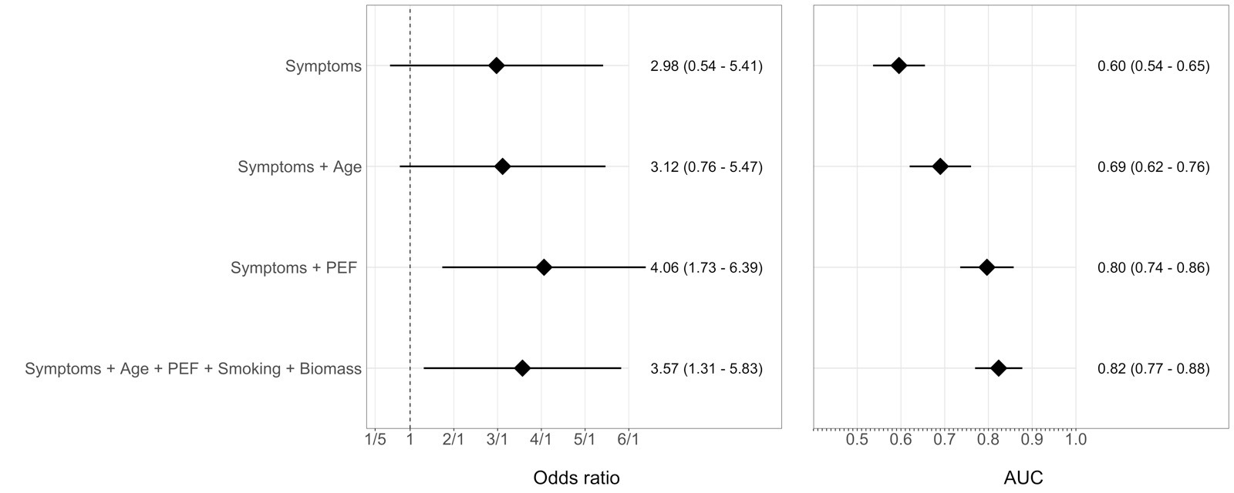

Sensitivity Analysis using PEF cutoffs
450L/min
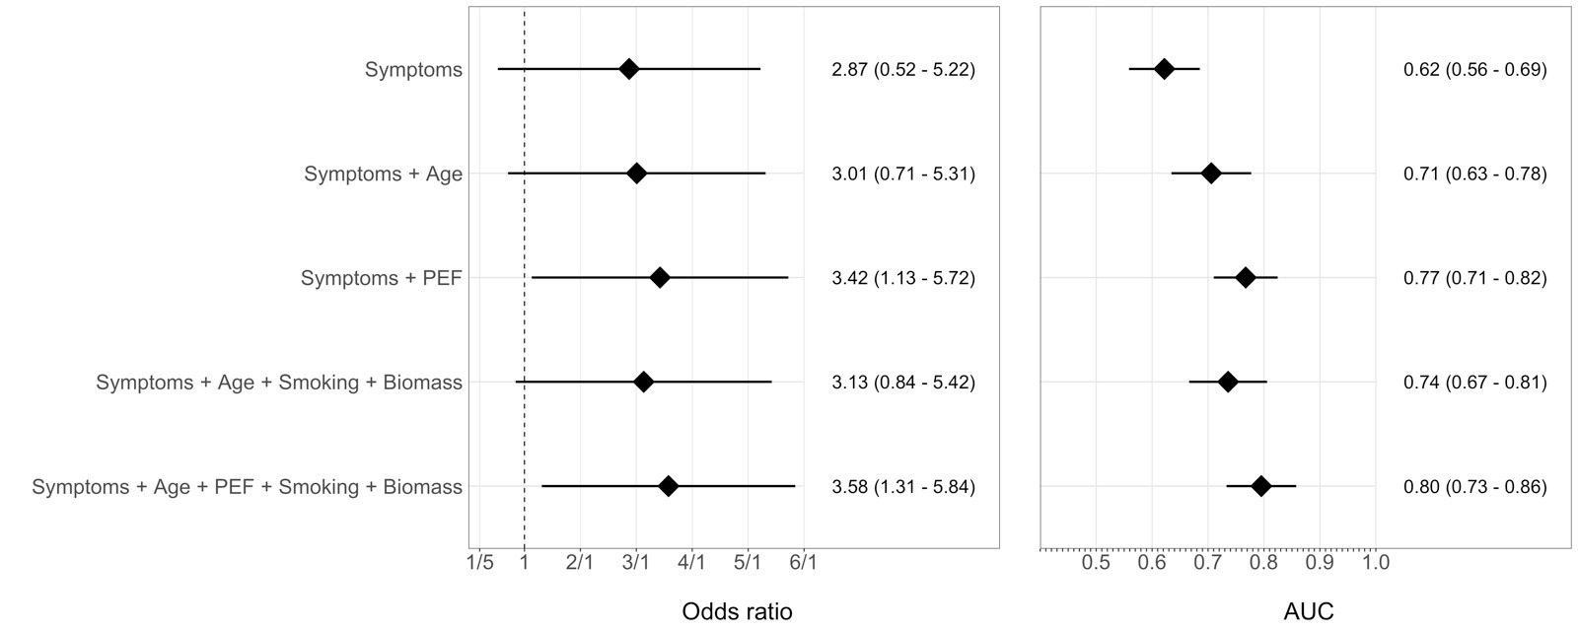
400 L/min
