Supplementary Figure 1 HPLC-MS/MS chromatograms of cerebrospinal fluid (CSF) samples in rats. (A) control CSF. (B) CSF sample was collected at 6 h in rats after oral administration of physcion in the I/R + physcion_40 mg/kg group.
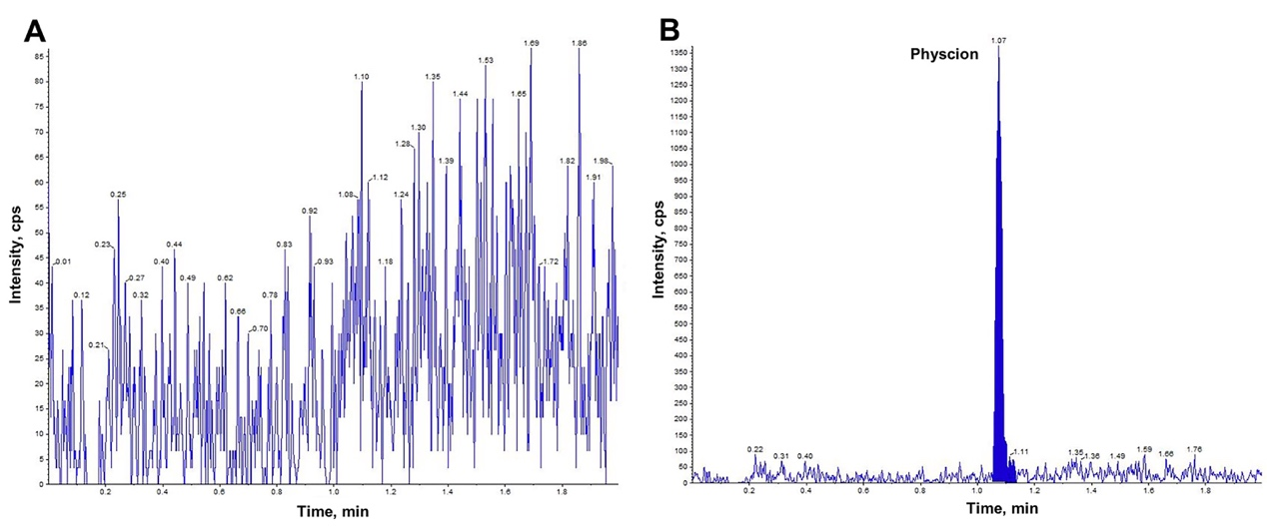
Supplementary Table 1 Cerebral infarction area
 | No. | Sham | I/R | I/R + Physcion_20 mg/kg | I/R + Physcion_40 mg/kg
Cerebral infarction area | 1 | 0 | 153108 | 111279 | 72325
Cerebral infarction area | 2 | 0 | 145356 | 109953 | 57683
Cerebral infarction area | 3 | 0 | 168755 | 123441 | 83341
Cerebral infarction area | 4 | 0 | 153314 | 131145 | 75663
Cerebral infarction area | 5 | 0 | 142235 | 99115 | 68761
Cerebral infarction area | 6 | 0 | 172331 | 116713 | 73114
Total area | 1 | 608520 | 591366 | 603322 | 630892
Total area | 2 | 615514 | 622114 | 603114 | 617813
Total area | 3 | 624413 | 598871 | 603341 | 611413
Total area | 4 | 598711 | 611345 | 604418 | 609871
Total area | 5 | 611453 | 603341 | 611347 | 618763
Total area | 6 | 623411 | 607311 | 613435 | 623466
Supplementary Table 2 Cerebral water content
 | No. |  | Sham | I/R | I/R + Physcion_20 mg/kg | I/R + Physcion_40 mg/kg
wet weight/g |  | 1 | 0.732 | 0.805 | 0.796 | 0.756
 |  | 2 | 0.741 | 0.811 | 0.785 | 0.761
 |  | 3 | 0.735 | 0.792 | 0.773 | 0.731
 |  | 4 | 0.737 | 0.771 | 0.811 | 0.756
 |  | 5 | 0.743 | 0.845 | 0.765 | 0.747
 |  | 6 | 0.756 | 0.825 | 0.781 | 0.783
dry weight/g |  | 1 | 0.219 | 0.151 | 0.162 | 0.179
 |  | 2 | 0.231 | 0.173 | 0.156 | 0.201
 |  | 3 | 0.206 | 0.162 | 0.168 | 0.164
 |  | 4 | 0.225 | 0.189 | 0.178 | 0.186
 |  | 5 | 0.216 | 0.157 | 0.188 | 0.183
 |  | 6 | 0.235 | 0.139 | 0.148 | 0.214
Cerebral water content (%) |  | 1 | 70.08 | 81.24 | 79.65 | 76.32
 |  | 2 | 68.83 | 78.67 | 80.13 | 73.59
 |  | 3 | 71.97 | 79.55 | 78.27 | 77.56
 |  | 4 | 69.47 | 75.49 | 78.05 | 75.40
 |  | 5 | 70.93 | 81.42 | 75.42 | 75.50
 |  | 6 | 68.92 | 83.15 | 81.05 | 72.67
Supplementary Table 3 Neurological severity scores
Time | Group | 1 | 2 | 3 | 4 | 5
 | Sham | 18 | 18 | 18 | 18 | 17
6h | I/R | 10 | 11 | 10 | 12 | 11
6h | I/R + Physcion_20 mg/kg | 13 | 13 | 12 | 14 | 12
6h | I/R + Physcion_40 mg/kg | 14 | 14 | 14 | 15 | 13
1 d | I/R | 6 | 5 | 8 | 8 | 9
1 d | I/R + Physcion_20 mg/kg | 10 | 9 | 8 | 8 | 12
1 d | I/R + Physcion_40 mg/kg | 11 | 11 | 13 | 10 | 10
3 d | I/R | 6 | 6 | 4 | 5 | 5
3 d | I/R + Physcion_20 mg/kg | 9 | 6 | 7 | 9 | 8
3 d | I/R + Physcion_40 mg/kg | 11 | 9 | 9 | 12 | 8
5 d | I/R | 11 | 8 | 9 | 12 | 10
5 d | I/R + Physcion_20 mg/kg | 12 | 10 | 11 | 14 | 11
5 d | I/R + Physcion_40 mg/kg | 15 | 15 | 13 | 12 | 13
7 d | I/R | 11 | 12 | 10 | 10 | 11
7 d | I/R + Physcion_20 mg/kg | 13 | 13 | 13 | 12 | 12
7 d | I/R + Physcion_40 mg/kg | 14 | 16 | 14 | 16 | 15
Supplementary Table 4 TUNEL positive cells
 | No. | Sham | I/R | I/R + Physcion_20 mg/kg | I/R + Physcion_40 mg/kg
Total cells | 1 | 123 | 113 | 123 | 127
Total cells | 2 | 116 | 118 | 129 | 123
Total cells | 3 | 120 | 123 | 113 | 118
TUNEL positive cells | 1 | 4 | 55 | 27 | 31
TUNEL positive cells | 2 | 5 | 51 | 33 | 20
TUNEL positive cells | 3 | 6 | 53 | 35 | 23
TUNEL positive cells rate | 1 | 3 | 49 | 22 | 24
TUNEL positive cells rate | 2 | 4 | 43 | 26 | 16
TUNEL positive cells rate | 3 | 5 | 43 | 31 | 19

