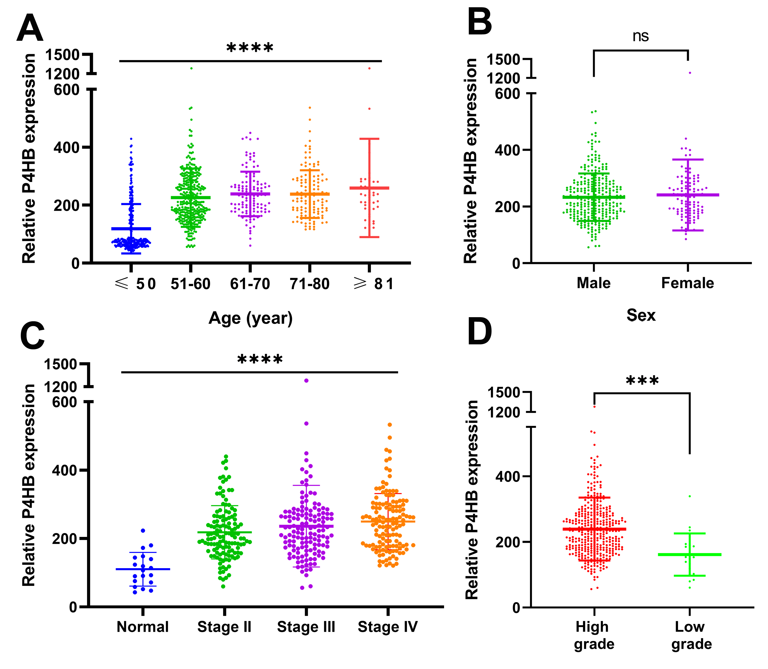
Figure S1 Subgroup analysis of P4HB expression in BC samples. The P4HB mRNA expression in different age (A), sex (B), stage (C) and grade groups (D) is shown. Values are expressed as the mean ± SD.
Statistical significance was analyzed by Student’s t test and One-way ANOVA test. ns, p>0.05; *** p < 0.001 and **** p < 0.0001.
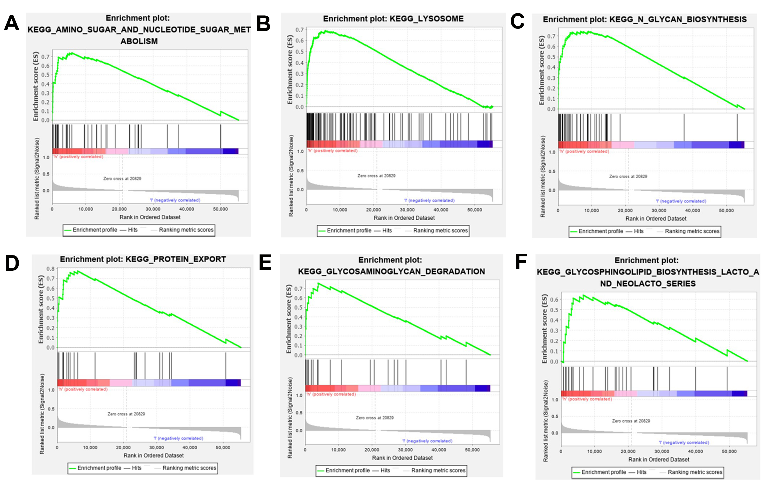
Figure S2 (A-F) GSEA was conducted using 411 BC samples from the TCGA database with high and low expression of P4HB, showing the association of P4HB with cellular metabolism.
The normalized enrichment score (NES) indicates the degree to which the gene set is overrepresented at the top or bottom of the ranked list of genes.

Table S1 The most significantly enriched KEGG signaling pathway based on GSEA analysis in BC patients.
 | Enriched KEGG Pathway | SIZE | ES | NES | NOM p-val | FDR q-val
1 | KEGG_AMINO_SUGAR_AND_NUCLEOTIDE_SUGAR_METABOLISM | 43 | 0.74 | 2.42 | 0 | < 0.001
2 | KEGG_LYSOSOME | 121 | 0.69 | 2.36 | 0 | 0.001
3 | KEGG_N_GLYCAN_BIOSYNTHESIS | 46 | 0.74 | 2.33 | 0 | < 0.001
4 | KEGG_PROTEIN_EXPORT | 24 | 0.77 | 2.23 | 0 | 0.001
5 | KEGG_VIBRIO_CHOLERAE_INFECTION | 54 | 0.67 | 2.21 | 0 | 0.001
6 | KEGG_GLYCOSAMINOGLYCAN_DEGRADATION | 21 | 0.75 | 2.16 | 0 | 0.002
7 | KEGG_GLYCOSPHINGOLIPID_BIOSYNTHESIS_LACTO_AND_NEOLACTO_SERIES | 26 | 0.64 | 2.1 | 0 | 0.004
8 | KEGG_GALACTOSE_METABOLISM | 26 | 0.68 | 2.08 | 0 | 0.006
9 | KEGG_ENDOCYTOSIS | 181 | 0.48 | 2.05 | 0 | 0.008
10 | KEGG_OTHER_GLYCAN_DEGRADATION | 16 | 0.78 | 2.02 | 0 | 0.01
Abbreviations: KEGG: Kyoto encyclopedia of genes and genomes; ES: Enrichment score; NES: Normalized enrichment score; NOM: Normalized; FDR: False discovery rate.

