Supporting Information

Multifunctional Hf/Mn-TCPP Metal-organic Framework Nanoparticles for Triple-modality Imaging-guided PTT/RT Synergistic Cancer Therapy

Table of Contents:
- Representative SEM and TEM images of HMNM. | Figure S1
- Particle size distributions. | Figure S2
- UV-Vis spectra of fHMNM samples with varying ratios of folic acid and HMNM. | Figure S3
- FT-IR spectra of HMNM, FA and fHMNM, | Figure S4
- UV-Vis spectra of fHMNM samples after treated in some extreme situations. | Figure S5
- MTT results | Figure S6
- In vitro cell RT experiments | Figure S7
- The surviving fraction parameter. | Table S1
- O₂ generation catalyzed by fHMNM. | Figure S8
- ROS detection by DCFH-DA. | Figure S9
- Longitudinal relaxation rates R1 under different B₀ fields. | Figure S10
- Haemocompatibility study | Table S2
- Histological analysis of five major organs. | Figure S11
- Fluorescence studies. | Figure S12

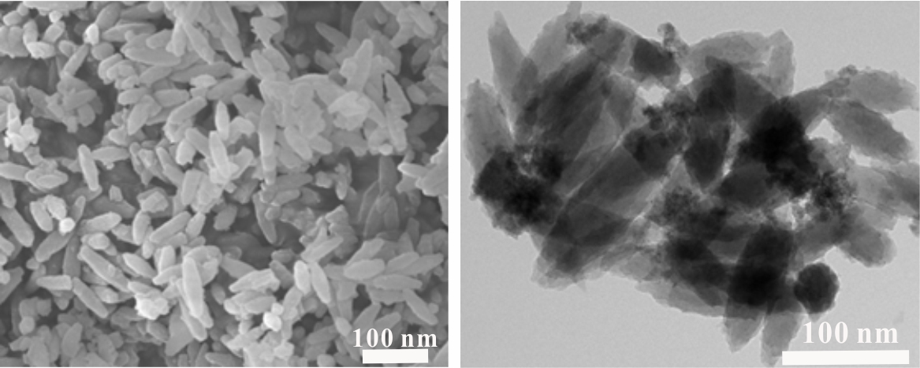

Figure S1 Representative SEM and TEM images of HMNM.

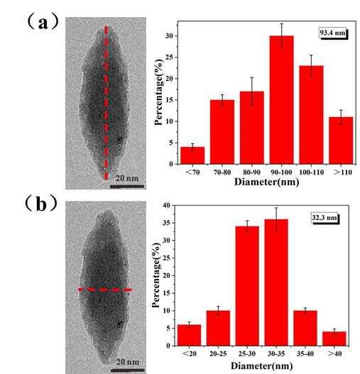

Figure S2 Particle size distributions of fHMNM: (a) long axis; (b) short axis.

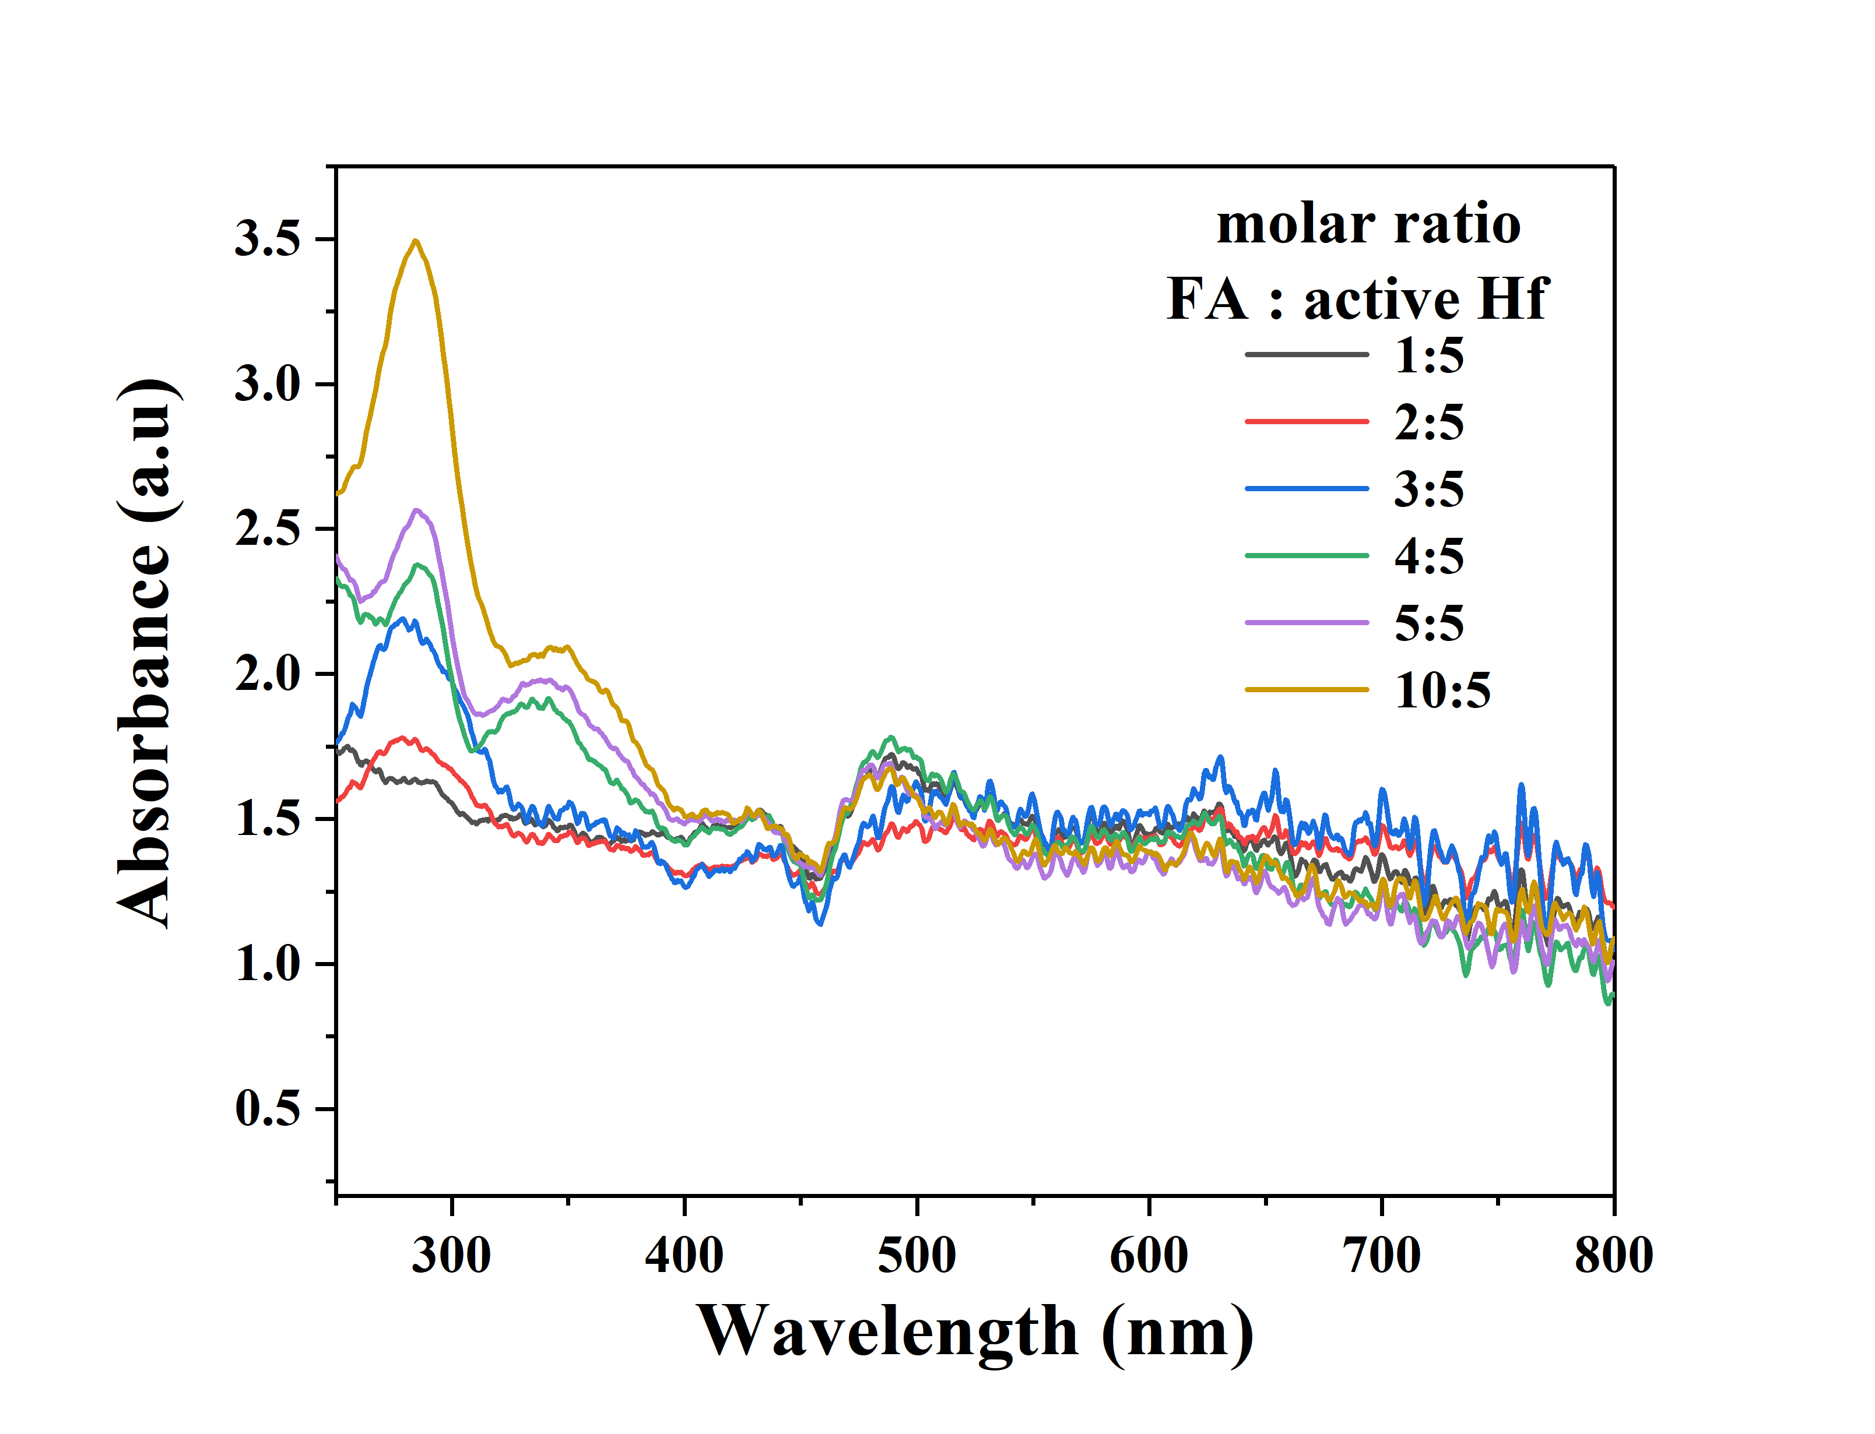
Figure S3 UV-Vis spectra of fHMNM samples with varying ratios between folic acid and HMNM. The percentages are the calculated approximate molar ratios between FA and the surface active Hf atoms.

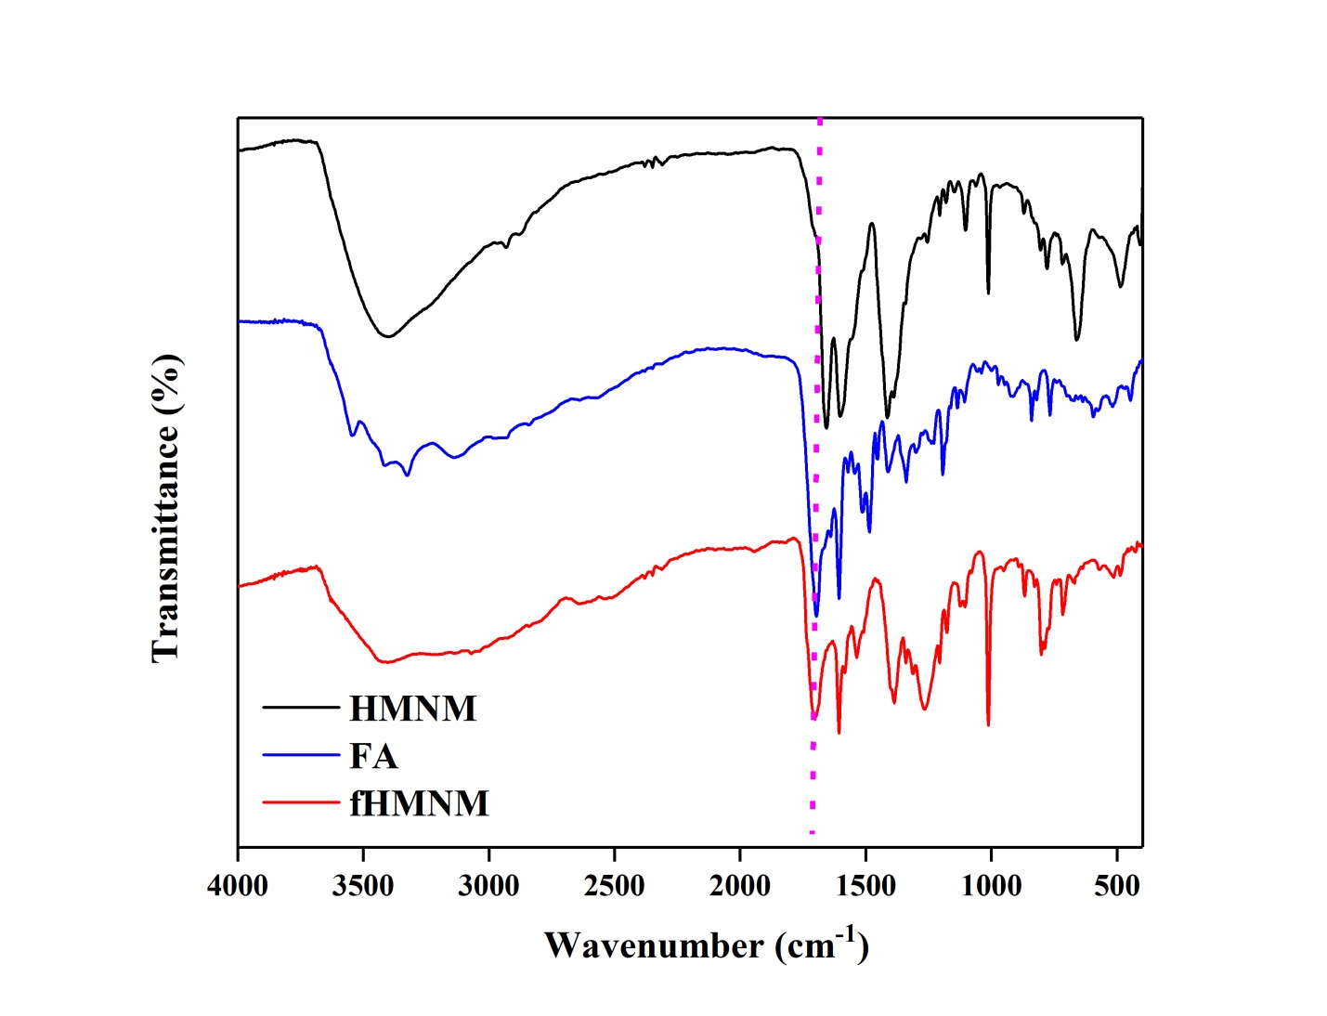
Figure S4 FT-IR spectra of HMNM, FA, and fHMNM.

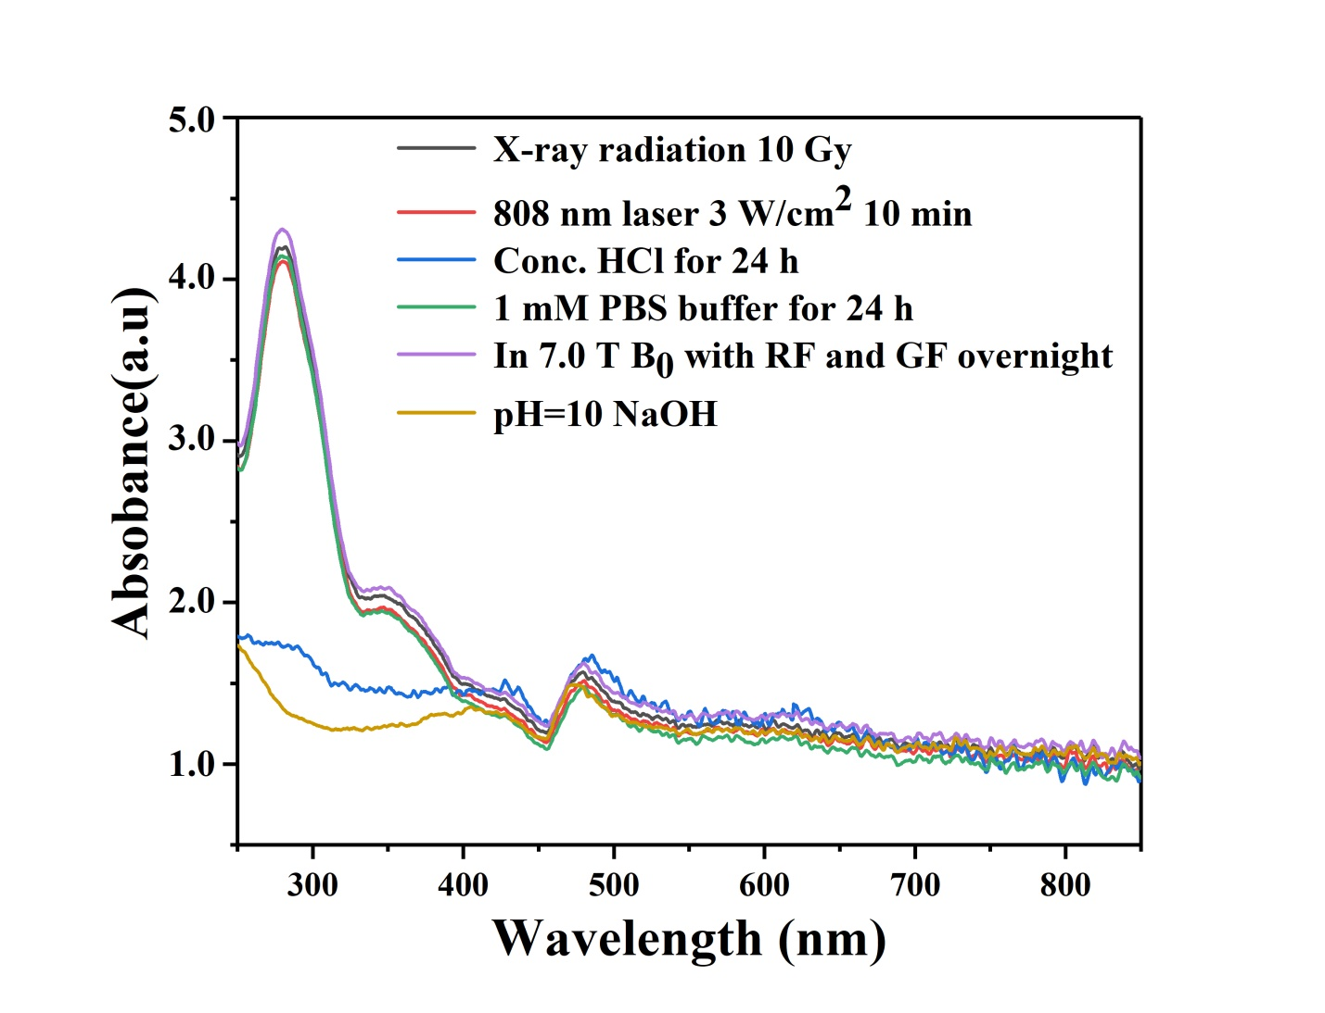

Figure S5 UV-Vis spectra of fHMNM samples after treated in some extreme situations.

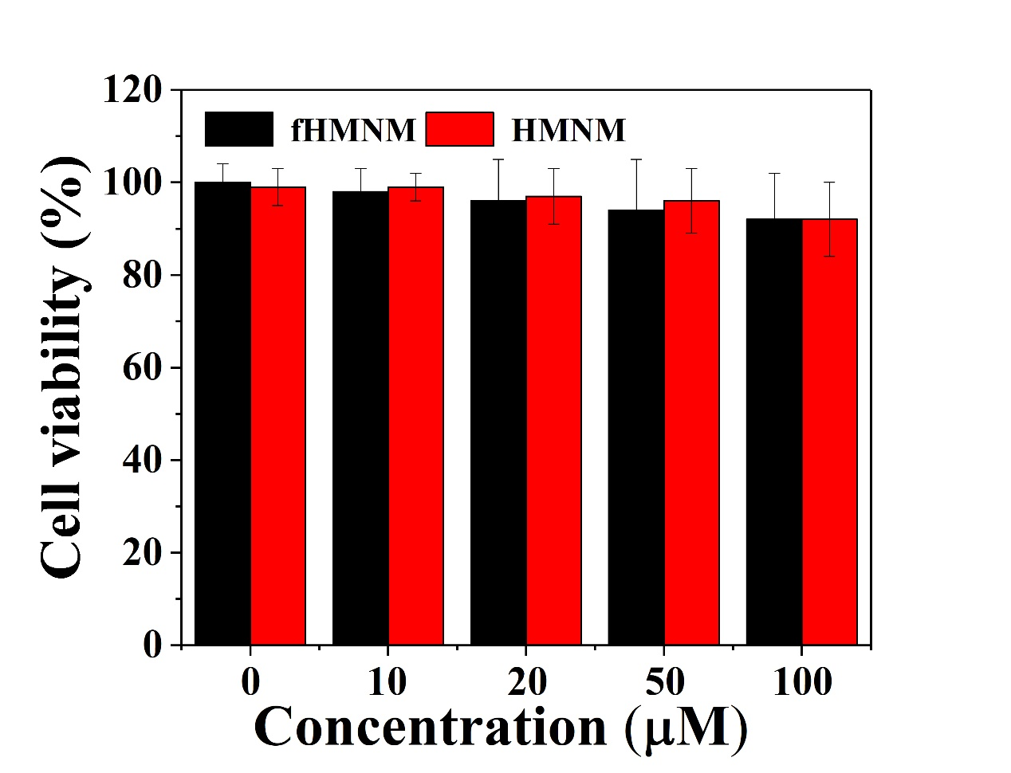
Figure S6 Viability of HeLa cells via co-incubation with different concentrations of fHMNM and HMNM nanocomposites in cell medium for 24 h as determined by MTT assay.
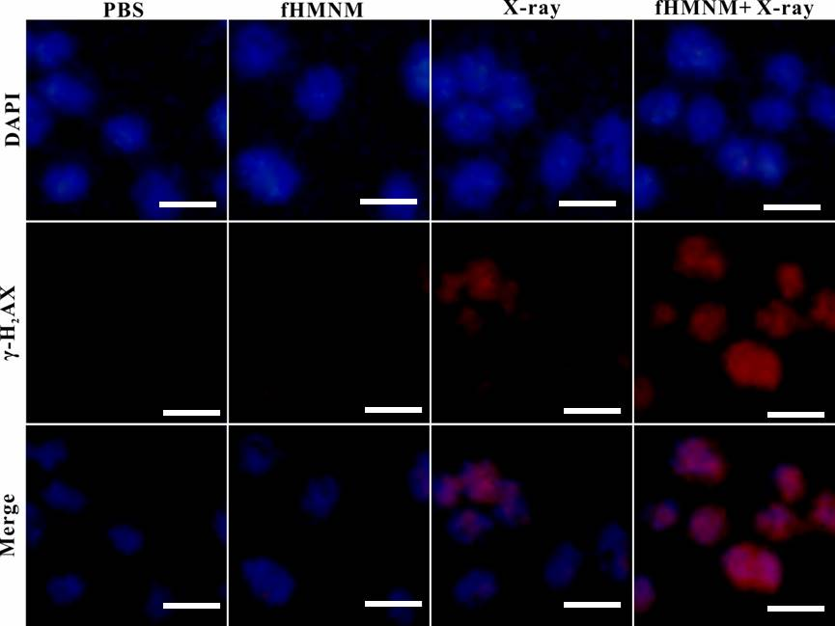

Figure S7 In vitro cell RT (4 Gy) experiments. Fluorescence images of DAPI- (blue) and γ-H2AX-stained (red) HeLa cells treated with PSB, 20 μM fHMNM, RT and fHMNM+RT. Scale bar: 20 µm.

Table S1 The surviving fraction parameters are estimated in the following table.
 | PTT |  |  | RT
- | D0 | N |  | D0 | N
PBS | 1.47 ± 0.17 | 1.26 ± 0.17 |  | 2.96 ± 0.33 | 2.18 ± 0.41
fHMNM | 0.74 ± 0.06 | 1.67 ± 0.18 |  | 2.06 ± 0.01 | - ± 0.02

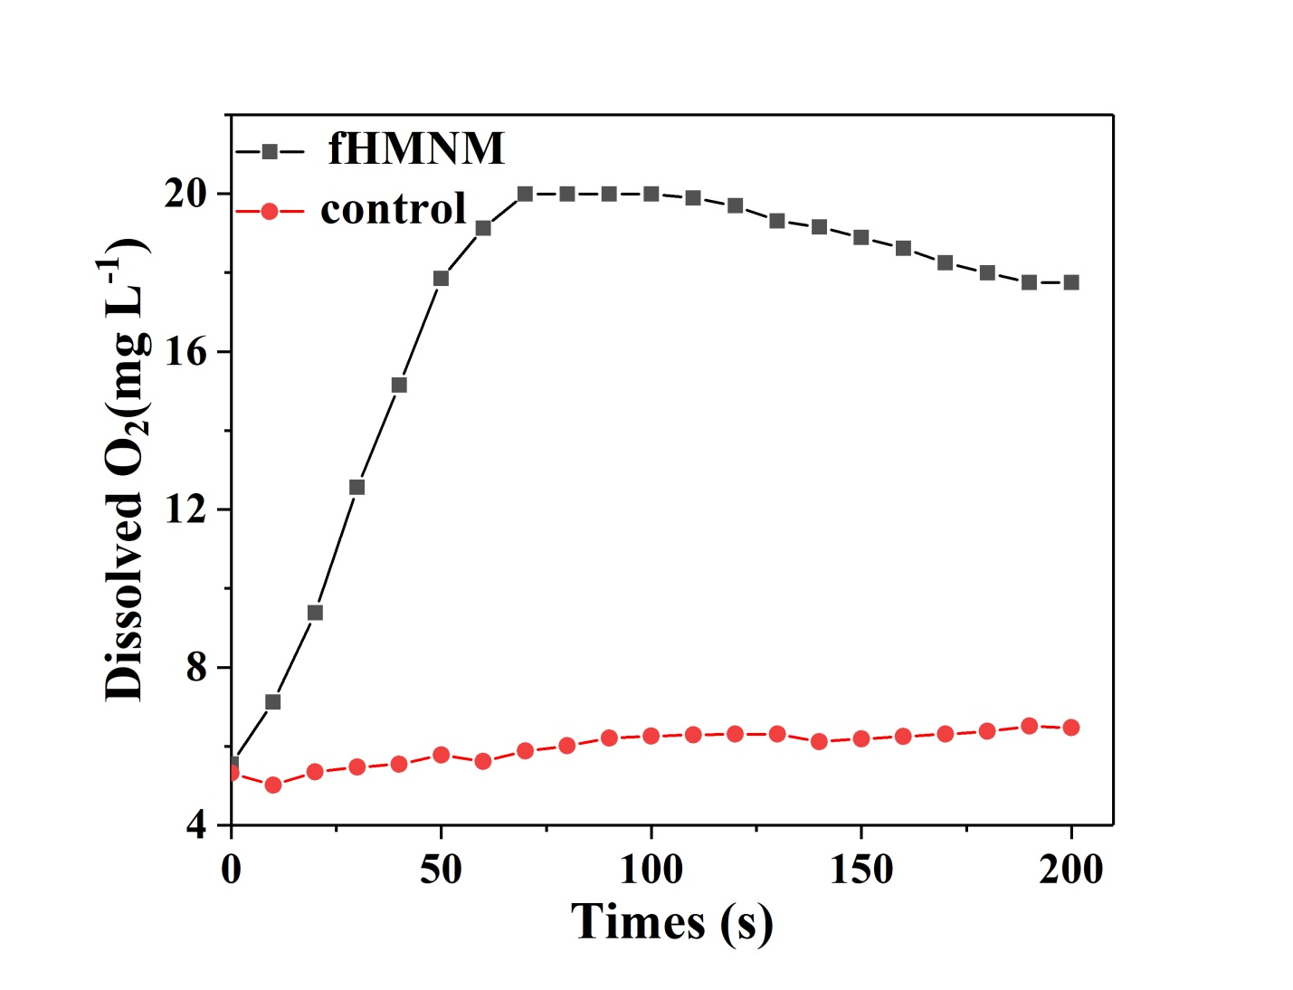
Figure S8 O₂ generation curve in 20 mL of 50 μmol H₂O₂ deoxygenated water with and without 100 μmol fHMNM.

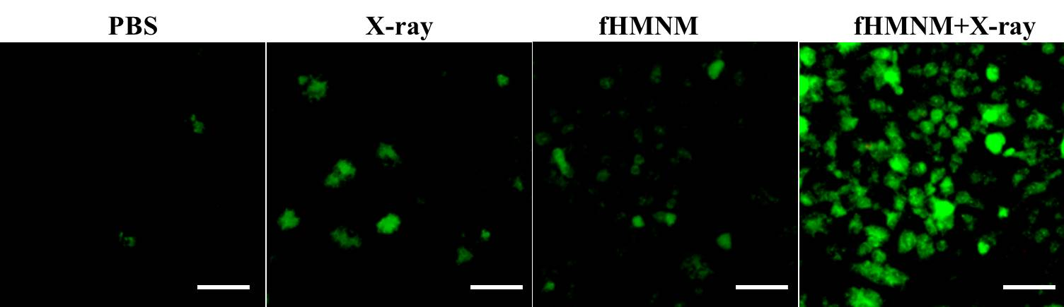

Figure S9 In vitro study of X-ray-responsive intracellular ROS detection by DCFH-DA. Scale bar: 50 µm.

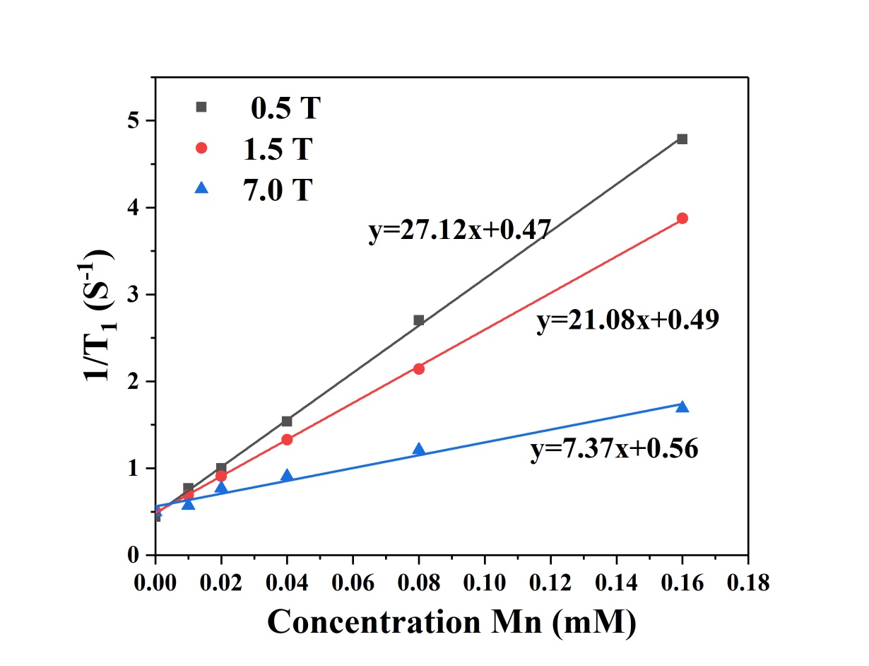
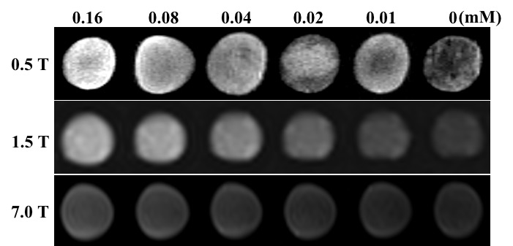

Figure S10 Comparison of longitudinal relaxation rates R₁ under different B₀ main field strengths and corresponding T₁ weighted images with the same number of repetitions and echoes.

Table S2 Haemolytic ratio (HR), prothrombin time (PT), activated partial thromboplastin time (APTT) and thrombin time (TT) of the as-synthesized nanoparticles (n = 5).
Material | HR (%) | PT (s) | APTT (s) | TT (s)
fHMNM | 2.52 ± 0.41 | 11.6 ± 2.8 | 33.5 ± 4.7 | 15.2 ± 1.4
HMNM | 3.48 ± 0.55 | 10.7 ± 3.3 | 31.5 ± 3.2 | 14.5 ± 2.1
Saline | 2.78 ± 0.62 | 10.5 ± 1.7 | 32.8 ± 2.9 | 14.1 ± 1.8

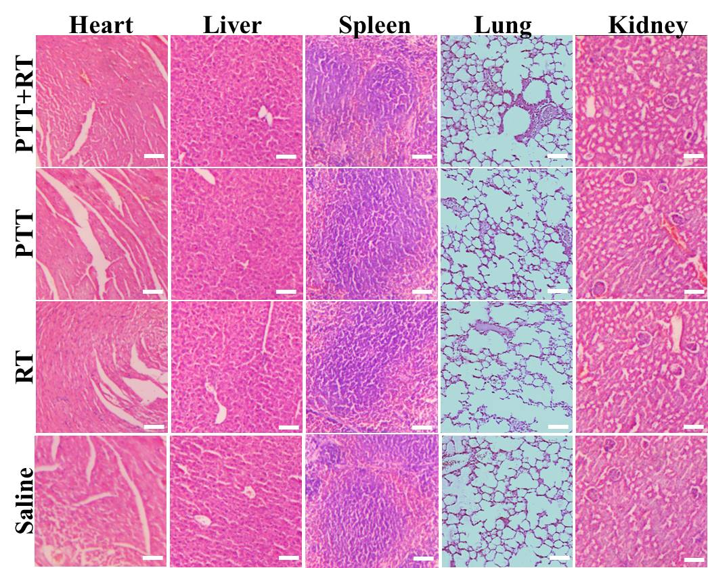

Figure S11 Histological analysis of five major organs (heart, liver spleen, lung and kidney) of different groups through H&E staining. No changes were observed in cellular integrity or tissue morphology with the proposed treatment. Scale bar: 100 µm.

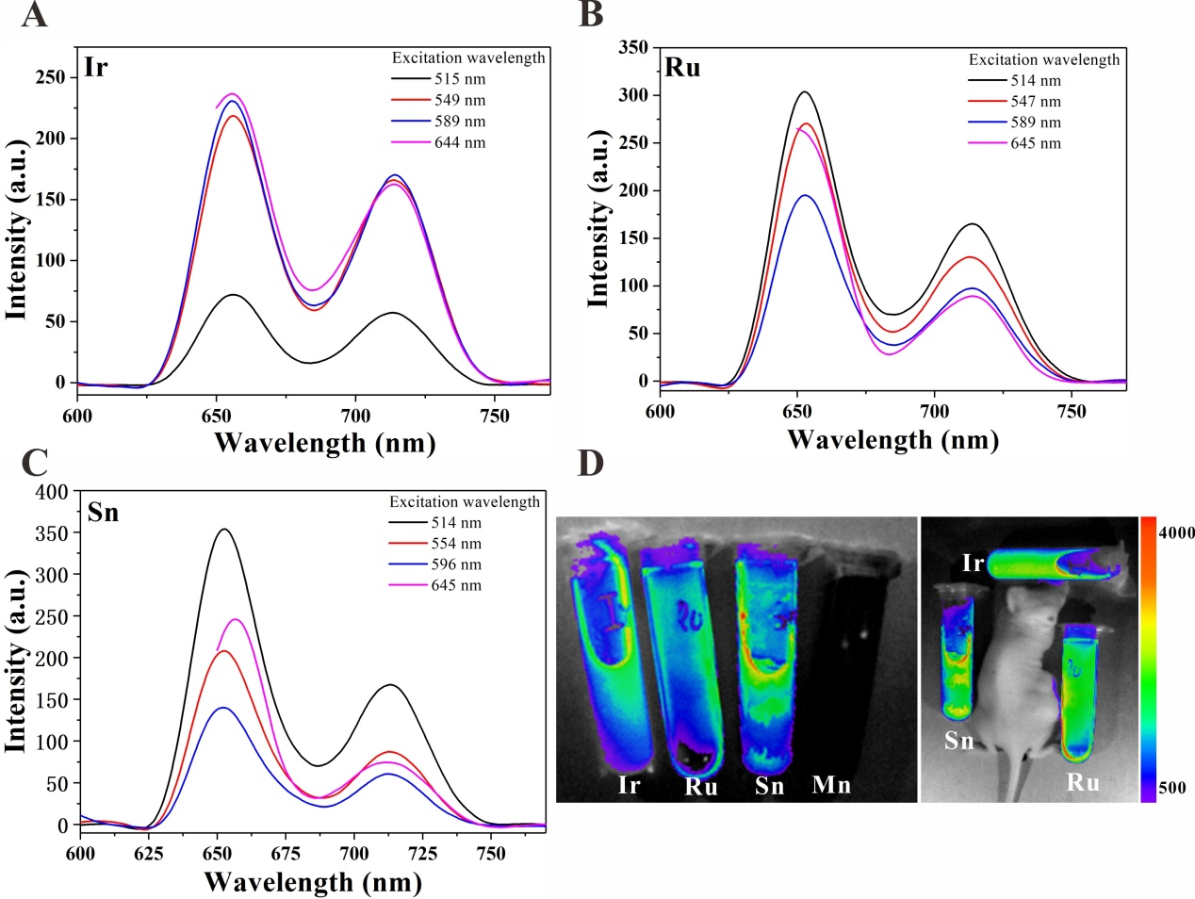

Figure S12 Pilot fluorescent ability recovery study. Fluorescence emission spectra of NMOF samples with manganese replaced by iridium (A), ruthenium (B) and tin (C) at different excitation wavelengths. (D) Representative in vitro fluorescence images.

