Figure S1. Flow cytometry assessment of relative affinity and specificity of yeast-displayed antibodies for purified antigen F1V. (A) Flow cytometry dot plots obtained for yeast displaying single chain antibodies (scFv) αF1sc 2 and 8 along with negative control Z3 (anti influenza M2) are shown. Biotinylated F1V binding was detected using Alexa 633-labelled streptavidin, and measured by the intensity of APC fluorescence (y-axis). Level of display was detected using a phycoerythrin (PE)-labelled antibody recognizing the SV5 tag (co-expressed with every scFv), and measured by PE fluorescence (x-axis). (B) F1V binding (mean APC fluorescence) by the full set of yeast-displayed scFvs is shown. The blue bars represent the mean APC fluorescence calculated from a sample size of 10,000 yeast cells (blue dots in Q2 and Q4 in A), and normalized for level of scFv expression (mean PE fluorescence). All antibodies, except for αF1sc 6 and negative control Z3, bound F1V and did not cross react with the negative control antigen myoglobin (orange bars). The gray bars indicate background signal detected in the absence of antigen.

Figure S2. ELISA assessment of relative affinity and specificity of anti-F1 IgGs for purified antigen F1V. Binding of various anti-F1 IgGs to biotinylated F1V (blue bars) and biotinylated myoglobin (negative control, orange bars) was detected by using anti-human HRP and measured by the amount of HRP product (based on absorbance at 450 nm). The data presented are averages of three experiments with correspondent standard deviations. Natural human IgG1 was used as negative control antibody. Antibody scFv 7 was not converted to IgG; hence it is not included in this assay.

Figure S3. Determination of antibody affinity by whole cell ELISA. Fixed Y. pestis cells were immobilized on Nunc Maxisorp ELISA plates (10⁴ on average counted before antibody binding) and used as “antigens”. The antibody binding to cells (AB, as revealed by Abs₄₅₀) and the corresponding antibody concentration ([A]) were fit to this equation: AB = AB_{max}*[A]/(K_{D} + [A]), using Kaleidagraph version 4.5.4. The calculated functional affinities (K_{D}s) and the corresponding errors are indicated in the insets. (A) All unconjugated αF1Igs, including the commercial mouse αF1 IgG1 YPF19, were analyzed, as well as (B) αF1Ig 2 and αF1Ig 8 conjugated with diethylenetriamine pentaacetic acid (αF1Ig 2-DTPA and αF1Ig 8-DTPA respectively). Each data point is an average of three experiments with corresponding standard deviation.

Figure S4. Flow cytometry analyses supports that αF1Ig 2 and αF1Ig 8 target two different epitopes of F1 antigen. (A) Y. pestis pre-saturated with αF1Ig 8-APC do not lose their fluorescence (same within error, green bars) upon treatment with various concentrations of αF1Ig 2-PE (red bars), including saturating concentration (right most red bar). (B) Y. pestis pre-saturated with unlabeled αF1Ig 8 (red dots) or not pre-saturated (blue squares) bind to αF1Ig 2-PE with same affinity (within error). The maximum amount of antibody binding is reduced, probably due to the steric clash of the bulky PE in αF1Ig 2-PE, with αF1Ig 8.

Figure S5. Detection of F1 antigen by lateral flow assay. Various concentrations of monomer-enriched F1V antigen were detected by LFA using αF1Ig 8 as the capturing antibody, and αF1Ig 2-colloidal gold conjugate as the detecting antibody. The fact that the antibody pair enabled detection of even 5 ng of antigen, suggests that αF1Ig 8 and αF1Ig 2 recognize two different epitopes of F1. 1 = 10 ng F1; 2 = 7 ng F1; 3 = 5 ng F1.

Figure S6. Determination antibody activity for stability studies. (A) Antibodies dissolved in preservation buffer were tested for antibody binding by whole cell ELISA before the start of incubation at 37°C (Y. pestis bound HRP activity at various αF1Ig concentrations (blue and orange circles). For both αF1Ig 2 (left) and αF1Ig 8 (right) a linear increment of antibody binding activity was obtained in the 0.11-0.44 nM antibody concentration range (orange circles). (B) Antibody aliquots stored at 37°C for a period of four weeks, and removed from incubation at one-week intervals, were tested for cell binding within the linear range of concentrations determined in A, in triplicate (blue, orange and gray circles) or duplicate (αF1Ig 8 week 2 and 3). The plots were linear in every case, the slopes were averaged and standard deviations calculated to obtain the data in Figure 3.

Figure S7. Effect of IgGs on Y. pestis’ growth (A) Y. pestis cell density (Abs₆₀₀) was monitored for more than 19 hours in the absence (grey diamond) or the presence of either (left) αF1Ig 2 (at 350 nM, red squares and 90 nM, maroon squares), (right) αF1Ig 8 (at 350 nM, blue squares, and 90 nM, turquoise triangles) or (both sides) αM2Ig (at 350 nM, black squares). αF1Ig 2 effectively reduces Y. pestis density at both concentrations tested, whereas αF1Ig 8 has the same effect only at the higher concentration. (B) Lower respiratory human small airway epithelial cells (HSAEC) were incubated alone (upper left), with Y. pestis (upper right), with Y. pestis plus αF1Ig 2 (180 nM, lower left), or with Y. pestis plus αF1Ig 8 (180 nM, lower right) for 18 hours. Optical imaging shows that Y. pestis agglutinate in the presence of both αF1IgGs, which might explain the cell density drop seen in A.

Figure S8. Effect of IgGs on epithelial cells. Lower Respiratory Human Small Airway Epithelial Cell (HSAEC) were assessed for cell damage (Lactate Dehydrogenase, LDH, release, top) and cell metabolism/viability (metabolization of Water-Soluble Tetrazolium salt, WST, bottom) in the absence of antibodies (grey) or the presence of αF1Ig 2 (red), αF1Ig 8 (blue), or αM2Ig (black). Neither of the antibodies have a cytotoxic effect on HSAECs.

Figure S9. Mass spectrometry characterization of free and labelled antibodies. MALDI-MS spectra of intact (A) and DTPA-conjugated (B) antibodies. The lowest mass peaks correspond to the +1 charged proteins. The additional higher mass main peaks correspond to protein with more than 1 positive charge (up to +5).
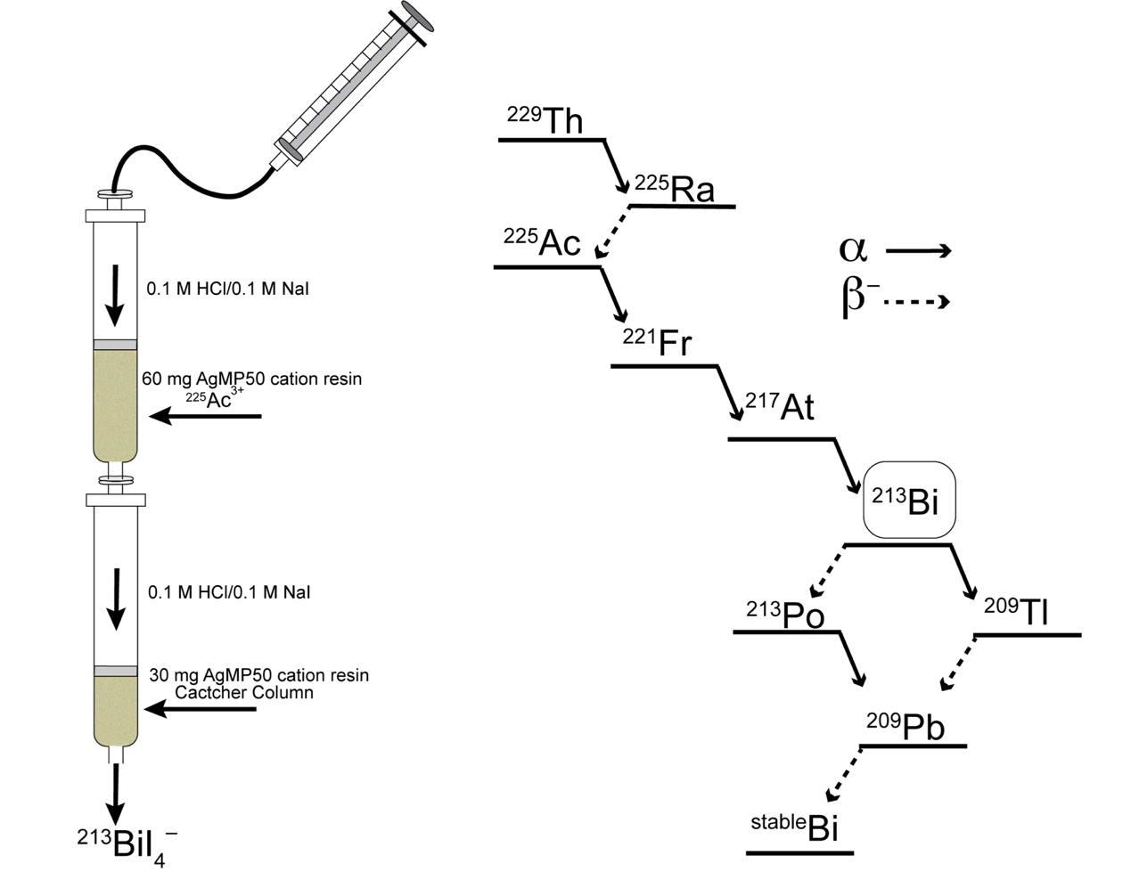

Figure S10. ²¹³Bi generator setup (left) with AG MP50 cation resin to retain ²²⁵Ac that was isolated from the decay of the parent ²²⁹Th isotope (right). ²¹³Bi, as the BiI₄– anion, can be eluted daily from the generator by flowing a solution containing 0.1 M HCl/0.1 M NaI through.

Figure S11. Comparison of αF1Ig 2 and 8 to αF1 m252. (A) Identity and homology of variable regions (VL and VH) and single complementarity determining regions (CDRs) sequences of αFIg 2 and 8 compared to αF1 m252. (B) Alignment of αF1 m252 with αFIg 2 (top) and αFIg 8 (bottom). The different color frames enclose the various CDR sequences. The color of the frames matches the colors used to write the CDRs in A, and serve to identify the specific CDRs (e.g. CDRL1 corresponds to the sequence framed in orange).

