<SUPPLEMENTARY DATA>

Figure S1 COPD Exacerbations (percentage) by SGRQ, CAT, MRC and CB definitions of CMH at 12 months prior to baseline and during first, second and third year of follow-up
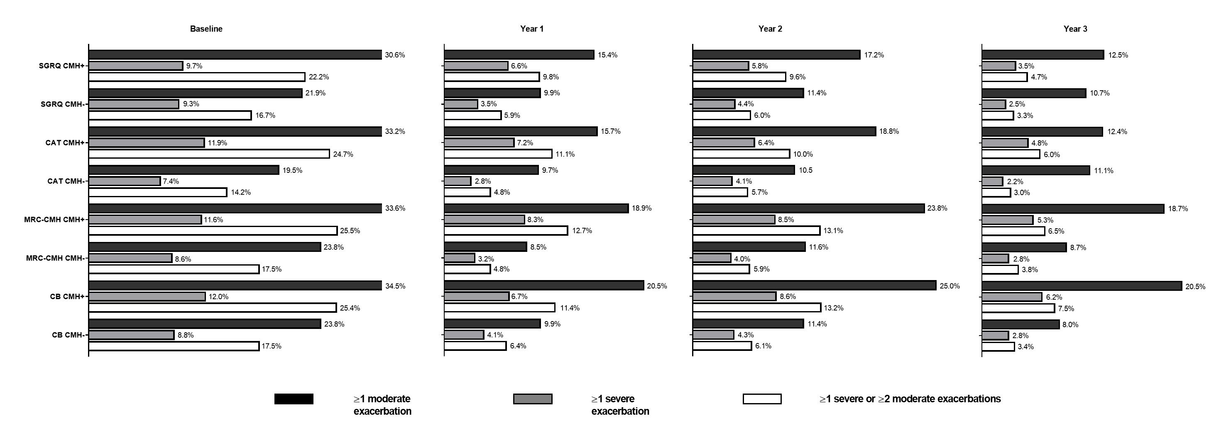
Abbreviations: CAT, COPD Assessment Test; CB, chronic bronchitis; CMH, chronic mucus hypersecretion; MRC, Medical Research Council; SGRQ, St. George’s Respiratory Questionnaire

Table S1 COPD exacerbations for CMH+ and CMH− participants based on SGRQ and CAT definitions
 | SGRQ |  |  | CAT
Characteristic, n (%) | CMH+  N=639 | CMH−  N=722 | P-value | CMH+  N=686 | CMH−  N=721 | P-value
Exacerbations 12 months prior to baseline
≥1 moderate | 175 (30.6%) | 142 (21.9%) | 0.0002 | 200 (33.2%) | 128 (19.5%) | <0.0001
≥1 severe | 62 (9.7%) | 66 (9.3%) | 0.585 | 81 (11.9%) | 53 (7.4%) | 0.005
≥1 moderate or ≥2 severe | 135 (22.2%) | 117 (16.7%) | 0.004 | 162 (24.7%) | 99 (14.2%) | <0.0001
Abbreviations: CAT, COPD Assessment Test; CMH, chronic mucus hypersecretion; SGRQ, St. George’s Respiratory Questionnaire

