Supplementary Data
Supplementary Figure 1. Nyquist diagrams for MASMC, sEND1 and co-culture with LIDE and SIDE.

Supplementary Figure 2. Normalised impedance (Impedance with cells / Impedance without cells) for MASMC, sEND1 and co-culture with LIDE and SIDE.

Supplementary Figure 3. Area under Curve and Student’s t-test results for Normalised impedance

Supplementary Figure 4. Short sweep (1 kHz to 50 kHz) Bode plots for MASMC and sEND1 at 1 day and 2 days post-seeding.

Supplementary Figure 5. Compiled Bode plots for MASMC, sEND1 and co-culture, acquired using LIDE

Supplementary Figure 6. Compiled Bode plots for MASMC, sEND1 and co-culture, acquired using SIDE

Supplementary Figure 7. Compiled MIPUA vs Mean Phase plots for MASMC, sEND1 and co-culture, acquired using LIDE

Supplementary Figure 8. Compiled MIPUA vs Mean Phase plots for MASMC, sEND1 and co-culture, acquired using SIDE

Havriliak-Negami Model curve fitting
The following equation from Joshi et al. (2017) was used to derive the dielectric constant data from the impedance data in Figure 6 (for MASMC and sEND1 acquired using SIDE), where ε’ is the dielectric constant, t is the distance between the electrodes, ω is the angular frequency, ε₀ is the permittivity of free space, Z’ is the real part of the impedance and Z’’ is the imaginary part of the impedance:
$$ε^{'}=\frac{t}{ωAε_{0}} × \frac{Z''}{({Z^{'}}^{2}+{Z^{''}}^{2})}$$
The experimental dielectric constant data acquired using the above equation was then fitted using the Havriliak-Negami model curve:
$$ε^{*}= ε_{∞}+ \frac{ε_{0}- ε_{∞}}{{{[1+(jωτ)}^{1-α}]}^{β}}$$
The curve fitting was carried out by rewriting the equation as follows, and building a fitting function in Origin 2020b Version 9.7.5.184:
$$y= P1+ \frac{P2- P1}{{{[1+(P3*x)}^{P4}]}^{P5}}$$

Supplementary Table. 1. Havriliak-Negami Model curve fitting parameters

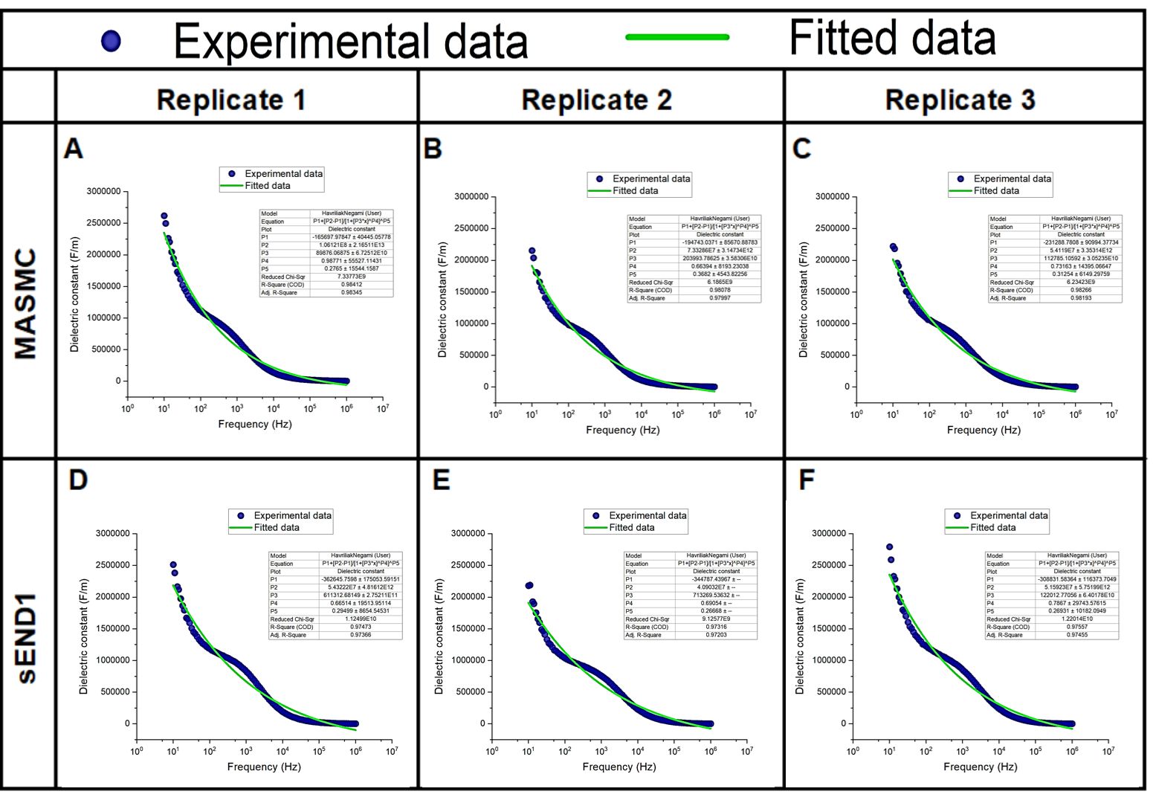
Supplementary Figure 9. Experimental and fitted dielectric constant data for MASMC and sEND1 acquired using SIDE.

The curve fitting is shown in Supplementary Figure 7. and the analysis of the fitting parameters is shown in Supplementary Table 1. The fitting parameters were compared using Student’s t-test. The r² value was significantly different (p < 0.01), indicating that the Havriliak-Negami model curve was a better fit for the data with MASMC compared to sEND1. The parameter P1, which represents $ε_{∞},$is significantly different (p < 0.01) between MASMC and sEND1, and could thus be a potential method of distinguishing between the 2 cell types.

