SUPPLEMENTARY MATERIAL
Supplementary Figure 1. Incidence rate of metabolic syndrome according to ATP-III and IDF definitions stratifying by age groups categorized in <35 years, 35-50 years and >50 years.
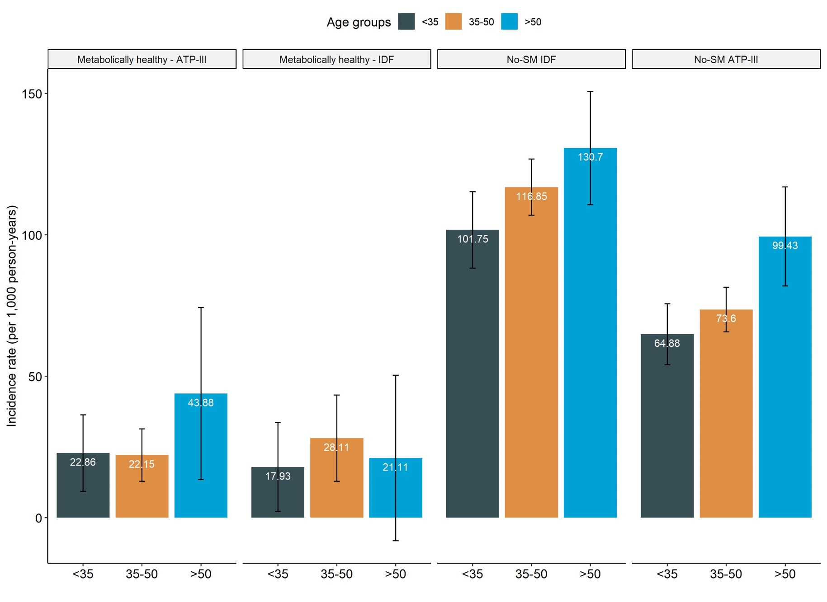

Supplementary Figure 2. Incidence rate of metabolic syndrome according to ATP-III and IDF definitions stratifying sex in the MS cohort.
