Supporting information for
Structure guided design of CRM1 peptide inhibitors for targeted cancer therapy
Min Sui1#, Meimei Xiong2#, Yuling Li1#, Qiao Zhou1, Xiaofei Shen3, Da Jia3, Maling Gou2*, Qingxiang Sun1*

Figure S1. Some of the designed mutations that did not significantly improve binding to CRM1 and thus were not discussed in the text.

Figure S2. ITC isotherms and fitting for Nm2, Nm3, Nm12, Nm13, Nm16. Error bars represent the 95% confidence interval of heat measurement integration. K_{d} and ΔH are displayed in Figure 2D.

Figure S3. Fo-Fc simulated annealing omit maps of MVM WT and mutant peptides contoured at 3 σ level. Green: positive density; Red: negative density.

Figure S4. Zoom-in view of Nm15 crystal structure (cyan) on the M82L mutation region. MVM WT (green) is overlaid for comparison. Residues within 4 Å of L82 or M82 are shown as sticks. L82 contacts two more residues on CRM1 than M82.

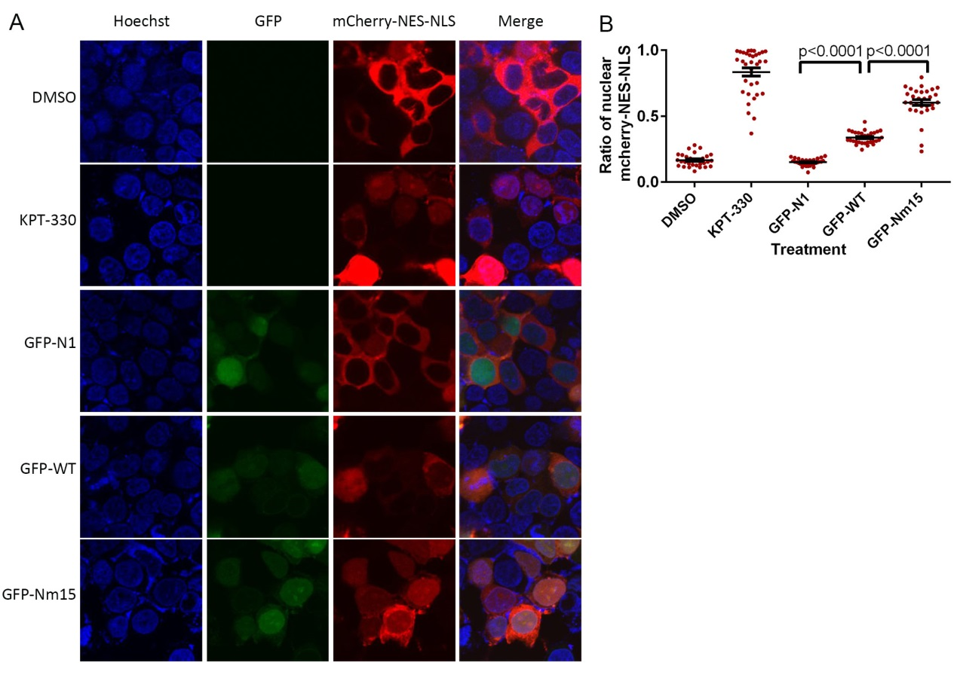
Figure S5. Inhibition of nuclear export by Nm15 in 293T cells. A) Confocal images on nuclear export cargo (mCherry-NES-MBP-NLS) transfected 293T cells treated by KPT-330 or listed transfections. B) Quantification and statistical analysis of nuclear cargo percentages on images collected in panel A. Error bars represent the standard error of measurements.

Figure S6. Nm15 is superior to the previously reported high-affinity NESs by pull-down (A), nuclear export inhibition (B,C) and cell survival (D,E,F). SPN: super PKI-NS2; CN: Cdc7-NS2. Error bars in D/E/F represent the standard deviation. For nuclear export inhibition by GFP-Nm15 in A549 cells, please refer to figure 5B.
Figure S7. Anti-cancer activity of several designed peptides. A) List of new mutation designed based on Nm15. The NES minimum sequences are boxed. Lower case letters represent D amino acids. The designed peptides (Nm21-25) carry charges ranging from -3 to +5. In addition, the peptides were capped with an N-terminal Valine to prolong cellular half-life, and D amino acids were used for the second position to limit digestion. B) Cell penetration of FITC-labeled Nm15 and Nm23 at different time. Increasing net positive charge does enhance cellular uptake. C) Cell viability of different peptides at 100 µM. KPT-330 (20µM) is used as a positive control. Error bars represent standard deviation of each sample (10 replicates).

Figure S8. Fo-Fc simulated annealing omit maps of Nm42 contoured at 3 σ level. Green: positive density; Red: negative density.

Figure S9. Particle size (A) and zeta potential (B) of iDPP/Nm42 nanocomplex.
Figure S10. The fluorescent (left) and bright-field (right) image of B16-F10 cells after transfected by iDPP/GFP-N1 nanocomplex. Scale bar,100 μm.
Figure S11. Images of xenograft tumors in each treatment groups.
Figure S12. Serologic and biochemical analysis after intravenous injection of iDPP/DNA nanocomplex at the end of treatment. No significant blood biochemical changes are detected in iDPP/Nm42 treated mice.

Table S1. Crystal data collection and refinement statistics.
 | WT:  CRM1:Ran:RanBP1 | Nm2:  CRM1:Ran:RanBP1 | Nm12:  CRM1:Ran:RanBP1 | Nm13:  CRM1:Ran:RanBP1 | Nm15:  CRM1:Ran:RanBP1 | Nm42:  CRM1:Ran:RanBP1
Cell axial lengths (Å) | a=b=105.44, c=303.07 | a=b=106.65, c=304.31 | a=b=106.10, c=303.83 | a=b=106.36, c=303.86 | a=b=105.65, c=303.00 | a=b=105.92, c=303.45
Spacegroup | P4₃2₁2 | P4₃2₁2 | P4₃2₁2 | P4₃2₁2 | P4₃2₁2 | P4₃2₁2
Data collection
Resolution range (Å) | 50.00-2.70 (2.75-2.70) | 50.00-2.30 (2.34-2.30) | 50.00-2.35 (2.39-2.35) | 50.00-2.50 (2.54-2.50) | 50.00-2.70 (2.75-2.70) | 50.00-2.45 (2.45-2.51)
Number of observed reflections | 693490 (34470) | 971908 (40735) | 992557 (47401) | 857793 (28123) | 593179 (26617) | 1665071 (125988)
Number of unique reflections | 48581 (2361) | 78675 (3843) | 73152 (3564) | 61540 (3024) | 49549 (2442) | 64599 (4681)
Completeness (%) | 100.0 (100.0) | 99.6 (99.0) | 100.0 (100.0) | 100.0 (99.6) | 100.0 (100.0) | 100.0 (99.9)
Redundancy | 14.3 (14.6) | 12.4 (12.7) | 13.6 (13.3) | 13.9 (9.3) | 12.0 (10.9) | 25.8 (26.9)
R_{pim} | 0.063 (0.897) | 0.045 (0.867) | 0.045 (0.871) | 0.061 (0.975) | 0.077 (0.694) | 0.043 (0.977)
Highest shell CC1/2 | 0.319 | 0.330 | 0.391 | 0.413 | 0.377 | 0.634
Mean I/I_{sigma} | 13.0 (0.8) | 16.3 (0.6) | 17.8 (0.8) | 16.0 (0.9) | 9.9 (1.0) | 15.4 (1.4)
Refinement
Resolution range (Å) | 50.01-2.69 (2.76-2.69) | 50.01-2.30 (2.36-2.30) | 50.00-2.35 (2.41-2.35) | 50.01-2.51 (2.58-2.51) | 47.31-2.70 (2.77-2.70) | 50.00-2.45 (2.51-2.45)
R_{work}ª (no. of reflections) | 0.218 (0.353) | 0.218 (0.368) | 0.220 (0.392) | 0.213 (0.347) | 0.203 (0.342) | 0.197 (0.371)
R_{free}^{b} (no. of reflections) | 0.256 (0.392) | 0.248 (0.345) | 0.266 (0.358) | 0.254 (0.361) | 0.241 (0.378) | 0.235 (0.401)
R.m.s. deviation bond lengths (Å) | 0.007 | 0.007 | 0.008 | 0.008 | 0.006 | 0.004
R.m.s. deviation bond angles (°) | 1.131 | 1.085 | 1.183 | 1.183 | 1.025 | 1.236
Avg B-factors (Å2) (# of atoms) | 81.7 (11078) | 72.3 (11227) | 74.2 (11273) | 72.0 (11088) | 72.9 (11251) | 69.0 (11194)
Ramachandran plot
Most favored regions (%) | 93.8 | 93.8 | 94.3 | 93.5 | 93.1 | 94.2
Allowed regions (%) | 6.1 | 6.1 | 5.4 | 6.3 | 6.7 | 5.6
General allowed regions (%) | 0.0 | 0.1 | 0.1 | 0.0 | 0.0 | 0.1
Disallowed regions (%) | 0.2 | 0.1 | 0.2 | 0.2 | 0.2 | 0.2
R_{work}^{b} = Σ|Fo – Fc|/|Fo|, where Fc and Fo are the calculated and observed structure factor amplitudes, respectively
R_{free}^{c} calculated as for R_{work} but for 5.0% of the total reflections chosen at random and omitted from refinement for all data sets

