Supplementary information
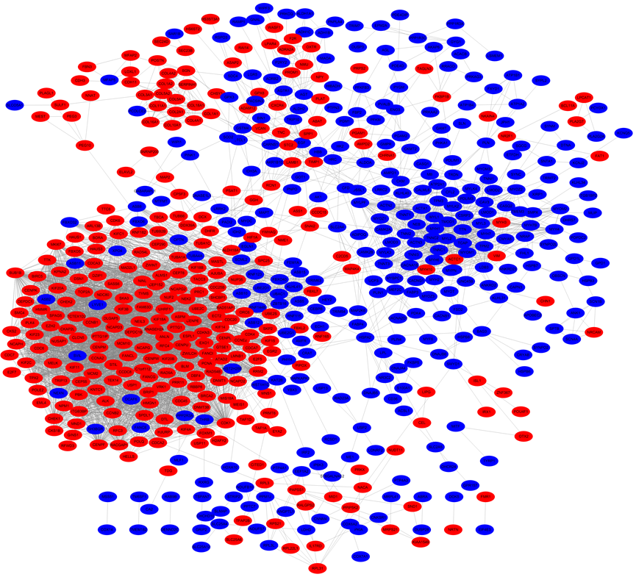
Figure S1. DEGs PPI network complex and modular analysis. Based on STRING and Cytoscape analysis, 498 up-regulated and 480 down-regulated DEGs were filtered into the PPI network complex. Only protein pairs with a confidence score that was >0.7 were utilized to construct the PPI network. There were 612 nodes and 5129 edges in this PPI network. Each node expresses a protein. Red nodes represent up-regulated and blue nodes indicate down-regulated DEGs. Each line represents the relationship of proteins to each other.
Abbreviations: DEGs: differentially expressed genes.
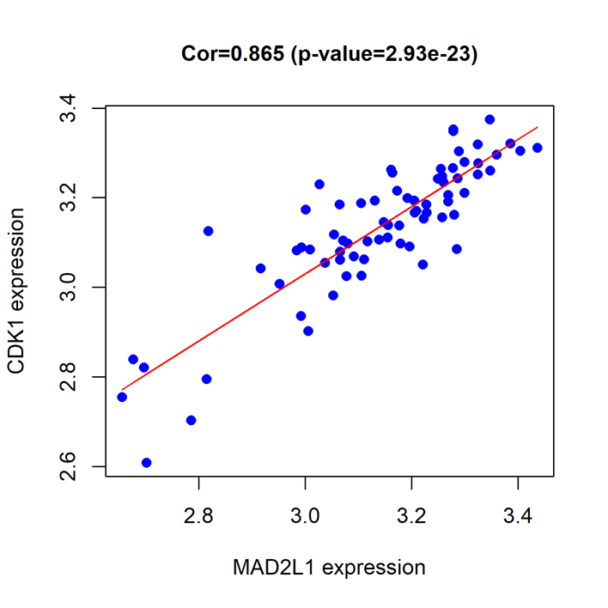
Figure S2. CDK1 and MAD2L1 are linearly co expressed.

Table S1. TOP10 hub genes
No. | Name | Type | Multiple logFC | entrezID | Gene annotation
1 | TOP2A | up-regulated gene | 5.327443665 | 7153 | DNA Topoisomerase II Alpha
2 | CCNB1 | up-regulated gene | 4.736529931 | 891 | cyclin B1
3 | UBE2C | up-regulated gene | 4.553486534 | 11065 | ubiquitin-conjugating enzyme E2C
4 | KIF11 | up-regulated gene | 4.231225971 | 3832 | kinesin family member 11
5 | NCAPG | up-regulated gene | 4.160005796 | 64151 | non-SMC condensin I complex, subunit G
6 | CDC20 | up-regulated gene | 3.530823758 | 991 | cell division cycle 20
7 | CDK1 | up-regulated gene | 3.387191832 | 983 | cyclin-dependent kinase 1
8 | MAD2L1 | up-regulated gene | 3.132076884 | 4085 | MAD2 mitotic arrest deficient-like 1
9 | CCNA2 | up-regulated gene | 2.485590775 | 890 | cyclin A2
10 | CCNB2 | up-regulated gene | 2.383649319 | 9133 | cyclin B2

Species | Name of genes | Forward primer (5'->3') | Reverse primer (5'->3')
human | TOP2A | TAATCAGGCTCGCTTTATCTT | TCCGAATCATATCCCCTCT
human | CCNB1 | CTTTCGCCTGAGCCTATTT | CCATCTTCTGCATCCACAT
human | UBE2C | TGAAGGAAAAGTGGTCTGC | GCATGTGTGTTCAAGGGA
human | KIF11 | CTACGATTGATGGAGAAGAGC | CCCAAAGTCAACAGGGATT
human | NCAPG | GATGAGGAAGAGGAAGATGGT | TGTTTATGAGCAGGCACACT
human | CDC20 | CCTGAGCAAGGAGAACCAG | TCCACTGAGCCGAAGGA
human | CDK1 | AAACTACAGGTCAAGTGGTAGCC | TCCTGCATAAGCACATCCTGA
human | MAD2L1 | ACGGTGACATTTCTGCCACT | TGGTCCCGACTCTTCCCATT
human | CCNA2 | CGGGAGCAGTGATGTTG | TCCGGGTTGATATTCTCCT
human | CCNB2 | CAAGCAGCAAACTCCTGAA | GGCACAATGAAGCACACA
Table S2. Primer sequence used for quantitative RT-PCR
Abbreviations: TOP2A, DNA Topoisomerase II Alpha; CCNB1, cyclin B1; UBE2C, ubiquitin-conjugating enzyme E2C; KIF11, kinesin family member 11; NCAPG, non-SMC condensin I complex, subunit G; CDC20, cell division cycle 20; CDK1, Cyclin-dependent kinases 1; MAD2L1, Mitotic Arrest Deficient 2 Like 1; CCNA2, cyclin A2; CCNB2, cyclin B2.

