Supplementary Data

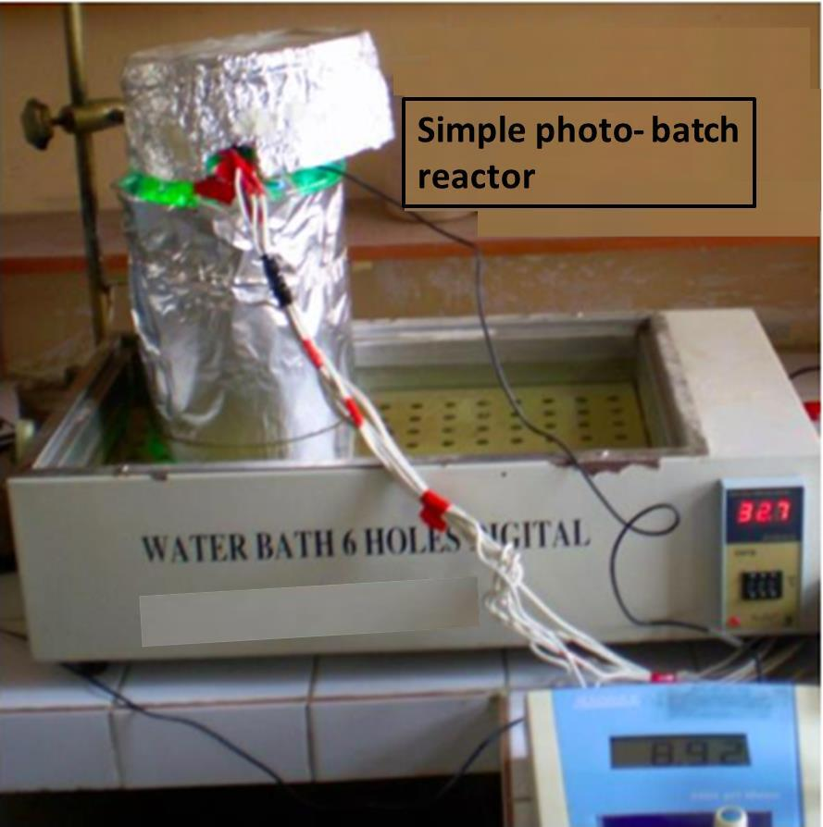
Figure S1 Simple photo-batch catalytic oxidation reactor.

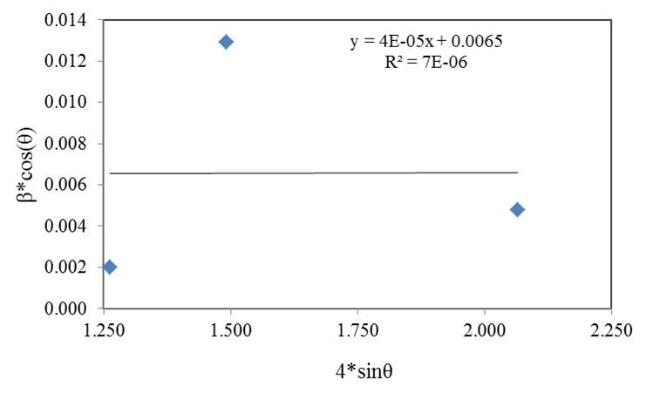
Figure S2 Williamson-Hall plots for MgO NP.

Table S1 Parameters obtained for MgO NP from XRD analysis
Pos. 2θ  (deg) | fwhm  (deg) | hkl  planes | β*cos(θ) | 4*sin(θ) | 4*tan(θ) | Williamson-Hall |  | Debye-Scherer
 |  |  |  |  |  | crystallite size  (nm) | lattice strain | crystallite size  (nm) | lattice strain
36.811 | 0.12079 | 111 | 0.002 | 1.263 | 1.33 | 21.33 | 0.00004 | 69.31 | 0.0016
43.781 | 0.79776 | 200 | 0.013 | 1.491 | 1.61 | 21.33 | 0.00004 | 10.73 | 0.0087
62.156 | 0.31893 | 220 | 0.005 | 2.065 | 2.41 | 21.33 | 0.00004 | 29.08 | 0.0023
Average |  |  |  |  |  | 21.33 | 0.00004 | 36.38 | 0.0042
2θ (degrees): Diffraction angle; hkl: The Miller indices define the reciprocal axial intercepts of a plane of atoms and fwhm: full width half maximum

