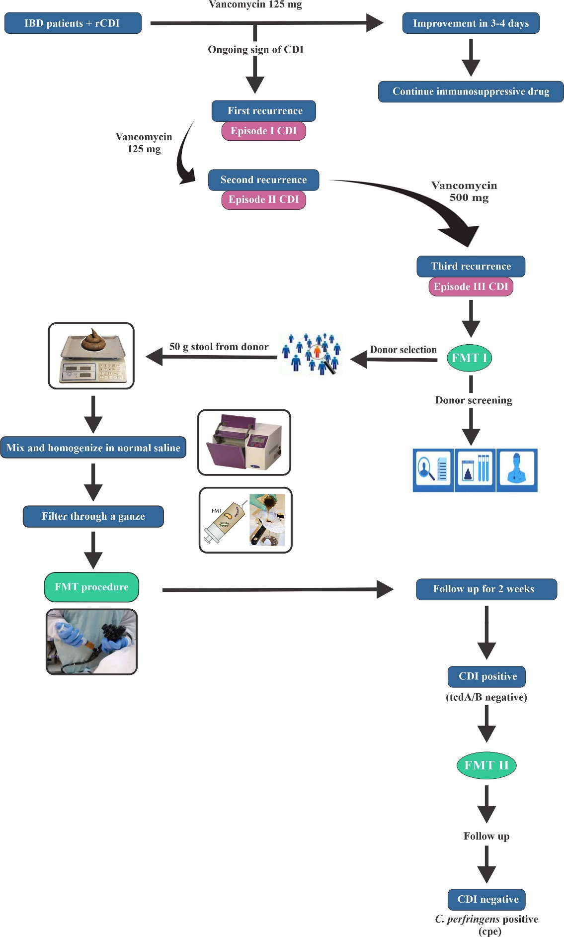
Supplementary Figure 1. Schematic workflow of FMT in rCDI patients with underlying IBD.

Patients | Age (years) | Sex | Diagnosis/duration (years) | Antibiotic therapy in 1st rCDI treatment | Antibiotic therapy in 2nd rCDI treatment | Antibiotic therapy in 3rd rCDI treatment | Concomitant therapy before FMT | CDI severity | Number of FMT | Sex/age (years) of donor | Relation to donor
1 | 45 | M | UC/10 | Vancomycin 125 mg given 4 times daily for 10 days | Vancomycin 500 mg given 4 times daily for 10 days | Vancomycin 500 mg given 4 times daily for 10 days | Anti-TNF alpha (infliximab) 40 mg/fortnight, Asacol tablets 3200 mg/day, one Asacol suppository every night, one Asacol enema every night, Azathioprine tablet 200 mg/day | Mild-to-moderate | 2 | F/40 | Brother
2 | 37 | M | UC/5 | Vancomycin 125 mg given 4 times daily for 10 days | Vancomycin 500 mg given 4 times daily for 10 days | Vancomycin 500 mg given 4 times daily for 10 days | Anti-TNF alpha (infliximab) 40 mg/ fortnight, Azathioprine tablet 200 mg/day, Sulfasalazine 2000 mg/day | Mild-to-moderate | 1 | F/35 | Friend
3 | 60 | F | UC/8 | Vancomycin 125 mg given 4 times daily for 10 days | Vancomycin 500 mg given 4 times daily for 10 days | Vancomycin 500 mg given 4 times daily for 10 days | Anti-TNF alpha (infliximab) 40 mg/fortnight, Azathioprine tablet 200 mg/day | Mild-to-moderate | 1 | M/38 | Son-in-law
4 | 24 | M | UC/5 | Vancomycin 125 mg given 4 times daily for 10 days | Vancomycin 500 mg given 4 times daily for 10 days | Vancomycin 500 mg given 4 times daily for 10 days | Anti-TNF alpha (infliximab) 40 mg/fortnight, Asacol tablets 3200 mg/day, one Asacol suppository every night, one Asacol enema every night, Azathioprine tablet 200 mg/day | Mild-to-moderate | 2 | M/57 | Father
5 | 22 | F | CD/3 | Vancomycin 125 mg given 4 times daily for 10 days | Vancomycin 500 mg given 4 times daily for 10 days | Vancomycin 500 mg given 4 times daily for 10 days | Anti-TNF alpha (infliximab) 40 mg/fortnight, Azathioprine tablet 200 mg/day | Mild-to-moderate | 1 | F/25 | Sister
6 | 52 | M | UC/5 | Vancomycin 125 mg given 4 times daily for 10 days | Vancomycin 500 mg given 4 times daily for 10 days | Vancomycin 500 mg given 4 times daily for 10 days | Anti-TNF alpha (infliximab) 40 mg/fortnight, Asacol tablets 3200 mg/day, one Asacol suppository every night, one Asacol enema every night | Mild-to-moderate | 1 | M/38 | Cousin
7 | 33 | M | UC/5 | Vancomycin 125 mg given 4 times daily for 10 days | Vancomycin 500 mg given 4 times daily for 10 days | Vancomycin 500 mg given 4 times daily for 10 days | Anti-TNF alpha (infliximab) 40 mg/fortnight, Asacol tablets 3200 mg/day, one Asacol suppository every night, one Asacol enema every night | Mild-to-moderate | 1 | M/37 | Brother
8 | 23 | M | UC/3 | Vancomycin 125 mg given 4 times daily for 10 days | Vancomycin 500 mg given 4 times daily for 10 days | Vancomycin 500 mg given 4 times daily for 10 days | Anti-TNF alpha (infliximab) 40 mg/fortnight, Asacol tablets 3200 mg/day, one Asacol suppository every night, one Asacol enema every night | Mild-to-moderate | 1 | F/58 | Mother
Supplementary Table 1 Baseline characteristics of the study patients and their FMT donors
Abbreviations: CD, Crohn’s disease; F, female; M, male; UC, ulcerative colitis.

