Supplementary Table1 . PCR Primer sequence
Target ID | Primer | sequence (5'-3')
ESRRA | Forward  Reverse | TCAAAGAGGTCACAGAGGGTAG  CAATGAGTGTGAGATCACC
GPER-1 | Forward  Reverse | GCCACATCTGACCGCAGTTTA  TGGGGAAGAGGCCACCA
ACTB | Forward  Reverse | CTACCTCATGAAGATCCTCACCGA  TTCTCCTTAATGTCACGCACGATT
GAPDH | Forward  Reverse | GGACCTGACCTGCCGTCTAG  GTAGCCCAGGATGCCCTTGA

Supplementary Figure 1. Correlation analysis between the expression of ERRα and GPER in TNBCs (n=199). IR-ERRα, immunoreactive score of ERRα; IR-GPER, immunoreactive score of GPER. Two-tailed p<0.05 is considered statistically significant.
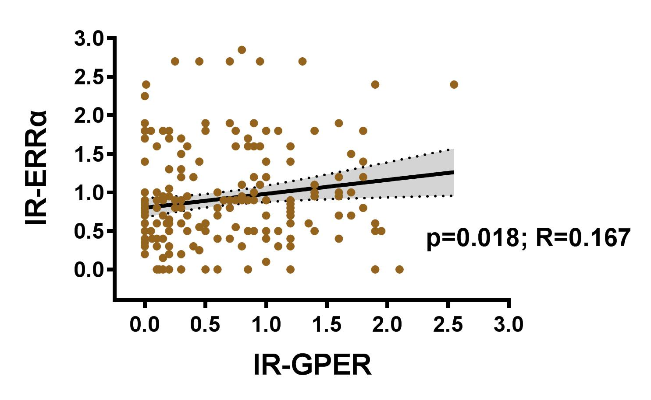

Supplementary Figure 2. Survival curves of OS, LRFS, and DDFS in GPER-low and GPER-high groups. Kaplan-Meier curves of OS (A), LRFS (B), and DDFS (C) among groups in patients with TNBC in the unmatched cohort.
