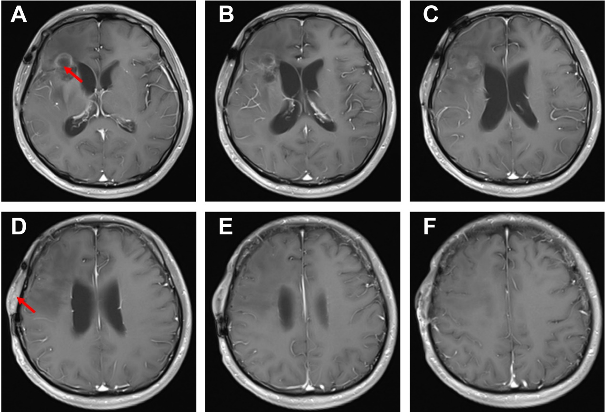
Figure. S1 Continuous MR images around the extracranial tumor.
（A-F）Continuous MR images of this patient's head. The intracranial (A) and extracranial tumor (E) were indicated by the red arrow.

