Table S1 TLC screening of the oleogum resin of Boswellia carterii Birdwood.
Spot No. | R_{f} value | Color with Vanillin/ H₂SO₄
1 | 0.43 | Faint brown
2 | 0.33 | Purple
3 | 0.71 | Orange red changing into purple
4 | 0.7 | Orange red
5 | 0.69 | Orange brown
6 | 0.6 | Green
7 | 0.5 | Brick-red
Abbreviations: R_{f}, Retention factor

Table S2 Column chromatographic separation of the resin of Boswellia carterii Birdwood.
Fraction | Eluent  (Petroleum ether: Ethyl acetate) | TLC
Fraction | Eluent  (Petroleum ether: Ethyl acetate) | Number of Spots | R_{f} | Color with vanillin/  Sulfuric acid | Compound
1-11 | 2.5 % | 2 | 0.95  0.75 | Purple | Poor yield
11-40 | 5 % | 2 | 0.75  0.65 | Purple  Faint brown | Poor yield
41-50 | 5 % | 3 | 0.65  0.55  0.48 | Faint brown | Poor yield
51-70 | 5 % | 2 | 0.48  0.45 | Faint brown | Palmitic acid
71-100 | 5 % | 2 | 0.35  0.33 | Purple | Lupeol
101-130 | 5 % | 2 | 0.71  0.70 | Orange-red  Orange-brown | Acetyl- β -boswellic acid
131-160 | 5 % | 2 | 0.71  0.70 | Orange-red  Orange-brown | Acetyl-α-boswellic acid
161-190 | 8 % | 2 | 0.69  0.5 | Faint brown | 3-Oxo-tirucallic acid
191-220 | 8 % | 3 | 0.6  0.5  0.4 | Green | Acetyl-11-keto- β -boswellic acid (AKBA)
221-250 | 8 % | 2 | 0.6  0.5  0.4 | brick-Red | β-boswellic acid
251-280 | 8 % | 2 | 0.4  0.37 | Faint brown | 3-hydroxy-tirucallic acid
281-310 | 10 % | 2 | 0.4  0.37 | Faint brown | Poor yield
311-340 | 10 % | 2 | 0.35,  0.29 | Green | 11-keto--boswellic acid
341-370 | 10 % | 2 | 0.53,  0.31 | Faint brown | Poor yield
Abbreviations: R_{f}, Retention factor

Table S3 Determination of solubility of AKBA in different solvents.
Solvent | Solubility (mg/ml)
Distilled water | 0.023
Phosphate buffer solution (7.4) | 0.038
Phosphate buffer solution (7.4) and 1%SLS | 0.169
Ethanol | 5.22
DMSO | 23.97
Abbreviations: SLS, Sodium lauryl sulphate; DMSO, Dimethyl sulfoxide

Table S4 ¹H-NMR and ¹³C-NMR spectral data for AKBA.

Atom  C/H | ¹H  (δ, ppm)  (J,Hz) | ¹³C  (δ, ppm) | DEPT | Atom  C/H | ¹H  (δ, ppm)  (J,Hz) | ¹³C  (δ, ppm) | DEPT
1 | 2.53 dd,  (J=13.2,2) | 35.0 | CH₂ | 17 | - | 34.2 | C
2 | 1.56 m,  2.22 m | 23.9 | CH₂ | 18 | 1.37 d  ( J=12.3) | 59.4 | CH
3 | 5.28 t | 73.6 | CH | 19 | 1.52 m | 39.7 | CH
4 | - | 46.7 | C | 20 | 1.39 m | 39.6 | CH
5 | 1.38 dd,  (J=12,2) | 50.8 | CH | 21 | 1.01 dd  (J=11.8, 3) | 27.9 | CH₂
6 | 1.75 m | 19.2 | CH₂ | 22 | 1.29 m  1.46 m | 41.3 | CH₂
7 | 1.43 m | 31.3 | CH₂ | 23 | 1.21 s | 24.3 | CH₃
8 | - | 43.9 | C | 24 | - | 182.2 | C
9 | 2.39 s | 60.7 | CH | 25 | 1.12 s | 13.6 | CH₃
10 | - | 37.6 | C | 26 | 1.17 s | 18.8 | CH₃
11 | - | 199.6 | C | 27 | 1.33 s | 20.9 | CH₃
12 | 5.54 s | 130.8 | CH | 28 | 0.93 s | 21.5 | CH₃
13 | - | 165.3 | C | 29 | 0.78 d  ( J=6.3) | 17.8 | CH₃
14 | - | 45.3 | C | 30 | 0.80 d  ( J=7.4) | 29.3 | CH₃
15 | 1.66 m | 33.2 | CH₂ | CH₃CO | 2.07 s | 21.7 | CH₃
16 | 1.88 m | 27.6 | CH₂ | CH₃CO | - | 170.5 | C
Abbreviations: DEPT, Distortions enhancement by polarization

Table S5 Output data of the 2³ factorial design of AKBA-loaded SNVs.
Responses | R² |  | Adjusted R² | Predicted R² |  | Adequate precision
EE% (Y1) |  | 0.9768 | 0.9593 | 0.9071 | 21.134
Q_{8h}(Y2) |  | 0.9644 | 0.9377 | 0.8577 | 13.399
PS (nm) (Y3) |  | 0.9615 | 0.9326 | 0.8460 | 16.894

Regression equations of different responses in terms of coded factors

$EE \left(Y1\right) =+81.13+3.85* X1-4.38* X2 -8.30* X3$ (3)

$Q8h\left(Y2\right)=+74.85+19.55*X1+1.11*X2-5.51* X3$ (4)

$PS \left(Y3\right) =+242.24+11.06* X1-6.39* X2-10.51* X3$ (5)

Table S6 ANOVA for the 2³ factorial design of AKBA-loaded SNVs.
Indepndent variable | Source | Sum of squares | df | Mean square | F-value | P- value
EE% (Y1)  Q_{8h} (Y2) | Model  X1  X2  X3  Model  X1  X2  X3 | 823.86  118.54  153.78  551.54  3310.35  3057.39  9.93  243.04 | 3  1  1  1  3  1  1  1 | 274.62  118.54  153.78  551.54  1103.45  3057.39  9.93  243.04 | 56.07  24.20  31.40  112.60  36.14  100.15  0.33  7.96 | 0.0010  0.0079  0.0050  0.0004  0.0023  0.0006  0.5989  0.0478
PS (Y3) | Model  X1  X2  X3 | 2189.53  979.03  326.40  884.10 | 3  111 | 729.84  979.03  326.40  884.10 | 33.30  44.67  14.89  40.34 | 0.0027  0.0026  0.0182  0.0031
Notes: Values of Prob>F" less than 0.05 indicate model terms are significant, X1: Ratio of Span 60 to Tween 80, X2: Rotation speed (rpm), X3: Sonication time (min)
Abbreviations: EE, entrapment efficiency; Q_{8h,} drug released after 8h; PS, particle size; df, degree of freedom.

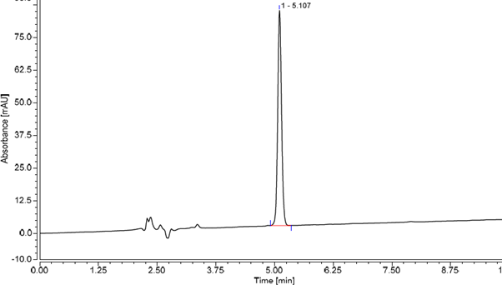
Figure S1 HPLC chromatogram of AKBA

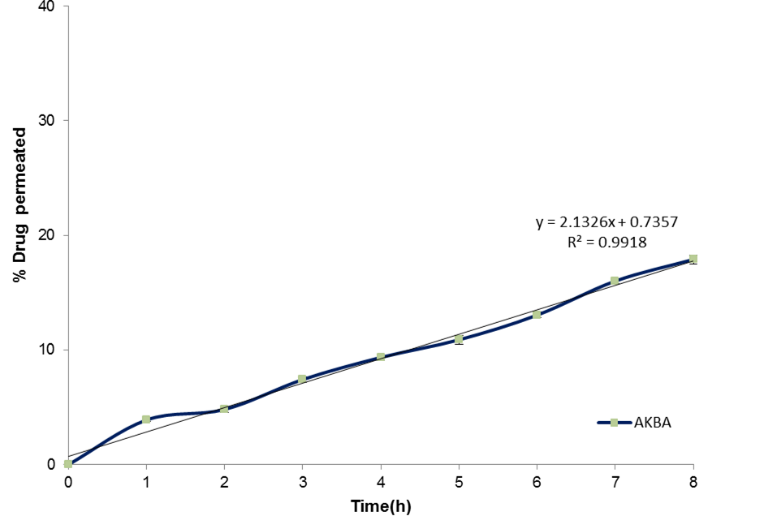

Figure S2 Zero order kinetics graph of ex vivo permeation of AKBA dispersion

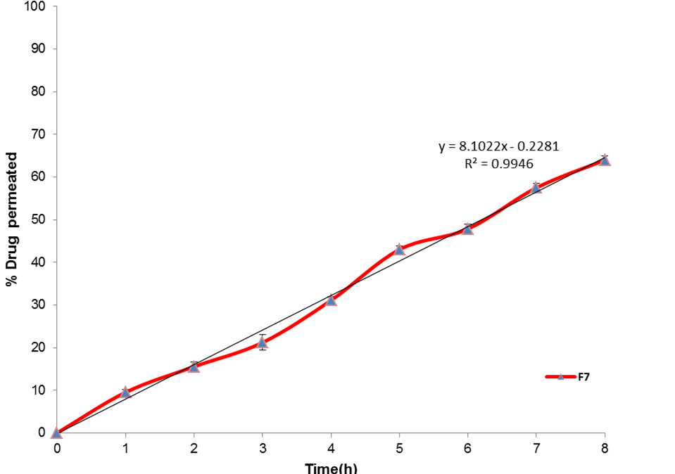

Figure S3 Zero order kinetics graph of ex vivo permeation ‎ of F7

