Supplementary Table 1

A questionnaire for COPD patients followed-up during COVID-19 outbreak in Hubei Province, China.
Since the December 01, 2019 to the end of March, 2020 (last 4 months)
(1) Did you live in Wuhan, or in Hubei Province except Wuhan, or outside Hubei Province?
(2) Did you infect COVID-19 and hospitalized?
(3) If infected, was your condition mild, moderate, severe, or critical?
(4) Was there infected case in your family?
(5) Did you smoke during the epidemic?
(6) Did your COPD condition get worse?
(7) If your COPD condition got worse, how many times?
(8) Did you go to the emergency for your acute exacerbation and how many times?
(9) Have you been hospitalized and how many times?
(10) Did you require additional therapy for your worsening of respiratory symptoms?
(11) How did you get your medicine during the last 4 months?
(12) Have you ever experienced cardio-cerebrovascular disease or other accident during the last 4 months?
COPD = Chronic obstructive pulmonary disease.

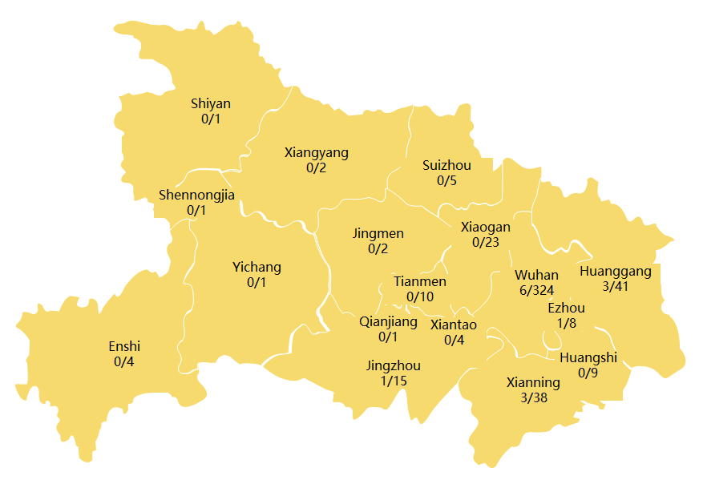

Supplementary Figure 1. Regional distribution of COPD patients on the map of Hubei Province, China.
[district, death(s) / patient(s) undergoing follow-up]

