Bifunctional Therapeutic Application of Low-Frequency Ultrasound Associated with Micelles of Zinc Phthalocyanine
Yugo A. Martins¹, Maria J. V. Fonseca¹, Theo Z. Pavan², Renata F. V. Lopez¹
¹ School of Pharmaceutical Sciences of Ribeirao Preto (FCFRP), University of Sao Paulo, Avenida do Café, s/n, 14040-903, Ribeirao Preto, São Paulo, Brazil
² School of Philosophy, Sciences and Letters of Ribeirao Preto (FFCLRP), University of Sao Paulo, Avenida Bandeirantes, 3900, 14090-900, Ribeirao Preto, Sao Paulo, Brazil

Supplementary material

Section S1. Skin resistivity as a function of contact time with SLS 1%

Figure S1.1. Skin resistivity influenced by 1% (m/v) SDS solution in PBS (pH 7.4). The error bars represent the standard deviation (n=4 determinations) and (*) indicate significant difference, according to ANOVA, followed by post hoc analysis using Tukey’s test with p < 0.05 as the minimum level of significance.

Section S2. Experimental setup used in in vitro cell viability studies

Microplate

coupling medium reservoir
Plug-in for ultrasound probe
Microplate holder

Thermometer

Figure S2.1. Experimental set up for LFU application to cell cultured in microplates.

Section S3. DSPE-PEG micelles development

Figure S3.1. Determination of CMC for DSPE-PEG in HEPES buffer solution (pH 7.4, 20 mmol.L⁻¹) by pyrene fluorescence method.

Table S3.1. Results of the ANOVA analysis for the prediction models, equation terms, lack of fit values for the models and a summary of the models’ equations and their adjusted and predicted correlation coefficients.
 |  | Responses
 |  | Size (nm)  (Y1) |  | PdI  (Y2) |  | Zeta potential (mV)  (Y3) |  | ZnPc concentration (μg.mL⁻¹) (Y4)
 |  | F value | P value | F value | P value | F value | P value | F value | P value
Prediction Model |  | 21.51 | 0.0018 | 18.8 | 0.0024 | 72.3 | < 0.0001 | 12.55 | 0.0007
Terms | X₁ | 0.482 | 0.5185 | 0.0006 | 0.982 | 2.78 | 0.1561 | 0.5308 | 0.4815
Terms | X₂ | 1.17 | 0.3282 | 1.79 | 0.2391 | 0.0109 | 0.921 | 32.16 | 0.0001
Terms | X₃ | 100.56 | 0.0002 | 93.33 | 0.0002 | 471.85 | < 0.0001 | 4.95 | 0.0479
Linear interaction | X₁X₂ | 0.0789 | 0.79 | 0.002 | 0.9662 | 0.2923 | 0.6119 | - | -
Linear interaction | X₁X₃ | 0.6467 | 0.4578 | 0.0548 | 0.8242 | 3.67 | 0.1134 | - | -
Linear interaction | X₂X₃ | 0.9849 | 0.3665 | 4.46 | 0.0883 | 0.2416 | 0.6439 | - | -
Quadratic interaction | X₁² | 0.3531 | 0.5782 | 2.14 | 0.2033 | 0.1311 | 0.7321 | - | -
Quadratic interaction | X₂² | 0.1277 | 0.7354 | 0.8273 | 0.4048 | 0.67 | 0.4503 | - | -
Quadratic interaction | X₃² | 88.44 | 0.0002 | 66.28 | 0.0005 | 168.24 | < 0.0001 | - | -
 | Lack of fit | 1.19 | 0.4864 | 13.27 | 0.0709 | 0.7666 | 0.6088 | 0.9926 | 0.5971
 | Equation | Y1 = 15.7 + 419.5 X₃ – 303.1X₃² |  | Y2 = 1.7 -2.6X₃ + 1.5X₃² |  | Y3= -11.2 – 47.9X₃ + 27.5X₃² |  | Y4 = 0.7 + 0.05X₂ – 2.8X₃
 | R² adjusted | 0.9295 |  | 0.9196 |  | 0.9786 |  | 0.7122
 | R² predicted | 0.7213 |  | 0.5596 |  | 0.9268 |  | 0.5644
Values in bold highlight the statistically significant values with P value < 0.05 calculated by ANOVA. X1: mass of DSPE-PEG (mg) in 3 mL of dispersion; X₂: mass of ZnPc (µg) in 3 mL of dispersion; X₃: Tween 80 and Span 80 (1:3 mol).

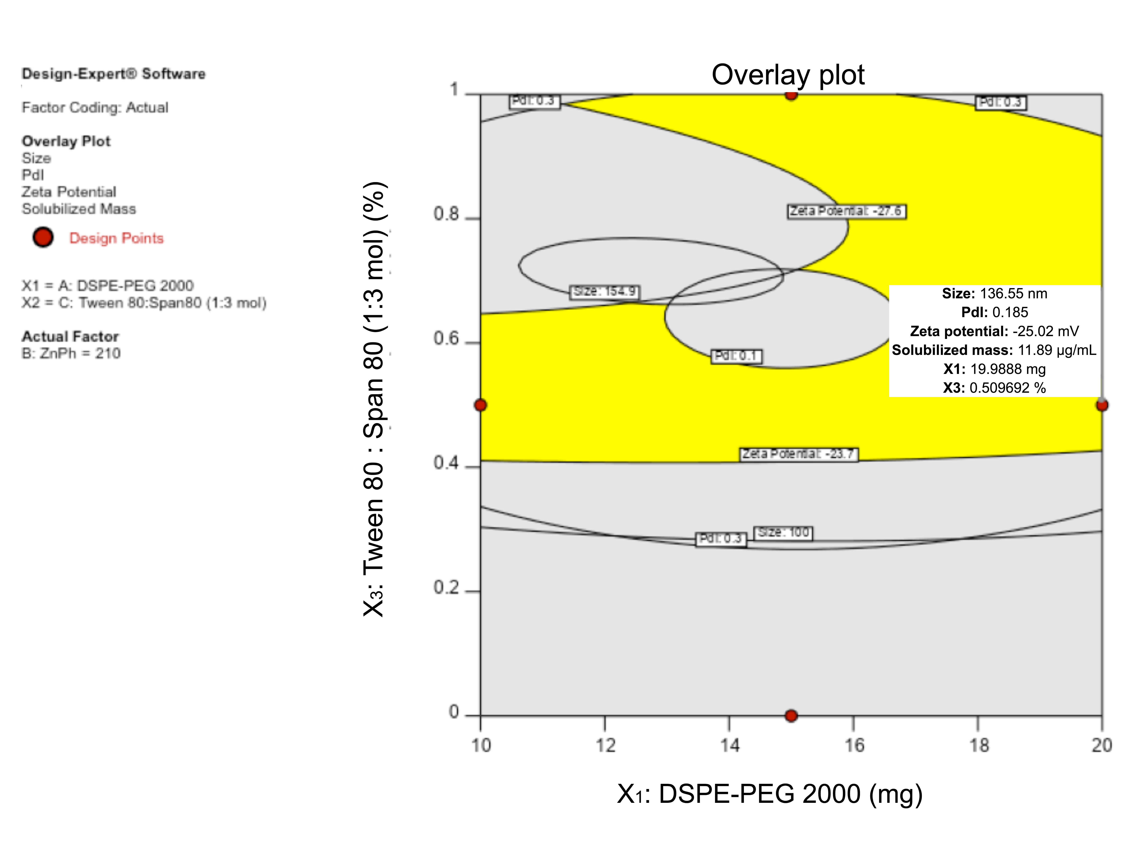
Figure S3.2. Graph representing the design space (in yellow) for optimized micelle formulation.

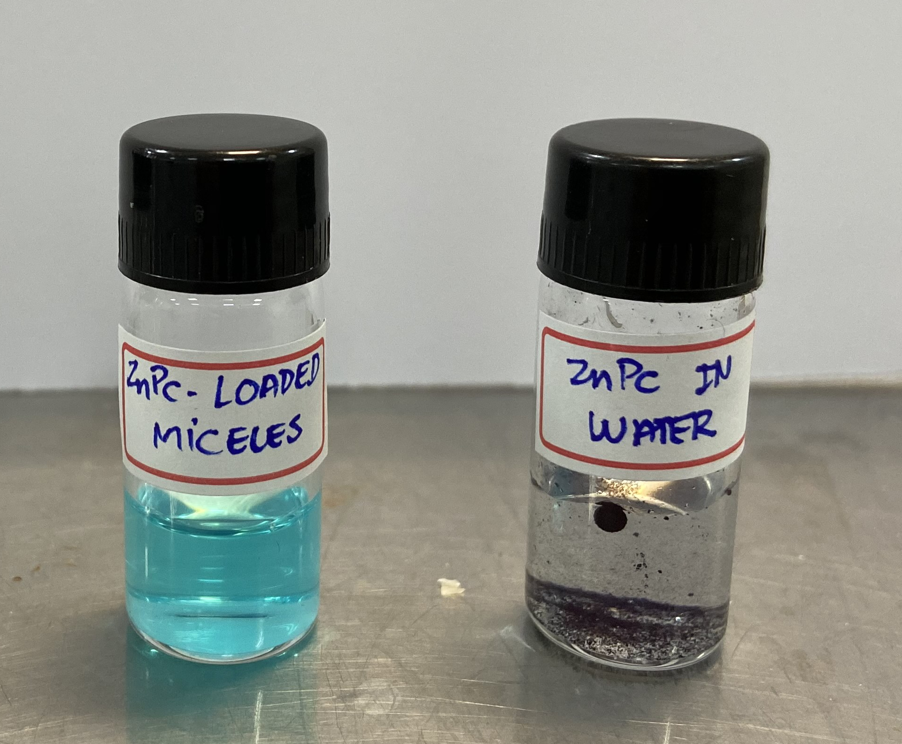
A
B

Figure S3.3. ZnPc-loaded micelles (A) and insoluble ZnPc in HEPES buffer solution (B). The blue color in A indicates the ZnPc loading in the hydrophobic core of the nanocarrier whereas the dark aggregates in B are the insoluble crystals of the drug in the aqueous medium.

A
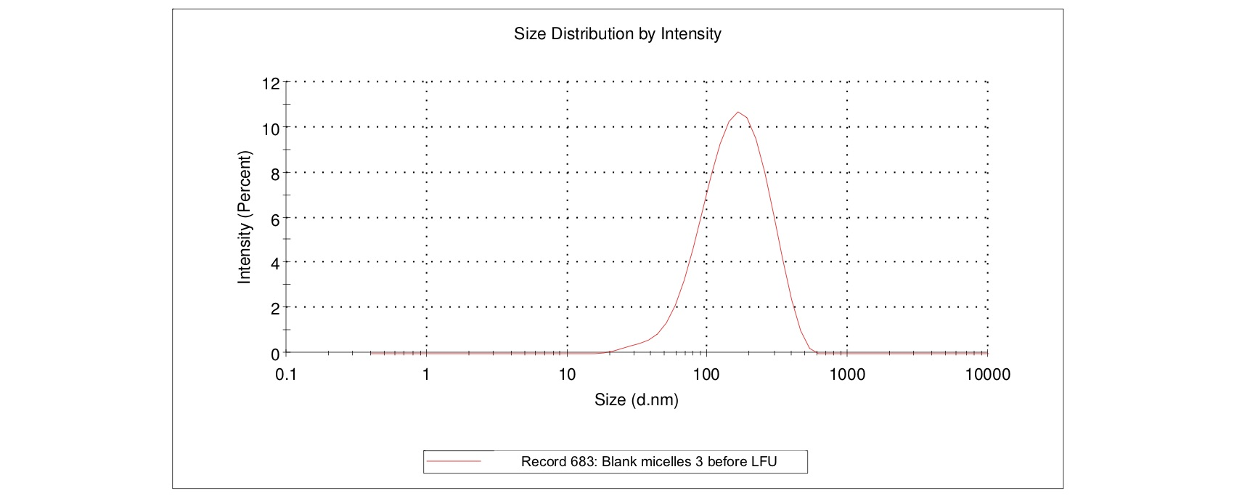

B
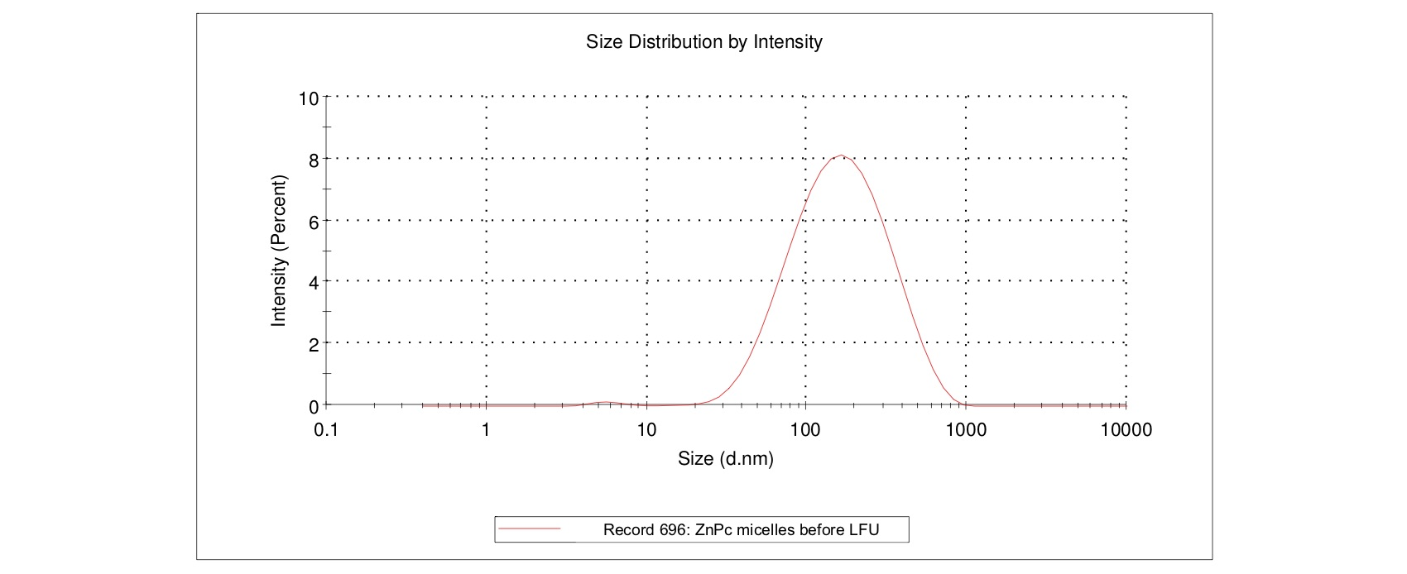

Figure S3.4. The size distribution, evaluated by dynamic light scattering, of blank (A) and ZnPc-loaded micelles (B) prepared by hydrating the thin lipid film composed of 20 mg of DSPE-PEG, 210 µg of ZnPc (in the case of the ZnPc-contaning micelles) and 0.5% Tween 80/Span 80 (1:3 mol) in HEPES buffer solution (20 mmol/L pH 7.4).

Section S4. Cavitational activity of DSPE-PEG micelles

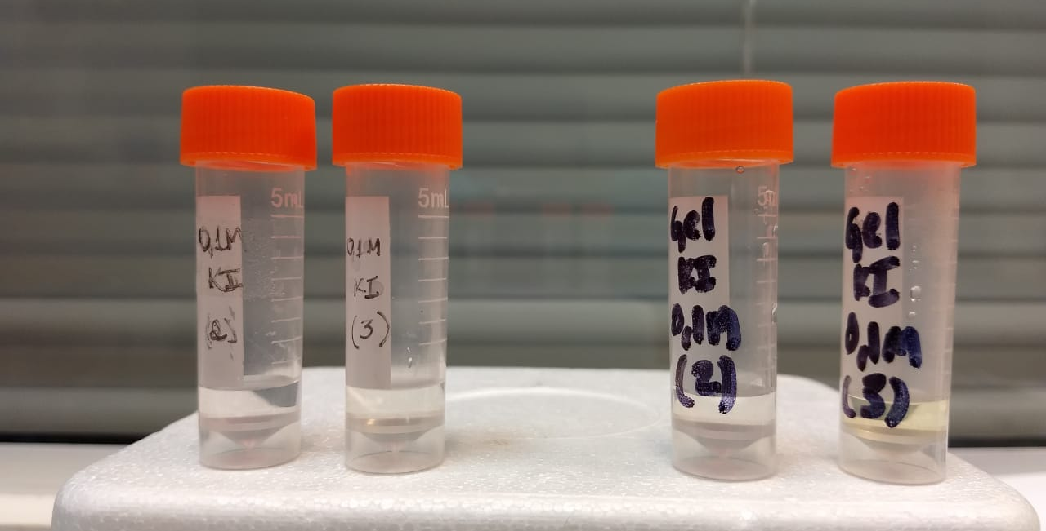
After
LFU
Before
LFU
After
LFU
Before
LFU

Water
Hydrogel

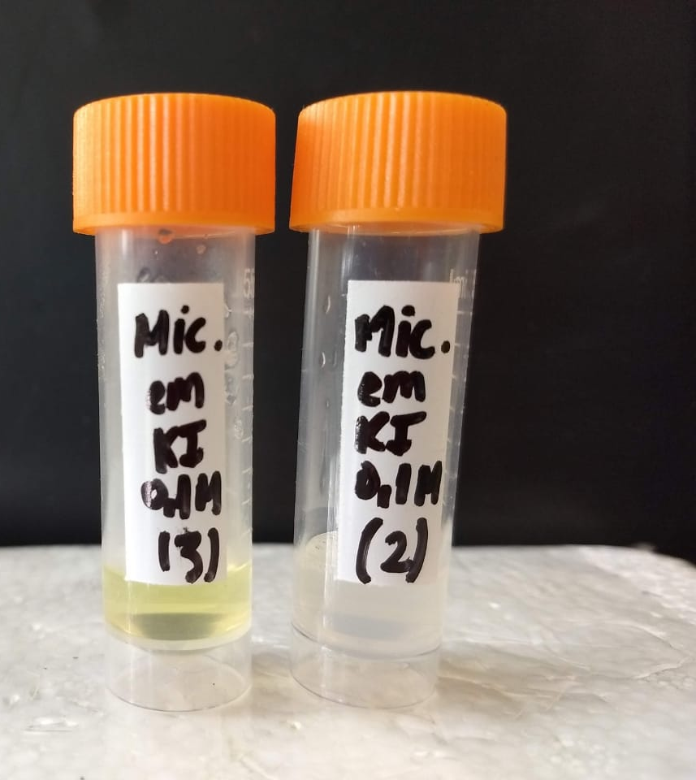
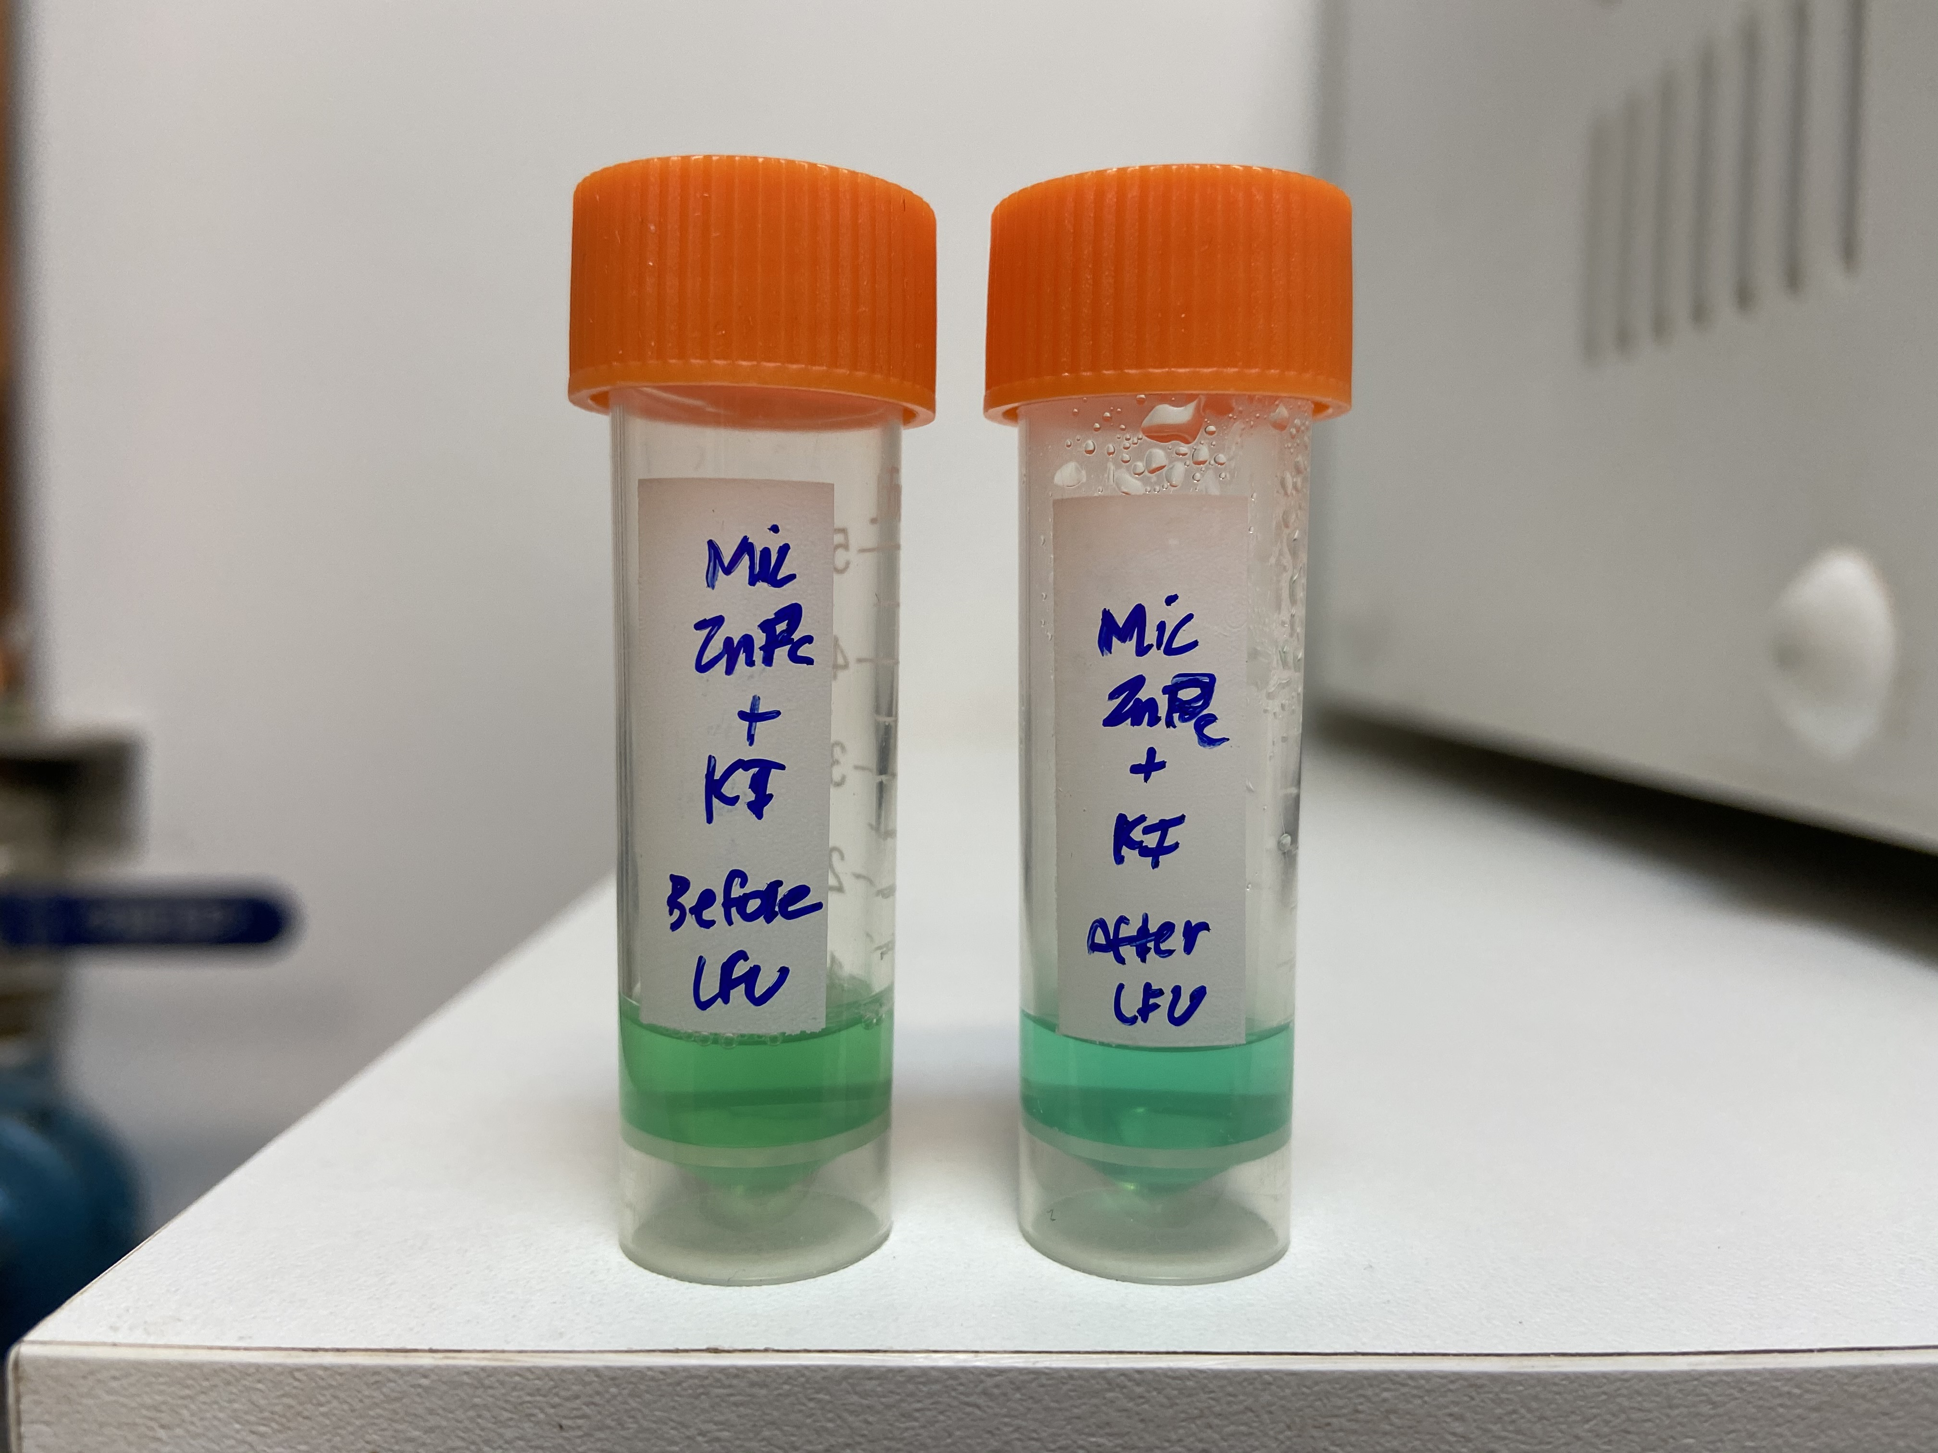
Before
LFU
After
LFU
Before
LFU
After
LFU

ZnPc-loaded micelle
Blank Micelle

Figure S4.1. Sonication of water, hydrogel, blank and ZnPc-loaded micelles in KI medium. Dispersions that did not contain ZnPc were colorless before sonication. After sonication, colorless gel and blank micelle dispersions turned yellow, indicating the formation of triiodide ions due to high cavitational activity. ZnPc-loaded micelle dispersion was greenish before and after sonication.

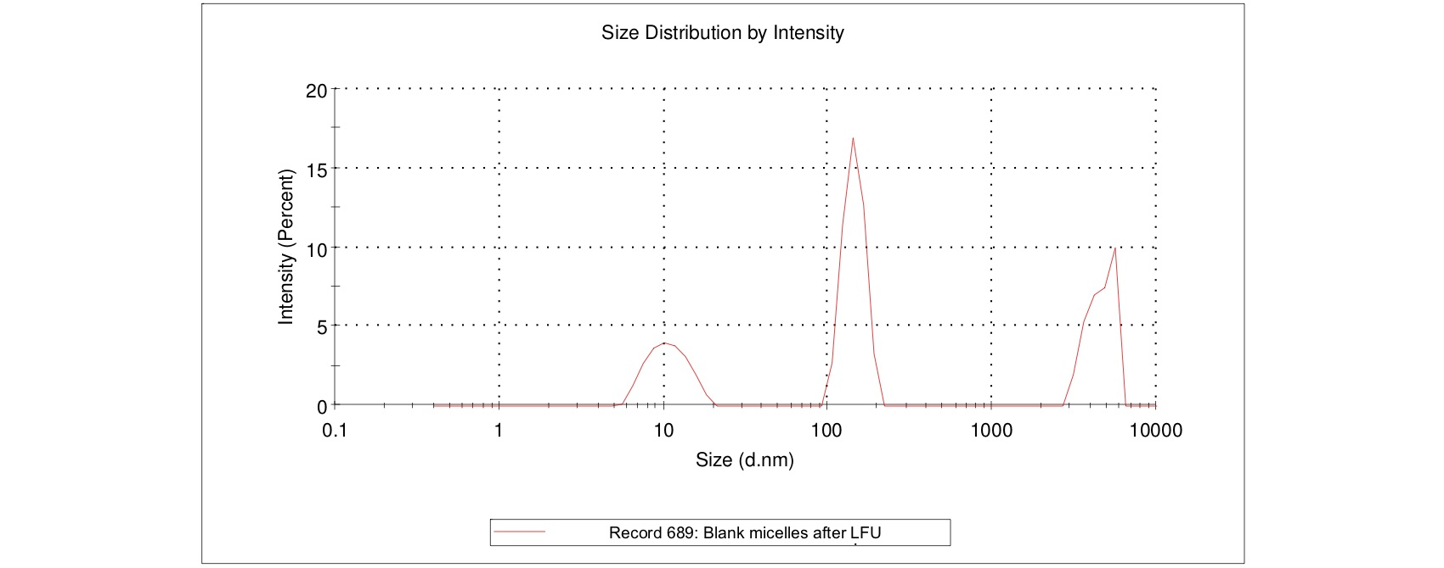

Figure S4.2. Size distribution and polydispersity of the blank micelles after LFU irradiation (20 kHz, I_{sata} of 10 ± 0.5 W/cm², 50% duty cycle (5s on and 5 s off) for 1 min).

(A) SLS

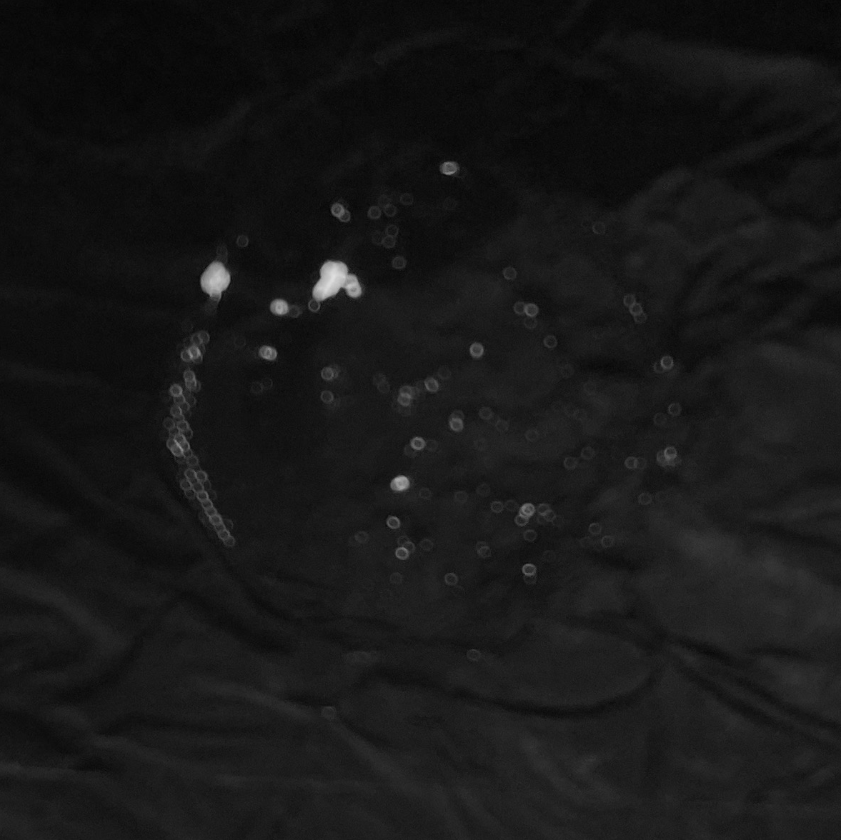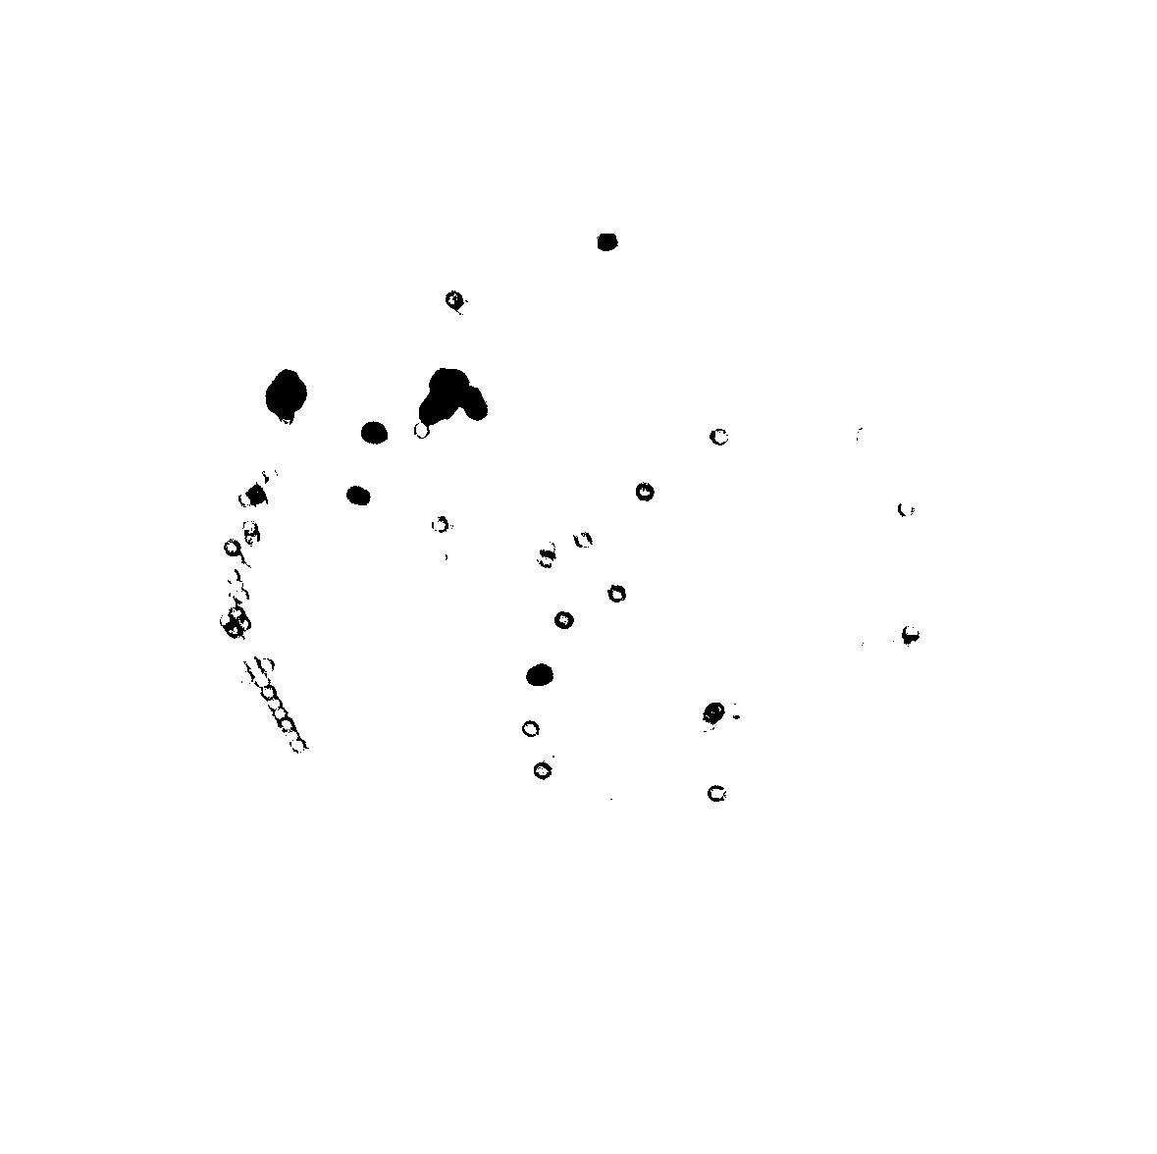

(B) Blank micelle

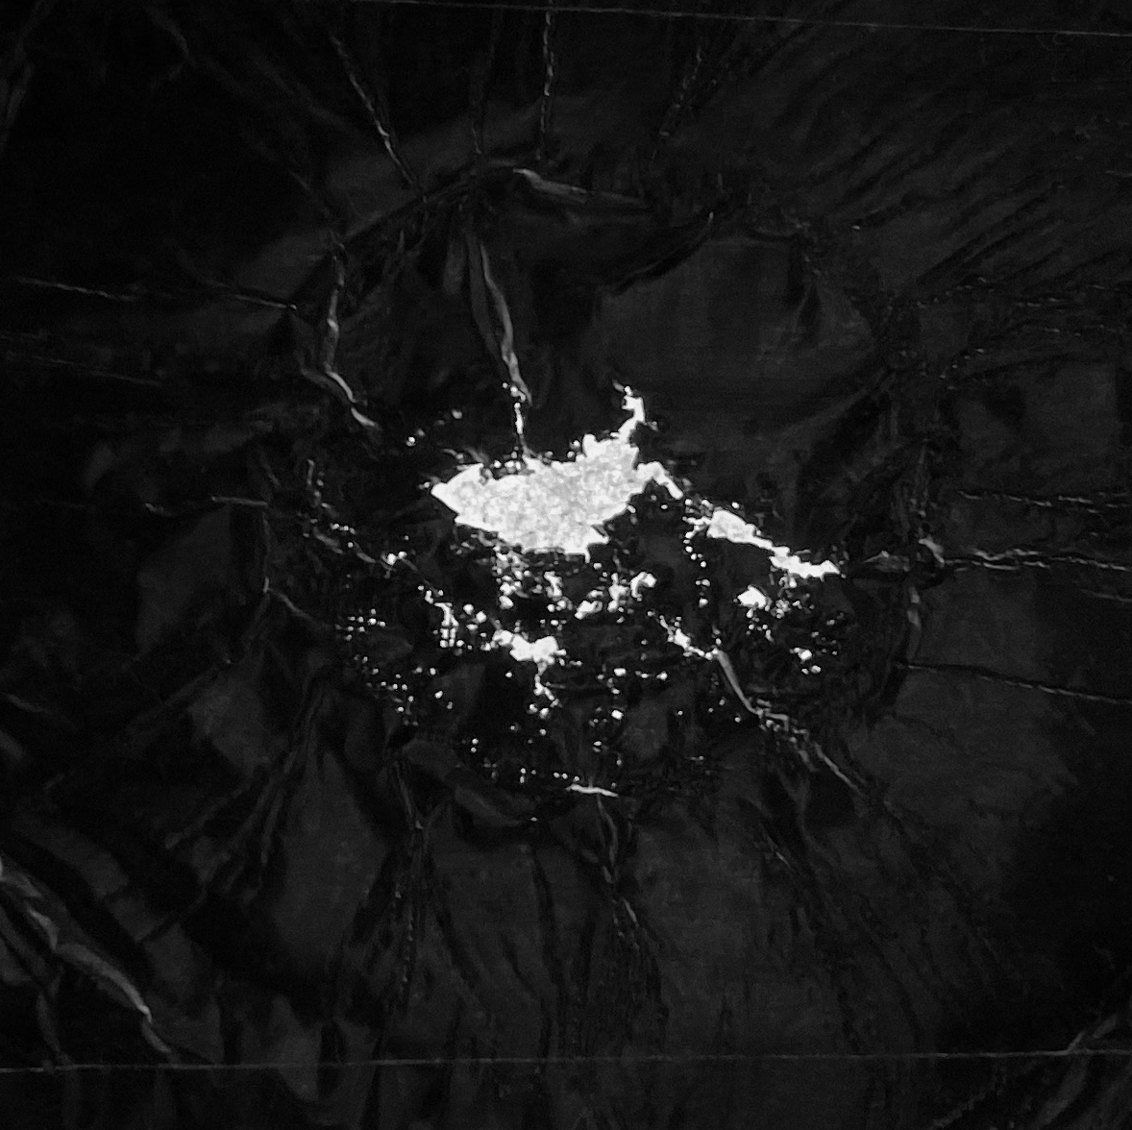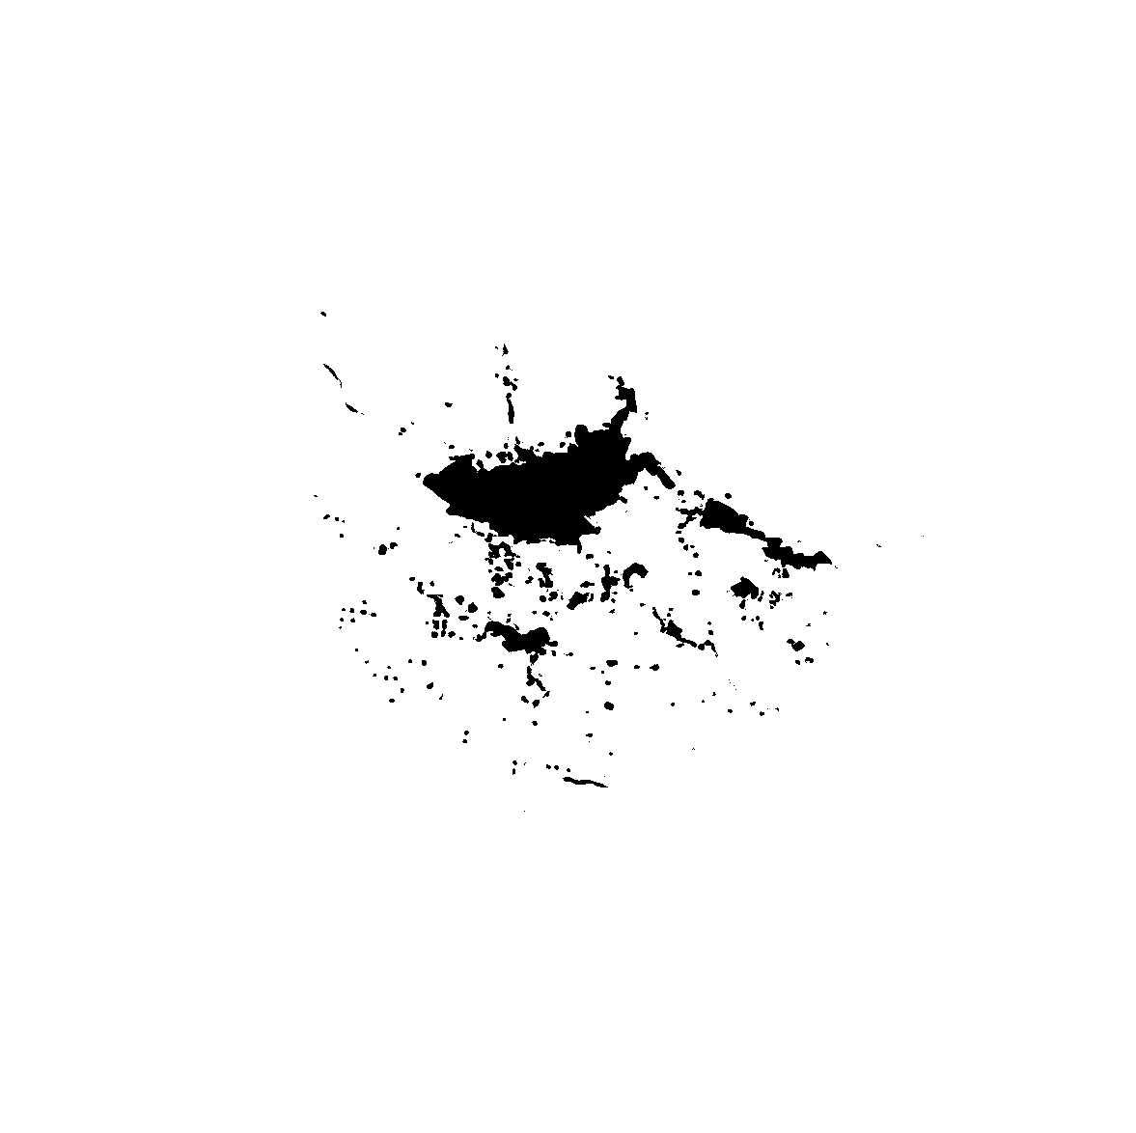

(C) ZnPc-loaded micelles
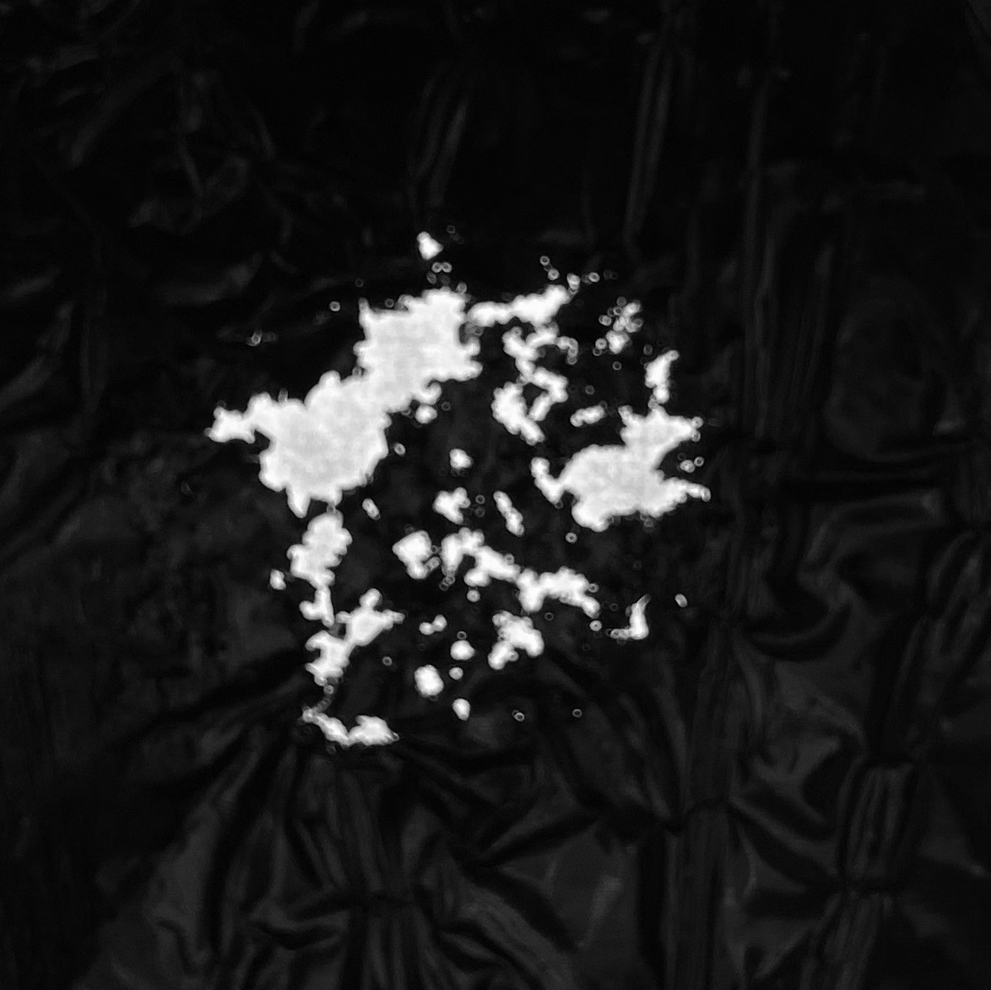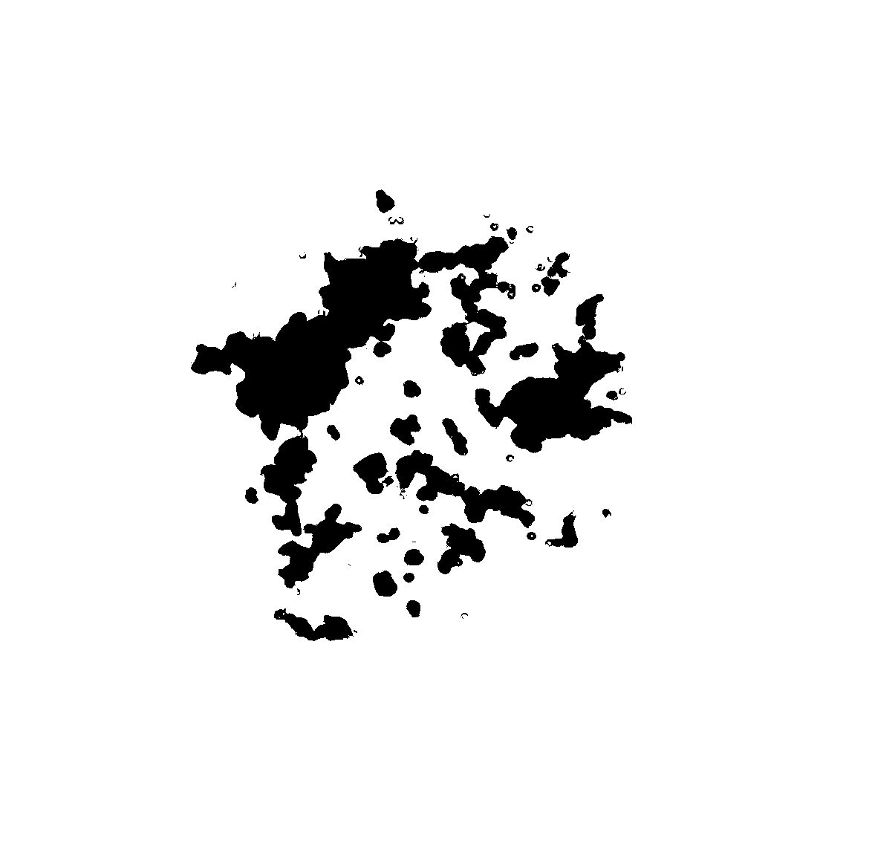

Figure S4.3. Representative images of the pits in the aluminum foil produced by 10 s application of LFU using (A) SLS solution, (B) Blank micelles; and (C) ZnPc-loaded micelles as coupling media. The original images of the aluminum foil pits are at the left and binary image of the region of interest marked and quantified using Fiji software at the right.

