Supplementary Information

MRI scan of the rectum
To overcome the huge variability in terms of bowel distension and to reduce the overall duration of the resonance exam, MR scanning was restrained to the most distal part of the colon corresponding to the rectum. In all examined mice, the rectum displayed mucosal inflammation and thickening of the intestinal wall, making it an excellent bowel region to study. Moreover, rectum could be easily cleaned and cleared from stool and food particles, and is much less affected by bowel contractions which can blur the MRI pictures, thus allowing to standardize the protocol for MRI scan.
Acquired sequences for the axial MRI scan of the rectum were: Rapid Acquisition with Relaxation Enhancement (RARE) T2-weighted, RARE T1-map, RARE T1-weighted (slice thickness 0.8 mm, total number of slices 9). RAREVTR (RARE with variable repetition time) and Multi Slice Multi Echo (MSME) sequences were applied to determine T1 and T2, respectively. Mice breath and body temperature were monitored all over the MRI exam. Before MR enterography, bowel preparation was performed by overnight fasting and administration of macrogol (Selg Esse, 3.5 % w/v, ad libitum) in tap water. Just prior to the MRI scan, the rectum was cleared from stool residues by gentle flushing with saline solution upon anesthesia. In order to assess bowel inflammation and to get non-contrast-enhanced images, MRI scan of the rectum was performed before NPs administration for all examined mice.

Supplementary Figures

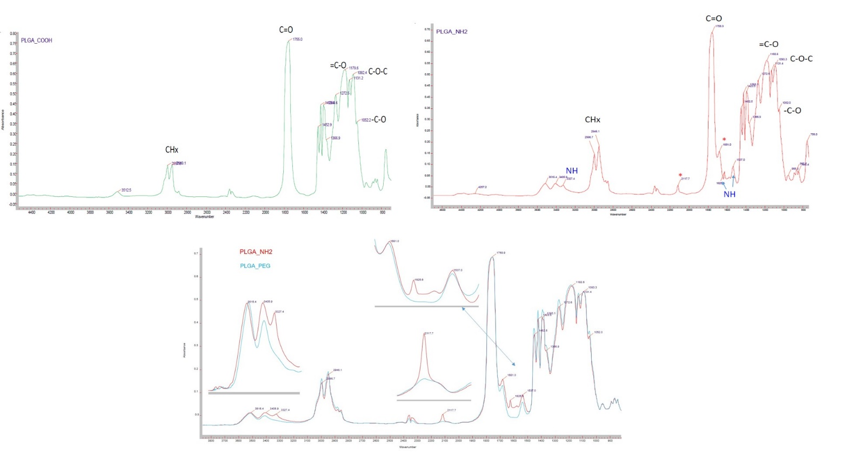
A
C
B
Supplementary Figure 1. FTIR analysis of PLGA-COOH (A), PLGA-NH₂ (B) and the comparison between PLGA-NH₂ and PLGA-PEG-Mal spectrum, which no longer shows the typical peak of PLGA- NH₂ (C).

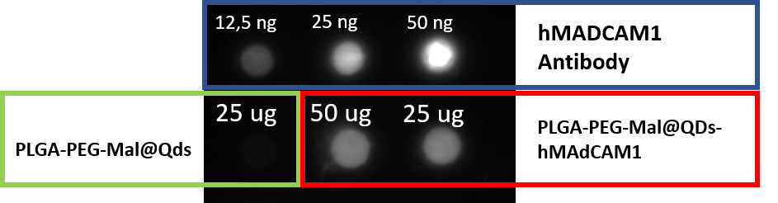
Supplementary Figure 2. Dot blot analysis of P@QD-MdC NPs. Positive control was achieved by three different concentrations of half chain MAdCAM-1 antibody (hMADCAM1, 12.5, 25, 50 ng) and the negative control was performed by unconjugated NPs (PLGA-PEG-Mal@QDs, 25 μg). The quantification of P@QD-MdC signal (50 and 25 μg of NPs) was characterised by Image J software for a semiquantitative analysis and it corresponds to 26 ng ± 0.22 and 13 ng ± 5.60 of antibody, respectively (n=3). (Analysis were determined using a calibration curve, data no shown)

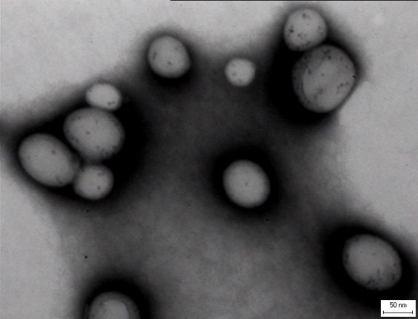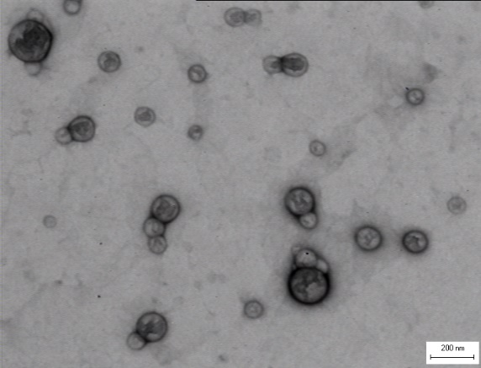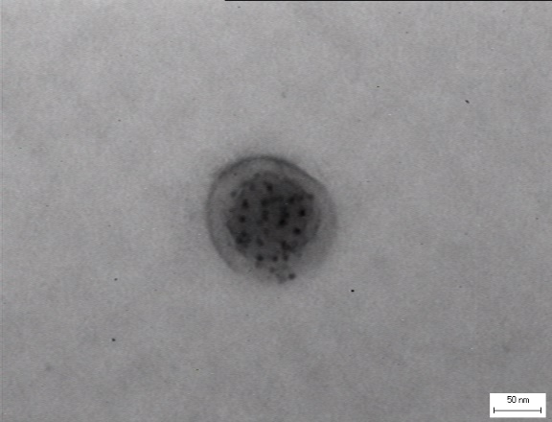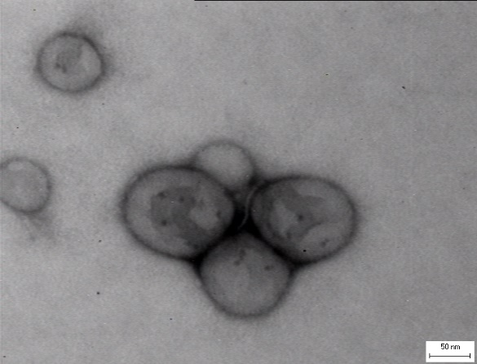
Supplementary Figure 3. TEM images of P@QD-MdC NPs.

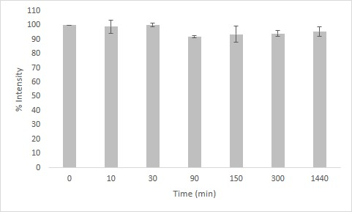
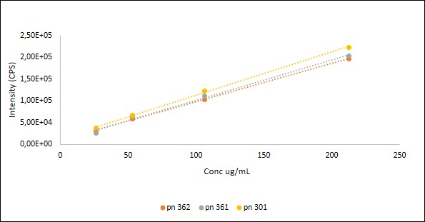
Supplementary Figure 4. Fluorescence of QD-loaded PLGA-PEG-Mal NPs was analyzed by diluting NPs in water (λex = 300 nm; λem = 764 nm). Calibration curves from three batches of NPs (PN301, PN361, PN362) are reported to show reproducible signals (left panel). Fluorescence intensity stability of P@QD in PBS (pH 7.2) for 24 h is shown in the right panel.

Supplementary Figure 5. Binding capability of PLGA-PEG NPs conjugated with either whole (P-TZ) or half chain (P-HC) trastuzumab antibody was assessed by flow cytometry on SKBR3 cells. Different concentrations were used and compared to corresponding concentrations of free trastuzumab (TZ, 1 - 0.1 - 0.01 μg mL⁻¹). Binding assay was performed on cells in suspension in tubes containing 0.3% BSA-PBS by incubating NPs for 2 h at 4 °C (A) or on cells adhering to tissue-culture plates by incubating NPs in culture medium for 1 h at 37 °C (B). Results were analyzed by flow cytometry and expressed as means ± SE (n = 3).

Supplementary Figure 6. PLGA-PEG-HC NPs were prepared by using 25% (PN340), 50% (PN341) or 100% (PN342) of PEG-Mal (w/v). (A) The conjugation efficiency was assessed by dot blot analysis on 50, 25 or 12.5 μg of NPs by means of HRP-conjugated anti-human antibody. (B) Recognition of the biological target was assessed by flow cytometry binding assay by incubating 0.3 mg mL⁻¹ of PN340, PN341 or PN342 on SKBR3 cells for 2 h at 4 °C.

Supplementary Figure 7. Plasma bioavailability of fluorescent NPs was measured at 10 min, 1, 6 and 24 h post-injection in colitic mice and expressed as percentage of the injected dose (ID). As reference for ID, NPs were freshly resuspended in blood samples at the same dosage used for administration; then processed for plasma isolation and analyzed for fluorescence together with blood sampling from treated mice.

Supplementary Figure 8. Scanning electron microscopy of P@QD-MdC NPs as is (A) or lying on the endothelium of bowel mucosal vessels in colon specimens from mice treated for 24 h with P@QD-MdC NPs (B). Size analysis was performed by point to point measurements. Scale bar: 1 μm.

Supplementary Figure 9. NPs accumulation and transit kinetics in liver, lungs and spleen at 10 min, 1 h and 24 h post-injection. Average epifluorescence is shown as radiant efficiency (p/sec/cm2/sr)/(μW/cm2). Results are means ± SE (n = 15). Statistical analysis was conducted by Wilcoxon-Mann-Whitney test (90% confidence level), *p=0.06, **p=0.01.

Supplementary Figure 10. Representative axial MR images (T2, T1 and T1 map) of the rectum before and after injection of NPs in a DSS-treated mouse presenting with chronic colitis. Post-contrast images show rim enhancement of the bowel mucosa (outlined in yellow). The anatomic structures and different layers of the bowel wall were distinctively depicted in the MRI pictures. No appreciable contrast enhancement in T2 MRI was observed at the concentration of agent used in this study, thus supporting the main potential of the here presented NPs as T1 contrast agents.

Supplementary Table 1. Histomorphological scores of intestinal inflammation from individual mice treated with NPs for 24 h (n = 3 per group)

 | Density of inflammatory cell infiltrate ¹ | Extent of leukocyte infiltration ² | Granulocyte component ³ | Epithelial changes ⁴
P@QD-MdC | 1 | 2 | 1 | 1
P@QD-MdC | 1 | 2 | 1 | 2
P@QD-MdC | 1 | 1 | 1 | 1
P@QD-IgG | 3 | 3 | 2,5 | 3
P@QD-IgG | 3 | 2 | 2,5 | 3
P@QD-IgG | 2 | 1 | 1 | 3
P@QD | 3 | 2 | 3 | 3
P@QD | 1 | 1 | 1 | 3
P@QD | 2 | 2 | 1,5 | 3

¹ Mild 1, Moderate 2, Severe 3
² Mucosal 1, Mucosal and submucosal 2, Mucosal, submucosal and transmural 3
³ 0-10 % granulocytes 1, >10% focal 2, >10% diffuse 3
⁴ Epithelial regeneration 1, Erosion and regeneration 2, Ulceration 3

